Introduction
This document was developed by the Data Standardization Work Group (DSWG) of the CSTE Surveillance Practice and Implementation Subcommittee and will be published and maintained in a repository on the CSTE website. For additional background on the CSTE Brief associated with this work, please refer to [Insert website].

Data Element Description
This section focuses primarily on 10 data elements representing laboratory-related dates in Generic v2.0 (GenV2)-based MMGs:

Laboratory Interpretative Repeating Group Data Elements:
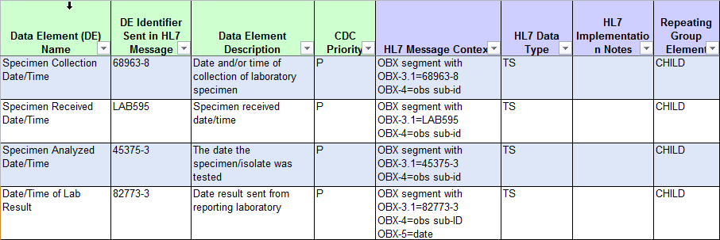

Laboratory Template Data Elements:
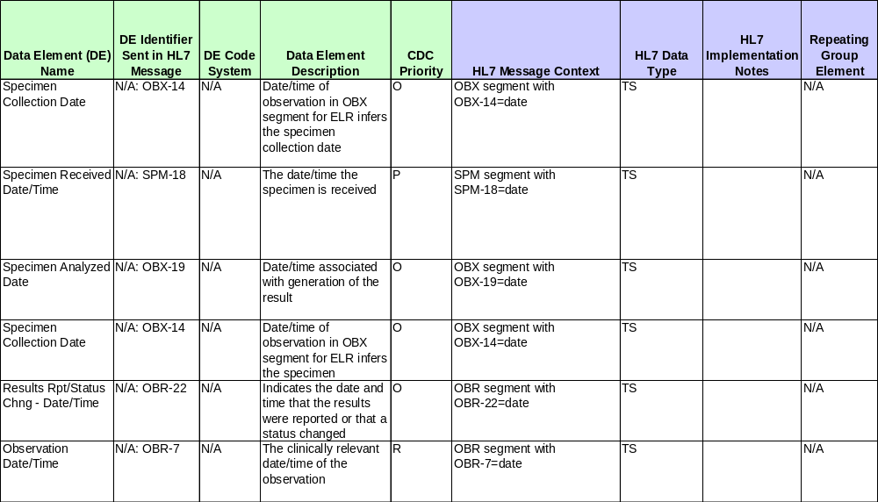

Four of these dates are part of the Lab Interpretive Repeating Group within GenV2-based MMGs, while an additional six lab result data elements are included in the Laboratory Template associated with these guides:
Lab Interpretive repeating group | Laboratory Template
Specimen Collection Date/Time | Specimen Collection Date/Time (SPM-17)
Specimen Received Date/Time | Specimen Received Date/Time (SPM-18)
Specimen Analyzed Date/ Time | Specimen Analyzed Date (OBX-19)
Date/Time of Lab Result | Specimen Collection Date (OBX-14)
 | Results Rpt/Status Change Date/Time (OBR-22)
 | Observation Date/Time (OBR-7)

The dates in the repeating group and the Laboratory Template overlap as they reference the same date concepts. Dates from both sources are discussed together below when they reference the same date concept. Note that the laboratory-related date elements addressed here are associated with disease-specific GenV2-based MMGs, but there are no laboratory-related dates included within GenV2 itself.

Please note, only specimen collection date is included in the Arboviral v1.3 MMG.
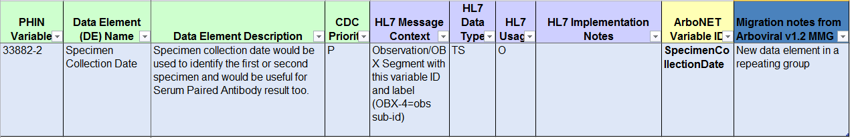

Lab Dates: Background and Overview

Lab Dates: Data Element Priority and Usage
The CDC Priority for all four dates included in the lab interpretive repeating group is preferred. The inclusion of individual laboratory-related dates within the repeating group varies not only by guide but, in the case of the Foodborne and Diarrheal Diseases (FDD) guide, by condition within the MMG.

Laboratory Template data elements are standard for all MMGs using the template; Observation Date/Time (OBR-7) is a required element, Specimen Received Date/Time (SPM-17) is preferred, and the rest are optional.

Specimen Collection Dates

Lab Interpretive Repeating Group:
- Specimen Collection Date/Time

Laboratory Template:
- Observation Date/Time (OBR-7)
- Specimen Collection Date (OBX-14)
- Specimen Collection Date/Time (SPM-17)
Specimen Collection Date is widely available for both paper and electronic laboratory reports and is captured in most jurisdictions’ surveillance systems. Specimen collection date is an important data element with many applications for public health surveillance and control. It frequently contributes to calculated/hierarchical aggregate reporting dates for case counting and public health reporting (MMWR Week, Event Date). It may also be used to determine timing/appropriateness of testing, whether testing was done pre- or post-treatment, and differentiating between multiple specimens collected over the course of a disease event. It can also be useful, along with accession number, in deduplication of lab results that are reported by multiple sources.

The Specimen Collection Date represents the date a clinical specimen was collected from the patient for testing for the reportable condition of concern; this date does not typically represent the date an isolate was created. The lab interpretive lab data element Specimen Collection Date/Time is directly comparable with Specimen Collection Date/Time (SPM-17) and Specimen Collection Date (OBX-14) in the laboratory template, and by HL7 2.5.1 standards should also be synonymous with Observation Date/Time (OBR-7).

Specimen Collection Date should be populated directly from the corresponding date on the paper or electronic laboratory report or from a data element in the surveillance system that captures this information. For jurisdictions using the Laboratory Template, Observation Date/Time (OBR-7) is required and must be populated; therefore jurisdictions using the Laboratory Template must be able to capture the date of specimen collection within their surveillance system. For other data elements, if this information is not available, the associated HL7 segment should not be sent.

Recommended Implementation: Specimen Collection Date
Specimen Collection Date (i.e., Specimen Collection Date/Time (repeating group), Specimen Collection Date/Time (SPM-17), Specimen Collection Date (OBX-14) and Observation Date/Time (OBR-7)) should be interpreted as the date a clinical specimen was collected from the patient for the laboratory testing relevant to the condition being reported to a public health agency.

Specimen Received Dates:

Lab Interpretive Repeating Group:
- Specimen Received Date/Time

Laboratory Template:
- Specimen Received Date/Time (SPM-18)
Specimen Received Date is not frequently captured in surveillance systems, though it is typically available for electronically reported labs. It is usually available within a public health laboratory’s LIMS system and some jurisdictions may use data from this source rather than importing it into the surveillance system. Some jurisdictions may use this date to track specimens within the public health laboratory, particularly processing of outbreak specimens for foodborne conditions. States may use the date for quality control metrics within the public health lab, including turnaround time. It could also be used with commercial labs to track timing of specimens that were tested in multiple facilities; although timing of receipt at a commercial lab was not widely considered relevant to public health surveillance or investigation.

Specimen Received Date represents the date that a specimen is received at the laboratory performing the test for the notifiable condition of concern. This typically represents when a specimen package is opened by the lab rather than when it is first received at a facility, which may introduce a margin of error for use of this date. This date is directly comparable to Specimen Received Date/Time (SPM-18) in the laboratory template.

When available, this data element should be populated directly from the corresponding date on the paper or electronic laboratory report or from a data element in the surveillance system that captures this information. If this information is not available, the data element should not be populated in the HL7 message.

Recommended Implementation: Specimen Received Date/Time
Specimen Received Date/Time (repeating group) and Specimen Received Date/Time (SPM-18) should be interpreted as the date the specimen was received by the performing laboratory for the condition being reported to a public health agency, be it county/local or state

Result Dates:

Lab Interpretive Repeating Group:
- Date/Time of Lab Result
- Specimen Analyzed Date/Time

Laboratory Template:
- Results Rpt/Status Chng - Date/Time (OBR-22)
- Specimen Analyzed Date (OBX-19)
Existing MMGs include one or both of two laboratory result-related dates in the interpretive laboratory repeating group, while both are part of the laboratory template:
- Specimen Analyzed Date/Time (comparable to Specimen Analyzed Date (OBX-19)) is intended to represent the date testing occurred/when the result was generated.
- Date/Time of Lab Result (comparable to Results Rpt/Status Chng - Date/Time, OBR-22) represents when a result was reported out by the laboratory. (N.B: Date Result Reported (OBR-22) may change if updated results are released as newer results become available.)

While these fields are distinct in most HL7 ELR messages, Specimen Analyzed Date and data elements representing the date a result was reported (Date/Time of Lab Result, Results Rpt/Status Chng) may not be stored separately in some surveillance systems. In general, a ‘result date’ data element may be captured that could represent either or both of the two dates. Paper labs also frequently do not include both the date a result was reported and the specimen analyzed dates and may not clearly specify which date is reflected on the lab result paper form. For practical purposes, in most cases the date that a test is completed/result generated is unlikely to vary greatly from the date the result is reported out by the laboratory (especially in the case of electronic test reporting where results can be reported as soon as they are available). Any difference is unlikely to be meaningful in terms of public health surveillance and control. For this reason, it was the workgroup’s view that when these dates could not be distinguished, any ‘result date’ captured in the jurisdictional surveillance system would be an acceptable date for populating all of these data elements.

In systems that capture only one of these dates or do not differentiate between the types of ‘result date’ the single ‘result date’ that is captured may be used to populate both Lab Interpretive data elements and both Laboratory Template data elements.

For systems that feed ELR data directly into the NNDSS HL7 messages, or for systems in which the two dates (OBR-22 and OBX-19) are captured as two distinct data elements, the two result dates can be populated accordingly. In systems with two distinct dates, values captured from OBR-22 should be used to populate Date/Time of Lab Result in the Interpretive Lab group and Results Rpt/Status Chng – Date/Time in the Laboratory Template. Values captured from OBX-19 should be used to populate Specimen Analyzed Date/Time in the Lab Interpretive group and Specimen Analyzed Date in the Laboratory template.

If no result date is available, the associated HL7 segment should not be included.

Recommended Implementation: Result Date
Result date may reflect either the date the specimen was analyzed or the date the latest result was released for reporting. If the surveillance system captures and stores both Specimen Analyzed Date and the date a result was reported out, both data elements should be maintained and reported accordingly. If only one result date is available, that date can be used to populate Specimen Analyzed Date/Time/Specimen Analyzed Date (OBX-19) and Date/Time of Lab Result/Results Rpt/Status Change.

Lab Dates: Data Source
Laboratory-related dates may be obtained from ELR, paper laboratory reports, electronic medical records (EMR or eICR), or sometimes from provider-submitted reports, other forms of medical records or a provider interview (uncommon). Data from ELR laboratory reports should be the gold standard, as each of these fields is captured distinctly and can be used to populate the HL7 case notification directly. Other sources may be missing some laboratory-related dates or dates may require some clarification as to what information is actually represented by available dates.

Examples of specific scenarios:
- A jurisdictional surveillance system captures specimen collection date and a single result date (which includes a mix of date result generated and date result reported). A lab is received with a specimen collection date of 03/01/2019, and a result date of 03/02/2019. MMG elements should be captured as follows:
- Specimen Collected Date/Time, Observation Date/Time (OBR-7), Specimen Collection Date (OBX-14), Specimen Collection Date/Time (SPM-17) : 03/01/2019
- Specimen Received Date/Time, Specimen Received Date/Time (SPM-18): Do not send
- Specimen Analyzed Date, Specimen Analyzed Date/Time (OBX-19): 03/02/2019
- Date/Time of Lab Result, Results Rpt/Status Chng (OBR-22): 03/02/2019
- A jurisdictional surveillance system captures each of the above dates separately from ELR messages. A lab result is received with a specimen collection date of 3/5/2019, a specimen received date of 3/6/2019, and specimen analyzed date of 3/6/2019, and a results reported date of 3/7/2019. MMG elements should be captured as follows:
  - Specimen Collected Date/Time, Observation Date/Time (OBR-7), Specimen Collection Date (OBX-14), Specimen Collection Date/Time (SPM-17) : 03/05/2019
  - Specimen Received Date/Time, Specimen Received Date/Time (SPM-18): 03/06/2019
  - Specimen Analyzed Date, Specimen Analyzed Date/Time (OBX-19): 03/06/2019
  - Date/Time of Lab Result, Results Rpt/Status Chng (OBR-22): 03/07/2019

Recommended Actions

CSTE

- Provide support for the vetting process and distribution of the final products to the CSTE community.
- Publish the Data Standardization Brief and supporting documents on the CSTE website in a repository.
- Data Standardization Work Group and Surveillance Practice and Implementation Subcommittee:
- Promote the Data Standardization Brief and supporting documents on the Surveillance/Informatics Steering Committee and SPIS Subcommittee conference calls.
- Review and update the brief upon changes to the GenV2-based Messaging Mapping Guides.

CDC

- Incorporate the following changes into any revisions of the GenV2-based Message Mapping Guides, or comparable Generic V3-based guides:
  - Revise the Data Element Names to match date type
    - Dates with data type ‘Date’ should not include Date/Time in the data element name.
  - Remove the Specimen Received Date, as it is infrequently captured or used in surveillance systems.

State, Territorial and Local Health Departments

- Review the brief and conduct a gap analysis for each data element to identify differences in the surveillance system implementation and application of the data elements across disease programs.
- Implement necessary revisions to the surveillance system to address the following:
  - Ensure that surveillance system can capture Specimen Collection Date and at least one type of ‘result date.’
  - Consider collecting result date data elements separately as Specimen Analyzed Date (Date result was generated) and Date of Laboratory Report (Date result reported by laboratory).

The name of this repeating group varies slightly across MMGs.

