Introduction
This document was developed by the Data Standardization Work Group (DSWG) of the CSTE Surveillance Practice and Implementation Subcommittee and will be published and maintained in a repository on the CSTE website. For additional background on the CSTE Brief associated with this work, please refer to [Insert website].

Data Element Description
This section focuses on four data elements related to reporting dates in the Generic v2.0 MMG:
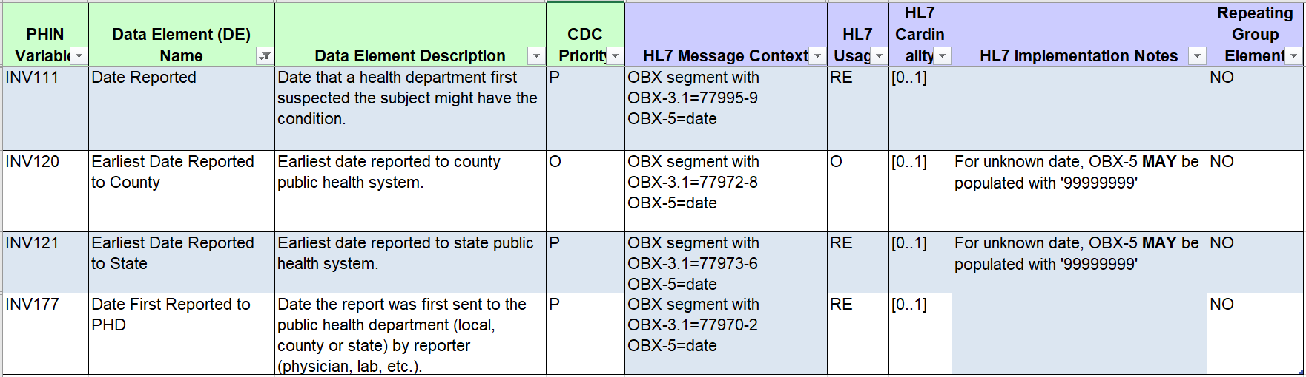
Please note, these data elements are not included in the Arboviral v1.3 MMG.

Report Date: Background and overview

Report Dates: Data element Priority and usage
These data elements are core GenV2 non-repeating data elements. While multiple reports from multiple sources may be received for a given case, these data elements are defined only once for the case and should represent the “first” or “earliest” of the applicable reports for each element.

Jurisdictions generally collect a date to represent when a case is reported to the public health agency, but may not collect all four dates shown above or the date(s) captured may vary across jurisdictions.

The date most consistently utilized across jurisdictions, although with varied names in the surveillance systems and definitions for application, is the Date First Reported to Public Health Department.

Some jurisdictions track components of the reporting process, capturing when a report is first made to the local or county level (Earliest Date Reported to County) separately from when the state public health agency first receives a report or is notified (Earliest Date Reported to State). Depending on multiple factors, including the reporting requirements for each jurisdiction, either date may occur first. Recording this level of specificity (date reported to county versus state) may be helpful to monitoring the timeliness of implementing the public health response, and may be especially helpful in those states with decentralized local health departments, but may not be relevant or applicable for all jurisdictions.

Most jurisdictions do not collect a separate date to represent when a public health agency “first suspected the subject might have the condition” as defined for Date Reported. This data element may have been more relevant for public health reporting completed via mail, when there was a lag between the suspicion of a case and receipt of the actual report to the public health agency, or when multiple, specific data elements were not available for recording the separate dates. More and more public health reporting is completed electronically via electronic laboratory reporting (ELR), and will be completed via electronic case reporting (eCR). Consequently, this data element may no longer be pertinent to tracking the report of a case.

Date First Reported to Public Health Department
The recommendation of the workgroup is that all jurisdictions utilize the data element Date First Reported to Public Health Department as named in the Generic v2.0 MMG, whether this is the only one of the four data elements used, or in combination with one or more of the others.

As defined in Generic v2.0 currently, jurisdictions may experience ambiguity in applying a date for this data element. The data element could represent a variety of dates including the date a report was printed from a laboratory or electronic health record system, the date a paper form was faxed or mailed, or many additional dates in the transmission of an electronic report. For the purposes of improving standardization in the application of this data element, the recommendation of this workgroup is as follows:

Recommended Implementation: Date First Reported to Public Health Department
The data element Date First Reported to Public Health Department should be defined as the earliest date a report for the case was received by a public health agency in the jurisdiction, whether a state/territory or county/local agency.

The term “received” should be operationalized as the date the report was received by the public health agency rather than when the report was sent, if different.

The CDC Priority for this date is Preferred. We recommend that this date be recorded for all cases (i.e., is never NULL), though with no change to the CDC Priority.

Date First Reported to PHD may be a calculated field taking the earliest of the other data elements in this brief, if used, or may be used by itself.
- If Date First Reported to PHD is a calculated field, some jurisdictions may find it useful to be able to manually override the calculation, in the event that a more appropriate “earliest reported” date is identified on a case-by-case basis.

Earliest Date Reported to State and Earlist Date Reported to County

Recommended Implementation: Earliest Date Reported to State and Earliest Date Reported to County
The data element Earliest Date Reported to State should be defined as the earliest date a report for the case was received by the state public health agency.

The data element Earliest Date Reported to County should be defined as the earliest date a report for the case was received by the county/local public health agency.
“Received” should be operationalized as above.

The CDC Priority for Earliest Date Reported to State is Preferred. We recommend making it Optional. The Earliest Date Reported to County is currently Optional.

The Earliest Date Reported to State may not be relevant for local health department systems. The Earliest Date Reported to County may not be relevant for jurisdictions/states with a centralized health department. Differentiating the state versus local report dates may also not be deemed important by all jurisdictions. Furthermore, while these data elements may be valuable at the state or local level, their primary value may be as components to the Date First Reported to PHD.

If the jurisdiction chooses to include one or both of these data elements in their system, they should be populated if the date is known; otherwise, the data elements should remain NULL and the HL7 segments should not be sent.

Date First Suspected by Public Health (currently Date Reported)

Recommended Implementation: Date First Suspected by Public Health
The data element Date Reported should be renamed to Date First Suspected by Public Health and represent the date that a health department “first suspected the subject might have the condition” as defined currently for Date Reported.

The CDC Priority for this date is Preferred. We recommend making it Optional.

Inclusion and use of this data element should be at the discretion of the health department.

If the jurisdiction chooses to include the data element in their system, it should be populated when applicable. For example, if a PHD is notified of a suspected case and wishes to record that date separately from the earliest of any reports that are received with further confirmation of the illness, this data element may be used. Otherwise, the data element should remain NULL and the HL7 segment should not be sent. It is anticipated that most cases will not have a Date First Suspected recorded.

Report Dates: Data Source

The data sources for these elements may vary across jurisdictions or programs, depending on the methods by which the jurisdiction receives information. Possible sources include:
- Reports from healthcare providers or healthcare institutions
- Report from laboratories
- Case investigations (e.g., symptomatic contacts identified during the course of a public health investigation)
- Medical records, death certificates, or other sources that provide the first knowledge of the case

Submissions from any of these sources may be electronic (eCR, ELR or direct entry into the surveillance system), or by fax, mail, telephone call, or any other method that the public health agency accepts. Each agency should have a procedure for recording the dates that an initial report was received from the sources they accept.

Because these data elements represent the “earliest” or the “first” for each concept, multiple report types or data sources may need to be considered concurrently when populating these data elements. For example, Date First Reported to PHD for some cases may need to reflect the date a laboratory report was received, while for others it reflects a provider report, depending on which report came first.

Examples of specific scenarios (where all four data elements are included in the surveillance system):
- A lab report is received by the state health agency on 1/5/2019. It is shared with the local health agency on 1/6/2019.
  - Date First Reported to PHD: 1/5/2019
  - Earliest Date Reported to State: 1/5/2019
  - Earliest Date Reported to County: 1/6/2019
  - Date First Suspected by Public Health: NULL/blank
- A provider report is received by the local health agency on 1/5/2019. It is shared with the state health agency on 1/6/2019.
  - Date First Reported to PHD: 1/5/2019
  - Earliest Date Reported to State: 1/6/2019
  - Earliest Date Reported to County: 1/5/2019
  - Date First Suspected by Public Health: NULL/blank
- A telephone call is made to the local health agency on 1/5/2019 reporting a suspected case of measles but no diagnosis or testing information is available. The first formal report from a healthcare provider is received by the local health agency on 1/7/2019 and shared with the state health agency on the same day.
  - Date First Reported to PHD: 1/5/2019
  - Earliest Date Reported to State: 1/7/2019
  - Earliest Date Reported to County: 1/7/2019
  - Date First Suspected by Public Health: 1/5/2019

Recommended Actions

CSTE

- Provide support for the vetting process and distribution of the final products to the CSTE community.
- Publish the Data Standardization Brief and supporting documents on the CSTE website in a repository.
- Data Standardization Work Group and Surveillance Practice and Implementation Subcommittee:
- Promote the Data Standardization Brief and supporting documents on the Surveillance/Informatics Steering Committee and SPIS Subcommittee conference calls.
- Review and update the brief upon changes to the Generic Messaging Mapping Guide.

CDC
- Incorporate the following changes into any revisions of the GenV2-based Message Mapping Guides, or into GenV3:
  - Revise the Date Reported
    - Revise the Data Element Name to Date First Suspected by Public Health
    - Make this data element optional
  - Revise the definition of Date First Reported to PHD, as shown above
  - Revise the Earliest Date Reported to State
    - Revise the definition, as shown above
    - Make this data element optional
    - The HL7 Implementation Notes indicate, “For unknown date, OBX-5 MAY be populated with ‘99999999’”. Recommend allowing jurisdictions to not include the HL7 segment for the associated data element when the date is not available for reporting.
  - Revise the Earliest Date Reported to County
    - Revise the definition, as shown above
    - The HL7 Implementation Notes indicate, “For unknown date, OBX-5 MAY be populated with ‘99999999’”. Recommend allowing jurisdictions to not include the HL7 segment for the associated data element when the date is not available for reporting.

State, Territorial and Local Health Departments

- Review the brief and conduct a gap analysis for each data element to identify differences in the surveillance system implementation and application of the data elements across disease programs.
- Implement necessary revisions to the surveillance system to ensure that Date First Reported to PH is populated and is defined as above.

