Meeting Title: | CSTE Data Standardization Workgroup Meeting
Date: | 12/9/2022
Location: | https://zoom.us/j/96601644340?pwd=WUloTEl6NmxWZkNpMFFacHFHb2NpZz09
Attendees: 34
CSTE |  | PHAs
Annie Fine |  | Allison La Pointe (MN)
Becky Lampkins |  | Amy Lai (AZ)
Gillian Haney |  | Andria Apostolou (IHS)
Grace Mallard (JMC Consultant) |  | Beth Isaac
Laura Lane (JMC Consultant) |  | Ben Hornstein (AL)
Susan Downer (JMC Consultant) |  | Bill Morrill
CDC |  | Chris P
Danielle Tack |  | Delicia Carey
Lesliann Helmus |  | EJ Klingler (NYC STI)
Ruth Jajosky |  | Eman Addish
Sara Johnston, NNDSS |  | Heather Crawford (OR)
Umed Ali Ajani |  | Jeff Swanson (TX)
 |  | Judie Huyn
Co-Chairs |  | Karene Thomas-Watts (CO)
Laura Erhart (AZ) |  | Kate Goodin
Molly Crockett (MA) |  | Marijoyce N (CA)
 |  | MisChele Vickers (AL)
 |  | Nancy Barrett (CT)
 |  | Rachelle Boulton
 |  | Suzanne Gibbons-Burgener
 |  | Tracy Miller (ND)
 |  | Yvette Dominique

Agenda and Meeting Notes:
Welcome (Laura/Molly)
- Focus today will be on the collaboration with standardizing and harmonizing some of the case date elements
Updates on submission on the Best Practices document for Calculated Case Counting Date​
- This has been moved forward to the SPIS Chair and S/I Chair and is in the CSTE process for approval!
- The draft that was submitted will be shared with the DSWG
- Thank you to everyone who participated and all your hard work
Approach to CSTE/CDC collaboration on case data element standardization​
This is an extension of the discussion from October’s DSWG call for the CSTE | CDC collaboration on case data element standardization.
- Partnership for data standardization (Laura Erhart, Co-Chair)
  - DSWG has been partnering with CDC on these efforts. As we move forward, everyone is likely familiar with changes CDC is making and the need to standardize data elements across jurisdictions, programs, systems, etc.
  - Process details will be worked out more fully as we move forward. We’ll have discussions for that approach.
  - We will need to move through data elements/data classes more quickly and the DSWG can consider forming sub-groups, continue with off-line data collection and feedback. The goal will be to provide agenda clarity and communications about what will be covered. These may also require partnerships with individuals who are not currently involved in DSWG and we appreciate your assistance in bringing those individuals and experts to the table when needed.
- Data Standardization is the Key (Sara Johnston, CDC)
  - Standardization is the key to having disparate systems talk to one another and share services and information more efficiently. The project with standardization for case surveillance is to make the case surveillance more efficient.
- Background (Sara Johnston, CDC)
  - Sharing case surveillance data is often difficult, including between jurisdictions, from the local to federal level, locally between lab and hospital systems, and more. Data standardization is to look at case surveillance as a whole and how to make the process more efficient. This starts with the initial report through to CDC, knowing this is not a single pipeline but the simplest use case.
  - This is an important component of the data modernization initiative. Not just the technology but the agreement we have on what we are collecting and how we are sharing information.
- Case Surveillance Data Flow (Sara Johnston, CDC)
  - Reviewed a visual of the data flow and the complexity of data sharing. There is data flowing through local components including lab (ELR), electronic case reporting (eCR), and additional and expanding interoperability between public health systems like vital records, immunizations, and contact tracing systems. Much of the data feeds in through electronic systems while there are still manual methods for data collection such as patient interviews. Then the information is shared up through CDC and outward among different programs within CDC.
- The case data standardization effort will: (Sara Johnston, CDC)
  - Create standards for data across the case surveillance ecosystem. This is not just about message mapping guides to CDC. The intent is to impact and benefit jurisdiction surveillance systems.
  - This project will coordinate with the CDC emergency response case data element project, which looks at which data should be collected during emergency responses at the beginning of a response. For example, what is needed at the national level and what should the expectations be for local jurisdictions to send.
  - This work will also inform the new data dictionary for case notification to CDC, not relying on the HL7 message mapping guide but broadening this to something referred to as the “data dictionary”
- Approach (Laura Erhart, Co-Chair)
  - CSTE DSWG is an important part of the process.
  - In upcoming meetings we’ll continue to bring together jurisdictions as per usual, and also bring CDC programs and other SME’s (jurisdictions or other parts of CDC) as we talk about data elements relevant to them. The goal is to have the right people in the room for comment and discussion to bring the greatest value as we discuss various data elements.
  - These meetings will be an opportunity for the local jurisdictions and CDC to have discussions as we move forward.
  - We will review specific data elements or data classes and provide recommendations; this might involve subgroups
  - This will be a phased approach, piece by piece. We will not have to wait for the entire project to be completed to make recommendations and will focus on data elements/data classes one by one and make recommendations as we move forward.
  - Open discussion and comments on the approach for this work:
    - Amy Lai: This is more down the road but I'm curious, once we established public health data standard is there a plan to implement this this to reporting agency
      - Laura Erhart: We will want to be able to take some of the recommendations back to our surveillance systems at state and local and getting information from local reporting agencies and getting the value sets and data needed is something to consider. We will also discuss this later in today’s call as we look at what is important to prioritize. Certainly, we’ll need to be thinking about where information is coming from and what is available to us.
    - Annie Fine: This is exciting and a needed approach. Will this group tackle the big ecosystem from soup to nuts from reporting all the way to CDC? While it would be ideal for all those data elements to be standardized, harmonized, and consistent as possible, they are different subsets at each stage and different Venn diagrams. What is reported from a public health institution or laboratory to public health is one set. What gets stored and managed within a health department, analyzed, and collected, is an entirely larger and maybe different subset. Then there is another subset that is reported to CDC. They may be related but they are not the same. I wonder what we are envisioning as the scope for this workgroup.
        - Sara Johnston: I would say take that string of how data elements change and evolve in the process, flatten it, and see what is common. That is part of the approach here, which we also touch on in some of the upcoming discussion. The project is not looking at a certain piece of the pipeline but looking at it as a whole and finding the commonalities and how we can determine the data standards that can be used for data elements that are used throughout the pipeline and are common across conditions. This will not hit on every data element in case surveillance but where we have common concepts and data classes that are used across case surveillance, look at what we can standardize within that, so that when we have information flowing to local, state, CDC, or whatever the pathway may be, how do we make sure we’re talking about the same thing? We want to look at shared understanding as well as interoperability. We need to determine what to tackle within that. For example, within concepts like travel. We do not need to standardize every component within travel but look at what are the components we should standardize across public health for case surveillance when it comes to travel.
        - Annie Fine: That is helpful. Whether you want it to or not, it does expand the complexity a bit. If you are tackling travel for example then you are thinking about what it should look like in an EHR system and what that message looks like from EHR to a public health agency, and what it should look like in a public health agency surveillance system, and then what it looks like going to CDC. While you can have standardization across that it does add some complexity. I wonder, because of the need for rapid action, would we want to think about, more within the public health realm. Then we could roll that back towards the reporters, to see what would be reasonable to be included in the EHR system, for example. This is just a thought about approach. You did answer my question, thank you.
        - Sara Johnston: Thanks for bringing that up. It is important to think about the complexities and in our approach think about how to keep it manageable. There are too many data elements to tackle within public health case surveillance and further, even too many data elements within a specific area, such as travel. We don’t need to standardize all of it but if we get the big ones, we’ll be able to share information on those much easier and we’ll get an understanding of what’s happening from another state on a case that is transferred with travel history. We do need to keep this in mind with scope, we still have a lot to figure out.
        - Laura Erhart: Thank you for raising that and as we consider the first elements there will be a lot of pieces we will be defining as we go, in terms of process.
    - Suzanne Gibbons-Burgener: I think of this as having a common language across the ecosystem - not each person/entity uses all the elements of the language, but the ones used are from the same dictionary. We usually define minimum standards.
    - Amy Lai: What is our approach to get this done. Are we doing something similar as in the past where we have a sprint for each date element before we approach the next one?
      - Laura Erhart: Yes, we will do some one-by-one but also might do others in parallel in groups. We’ll touch on that in the next few slides as well. The process is a huge part of the ongoing question for these.
- Data Elements Discussions- What would you like to see presented for each data element or data class to begin the discussions? (Laura Erhart, Co-Chair)
  - Some ideas include
    - How is it represented in other standards (eCR, ELR, VXU)
    - Related data elements in U.S Core data for interoperability USCDI and USCDI+
    - Other standardization work completed or ongoing
    - How it is represented across case notification message mapping guides
    - Feedback already received.
    - Other sources of information we should consider before tackling these data elements?
  - Open discussion and comments on data elements or data classes:
    - Annie Fine: Suggest reviewing data models from jurisdiction systems that have harmonized across diseases. Any previous efforts (eg previous mtg on harmonized travel data) and old sdp
    - Nancy Barrett: I would say we need to know what CDC has done in their programs as well. What we collect at state, local, and territorial health departments is heavily influenced by what CDC wants or in a case definition. If we are going to keep things flexible, we need to be cognizant on how we relate things or the need to rebuild data systems against these data elements and keep flexibility in mind, like what we do with other elements as we discuss data.
      - Laura Erhart: Thanks Nancy.
    - Danielle Tack: I want this to be the jurisdiction’s opportunity to truly dictate what it is that you all do for public health action to influence and have CDC programs take a step back and see if what they are asking aligns with what is needed locally. We know there are some exceptions when we are talking about enhanced surveillance, but this is an opportunity, a need, and a desire to understand what is driven locally and approach this by what you need, not what CDC needs, which has been a driver in the past. Keeping in mind that there are also times for reaching up for support and try to influence the support provided. This is an opportunity to help CDC programs understand what is useful locally day in and day out versus what CDC wants for data analysis. One of the other pieces is that within CSTE there are a lot of different groups and case definitions and I wonder if within those groups as they discuss these, how do we make sure the data system view is considered. In the past, the last thing on my mind was the data flow as we discussed the case definitions, but we need to be able to influence that. CDC is focused on the components that help decide, part of which is to understand trends or bias and what is influencing the trends. This is a good opportunity to push the local public health story day-to-day and how CDC can offer support within that.
      - Laura Erhart: Thank you Danielle. This group will be happy to take advantage of this opportunity and I anticipate there will be a lot of feedback coming!
      - Annie Fine: Agree that much of what CDC has asked for in the past has been for more “academic” purposes and we need to focus on the 80% that is needed for action. Can CDC programs support jurisdiction decisions re meeting the case def?
      - Annie Fine and Amy La and Nancy Barretti- and Gillian Haney- Agree with Danielle
- Prioritizing Data Elements to Work on (Molly Crockett, Co-Chair)
  - Factors to consider
    - Considered core data, maybe already standard across conditions
    - Very common across conditions (although may not be standardized across conditions)
    - Other standardization work that is going on
  - We can’t do this all at once, we need to move more rapidly, and from this call we need to get a more qualitative feel for the hot topics, what you feel is currently standardized or understood, but before we do that, things we need to take into account include elements that are used frequently across different disease areas and jurisdictions. Largely this is what drove us to select elements when we first started the DSWG. We want to get back to speaking the same language and not necessarily saying the exact same thing. There are a lot of data standardization efforts going on and we want to ensure we are not in conflict with those efforts, and we want to pull from conversations in those efforts. There are some elements that have an established standard, and we don’t want to spend too much time on those if it isn’t necessary and focus on data elements that are more widely variable. We need to take pain points into consideration and what are the most challenging data elements to focus on. What can we make progress on in the shorter term and focus on some more simple data elements at the start. Finally, we want to talk consider focusing where we can have the greatest impact. Are there other data elements or factors we should consider?
  - Open discussion and comments on prioritizing data elements to work on:
    - Kate Goodin: Health equity driven data elements.
      - Molly Crockett: That is a good point, definitely.
- Potential Data Elements/Data Classes (Molly Crockett, Co-Chair)
  - Slide presented for reference
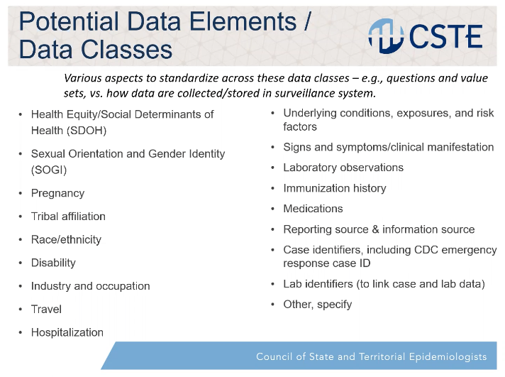
  - It will not be the same discussion for all these things. For the discreet elements in terms of which specific elements to collect and how to define them, like pregnancy or high-level travel elements. This versus the classes such as signs and symptoms where the focus will be how it is collected and how the data is transmitted. We want to look at the strategy for efficiently collecting and transmitting the data. For the broader classes we want to look at how we can get data in a usable fashion that can then be sent efficiently outward and used by jurisdictions at the local, state, tribal areas, and at CDC. The focus is on what will support public health surveillance and action. We want to vote on the elements and get feedback during this call, from the group. We want to gain the input, while on the call, and keep in mind what is important and which areas are hot topics, which are well handled in current systems. We will display the options for each of the data elements/classes for voting.
  - Open discussion and comments on potential data elements/data classes:
    - Annie Fine: One other criteria for prioritization could be to try to do 1 or 2 relatively simple ones first so we can nail down the process and get some “wins”
      - Molly- Agreed. As we figure out these processes, we will want to consider that. Though no data elements I have worked with have turned out to be simple but there are degrees of simplicity and we’ll want to try to focus on items that are less likely to get wildly out of hand.
    - Molly Crocket: Items not on the list we should think about?
      - Annie Fine: Vaccinations
      - Sara Johnston: Thought to add homelessness but that might fit under health equity/social determinants of health.
      - Molly: the first bullet encompasses a lot. Homelessness as a discrete item worth keeping in mind.
    - (Chat discussion) Amy Lau: Outbreak related items
      - Sara asked for expansion on this
    - Annie Fine: Exposures to me is different from underlying conditions
    - Suzanne Gibbons-Burgener: it would be great if we could get more than one address. There is a difference between permenant address and where they are experiencing the disease for travel (fun or business), school, etc. The jurisdiction they are in may need to respond now versus where their permanent/long term records reside. This is a difficult thing to capture, particularly if you don’t talk to the people.
      - Molly Crockett: That can definitely be challenging.
      - Amy Lai: but there is no easy way to identify which address is primary vs other
    - Annie Fine: Residence/Address is a good one to add!
    - Andria Aposolou: If you are receiving underlying conditions would be nice to get information on disability and I see that it’s on the list
    - Laura Erhart: Outcome may be another we've missed.
      - Gillian: Agree with Laura that outcome is a critical one.
    - Annie Fine: Substance use? Or is that part of risk factors/exposures
- Poll Molly Crockett, Co-Chair)
  - Slide presented on polling questions for each data element/data class for reference
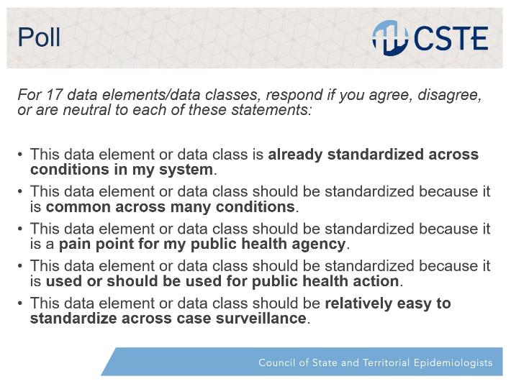
  - We are going to focus on getting the polling done in the meeting and come back together in January for discussion and to get started. For each of the conditions or classes we want you to think about whether it is already standardized in your system, or if something is particularly difficult on a daily basis and is a pain point, or if you think it can really drive public action, or maybe some of these will be easier on the difficulty scale to come to a common consensus.
  - Questions and open discussions on polling
    - Amy Lai: When we talk about standardizing across, are we talking about a standardized way but the underlying criteria may differ across conditions such a timeline. What is the definition of standardized?
      - Molly: For the purposes of this we want to keep this qualitative and we just want to ask you to answer with your gut sense of agreement or disagreement. If you feel like the differences between timelines and no timeliness is a minor issue and the fact that you are collecting it the same way is what is important and solid, then you could say this is well standardized. In the interest of getting through all of these we just want to get your first impression on these things. This will be an effort that goes on for quite a while and this is a first pass at seeing what really needs focus, why it is needed, and what might not be such a high priority.
    - Annie Fine: I want to acknowledge that some people have multiple systems and that it can be a complex issue and it may be hard to answer some of these questions.
      - Molly Crockett: Agreed this is just a first pass and it will feed into other discussions. We are hoping this will give us a little bit of information as to where we are and where to focus in the early days of this effort.
      - Nancy Barret: Annie - I thought of HE also in terms of policy - some systems may have and others not, but that may be because the PHA has not come up with a cross system policy yet.
    - Annie: Maybe we focus on the structure of the data set and not as much the value set. The structure of the data could be something we could potentially agree on.
      - Molly Crockett: That is something we had discussed and maybe I went over that too fast. Focus on the data we need and not specifically how we will categorize an answer.
    - Suzanne Gibbons- Burgener: What does disability mean
      - Molly Crockett: That is a good question. That reaction says a lot as to how well or poorly that is defined. This is a newer item for discussion and therefore might be a big pain point because it is not well standardized.
    - Molly: (During polling for Industry and occupation) We are not going to be able to get through all of the data elements on the call. We will follow-up with something electronic after the call. We had hoped to have some discussion, but we don’t have time today. There are good points coming up during this polling.
    - Note: The polling continued a few minutes past the hour and some participants began to fall off at this point.
    - Amy Lai: Country or origin vs country of birth could also be one we want to add?
    - Suzanne Gibbons-Burgener: Multiple hospitalizations are the pain points.
  - Poll ended at Laboratory Observations
  - Annie Fine: So happy to see this process and great thinking
  - Molly Crocket: This will be presented back to the DSWG on what was found and the consensus that was found, or not found, in the January call.

Adjourned
- Molly Crocket (Co-Chair): The next meeting is January 27. Between now and then you’ll likely hear from us to follow-up on some things including more polling as well as what we heard from today’s call. We are happy to be part of this process and for CDC to hear from the jurisdictions and for jurisdictions to hear some of the reasoning from CDC and for us all to be at the table as we work to serve a common purpose with some very complicated subjects.
- Laura Erhart (Co-Chair): Thanks for everyone’s participation. See you all on January 27!

