
Data Standardization: Dates of Importance to Public Health Surveillance
Illness Onset Date, Report Dates, Laboratory-Related Dates, Diagnosis Date
Molly Crockett, Laura Erhart, and the CSTE Data Standardization Workgroup
2019
Table of Contents
Introduction 4
Data Standardization Work Group Overview 4
Dates of Importance to Public Health Surveillance 4
Illness Onset Date 5
Current Data Element Description in MMG 5
Background and Overview 6
Data Element Priority and Current Usage 6
Recommended Definition and Implementation 6
Recommended Data Sources 7
Recommended Actions 9
Report Dates 10
Current Data Element Description in MMG 10
Background and Overview 11
Data Element Priority and Current Usage 11
Recommended Definitions and Implementation 12
Recommended Data Sources 15
Recommended Actions 16
Laboratory-Related Dates 18
Current Data Element Description in MMG 18
Background and Overview 20
Data Element Priority and Usage 20
Recommended Definitions and Implementation 20
Recommended Data Sources 24
Recommended Actions 25
Diagnosis Date 26
Current Data Element Description in MMG 26
Background and Overview 27
Data Element Priority and Usage 27
Recommended Definition and Implementation 28
Recommended Data Sources 29
Recommended Actions 30
Appendix: 2019 CSTE Data Standardization Work Group Members 31

Introduction
This document was developed by the Data Standardization Work Group (DSWG) of the CSTE Surveillance Practice and Implementation Subcommittee and will be published and maintained in a repository on the CSTE website. For additional background on the CSTE Brief associated with this work, please refer to [Insert website].

Data Standardization Work Group Overview

As CSTE has been working with the NNDSS Modernization Initiative (NMI) to improve notifiable disease data collection and implement standardized HL7 messages across jurisdictions, a need has been identified to develop consensus on common definitions for core surveillance data elements to address jurisdictional variation.
Having consistent, shared definitions and guidelines for data collection is imperative to accurately using epidemiology to improve health, not only at the jurisdiction level, but also at the national level. This information allows public health professionals to effectively allocate resources to identify and respond to disease threats.
The Data Standardization Work Group combines the expert knowledge of its members to achieve consensus on data standards across diseases and jurisdictions to facilitate and support data standardization for data elements, whether they are referenced as part of reporting to CDC, in communication between states, or in analysis.
This effort directly aligns with key portions of CSTE’s mission, including promoting the effective use of epidemiologic data to guide public health practice and improve health, as well as develop standards for practice.
The objective of the CSTE Data Standardization Work Group is to improve data quality through the development and application of consensus definitions for the core data elements for general communicable disease surveillance.

Dates of Importance to Public Health Surveillance

Within Generic v2.0 and Generic v2.0-based message mapping guides (MMGs), several dates are important both as individual core surveillance data elements as well as contributing components of other, hierarchical data elements used for case counting and CDC reporting. Due to the importance of these dates, four dates/date concepts were selected as the first set of data elements for the DSWG. Standardizing the use of these dates across programs and jurisdictions has the additional benefit of establishing a common vocabulary when dealing with complex or hierarchical data elements in the future.

Illness Onset Date

Current Data Element Description in MMG

The data element description for the Date of Illness Onset in the Generic v2.0 MMG is as follows, “Date of the beginning of the illness. Reported date of the onset of symptoms of the condition being reported to the public health system.”

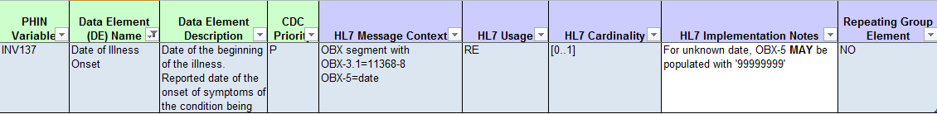

For the Arboviral v1.3 MMG, the specifications are as follows:

Background and Overview

Data Element Priority and Current Usage

Date of Illness Onset is considered a key data element for infectious disease surveillance and reporting by most jurisdictions. Because of its importance, it is currently common practice to populate this data element with alternate values if symptom onset date is not available. Some jurisdictions treat this data element as an ‘Event Date,’ using a hierarchical algorithm to populate the date with alternate dates – including diagnosis date, reporting dates, or laboratory dates – if symptom onset date is not available. In the Generic v2.0 MMG, the Date of Illness Onset has a CDC Priority of Preferred, and therefore is not required in the message. Additionally, the HL7 Implementation Notes indicate, “For unknown date, OBX-5 MAY be populated with ‘99999999’”.

Recommended Definition and Implementation

Recommended Implementation: Date of Illness Onset (rename to Symptom Onset Date)
The data element should be interpreted as the earliest date of the onset of signs or symptoms relevant to the reported condition and may be considered synonymous with symptom onset date.

Jurisdictions should populate the data element when information is available to meet the above description of the Date of Illness Onset; otherwise, the data element should remain NULL and the HL7 segment should not be sent. Jurisdictions may choose to discriminate between missing dates and unknown values if this level of specificity is available in the surveillance system.

Substitution of another date, or calculation from other dates, is not recommended. Some jurisdictions have substituted other dates or generated a calculated date to populate an Event Date due to a surveillance system requirement. If a surveillance system requires an Event Date, then the Event Date and Date of Illness Onset data elements should be distinct. Date of Illness Onset may be the date that populates Event Date for many investigations, but the data element “Date of Illness Onset” should not be used to store the Event Date.

Examples of specific scenarios resulting in a NULL Date of Illness Onset and exclusion from HL7 messages are described below:
- Asymptomatic Patients
  - If a patient is asymptomatic, the data element should remain NULL and the HL7 segment should not be sent.
- Date of Illness Onset is Not Collected
  - The data element may not be collected systematically for a particular condition, even after the adoption of the Generic v2.0 and disease-specific MMGs. As noted above, the data element is not required for the case notification message. For these cases, the data element should remain NULL and the HL7 segment should not be sent.
  - For some jurisdictions, individual cases for a condition may not be investigated and therefore the signs/symptoms may not be collected. For these cases, the data element should remain NULL and the HL7 segment should not be sent.
  - Upon investigation, some cases may have no sign/symptom onset information available. For these cases, the data element should remain NULL and the HL7 segment should not be sent.
  - Upon investigation, some cases may have signs or symptoms available, but no onset date. For these cases, the presence of signs and symptoms should be recorded in the investigation, but if the date of the earliest relevant sign or symptom cannot be obtained, the data element should remain NULL and the HL7 segment should not be sent.
    - Jurisdictions may choose to specify the individual signs and symptoms; utilize an indicator that the patient was symptomatic; or have an indicator to note the Date of Illness Onset is unknown.
  - Some cases may be lost to follow-up, with no onset information available. For these cases, the data element should remain NULL and the HL7 segment should not be sent.

Recommended Data Sources

During the course of an investigation, investigators may utilize data from a variety of sources, including interviews with the patient or a proxy, interviews with a healthcare provider, and medical record/chart reviews. Unless there is reason to believe the patient/proxy interview information is unreliable, the patient/proxy information should be considered the gold standard for the purpose of the investigation.

A recommended hierarchy for the data sources is as follows:

- Patient/proxy interview
- Provider interview or medical record/chart review
  - Documentation of the earliest date of the onset of signs or symptoms for the condition.
  - Dates in the medical record/chart indicating a patient sought medical care may be indicative of the Date of Illness Onset (e.g., date of visit, admission date) if the signs or symptoms started in close proximity to the date of care and there is no competing explanation for the signs or symptoms. If the relevant signs or symptoms for the condition are noted on that date, and no additional information from the patient/proxy or elsewhere in the medical record/chart is available, the date of care may be utilized as the Date of Illness Onset.
    - If the medical record/chart references the timing of sign/symptom onset, but does not specify the date, the investigator should identify the correct date for population. For example, if the medical record/chart indicates onset three days prior to the visit, which occurred on 01/01/2018, then the onset should be identified as 12/29/2017.

The dates obtained from the provider or medical record/chart, if different from the date provided by the patient/proxy, may have value for the larger public health investigation. For example, these dates may establish the:
- Incubation period and relevant risk factors
- Period of infectiousness and necessary exclusions or infectious disease precautions
- Timeframe during which post-exposure prophylaxis should be given

As described above, investigators should follow the hierarchy when identifying the most appropriate date for Date of Illness Onset for the case but note these additional dates elsewhere in the record.

Laboratory dates (e.g., specimen collection date, result date) are not included in the hierarchy, and not recommended as a source of information to determine the Date of Illness Onset. In general, laboratory reports do not contain sign or symptom information with onset dates.

Identifying the Sign or Symptom for the Date of Illness Onset

Across conditions, the recommended signs and symptoms to consider for the Date of Illness Onset vary. Investigators should refer to the latest case definition for the condition, as published on the CDC website at https://wwwn.cdc.gov/nndss/conditions/, for indication of the signs or symptoms that may be relevant for each condition. The case definitions are based on CSTE position statements, which are available in the CSTE position statement archive at: http://www.cste.org/default.asp?page=PositionStatements.

The disease-specific MMGs may require collecting onset dates for individual signs or symptoms. For these conditions, the date for the Date of Illness Onset should be the date of the earliest relevant sign/symptom, which may be one of the signs/symptoms with its own discrete data element or a sign/symptom without a discrete data element.

Recommended Actions

CSTE
- Provide support for the vetting process and distribution of the final products to the CSTE community.
- Publish the Data Standardization Brief and supporting documents on the CSTE website in a repository.
- Data Standardization Work Group and Surveillance Practice and Implementation Subcommittee:
- Promote the Data Standardization Brief and supporting documents on the Surveillance/Informatics Steering Committee and SPIS Subcommittee conference calls.
- Review and update the brief upon changes to the Generic Messaging Mapping Guide.

CDC
- Incorporate the following changes into any revisions of the Generic v2.0-based Message Mapping Guides, or into GenV3:
  - Revise the Date of Illness Onset data element
    - Revise the Data Element Name to Symptom Onset Date.
    - The HL7 Implementation Notes indicate, “For unknown date, OBX-5 MAY be populated with ‘99999999’”. Recommend allowing jurisdictions to not include the HL7 segment for the associated data element when the date is not available for reporting.
    - Include in the Data Element Description a reference to this document for appropriate application.

State, Territorial and Local Health Departments
- Review the brief and conduct a gap analysis for each data element to identify differences in the surveillance system implementation and application of the data elements across disease programs.
- Implement necessary revisions to the surveillance system to address the following:
  - Date of Illness Onset
    - Data element should not be required; NULL should be allowed
    - Data element should not be populated from another field via substitution, calculation, or application of an algorithm
    - Data element should be a discrete data element separate from the Event Date

Report Dates

Current Data Element Description in MMG

This section focuses on four data elements related to reporting dates in the Generic v2.0 MMG:

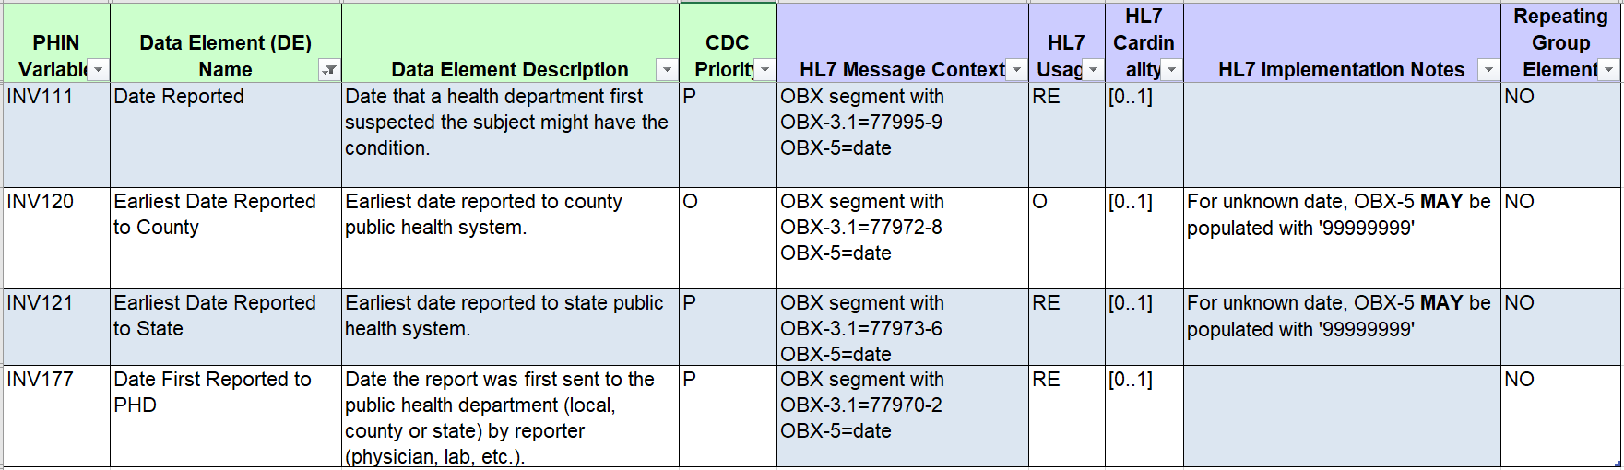

Please note, these data elements are not included in the Arboviral v1.3 MMG.

Background and Overview

Data Element Priority and Current Usage

These data elements are core GenV2 non-repeating data elements. While multiple reports from multiple sources may be received for a given case, these data elements are defined only once for the case and should represent the “first” or “earliest” of the applicable reports for each element.

Jurisdictions generally collect a date to represent when a case is reported to the public health agency, but might not collect all four dates shown above or the date(s) captured may vary across jurisdictions.

The date most consistently utilized across jurisdictions, although with varied names in the surveillance systems and definitions for application, is the Date First Reported to Public Health Department.

Some jurisdictions track components of the reporting process, capturing when a report is first made to the local or county level (Earliest Date Reported to County) separately from when the state public health agency first receives a report or is notified (Earliest Date Reported to State). Depending on multiple factors, including the reporting requirements for each jurisdiction, either date may occur first. Recording this level of specificity (date reported to county/local versus state) may be helpful to monitoring the timeliness of implementing the public health response, and may be especially helpful in those states with decentralized local health departments, but may not be relevant or applicable for all jurisdictions.

Most jurisdictions do not collect a separate date to represent when a public health agency “first suspected the subject might have the condition” as defined for Date Reported. This data element may have been more relevant for public health reporting completed via mail, when there was a lag between the suspicion of a case and receipt of the actual report to the public health agency, or when multiple, specific data elements were not available for recording the separate dates. More and more public health reporting is completed electronically via electronic laboratory reporting (ELR), and will be completed via electronic case reporting (eCR). Consequently, this data element may no longer be pertinent to tracking the report of a case.

Recommended Definitions and Implementation

Date First Received by Public Health Department
The recommendation of the workgroup is that the data element Date First Reported to Public Health Department as named in the Generic v2.0 MMG be renamed to Date First Received by Public Health Department, and that all jurisdictions utilize this data element, whether this is the only one of this set of data elements used, or in combination with one or more of the others.

As defined in the Generic v2.0 MMG currently, jurisdictions may experience ambiguity in applying a date for this data element. The data element could represent a variety of dates including the date a report was printed from a laboratory or electronic health record system, the date a paper form was faxed or mailed, or various other dates in the transmission of an electronic report. For the purposes of improving standardization in the application of this data element, the recommendation of this workgroup is as follows:

Recommended Implementation: Date First Received by Public Health Department
The data element Date First Received by Public Health Department should be defined as the earliest date a report for the case was received by a public health agency in the jurisdiction, whether a state/territory or county/local agency.

The term “received” should be operationalized as the date a report of the case was received by the public health agency rather than when the report was sent, if different. This distinction is the rationale for renaming the data element.
A “report” need not be a formal printed or electronic record, but may also include a telephone call or another method by which a health department may identify or be notified about a case. See the Data Sources section of this document for additional details.

Date First Received by PHD may be a calculated field taking the earliest of the data elements Date First Received by State and Date First Received by Local Health Department, if used, or it may be used alone.
- If Date First Received by PHD is a calculated field, some jurisdictions may find it useful to be able to manually override the calculation, in the event that a more appropriate “first received” date is identified on a case-by-case basis.

The data element will generally reflect receipt by the jurisdiction in which the case will be counted. In the event that a case report is triaged through multiple jurisdictions, or is first reported to a jurisdiction that is not the counting jurisdiction, the data element should reflect receipt by an agency within the jurisdiction of residence responsible for submitting the report to CDC. For example, the data element need not capture the date the case was first received by a public health agency in a different state.
- This situation should be considered when examining, for example, the timeliness of reporting or implementation of control actions; cases first received by another jurisdiction may have large delays in the recorded Date First Received by PHD.
- Jurisdictions may find it useful to have a mechanism to identify cases they first received from an out-of-jurisdiction health department, for example by means of a reporting source field or a flag for interjurisdictional transfers.

The CDC Priority for this date is Preferred. We recommend that this date be recorded for all cases (i.e., is never NULL in the surveillance system and is always sent in HL7 messages), though with no change to the CDC Priority.

Some jurisdictions may find it useful to have a separate field to record the earliest date that a report was sent by the reporter. As discussed above, the date that a report was sent may be different from the date the report was received; examples include a report submitted by mail or a report sent electronically but which fails to be received or successfully inserted by the receiving application or platform. This distinction may be important for identifying compliance with reporting regulations or for detecting problems with data transmissions. However, the date a report is sent should remain a separate concept from the data element Date First Received by PHD.

Date First Received by State and Date First Received by Local Health Department
The recommendation of the workgroup is that these data elements be renamed from “Earliest Date Reported to […]” to “Date First Received by […]”, to reflect that the date a report was sent may not be the same as the date a report was received by the health department. Furthermore, “County” should be replaced by “Local Health Department” in the Generic v2.0 MMG since not all local health departments are county health departments. For the purposes of this brief, tribal health departments may be considered local health departments.

Recommended Implementation:
The data element Date First Received by State should be defined as the earliest date a report for the case was received by the state public health agency.

The data element Date First Received by Local Health Department should be defined as the earliest date a report for the case was received by the local public health agency.

Date First Received by State and Date First Received by Local Health Department

“Received” and “report” should be operationalized as above.

The CDC Priority for Earliest Date Reported to State is Preferred. We recommend making it Optional. The Earliest Date Reported to County is currently Optional.

The Date First Received by State may not be relevant for local health department systems. The Date First Received by Local Health Department may not be relevant for jurisdictions/states with a centralized health department. Differentiating the state versus local report dates may also not be deemed important by all jurisdictions. Furthermore, while these data elements may be valuable at the state or local level, their primary value may be as components to the Date First Received by PHD.

If the jurisdiction chooses to include one or both of these data elements in their system, they should be populated if the date is known; otherwise, the data elements should remain NULL and the HL7 segments should not be sent.

Date Reported

Recommended Implementation: Date Reported
We recommend removal from the Generic Message Mapping Guides of the data element Date Reported.
This data element, in practice, is redundant of the Date First Received by Public Health Department.

Continued inclusion and use of a data element to capture the date that public health first suspected a subject might have the condition should be at the discretion of the health department.

Recommended Data Sources

The data sources for these elements may vary across jurisdictions or programs, depending on the methods by which the jurisdiction receives information. Possible sources include:
- Reports from healthcare providers or healthcare institutions
- Reports from laboratories
- Case investigations (e.g., symptomatic contacts identified during the course of a public health investigation)
- Other health departments
- Medical records, death certificates, or other sources that provide the first knowledge of the case

Submissions from any of these sources may be electronic (eCR, ELR or direct entry into the surveillance system), or by fax, mail, telephone call, or any other method that the public health agency accepts. Each agency should have a procedure for recording the dates that an initial report was received from the sources they accept.

Because these data elements represent the “earliest” or the “first” for each concept, multiple report types or data sources may need to be considered concurrently when populating these data elements. For example, Date First Received by Public Health Department for some cases may need to reflect the date a laboratory report was received, while for others it reflects a provider report, depending on which report came first.

Examples of specific scenarios (where the three “Date First Received by” data elements are included in the surveillance system):
- A laboratory report is received by the state health agency on 1/5/2019. It is shared with the local health agency on 1/6/2019.
  - Date First Received by PHD: 1/5/2019
  - Date First Received by State: 1/5/2019
  - Date First Received by Local Health Department: 1/6/2019
- A provider reports a suspected case to the local health agency by phone on 1/5/2019. Information about this case is shared with the state health agency on 1/6/2019.
  - Date First Received by PHD: 1/5/2019
  - Date First Received by State: 1/6/2019
  - Date First Received by Local Health Department: 1/5/2019

Recommended Actions

CSTE
- Provide support for the vetting process and distribution of the final products to the CSTE community.
- Publish the Data Standardization Brief and supporting documents on the CSTE website in a repository.
- Data Standardization Work Group and Surveillance Practice and Implementation Subcommittee:
- Promote the Data Standardization Brief and supporting documents on the Surveillance/Informatics Steering Committee and SPIS Subcommittee conference calls.
- Review and update the brief upon changes to the Generic Messaging Mapping Guide.

CDC
- Incorporate the following changes into any revisions of the Generic v2.0-based Message Mapping Guides, or into GenV3:
  - Revise the Date First Reported to Public Health Department
    - Change the Data Element Name to Date First Received by Public Health Department
    - Revise the definition, as shown above
  - Revise the Earliest Date Reported to State
    - Change the Data Element Name to Date First Received by State
    - Revise the definition, as shown above
    - Make this data element optional
    - The HL7 Implementation Notes indicate, “For unknown date, OBX-5 MAY be populated with ‘99999999’”. Recommend allowing jurisdictions to not include the HL7 segment for the associated data element when the date is not available for reporting.
  - Revise the Earliest Date Reported to County
    - Change the Data Element Name to Date First Received by Local Health Department to reflect that not all local health departments are county health departments.
    - Revise the definition, as shown above
    - The HL7 Implementation Notes indicate, “For unknown date, OBX-5 MAY be populated with ‘99999999’”. Recommend allowing jurisdictions to not include the HL7 segment for the associated data element when the date is not available for reporting.
  - Remove the Date Reported from message mapping guides, as in practice it is used redundantly with the current Date First Reported to Public Health Department.
  - Include in the Data Element Description a reference to this document for appropriate application.

State, Territorial and Local Health Departments
- Review the brief and conduct a gap analysis for each data element to identify differences in the surveillance system implementation and application of the data elements across disease programs.
- Implement necessary revisions to the surveillance system to ensure that Date First Received by Public Health Department is populated and is defined as above.
  - Data element should not be populated from another field via substitution, calculation, or application of an algorithm.
  - Data element should be discrete from laboratory and reporting dates; relevant laboratory dates (e.g. Specimen Collection Date, Result Date) should be stored as separate data elements.
  - If an existing calculated Diagnosis Date (e.g., incorporating laboratory dates) must be retained in the surveillance system for jurisdictional use, a new data element should be added to capture Clinical Diagnosis Date.

Laboratory-Related Dates

Current Data Element Description in MMG

This section focuses primarily on 10 data elements representing laboratory-related dates in Generic v2.0 (GenV2)-based MMGs:

Laboratory Interpretative Repeating Group Data Elements:
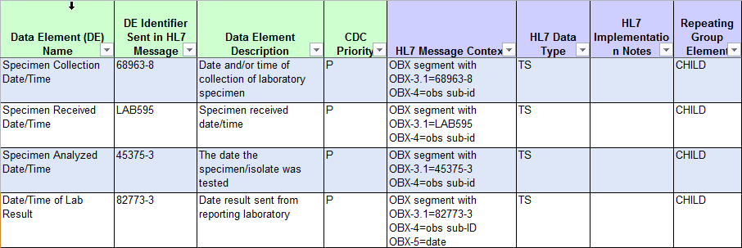

Laboratory Template Data Elements:
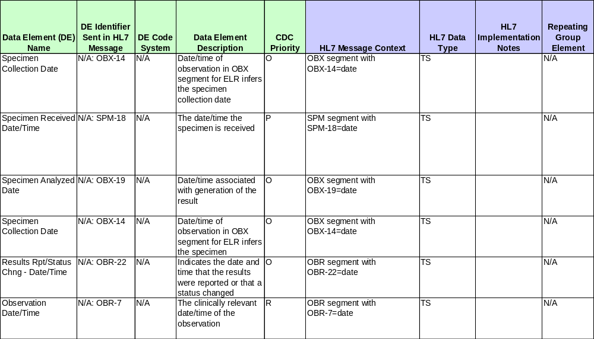

Four of these dates are part of the Lab Interpretive Repeating Group within GenV2-based MMGs, while an additional six lab result data elements are included in the Laboratory Template associated with these guides:

Lab Interpretive repeating group | Laboratory Template
Specimen Collection Date/Time | Specimen Collection Date/Time (SPM-17)
Specimen Received Date/Time | Specimen Received Date/Time (SPM-18)
Specimen Analyzed Date/ Time | Specimen Analyzed Date (OBX-19)
Date/Time of Lab Result | Specimen Collection Date (OBX-14)
 | Results Rpt/Status Change Date/Time (OBR-22)
 | Observation Date/Time (OBR-7)

The dates in the repeating group and the Laboratory Template overlap as they reference the same date concepts. Dates from both sources are discussed together below when they reference the same date concept. Note that the laboratory-related date elements addressed here are associated with disease-specific GenV2-based MMGs, but there are no laboratory-related dates included within GenV2 itself. Furthermore, the GenV2-based MMGs that use the repeating group might not include all four of the dates listed here.

Please note, only specimen collection date is included in the Arboviral v1.3 MMG.
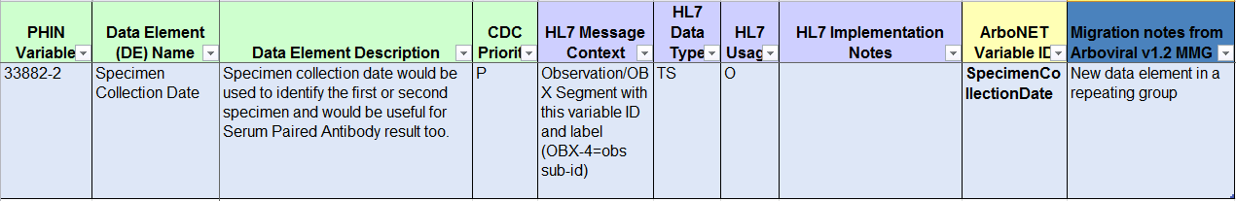

Background and Overview

Data Element Priority and Usage

The CDC Priority for all four dates included in the lab interpretive repeating group is preferred. The inclusion of individual laboratory-related dates within the repeating group varies not only by guide but, in the case of the Foodborne and Diarrheal Diseases (FDD) guide, by condition within the MMG.

Laboratory Template data elements are standard for all MMGs using the template; Observation Date/Time (OBR-7) is a required element, Specimen Received Date/Time (SPM-17) is preferred, and the rest are optional.

Recommended Definitions and Implementation

Specimen Collection Dates:

Lab Interpretive Repeating Group:
- Specimen Collection Date/Time

Laboratory Template:
- Observation Date/Time (OBR-7)
- Specimen Collection Date (OBX-14)
- Specimen Collection Date/Time (SPM-17)
Specimen Collection Date is widely available for both paper and electronic laboratory reports and is captured in most jurisdictions’ surveillance systems. Specimen collection date is an important data element with many applications for public health surveillance and control. It frequently contributes to calculated/hierarchical aggregate reporting dates for case counting and public health reporting (MMWR Week, Event Date). It may also be used to determine timing/appropriateness of testing, whether testing was done pre- or post-treatment, and differentiating between multiple specimens collected over the course of a disease event. It can also be useful, along with accession number, in deduplication of lab results that are reported by multiple sources.

The Specimen Collection Date represents the date a clinical specimen was collected from the patient for testing for the reportable condition of concern; this date does not typically represent the date an isolate was created. The lab interpretive lab data element Specimen Collection Date/Time is directly comparable with Specimen Collection Date/Time (SPM-17) and Specimen Collection Date (OBX-14) in the laboratory template, and by HL7 2.5.1 standards should also be synonymous with Observation Date/Time (OBR-7).

Specimen Collection Date should be populated directly from the corresponding date on the paper or electronic laboratory report or from a data element in the surveillance system that captures this information. For jurisdictions using the Laboratory Template, Observation Date/Time (OBR-7) is required and must be populated; therefore jurisdictions using the Laboratory Template must be able to capture the date of specimen collection within their surveillance system. For other data elements, if this information is not available, the associated HL7 segment should not be sent.

Recommended Implementation: Specimen Collection Date
Specimen Collection Date (i.e., Specimen Collection Date/Time (repeating group), Specimen Collection Date/Time (SPM-17), Specimen Collection Date (OBX-14) and Observation Date/Time (OBR-7)) should be interpreted as the date a clinical specimen was collected from the patient for the laboratory testing relevant to the condition being reported to a public health agency.

Specimen Received Dates:

Lab Interpretive Repeating Group:
- Specimen Received Date/Time

Laboratory Template:
- Specimen Received Date/Time (SPM-18)
Specimen Received Date is not frequently captured in surveillance systems, though it is typically available for electronically reported labs. It is usually available within a public health laboratory’s LIMS system and some jurisdictions may use data from this source rather than importing it into the surveillance system. Some jurisdictions may use this date to track specimens within the public health laboratory, particularly processing of outbreak specimens for foodborne conditions. States may use the date for quality control metrics within the public health lab, including turnaround time. It could also be used with commercial labs to track timing of specimens that were tested in multiple facilities; although timing of receipt at a commercial lab was not widely considered relevant to public health surveillance or investigation.

Specimen Received Date represents the date that a specimen is received at the laboratory performing the test for the notifiable condition of concern. This typically represents when a specimen package is opened by the lab rather than when it is first received at a facility, which may introduce a margin of error for use of this date. This date is directly comparable to Specimen Received Date/Time (SPM-18) in the laboratory template.

When available, this data element should be populated directly from the corresponding date on the paper or electronic laboratory report or from a data element in the surveillance system that captures this information. If this information is not available, the data element should not be populated in the HL7 message.

Recommended Implementation: Specimen Received Date/Time
Specimen Received Date/Time (repeating group) and Specimen Received Date/Time (SPM-18) should be interpreted as the date the specimen was received by the performing laboratory for the condition being reported to a public health agency, be it county/local or state

Result Dates:

Lab Interpretive Repeating Group:
- Date/Time of Lab Result
- Specimen Analyzed Date/Time

Laboratory Template:
- Results Rpt/Status Chng - Date/Time (OBR-22)
- Specimen Analyzed Date (OBX-19)
Existing MMGs include one or both of two laboratory result-related dates in the interpretive laboratory repeating group, while both are part of the laboratory template:
- Specimen Analyzed Date/Time (comparable to Specimen Analyzed Date (OBX-19)) is intended to represent the date testing occurred/when the result was generated.
- Date/Time of Lab Result (comparable to Results Rpt/Status Chng - Date/Time, OBR-22) represents when a result was reported out by the laboratory. (N.B: Date Result Reported (OBR-22) may change if updated results are released as newer results become available.)

While these fields are distinct in most HL7 ELR messages, Specimen Analyzed Date and data elements representing the date a result was reported (Date/Time of Lab Result, Results Rpt/Status Chng) may not be stored separately in some surveillance systems. In general, a ‘result date’ data element may be captured that could represent either or both of the two dates. Paper labs also frequently do not include both the date a result was reported and the specimen analyzed dates and may not clearly specify which date is reflected on the lab result paper form. For practical purposes, in most cases the date that a test is completed/result generated is unlikely to vary greatly from the date the result is reported out by the laboratory (especially in the case of electronic test reporting where results can be reported as soon as they are available). Any difference is unlikely to be meaningful in terms of public health surveillance and control. For this reason, it was the workgroup’s view that when these dates could not be distinguished, any ‘result date’ captured in the jurisdictional surveillance system would be an acceptable date for populating all of these data elements.

In systems that do not differentiate between the types of ‘result date’ the single ‘result date’ that is captured may be used to populate both Lab Interpretive data elements and both Laboratory Template data elements.

For systems that feed ELR data directly into the NNDSS HL7 messages, or for systems in which the two dates (OBR-22 and OBX-19) are captured as two distinct data elements, the two result dates can be populated accordingly. In systems with two distinct dates, values captured from OBR-22 should be used to populate Date/Time of Lab Result in the Interpretive Lab group and Results Rpt/Status Chng – Date/Time in the Laboratory Template. Values captured from OBX-19 should be used to populate Specimen Analyzed Date/Time in the Lab Interpretive group and Specimen Analyzed Date in the Laboratory template.

If no result date is available, the associated HL7 segment should not be included.

Recommended Implementation: Result Date
Result date may reflect either the date the specimen was analyzed or the date the latest result was released for reporting. If the surveillance system captures and stores both Specimen Analyzed Date and the date a result was reported out, both data elements should be maintained and reported accordingly. If the surveillance system does not differentiate between these two concepts, jurisdictions may choose to use the available date to populate Specimen Analyzed Date/Time/Specimen Analyzed Date (OBX-19) and Date/Time of Lab Result/Results Rpt/Status Change, or populate only one set of dates, leaving the others blank.

Recommended Data Sources

Laboratory-related dates may be obtained from ELR, paper laboratory reports, electronic medical records (EMR or eICR), or sometimes from provider-submitted reports, other forms of medical records or a provider interview (uncommon). Data from ELR laboratory reports should be the gold standard, as each of these fields is captured distinctly and can be used to populate the HL7 case notification directly. Other sources may be missing some laboratory-related dates or dates may require some clarification as to what information is actually represented by available dates.

Examples of specific scenarios:

- A jurisdictional surveillance system captures specimen collection date and a single result date (which includes a mix of date result generated and date result reported). A lab is received with a specimen collection date of 03/01/2019, and a result date of 03/02/2019. MMG elements should be captured as follows:
- Specimen Collected Date/Time, Observation Date/Time (OBR-7), Specimen Collection Date (OBX-14), Specimen Collection Date/Time (SPM-17) : 03/01/2019
- Specimen Received Date/Time, Specimen Received Date/Time (SPM-18): Do not send
- Specimen Analyzed Date, Specimen Analyzed Date/Time (OBX-19): 03/02/2019
- Date/Time of Lab Result, Results Rpt/Status Chng (OBR-22): 03/02/2019

- A jurisdictional surveillance system captures each of the above dates separately from ELR messages. A lab result is received with a specimen collection date of 3/5/2019, a specimen received date of 3/6/2019, and specimen analyzed date of 3/6/2019, and a results reported date of 3/7/2019. MMG elements should be captured as follows:
  - Specimen Collected Date/Time, Observation Date/Time (OBR-7), Specimen Collection Date (OBX-14), Specimen Collection Date/Time (SPM-17) : 03/05/2019
  - Specimen Received Date/Time, Specimen Received Date/Time (SPM-18): 03/06/2019
  - Specimen Analyzed Date, Specimen Analyzed Date/Time (OBX-19): 03/06/2019
  - Date/Time of Lab Result, Results Rpt/Status Chng (OBR-22): 03/07/2019

Recommended Actions

CSTE
- Provide support for the vetting process and distribution of the final products to the CSTE community.
- Publish the Data Standardization Brief and supporting documents on the CSTE website in a repository.
- Data Standardization Work Group and Surveillance Practice and Implementation Subcommittee:
- Promote the Data Standardization Brief and supporting documents on the Surveillance/Informatics Steering Committee and SPIS Subcommittee conference calls.
- Review and update the brief upon changes to the Generic v2.0-based Messaging Mapping Guides.

CDC
- Incorporate the following changes into any revisions of the GenV2-based Message Mapping Guides, or comparable Generic V3-based guides:
  - Revise the Data Element Names to match date type
    - Dates with data type ‘Date’ should not include Date/Time in the data element name.
  - Remove the Specimen Received Date, as it is infrequently captured or used in surveillance systems.
  - Include in the Data Element Description a reference to this document for appropriate application

State, Territorial and Local Health Departments
- Review the brief and conduct a gap analysis for each data element to identify differences in the surveillance system implementation and application of the data elements across disease programs.
- Implement necessary revisions to the surveillance system to address the following:
  - Ensure that surveillance system can capture Specimen Collection Date and at least one type of ‘result date.’
  - Consider collecting result date data elements separately as Specimen Analyzed Date (Date result was generated) and Date of Laboratory Report (Date result reported by laboratory).

Diagnosis Date

Current Data Element Description in MMG

The data element description for the Diagnosis Date in the Generic v2.0 MMG is as follows, “Earliest date of diagnosis (clinical or laboratory) of condition being reported to public health system.”

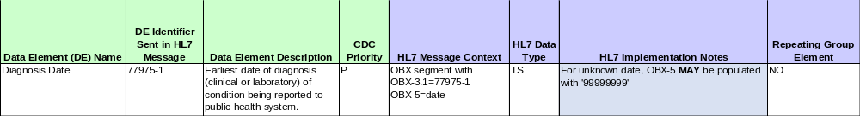

Please note, this data element is not included in the Arboviral v1.3 MMG.

Background and Overview

Data Element Priority and Usage

Diagnosis Date can be interpreted to represent the earliest date an illness was identified as a particular reportable condition. As the date of clinical diagnosis may not always be available to public health, many jurisdictions use other dates, typically laboratory-related, as a proxy for diagnosis, or populate diagnosis date using a hierarchy of available clinical and laboratory dates. Clinician diagnosis, Specimen Collection Date, and Test Result Date often contribute to the data in this field. While Diagnosis Date is a key data element for some jurisdictions, in other jurisdictions it is used primarily as a component of more complex data elements such as Event Date.

When Diagnosis Date is determined based on a hierarchy of other dates, there is a great deal of variability and complexity in which dates are considered relevant or contributory for the condition in question. For example:
- Clinical signs and symptoms and patient history may be sufficient for a presumptive diagnosis of some conditions, while for many others a laboratory test result may be required to differentiate a particular reportable condition from other conditions with a similar clinical presentation.
- Ordering of a laboratory test may not always indicate clinical suspicion or presumptive diagnosis of a specific reportable condition, since testing is often ordered simultaneously for multiple conditions, so use of Specimen Collection Date as a proxy for Diagnosis Date may not approximate clinical diagnosis in many instances.
- In addition, while a test result date may indicate identification of a particular organism or other laboratory findings suggestive of a condition, a true diagnosis requires a clinician interpretation of available clinical and laboratory information.
Hierarchical determination of Diagnosis Date can be based on a number of different algorithms incorporating any of the data elements mentioned above as well as other dates.

The substantial variability in practice across both jurisdictions and program areas currently limits the utility of Diagnosis Date as a standardized data element and makes interpretation of this data element challenging. Standardization efforts are focused on developing common terminology with a consistent meaning across conditions and jurisdictions, with the goal of standardized data elements that are discrete – clean, simple, and well-defined. For this reason the workgroup agreed that the Diagnosis Date should represent clinical diagnosis only, while capturing laboratory dates in separate, discrete data elements.

Recommended Definition and Implementation
Recommended Implementation: Diagnosis Date (rename to Clinical Diagnosis Date)
Diagnosis Date should represent clinical diagnosis only. Other dates relevant to diagnosis, such as laboratory dates, should be captured in separate, discrete data elements.

In order for Diagnosis Date to represent a discrete, well-defined element, it is recommended that the date of clinical diagnosis be stored separately from laboratory dates or other fields that may currently be used to populate Diagnosis Date. Many of these other dates are already typically captured elsewhere in jurisdictional surveillance systems, and jurisdictions may choose to use any combination of date types for internal use as appropriate.

In the Generic v2.0 MMG, Diagnosis Date has a CDC Priority of Preferred, and therefore is not required in the message. Jurisdictions should populate the data element when information is available to meet the above description of the Diagnosis Date; otherwise, the data element should not be sent. Jurisdictions may choose to discriminate between missing dates and unknown values if this level of specificity is available in the surveillance system. Substitution of another date, or calculation from other dates, is not recommended.

For most condition-specific MMGs, the laboratory-related dates of Specimen Collection Date and Result Date are collected in separate, discrete fields; both are collected in the laboratory template. Collecting clinical and laboratory dates as separate, discrete data elements may provide clarity in terms of which information is available, compared to a single date that could potentially represent a variety of time points. Because laboratory dates are not available for conditions that rely solely on core GenV2 data elements, implementation of this definition of Diagnosis Date may require the addition of one or more laboratory-related data elements to future updates of GenV2 or to GenV3 in order for those dates to be captured within fields collected by CDC.

Recommended Data Sources

During the course of an investigation, investigators may utilize data from a variety of sources, including case reports from healthcare providers (electronic or not), interviews with a healthcare provider, and medical record/chart reviews. Patient self-reported date of diagnosis is not a recommended data source for this element.
Recommended data sources include:
- Provider report, provider interview, or medical record/chart review
  - Date of earliest clinical diagnosis; generally speaking, the earliest date at which a clinician identified the specific condition of interest as a suspected or final diagnosis.
    - If multiple conditions are initially suspected, the date of diagnosis should reflect when the particular condition reported to public health was named as the diagnosis.
- Electronic case reports
  - Visit/encounter date associated with an eICR or other electronic case report for a particular condition.

Laboratory dates (e.g., Specimen Collection Date, Result Date) should not be used as a proxy for diagnosis and should instead be captured in separate data elements within the MMGs and the surveillance system.

Recommended Actions

CSTE
- Provide support for the vetting process and distribution of the final products to the CSTE community.
- Publish the Data Standardization Brief and supporting documents on the CSTE website in a repository.
- Data Standardization Work Group and Surveillance Practice and Implementation Subcommittee:
- Promote the Data Standardization Brief and supporting documents on the Surveillance/Informatics Steering Committee and SPIS Subcommittee conference calls.
- Review and update the brief upon changes to the Generic Messaging Mapping Guide.

CDC
- Revise the Generic Message Mapping Guide as follows:
  - Revise the Diagnosis Date data element
    - Revise the Data Element name to “Clinical Diagnosis Date”
    - Revise the Data Element description to “Earliest date that the condition being reported to public health system was diagnosed by a clinician.”
    - The HL7 Implementation Notes indicate, “For unknown date, OBX-5 MAY be populated with ‘99999999’”. Recommend to allow jurisdictions to choose not to send the data element if clinical diagnosis date is unavailable.
    - Include in the Data Element Description a reference to this document for appropriate application.
  - Consider adding laboratory dates that have commonly been used to populate Diagnosis Date, such as first Specimen Collection Date for the first positive test for the condition being reported or First Positive Result Date, to the Generic v2.0 MMG core set of data elements.

State, Territorial and Local Health Departments
- Review the brief and conduct a gap analysis for each data element to identify differences in the surveillance system implementation and application of the data elements across disease programs.
- Implement necessary revisions to the surveillance system to address the following:
  - Data element should not be required; NULL values should be allowed.

Appendix: 2019 CSTE Data Standardization Work Group Members

Umed Ajani
Rita Altamore
Andria Apostolou
Rob Arciuolo
Emily Augustini
June Bancroft
Andreea Bealle
Brooke Beaulieu
Ally Binder
Rachelle Boulton
Lizette Brenes
Erin Burdette
Delicia Carey
Rachel Corrado
Molly Crockett
Sherri Davidson
Corinne Davis
Yvette Dominique
Jeffrey Eason
Laura Erhart
Annie Fine
Alexandra Gagner
Gwendolyn Gallagher
Nedra Garrett
Suzanne Gibbons-Burgener
Janet Hamilton
Gillian Haney
Lesliann Helmus
Molly Howell
Judie Hyun
Beth Isaac
Ruth Jajosky
Teresa Jue
Ellen Klingler
Nicole Kosacz
Shaily Krishan
Mara Larson
Caitlin Law
Alicia Lepp
Meredith Lichtenstein
MaryKate Martelon
Tracy Miller
Desiree Mustaquim
Marijoyce Naguit
Kristen Nichols Heitman
Candace Noonan-Toly
Grace Oguntebi
Lux Phatak
Natalie Raketich
Jyotsna Ramachandran
Emily Roberts
Sandy Roush
Lina Saintus
Amanda Santander
John Satre
Amanda Smith
Corinne Thompson
Andrew Tibbs
Megan Toth Patel
Kathy Turner
Karen Wong
Lei Zhang

The name of this repeating group varies slightly across MMGs.

