Meeting Title: | CSTE Data Standardization Workgroup Meeting
Date: | 1/27/2022
Location: | https://zoom.us/j/96601644340?pwd=WUloTEl6NmxWZkNpMFFacHFHb2NpZz09
Attendees: 69 (orange text indicates presence at the meeting)
Co-Chairs | PHAs
Laura Erhart (AZ) | Alexa Ling (CA) | Desiree Mustaquim | Lei Zhang (NV) | Teresa Jue
Molly Crockett (MA) | Alexa Meinhardt (DE) | Dimple Patel (KY) | Lina Saintus (NC) | Tracy Miller (ND)
CSTE | Alexandra Gagner (Chicago) | Doris McGinness | Liu Yang (MS) | Trevor Maness (TX)
Annie Fine | Alicia Lepp (ND) | Eden Dietle (MO) | Like Dalton (MI) | Tye Harlow (CO)
Becky Lampkins | Allison LaPointe (MN) | Ellen (EJ) Klingler (NYC) | Madison Wierzel | Vajeera Dorabawila (NY)
Gillian Haney | Amanda Payne | Eman Addish (Philly) | Mara Larson (NC) | Yi Du (NE)
Janet Hamilton | Amita Worasilpchai (JMC) | Emily Holodnick | Marijoyce Naguit (CA) | Yvette Dominique
Meredith Lichtenstein | Amy Lai (AZ) | Emily McGibbon (NYC) | Mary Kate Martelon (MA)
Shaily Krishan | Amy Hyong | Emily Roberts (UT) | Meg Schaeffer
Taylor Pinsent | Amy Bogucki (TN) | Emily Augustini (JMC) | Melanie Epstein-Corbin (CA)
Grace Mallard (JMC) | Andy Tibbs | Erin Burdette | Michael Bryan (GA)
Laura Lane (JMC) | Andrea Perez (RUHS-PH) | Graham Crawbuck | Michelle Lin
Susan Downer (JMC) | Andrey Avakov (NH) | Gwendolyn Gallagher (NM) | Misty Johnson (WI)
CDC | Andria Apostolou (HIS) | Hailey Vest (IN) | Molly Howell (ND)
Allison Miller | Angela Herbert (NB) | Hanna Chakoian (MN) | Nancy Jingyi Li (CA)
Danielle Tack | Autumn Ward (KY) | Heather Crawford (OR) | Nancy Barrett (CT)
David Huang | Becca Mickels (MO) | Jacki Griffin (BSDS) | Natalie Raketich (JMC)
Erin Burdette | Benjamin Schram (ND) | Jeff Van Ausdall (Shasta County) | Nedra Garrett
Kate Woodworth | Benjamin Hornstein (AL) | Jeff Swanson (TX) | Nicole Turvey (CO)
Katie Fullerton | Bill Morill | Jenna Webb | Nora Alrubaie
Katherine DeBord | Brooke Beaulieu (APHL) | Jennifer Lockhart (AK) | Peter Binoj
Kevin Lan | Brooke Bregman (CA) | Jessica Mawdsley (VA) | Rachel Corrado
Keydra Oladapo | Caitlin Law | Jill Krause (NB) | Rachelle Boulton (UT)
Kimberly Mace | Candace Noonan-Toly (NY) | Joshua Bagley | Ramandeep Kaur
Kristie Clarke | Carly Babcock (MD) | Judie Huyn (MD) | Ravi Kafle (WA)
Laura Conn | Charlene Adams | Julia Aiken (CO) | Rebecca Jackson (CA)
Lesliann Helmus | Christy Crowley (ND) | June Bancroft (OR) | Rendi Murphree (Mobile County)
Loretta Foster | Cliff Mitchell (MD) | Justine Maxwell (TN) | Robert Arciuolo
Melissa Pagaoa | Collin Morris | Kacey Ingalls (WA) | Roselyn Thalathara (NM)
Michelle Hoover | Corina Chung (San Mateo) | Kadeen Okumu Camerra | Ruth Jajosky
Nicole Linsey | Corinne Davis (TN) | Karen Wong | Sai Kurmana (MS)
Nikolay Lipskiy | Cristin Larder (Ingham County) | Karene Thomas-Watts (CO) | Shan Maxey
Noreen Kloc | Crystal Snare (U of Washington) | Kate Goodin (TN) | Shawn
Sandy Roush | Danica Kuncio (Philly) | Kathy Turner | Sheila Malone (Jackson State Univ)
Sara Johnston | Delicia Carey | Katy Donovan (RI) | Sherri Davidson (AL)
Umed Anji |  | Kelly Wallblay (Chicago) | Steve “Ike” Eichner (TX)
 |  | Kiara Vicente (AL) | Tanner Turley (MO)

High-Level Meeting Notes (refer to meeting slides for more detail as needed):
Welcome (Laura/Molly)
Welcome to new members/DSWG Core Group Introductions
- Laura Erhart (Co-Chair): Epidemiologist by training; Informatics Section Lead for Arizona Department of Health Services
- Molly Crockett (Co-Chair): Senior Informatics and Surveillance Epidemiologist with Dept of Health in Massachusetts; also, epidemiologist doing case investigation and VPDs by training
- Becky Lampkins and Shaily Krishan (CSTE): Primary CSTE staff for the DWG
- Laura Lane and Grace Mallard (JMC Consultants): work closely with the Co-Chairs and CSTE to support the DSWG
- Lesliann Helmus, Sara Johnston, and Danielle Tack: CDC staff who are working within the newest collaboration efforts with the Co-Chairs, CSTE, and DSWG overall.
  - Danielle Tack the lead of the Data Standardization and Assistance Team under the NNDSS umbrella.
Process Overview
- As the group grows, we will be working on efforts to improve efficiency and to move through lots of data elements and classes over the next few months.
- This will include pre-meeting efforts including polling to the DSWG and behind the scenes efforts for data gathering.
- During the meeting background information will be introduced, the focus will be “core surveillance,” polling will occur in the meeting to gauge group agreement or disagreement and to help guide more in-depth discussions if needed
- Following meetings there may be additional polling, compilation of items that are agreed upon, identification of elements that need further clarification
- Communications will be coming from Becky Lampkins (CSTE) or Laura Lane (JMC Consultant)
Meeting Ground rules
- Co-Chairs and moderators will focus on 80/20 consensus where if a majority consensus is reached, we’ll continue to move forward and if there is less agreement indicated, then a guided discussion will occur to determine next steps or work towards resolution. There is not an expectation that the group will be able to reach 100% consensus.
- Post meeting survey is an ongoing forum to collect additional information, particularly if you have something for the group to consider that is against the majority.
Please use this link to submit information at any time: https://app.smartsheet.com/b/form/de1963ca422640dfba2dbba96e79da43

Hospitalization
Why Hospitalization?
- In December the Workgroup was polled on various of data elements for prioritization; within the results for that call hospitalization was indicated as a top priority. There is a lot of interest in standardizing this element, it is a pain point for several jurisdictions, there is agreement that it should be used for public health action, it is commonly collected, and in many systems, it is already standardized.
- Question: Steven: USCDI is currently out for comments and a bunch of groups are providing feedback. As part of our efforts are we tagging elements that are part of USCDI version 4? Any date element not currently included in USCDI would be included in future additions if submitted. That is something we should track as it might drive future efforts.
  - Laura E: You’ll see in a few minutes when CDC is presenting information they have collected, USCDI is incorporated here in terms of standards and efforts that have already been done. There was more background presented in December and Sara Johnston and Danielle Tack have also done presentations in December to the Workgroup as well as within eShare calls and informatics groups as well as some of the subgroups. As we do this work we will be thinking about where public health is getting this data. We need to align with current data sources including eCR, ELR, and USCDI standards, all need to be considered as we make these decisions.
  - We are also working to identify what the output will be from these efforts. In the past we have had some text heavy briefs and we will be working with CSTE to determine what the outputs ill look like, the approval process, etc. There is still a lot of work in progress to figure out some of these processes. In the meantime, we are driving forward with Hospitalization.

Hospitalization: In Scope
- We are looking at hospitalization as an indicator for severity of disease; roughly was the person hospitalized for the condition we are looking at.
- Core surveillance is the primary focus of consideration; what do we want to collect for “core surveillance” and what do we want that structure to look like
- Agreement upon common definitions and value sets, while acknowledging this won’t be possible for every value set.
What is “core surveillance”?
- This term has been used a lot and is not clearly defined. We need to agree on what that means as a group. As we have these discussions consider what are the data elements that are valuable for data exchange or interoperability. For example, is the data element something we would want to receive as part of jurisdictional exchange.
- Do we want to have an efficient way to ingest; standardization can help jurisdictions ingest the data more easily.
- Is the data element under consideration used across multiple conditions. If it is applicable for multiple conditions that is also a benefit and could be more applicable as a “core surveillance” component.
- This is not a focus on message mapping guides (MMGs); we can have more data elements and data classes outside of that emergency data set. This is also not a decision on what is next generation Gen V2.
Core surveillance
- Demonstrated the “teddy bear” graphic that has been used in previous CDC presentations. This can help us focus on items the group can keep in mind as we work through these decisions. The focus is data elements and data classes that will fit into the innermost two circles. Less about condition-specific case notification and the ears can be considered out of scope for what we are working to identify.
- Discussion:
  - Comment from Steven Eichner (chat): It may be helpful to use the USCDI v4 as a reference tool because the data elements/classes can form a baseline. One question to consider is whether the/an element in the USCDI is whether the field is coded in a way that is useful for public health. That would open the door to whether a different field is needed or whether the measure being collected in the way already defined in USCDI is sufficient for public health's need.
    - Annie’s Reply (chat) : It may be helpful to use the USCDI v4 as a reference tool because the data elements/classes can form a baseline. One question to consider is whether the/an element in the USCDI is whether the field is coded in a way that is useful for public health. That would open the door to whether a different field is needed or whether the measure being collected in the way already defined in USCDI is sufficient for public health's need. Also, this is NOT for aggregate data - it is really limited to individual case data. Though definitions for hospitalization for cases might be used for aggregate data collection too I suppose.
Hospitalization: Out of scope
- Are there elements we identify that are mainly for research or studies; we would consider those as non-core data elements.
- Condition-specific guidelines such as ICD-10 codes
- We will not be focusing on the mechanism for data sharing. The focus is on what we agree should be shared and information that should be included but not the “how” of sharing.
- There are all kinds of surveillance in public health. This is thinking in terms of case-based surveillance and what we want to collect as core.
- Discussion
  - Question from Sherrie Davidson (chat): Can you clarify whether these are the hospitalization post illness (hospitalized for the condition) versus hospitalization as a risk exposure (i.e., potential HAI)?
    - Laura E reply: There are certainly conditions where we do collect hospital or healthcare information that is less of an indicator of severity but instead is more of a risk factor or exposure. We are going to treat that as a separate concept even though it is hospital related. We are going to focus on hospitalization as severity or how we might use that within that context and not in terms of past exposure or risk factor.
  - Question from Angela Herbert (Nebraska DHHS)(chat): So hospitalization for the related condition or hospitalization as a sort of "co-morbidity" - ie. hospitalized for any reason prior to the case??
    - Gillian Haney’s answer: “hospitalized as related to the condition
Potential data elements related to hospitalization
- The group will want to decide if these fit into core surveillance or not.
  - Hospitalized? (yes/no)
  - Admission date
  - Discharge date
  - Duration of hospitalization
  - Admission location
  - ICU admission (yes/no)
  - ICU admission dates
  - ICU discharge dates
  - Capability to capture multiple hospitalization for a condition/case
Background Information: Hospitalization (CDC)
U.S. Core Data for Interoperability (USCDI)
- Have USCDI core data for operability; on the slide elements are identified in version 3 (V3) or in draft version for version 4 (V4).
- The main thing to notice is that hospitalization is derived or inferred from these various data elements or classes. Admission and discharge dates are pulled from “encounter time.”
- Items in the comment level, which means it hasn’t been pulled through the USCDI portion is the explanation of benefits data which talks about member admission and discharge dates, which are the codes that are used for billing, which drives a lot of those items to help identify hospital admission.
- There is nothing specific for ICU and that would most likely be embedded or derived from other data elements.
- Much of what we’ll be working through from for this public health use case is deriving data from other components when you are looking at the data flow through public health surveillance systems.
  - Comment from Steven Eichner (chat): Modifiers for ICU discharge status may include whether there is a place to discharge to.
  - Reply from Angela Herbert (NB) (chat): Good point Steve, but in my experience, it is not the bed location but rather the level of care
  - Steven: yes, Angela. agreed. The underlying issue is still the same, however. USCDI includes a new element- Procedure Time
Health Level 7 (HL7)
- Version 2 has been used mostly in syndromic surveillance with the admit, discharge, and transfer (ADT) messages and health information exchanges (HIEs). The patient class has been “inpatient” and had associated admit and discharge dates.
- It is a little bit different In FHIR (Fast healthcare interoperability resources) where you can see some alignment with USCDI where you have encounter resources where it starts getting into the class. Some of these codes are large and identify items that are most relevant.
  - Location can sometimes be a location in the hospital or the location of the provider.
  - Organizational resource might also have a name for the hospital.
  - For this you have to look at a component or a piece of a component within that healthcare record.
- There are also links provided for the electronic case reporting profile within the slide. This will provide additional details for those who want to look at this a little more deeply.
Electronic Case Reporting (eCR)
- Hospitalization is not a stand-alone data element and again would need to be derived from facility type or hospital unit.
- Clinical Data architecture mapping shows how, similar to FHIR, there is a hierarchy where you dig to derive information from.
- eCR does have data elements specific to admission and discharge date; those are CDA mappings.
- ICU is not listed necessarily but it might be a component that is buried within facility units or hospitalization information that is coming through.
Case Notifications to CDC (Message Mapping Guides)
- This is based on HL7 v2 and is divided into two groups for Generic v2 and Other MMGs
- The important part here is to see how it has been defined or reduced to the most recent admission.
- A point for the discussion, is that we really stress for this event, as an important discussion point for data flow, is the bold text for “was subject hospitalized because of this event.” People may be aware of or getting asked about other content related to a DMI project for emergency case data for situational awareness, and this is a date element within that item right now. It is not necessarily the description, that is evolving but it is important to point out.
- Other listed some other MMGs as an indicator for severity of disease. This list might not be fully inclusive but is related to hospitalization. This does not relate to hospitalization as an exposure
- There are some use cases, referring back to the “ears’ of the teddy bear that is out of scope, but something to keep in the back of our minds when making recommendations for “core” and what we need to think about for flexibility in the event that we are going to expand in special studies, enhance surveillance in other places, and where that data flow may leveraged to keep one message.
- There are some elements like hospital name and record number that gets more into the “ear” components and patient perspective.
- Then there is ICU, which most are familiar with from the COVID perspective, and that gets deeper into severity of hospitalization.
Discussion: Hospitalization (Co-Chairs)
- Comment from Yi Du in chat: How to define the discharge date? If a patient was discharge to a swing bed, should we consider it was not covered by the investigation?
  - Molly: There are already some questions about definitions. Recognizing that identifying what will be part of core surveillance that we need to agree on what we are surveying. At a start we will look at this at a high level, conceptually speaking. Then we will dive into the specifics about what we need to collect.
- We going to try a new approach to guide discussions. If there is a lot of agreement in the group maybe, we need to take less time to discuss. If there is disagreement, then we can discuss more and this will help us understand how to most efficiently move these conversations forward.
  - This should include CDC folks as well as opposed to the pre-meeting poll
What should be part of core surveillance?
- The focus is the concept—we will work on the exact question or value-set later
- We won’t worry too much about the exact definitions. We want the pulse from the group of what is thought about including these potential hospitalization data elements for inclusion as part of core surveillance.
Poll question 1: Hospitalized Yes/no
- Is it important to know if someone was hospitalized yes/no as part of core surveillance? This includes collecting in a standard way in your surveillance systems.
- Results:
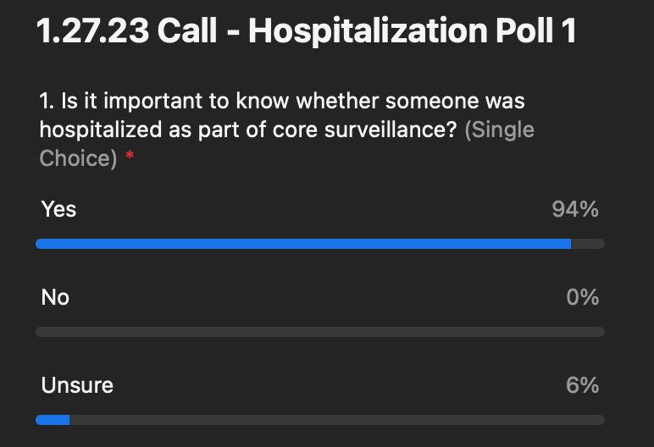
  - Summary: As expected, this resulted in consensus that this is important to know, if a person was hospitalized.
Poll Question 2: Admission date, discharge date, duration of hospitalization
- Does knowing the timing or duration of hospitalization, is that important as part of core surveillance as we have defined it.
- We will follow up with question on date vs duration as needed
- Results
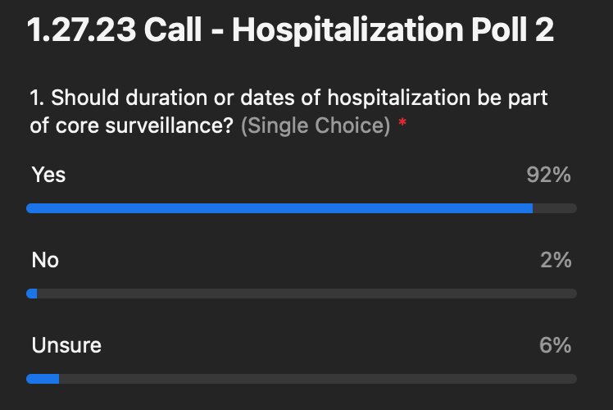
  - Summary: Most people agree that this is something to be part of core surveillance.
Poll Question 3: what time component do you prefer?
- If you think these are important, do you want exact dates or only duration or do you want both as part of core surveillance.
- Discussions:
  - Question from Steve: Are we presuming in-patient, ER, or what kind of hospitalization we’re thinking about?
    - Molly- the type of hospitalization such as in-patient is really a next step. If something is not clear and it makes it more difficult to answer then we can flag this as something to follow up on. I think in general we’re thinking in-patient but maybe this is something we need to discuss.
    - Steve: There are other permutations that might be considered like emergency, in-patient admitting through the ER, and more.
    - Molly: Yes, that can up the complexity level. We won’t be able to get into multiple hospitalizations or multiple blocks of hospitalizations today. This is beyond the high-level concept discussion for today.
    - Steven: I’m not trying to solve that today but we do need to consider this in the future for specificity and looking at the information in aggregate.
  - Comment from Angela Herbert (Nebraska) Thoughts for the future with "hospitalized" should it include outpatient visits, or only overnight stays? What about ED visits?? Might need to determine what type of hospitalization this would include. Discharge date thoughts: Even patients who die are "discharged" so what about adding a discharge disposition? That would include swing beds, home healthcare, died, home, etc. Or minimally discharged "alive."
    - Annie: There are also short stay surgeries etc - these are tough. it can be very hard to get that kind of granularity to even now.
    - Nancy Barrett (CT DPH): Usually we consider 'hospitalized' as an inpatient admission. We would collect other 'admissions' as separate data elements
    - Sherri Davidson (AL): Of Admission/Discharge, I would only recommend Admission
    - shawn: can admission location allow for department in the hospital specification - ICU/CCU/other units vs. a geographic location or facility name etc.
    - Amy Lai (AZ) In AZ, we also consider hospitalization as inpatient
    - Nicolay Lipskiy (CDC) We have in the list admission location and no facility name/info
- Results
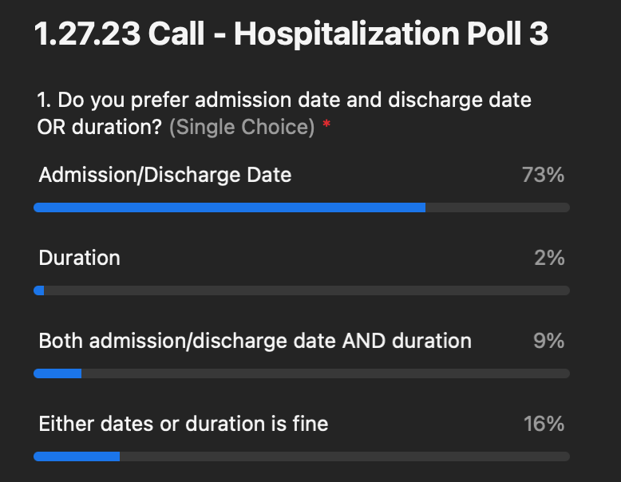
    - Summary: The ability to capture dates seems to be important.
Poll Question 4: Name of facility
- Again, keep in mind this is for core surveillance not patient-based follow up. This is hospitalization for illness not for risk factors or exposure.
- Discussions:
  - Comment from Annie: Before people answer this question this is for data going to the federal level or is it not? Because for a local or state health department this is important information but there are privacy issues, for some jurisdictions, when sending this type of information up to the federal level.
    - Molly- You’re right. We’re trying to think about jurisdiction to jurisdiction as well but this is a consideration that should be made in terms of whether or not this is a piece of core surveillance or is that enhanced surveillance or research or something used at the local level.
    - Annie: In terms of scope for this workgroup, we should try to be clear what we are talking about here. There is going to be different answers about what is core for a jurisdiction or what is core to exchange between jurisdictions or up to a federal level. Those are all different sets of data.
    - Steve: It also might be hospital identification information and not hospital name. There are a bunch of different ways of coding data and offhand I would not use the facility name but the equivalent of a name.
    - Molly: this is mixed so will require more discussion so lets move to the last question.
- Results:
    - 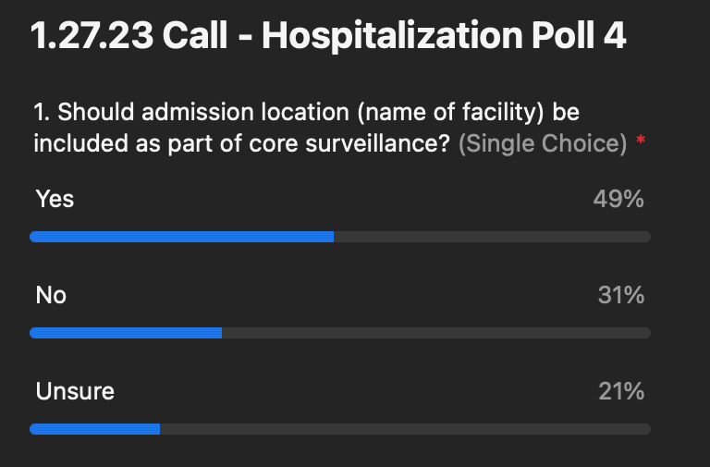
    - Summary: This is a mixed result and will require more discussion. We need to circle back to this in another poll to make sure we are being clear about this.
Poll Question 5: Should admission to ICU or other specialty care units be included as part of core surveillance?
- This is for any specialty care unit. Is this part of core surveillance, whether someone was specifically admitted to a specialty care unit?
- Discussion
  - Sara Johnston (CDC): People should look at this more broadly than what goes to CDC. Though we do hope to use the standardized data elements to CDC as well but think of this more broadly, as Laura mentioned, as to how you would like to see data being passed for inter jurisdictional notification or how you would like to see data standardized within your own system. In our discussions we cannot where data should or should not flow to CDC. The focus is NOT on the case notification to CDC.
- Results
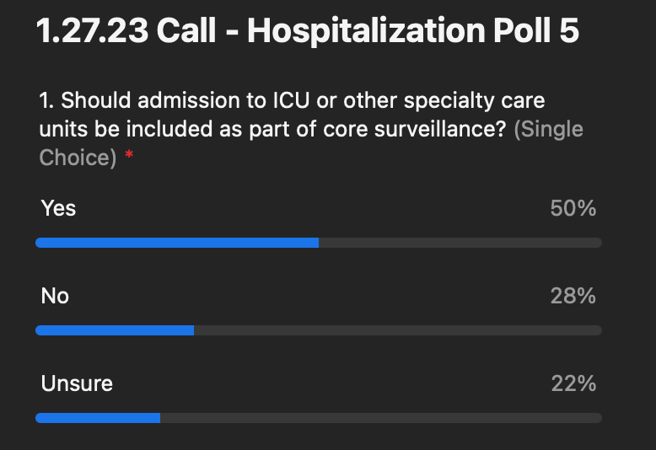
  - Summary: This is a mixed result. This is not as clear cut and something we will have to discuss further in terms of how it will fit into the recommendation.
What’s next?
- We will follow-up with a post call poll and follow-up questions. Let us know if there is something you wish we would have had time to discus or dig into.
- For further discussion
  - Definitions of selected items
  - Value sets of selected items as applicable
  - Capability to capture multiple hospitalizations for a condition/case
- Next meeting Friday, February 24, 2023

