Meeting Title: | CSTE Data Standardization Workgroup Meeting
Date: | 2/24/2022
Location: | https://zoom.us/j/96601644340?pwd=WUloTEl6NmxWZkNpMFFacHFHb2NpZz09
Attendees: 81 (orange text indicates presence at the meeting)
Co-Chairs | PHAs
Laura Erhart (AZ) | Abhilasha Saxena (TN) | Desiree Mustaquim | Lei Zhang (NV) | Sherri Davidson (AL)
Molly Crockett (MA) | Adrienne Erlinger (MA) | Dianna Hergott (WA) | Lindsay Horn (WA) | Sophia Cantor (WA)
CSTE | Alex Cox (WA) | Dimple Patel (KY) | Lina Saintus (NC) | Stephanie Moburg (NM)
Annie Fine | Alexa Ling (CA) | Doris McGinness | Liu Yang (MS) | Steve “Ike” Eichner (TX)
Becky Lampkins | Alexa Meinhardt (DE) | Eden Dietle (MO) | Luke Dalton (MI) | Tanner Turley (MO)
Gillian Haney | Alexandra Gagner (Chicago) | Ellen (EJ) Klingler (NYC) | Madison Wierzel | Teresa Jue
Janet Hamilton | Alicia Lepp (ND) | Eman Addish (Philly) | Mara Larson (NC) | Tiffany Firestone (WA)
Meredith Lichtenstein | Allison LaPointe (MN) | Emily Holodnick | Marijoyce Naguit (CA) | Tracy Miller (ND)
Shaily Krishan | Amanda Payne | Emily McGibbon (NYC) | Mary Kate Martelon (MA) | Trevor Maness (TX)
Taylor Pinsent | Amita Worasilpchai (JMC) | Emily Roberts (UT) | Mary McNeill (OH) | Tye Harlow (CO)
Grace Mallard (JMC) | Amy Lai (AZ) | Emily Augustini (JMC) | Meg Schaeffer | Vajeera Dorabawila (NY)
Laura Lane (JMC) | Amy Hyong | Erin Burdette | Melanie Epstein-Corbin (CA) | Yi Du (NE)
Susan Downer (JMC) | Amy Bogucki (TN) | Genie Tang (CA) | Michael Bryan (GA) | Yvette Dominique
CDC | Andy Tibbs | Graham Crawbuck | Michael From (GA)
Allison Miller | Andrea Perez (RUHS-PH) | Gwendolyn Gallagher (NM) | Michael Eberhart (PA)
Danielle Tack | Annalyse Bergman (AL) | Hailey Vest (IN) | Michelle Lin | Genny Grilli (MDH)
David Huang | Andrey Avakov (NH) | Hanna Chakoian (MN) | Misty Johnson (WI) | Devra Barter
Erin Burdette | Andria Apostolou (HIS) | Heather Crawford (OR) | Molly Howell (ND) | Beth Isaac
Erin Conners | Angela Herbert (NB) | Isaiah Francis (NM) | Morrow Toomey (AL) | John Satre
Jane Yang | Autumn Ward (KY) | Jacki Griffin (BSDS) | Myron Lizak (NH) | Claire Stump (AK)
Kate Woodworth | Becca Mickels (MO) | Jeff Van Ausdall (Shasta County) | Nancy Jingyi Li (CA) | Binoj Peter
Katie Fullerton | Benjamin Schram (ND) | Jeff Swanson (TX) | Nancy Barrett (CT)
Katherine DeBord | Benjamin Hornstein (AL) | Jenna Webb | Natalie Raketich (JMC)
Kevin Lan | Bill Morill | Jennifer Lockhart (AK) | Nedra Garrett
Keydra Oladapo | Brooke Beaulieu (APHL) | Jessica Mawdsley (VA) | Nicole Turvey (CO)
Kimberly Mace | Brooke Bregman (CA) | Jill Krause (NB) | Nora Alrubaie
Kristie Clarke | Caitlin Law | Jordan McBride (NH) | Paul Gillenwater (CO)
Laura Conn | Candace Noonan-Toly (NY) | Joshua Bagley | Peter Binoj
Lesliann Helmus | Carly Babcock (MD) | Judie Huyn (MD) | Rachel Corrado
Loretta Foster | Carmela Smith (NM) | Julia Aiken (CO) | Rachelle Boulton (UT)
Megan Swanson | Charlene Adams | June Bancroft (OR) | Ramandeep Kaur
Melissa Pagaoa | Christy Crowley (ND) | Justine Maxwell (TN) | Ravi Kafle (WA)
Michelle Hoover | Cliff Mitchell (MD) | Kacey Ingalls (WA) | Rebecca Jackson (CA)
Nicole Linsey | Collin Morris | Kadeen Okumu Camerra | Rendi Murphree (Mobile County)
Nicolette Bestul | Corina Chung (San Mateo) | Karen Wong | Robert Arciuolo
Nikolay Lipskiy | Corinne Davis (TN) | Karene Thomas-Watts (CO) | Roselyn Thalathara (NM)
Noreen Kloc |  | Kate Goodin (TN) | Ruth Jajosky
Sandi Bulens | Cristin Larder (Ingham County) | Kathy Turner | Sai Kurmana (MS)
Sandy Price | Crystal Snare (U of Washington) | Katy Donovan (RI) | Seth Rothbard (WA)
Sandy Roush | Danica Kuncio (Philly) | Keegan McCaffrey (CO) | Shan Maxey
Sara Johnston | Delicia Carey | Kelly Wallblay (Chicago) | Shaun Wilhelm (VA)
Sydney Adams |  | Kiara Vicente (AL)
Umed Anji |  | Kristen Merrell (MT) | Sheila Malone (Jackson State Univ)
*Some individuals dialed in and names are unknown
High-Level Meeting Notes (refer to meeting slides for more detail as needed):
CSTE Data Standardization Workgroup Meeting
- Main topic continues to focus on hospitalization.
Welcome to new members/DSWG Core Group Introductions
- January was the first of the meetings with heavy focus on hospitalization so please reference those notes and slides as needed
Overview and objectives of the DSWG
- This group has been in existence for about 5 years and while we are starting on a heavier collaboration with CDC, it’s important to know we have been working on this for several years.
- The focus is to improve data quality and surveillance through development of consensus for core data elements for surveillance.
- Convene epidemiologists and informaticians to develop consensus.
- The group has expanded recently by bringing in more jurisdictional partners and more individuals from CDC programs to participate
Meeting Ground rules
- The goal is to move through the material efficiently we have found that the chat function is a great way to communicate during the meeting and we will incorporate that feedback as we review input from the group.
- We are focusing on the 80/20 consensus and we may not focus on every detail or be able to dig into every point of discussion
- There is a link for a post meeting survey that can be used at any time to collect additional/broad information.
Hospitalization: In Scope
- Looking at hospitalization as an indicator for severity of disease, similar to what is used in GenV2
- Looking to identify structure and elements for core surveillance. Last time we discussed what it means to be “core surveillance” and there is no firm definition. However, think about the data elements or classes that should be considered across platforms and elements as part of core surveillance. These are elements that are good for situational awareness or routine jurisdictional data transfer. We want to consider the core data elements we would want to see across different platforms or data exchange mechanisms.
- We are looking to identify common values, data sets, and definitions and also be looking at some implementation and interpretation.
- This is for case-based surveillance, not aggregate reporting.
Assumptions
- It is okay for data to be left blank or unknown if not available we are not looking to fill in an answer for every case
- Do not think about this as setting requirements for data that would need to be found for every case but moreover as the common value sets, definitions, and data exchange elements you might need across conditions and systems.
- The goal is to facilitate data exchange, interjurisdictional transmission, and adding new conditions to your system.

Hospitalization: Out of Scope
- Not looking for Information collected as an exposure or risk factor for a case.
- Not looking to standardize data elements that are more for research purposes or non-core surveillance.
- We will not be going into condition-specific guidelines or criteria for timelines; we’re focusing on the common structure.
- We are not focusing on data exchange mechanisms such as sending to CDC from jurisdictions.
From Jan WG Meeting
- In that meeting a lot more background was provided, so please reference those notes as needed for context.
- We did identify which core data elements within hospitalization that this group considered to be important for core. This included:
  - Hospitalization
  - Admission date
  - Discharge date
    - These dates seemed to be more important component than duration of hospitalization, as discussed by the group.
- We began talking about admission location and facility identifiers as well as ICU or specialty care
  - We will be revisiting this as part of today’s call.
What should be part of core [revisited]??
- This slide covers what Laura mentioned on the previous slide and won’t be able to get into the details of the last meeting, but items highlighted here are pieces that between polling and the discussion on the last call there seemed to be majority consensus.
  - Hospitalized yes/no
  - Admission date
  - Discharge date
  - ICU/special care unit admission (yes/no)
These are the items where people indicated they were part of core surveillance.
- Duration of hospitalization identified as not core
- Facility name/identifiers are important for jurisdictions but not necessarily appropriate as part of sending case notifications to CDC
- The items we are going to try to work through today include ICU admission dates, ICU discharge dates, admission location (specified dept within the facility).
- During the polling, please focus on items that you would use globally.
- If you have thoughts or questions as we are going through these, we encourage you to use the chat and we will work to get back to you. You can also raise your hand.
Poll: Admit/Discharge Dates to CDC
- It was fairly clear from last call that admission/discharge dates are considered core surveillance elements.
- What was not as clear was if admission/discharge dates are appropriate for inclusion in routine case notifications to CDC, or are they core surveillance elements for jurisdictional use only.
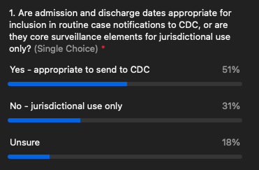
- Summary: The results are mixed, and admission/discharge dates need additional discussion as it does not meet the 80/20 rule. It is unclear if this information is appropriate to send through case notifications to CDC.
- Discussion/Chat
  - Annie Fine: one question would be whether it is ok for jurisdictions that do not feel comfortable sharing or may be actually prevented by law or reg to share a particular data element not to do so but still include the element in core surveillance. e.g., that variable would be preferred but not required
    - Gillian Haney: or include month and year only as the full date may be problematic.
    - Lesliann: I think concept is that none of these fields would be required. Sending a partial date (Mo/Yr only) would require different validation, but seems like it would still provide valid information when the jurisdiction isn't allow to send the full date.
Poll: ICU Dates
- It was unclear from the January call and in-between polling if admission to ICU/specialty care units would be considered part of core surveillance.
- Based on the feedback we got in between and mixed call, we would lean towards considering this something we would consider as a core element, but we would like to dig more into what that means.
- If we are we are going to consider ICU admission and discharge be captured as part of core, then should these dates be captured as part of core surveillance as well?
  - In addition to knowing if they were admitted to the hospital, should we know the dates they were admitted to the ICU or is that more than we need to be capturing as part of core surveillance?
- If you think this is something jurisdictions should be capturing globally, should that also be sent to CDC with dates? Should these dates for ICU admission be sent along or is that not necessary for core surveillance.

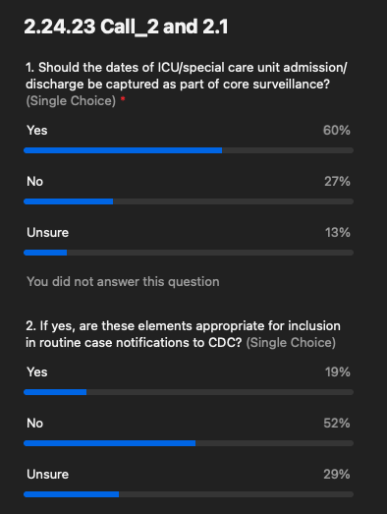
- Summary: This is a strong vote leaning towards these dates being considered part of core surveillance globally but not part of routine case notifications to CDC.
- Discussion/chat:
  - Kristie Clarke: would want to consider that people may go back and forth between the floor and ICU more than once
Poll: Specific Hospital Department/Location
- The wording here is slightly confusing but what we are trying to say here is that the question of ICU vs non-ICU became more clear. But something that came up was that outside of ICU, that the department should be recorded. For example, someone is admitted to a hospital and admitted to an OB/GYN unit or internal medicine or a non-specialty care unit then is it important to record where they were admitted and what department they were admitted to within the hospital as part of core surveillance? There are situations where that is important to know but in general, should this be part of core surveillance globally?
- Is this a specialty or situational piece of surveillance? Do you think collecting the department is important?
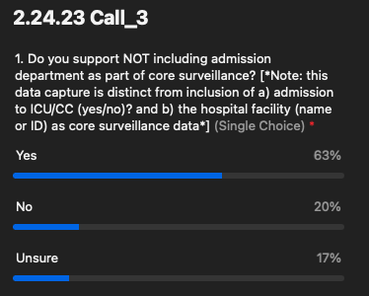

- Summary: It looks like in general there is agreement for this that we should not worry too much about the specific department except for capturing ICU/non-ICU.
- Discussion/chat:
  - Annie Fine: Not sure how we are defining core surveillance here. Apologies if I missed that. Does that mean data that can be exchanged electronically in a standardized way among jurisdictions even if not shared with CDC?
  - John Satre: Isn't nuanced requests more complicated to implement on the hospital side?
  - Sophia Cantor: Request to understand what you mean as not core surveillance?
    - Laura E: Core surveillance is not whether this should be sent to CDC but it is moreover whether this is something we should all be capturing within our systems in a standardized way and that it is something available and including within each of our systems.
    - Lesliann: It is a concept you would expect to collect it for every condition unless there was some reason you wouldn’t. It would be something standard across conditions and jurisdictions.
Hospitalization- Definition (for discussion)
- On the last calls and between the polls that were sent out we’ve been touching on what is important to be sending and what we need to send. But we also need to step back and define what hospitalization means and what counts as a hospitalized case.
- This table is meant to guide this discussion and elicit reactions and for people to respond to as we work through the rest of the slides.
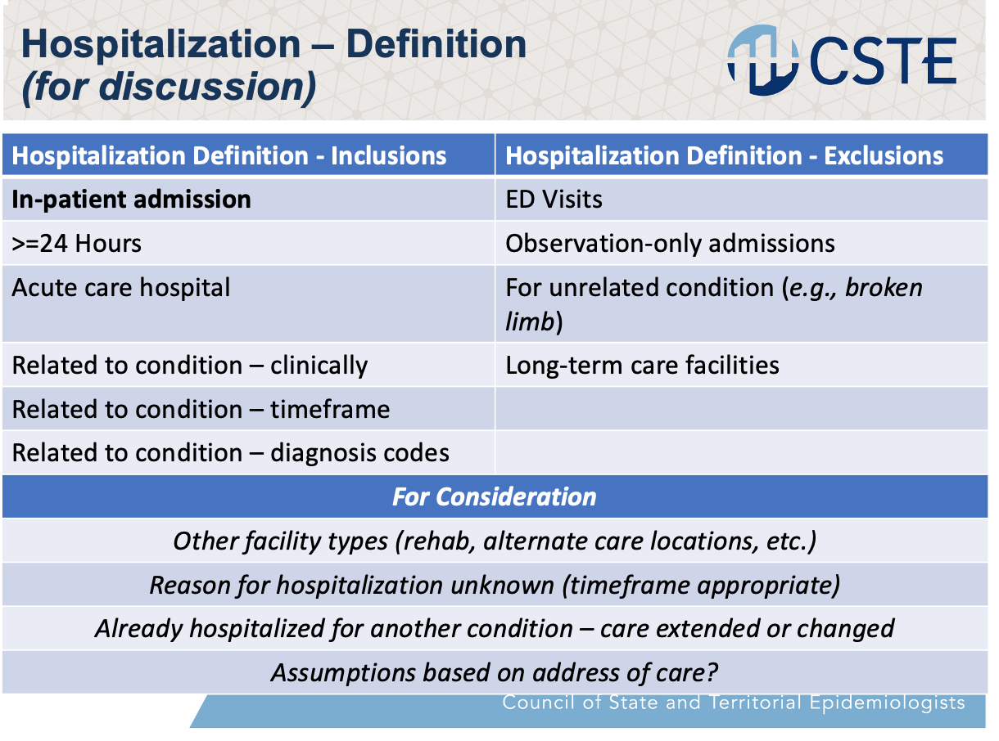
- We asked in the polls, what situations do you classify someone as hospitalized and what would be included.
- In what situations, would you feel comfortable saying “not hospitalized” and what is the default assumption if you don’t have enough information. In what situations do you feel comfortable classifying someone as hospitalized? In what situations do you feel comfortable classifying someone as NOT hospitalized? If you don’t have enough information or any information, what is the default assumption? At what point do you feel you have enough information to say one or the other or do you stick with an unknown type of answer.
- There has been guidance in the past with H1N1 that it was specific to acute care, related to a condition, and duration. For example, if someone was hospitalized for a broken ankle and had COVID but they weren’t hospitalized for COVID then it wouldn’t be a hospitalization.
- If someone is admitted for observation only, would you consider that a hospitalization or would you consider that outpatient only?
- Given there are so many pieces to this we want to share some scenarios and see if you would call the person hospitalized. We will see how that does to help us pull apart what is supportive and what will not let us feel comfortable that someone is hospitalized. These will be more realistic scenarios for having incomplete data.
- During the polling there was mixed responses for scenarios where assumptions had to be made based on limited information. The goal is to see where we feel comfortable as a group making assumptions and where we do not feel comfortable.
- Discussion/chat:
  - Carly Babcock: what about giving birth? Would that be a hospitalization?
    - Molly: That is a good question, it depends on what the hospitalization is for. If it is for an infection after giving birth, and remained in the hospital longer than expected, this might qualify. But a hospitalization for birth only might not, but that is what the group can help decide.
  - Annie Fine: sometimes we do not know if the hospitalization is related and need to classify hospitalizations as possibly related unless we know differently
  - Kristie Clarke: I'm thinking about times when my hospital 'inpatient' beds were full so we had to keep patients we would normally have admitted in the ED or in an obs unit... just for context of these scenarios
  - Amy Lai: How about a patient was hospitalized for something else but end up a communicable disease case?
Defining “hospitalization”
- This covers a lot of what we had done previously regarding when you can make assumptions.
Ideal Scenario
- Most people would agree about this scenario and most of us would feel comfortable saying this person was hospitalized for the condition, but this rarely happens.
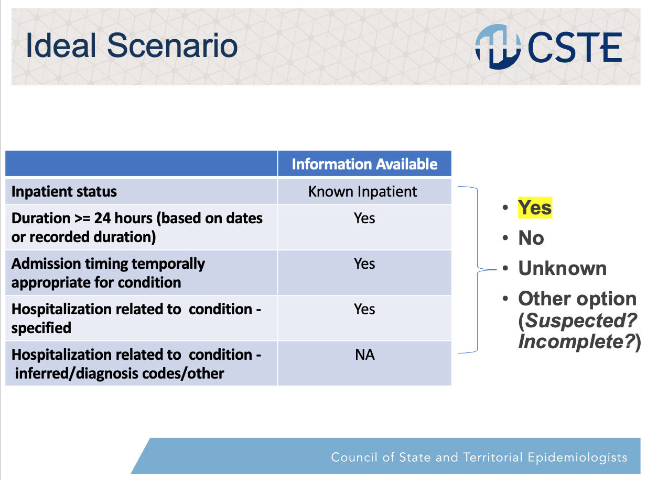
Poll: Scenario 1 (Reason unknown)
- We might not know why they were hospitalized or have information that specifies this was for a particular condition. In this situation, where you know they are inpatient and admitted for over 24 hours but you don’t know the reason, how would you classify the case? Assume this is the end point and you will not get any further information.
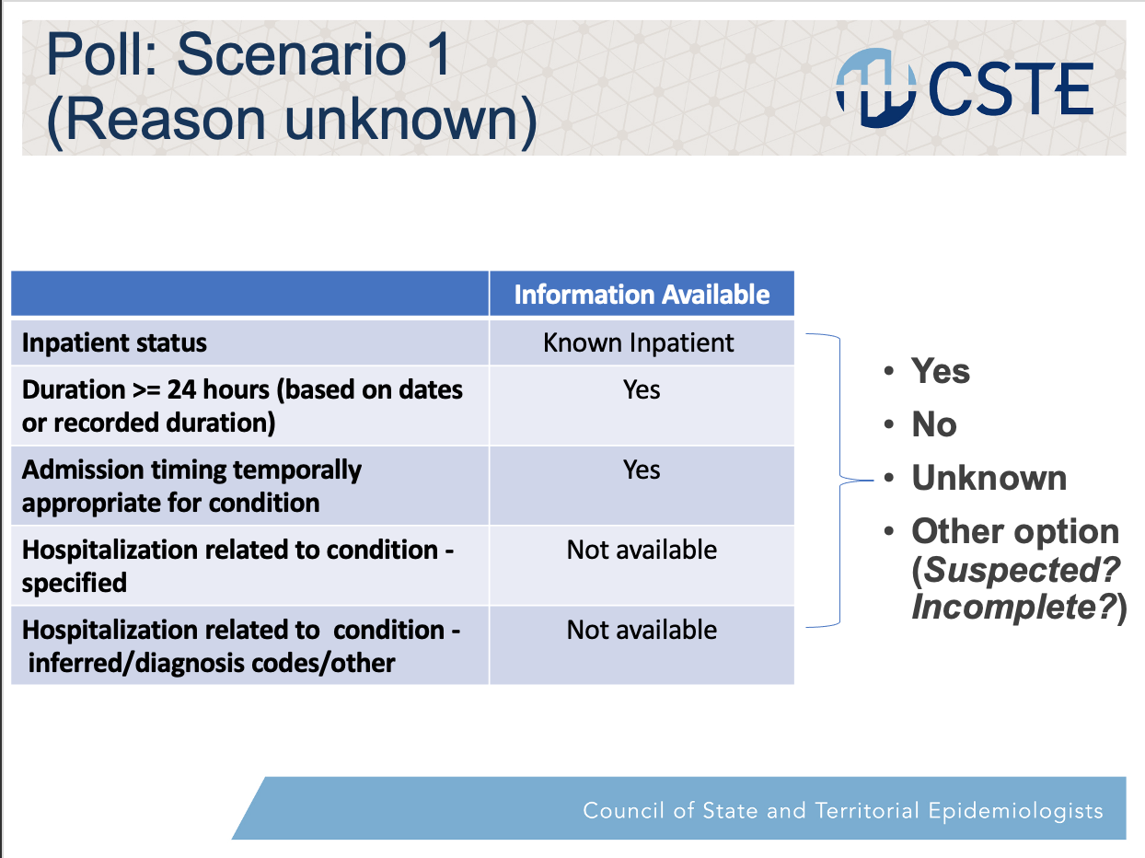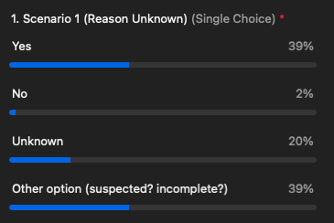

- Summary: After additional discussion and clarification the group was re-polled and 39% agree that yes they would consider this as a hospitalization, 2% would not consider this as hospitalization. The results are very mixed. Based on the chat this result was not surprising. The fact that we are trying to stress a hospitalization for a condition and separating this out as no/unknown/or other option makes sense.
- Discussion/chat:
  - John Satre: What is it that we’re getting to as an end point here. Are we thinking the hospital is going to communicate something to us? I’m thinking of a situation where the patient is truly hospitalized, are we going to ask them to not say they are hospitalized if the patient doesn’t meet certain criteria?
    - Molly: If the question is hospitalized related to the condition. We know they are hospitalized but we don’t know if it was because they broke their leg not because of COVID and we only want to be recording this if they were hospitalized due to COVID. That is the scenario here and for some reason you only have eCR data and the IP isn’t calling you back, you can’t get more information so how would you classify the information in your system?
    - Laura: Suggest we do this poll again so we can clarify a few things before we look at the results. There are a lot of great questions in the chat. In public health we know we are not getting all of the information we need from hospitals saying, “Yes, this person was hospitalized as an inpatient for more than 24 hours for the condition that you’re doing surveillance on.” So, what do we do with that information? Or better, what do we do with that lack of information? How do we interpret this to be able to get to a standardized way we are all looking at hospitalization. In some cases we are able to go back and do an in-depth investigation and find out all of those answers, but what is our default if we aren’t getting all of that answered. Can we get to a default?
    - Molly: Agreed on relaunching the poll. We know we can’t be too prescriptive within this group. We are trying to get to some of the key pieces of information that we sometimes have and sometimes don’t and what to do with them in those situations.
    - Note: The “best” poll results are the only ones shown.
  - Annie Fine: That index / primary reason could easily be related to severity of illness combined with the reason for the case.
  - Hanna Chakoian: It makes sense to me to have a standard way to indicate they were hospitalized, but not related - as a way to indicate we know they were there, and have looked at it, and we know it's not related
  - Angela Herbert: There is always a principal diagnosis code on inpatients.
  - Lesliann Helmus: Seems like it might depend on the condition, too.
  - Kristie Clarke: I think with another category we could have a hosp rate of known related and then a hosp rate that includes the "incomplete" category- sort of a de facto confidence interval
  - Annie Fine: This is highly dependent on the condition, because sometimes, like with COVID, because of the volume there was no way to gain all of the data needed. In that case it was important to be able to make assumptions based on the temporality. For temporal sensitive conditions there is an assumption that there is a timeframe that everybody would be using, which potentially could vary by condition. There could be some conditions where if they are not hospitalized within a week then they are not assumed to be hospitalized for that condition. That is a big piece of this.
    - Molly: Yes, and again without getting condition specific or too prescriptive, the way it is phrased is to indicate that there is some kind of relevant time period or that the Epi investigator is going to be able to make that determination themselves based on their knowledge of the condition. That is outside of what we are going to do today but we recognize this will likely vary by condition.
  - Binoj: I mostly approve varicella cases for the state of Texas. One thing I would like to say is that our investigators are basically looking at complications and most of the cases are seen in the emergency room. Admission is important for us because emergency room admission is not that serious. The other thing is that the reason would be ideal to know but if the case is hospitalized, during the time of that illness and even if the reason is unknown, I would document it as hospitalized, however, I would also like to get the medical record to see if the person was hospitalized for the condition. I would mark it as unknown unless otherwise needed.
    - Molly: I agree it is better to get more information however we are not always able to obtain that. This is likely real-life scenario but you’ll see other scenarios touch on the emergency room department element.
  - Annie: One option might be to have a hospitalization variable and a separate one to indicate the level of knowledge re. whether it was for the condition - such as a) definitely b) presumed c) pending
  - Danielle Tack: From an implementation point of view do we have 1 data element, but instead of Y/N/U there is some level of evidence included e.g. Y, definite; Y, presumed; Pending; No; unknown or better to offer that info a separate data element?

Poll: Scenario 2 (ED disposition unknown)
- We know someone was in the ED but we don’t know their disposition. What is unknown is where they went but we do know they were in the ED.
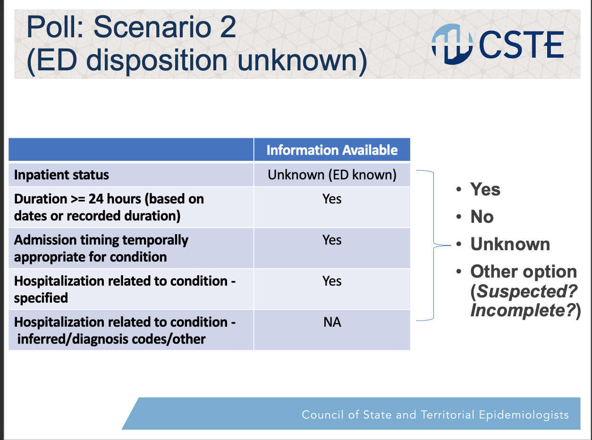
- Summary: The largest proportion would call this a hospitalization but certainly not as clear a majority as some of the other results.
- Note: Unfortunately a screenshot was not captured for this poll result.
- Discussion/chat
  - Annie Fine: know NYC used >2 days in ED without having info readmission.
  - Amy Lai: What if there are two hospitalizations, like how we have outcome vs did the patient pass away. So one to indicate the patient was hospitalized and a separate one to indicate if the hospitalized was due to the condition?

Poll: Scenario 3 (Observation admission)
- Remember these are helping us understand the importance of which pieces of information are needed and where assumptions can or cannot be made.
- This is one that is seen a lot. We know someone was admitted for hospitalization but it is not clear if they made it to a floor or somewhere else but it was specifically an observation admission. We know it was long enough, temporal, and related to the condition. Would you classify this as a hospitalization if you could not get further information?
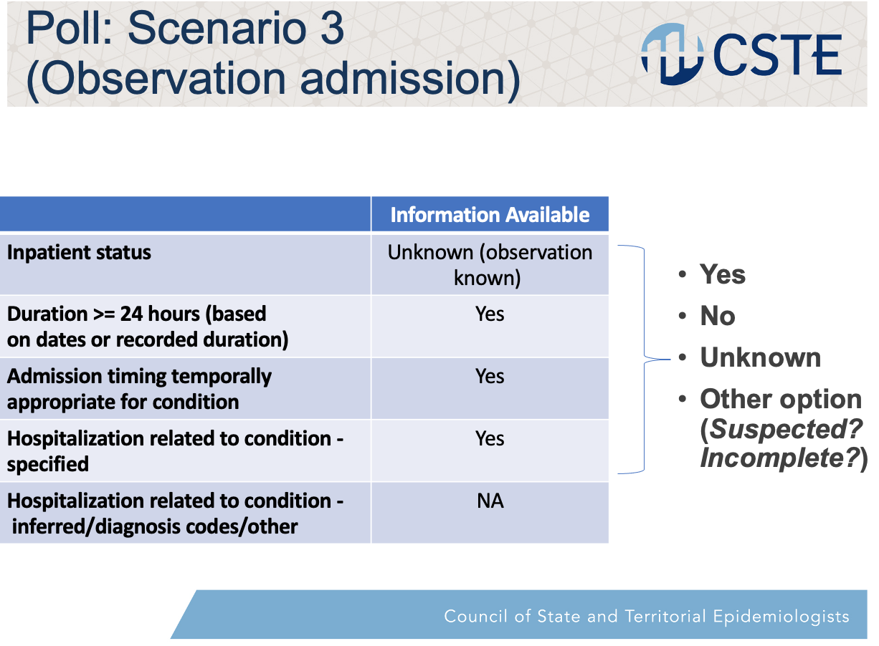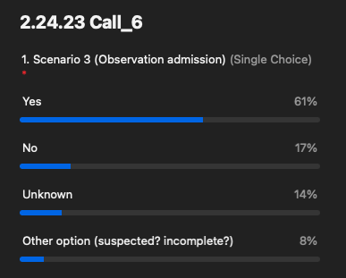
- Summary: This is much more clear.

Note: At this point in the meeting, we were running short on time, and the remainder of these polling questions went very quickly.

Poll Scenario 4 (Inferred Reason)
- Imagine this is like an eCR and you have a diagnostic code, timing, but you do not know for certain if it is related to the hospitalization.
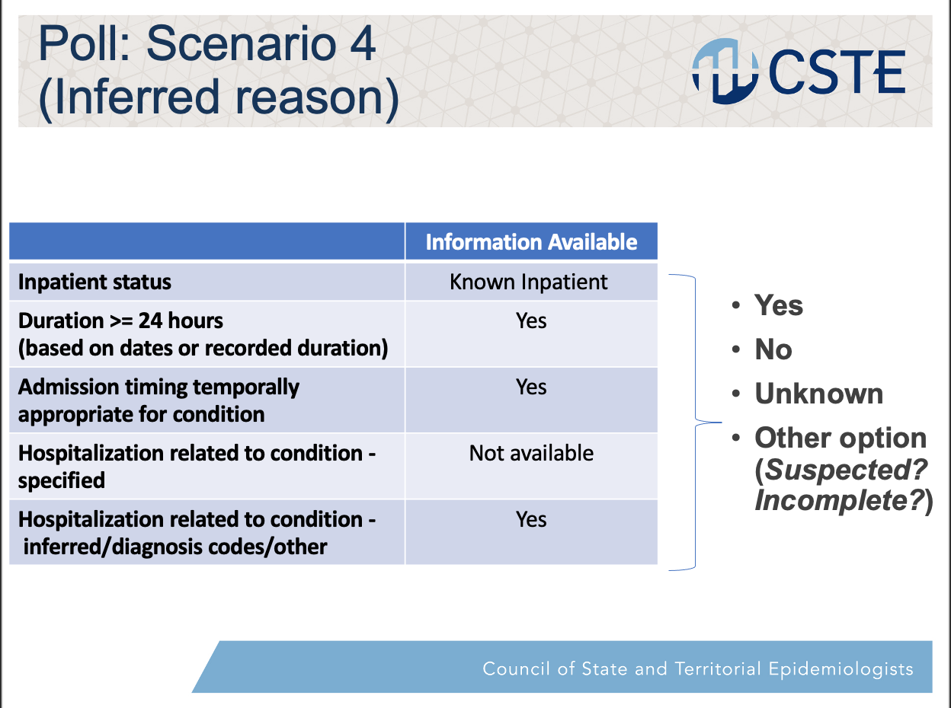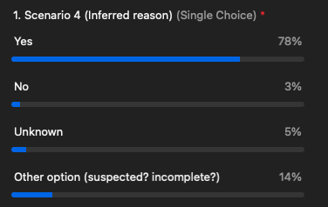
- Summary: ICD Code seems to be good.

Poll: Scenario 5 (Unknown department and duration)
- We have an ICD code, we know it was the right timing, but we don’t know how long they were there or where they were. We know they were at the hospital and there was a diagnostic code related to at least and ED or observation but we don’t know if they were there 24 hours or if they were an inpatient.
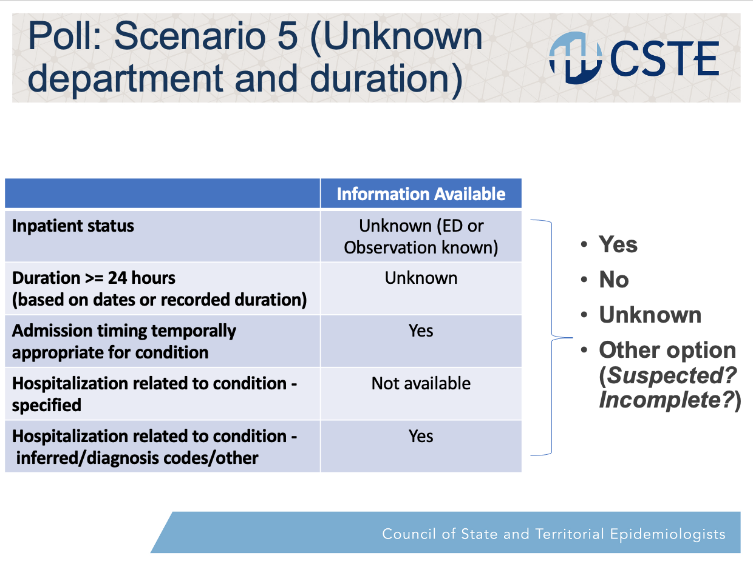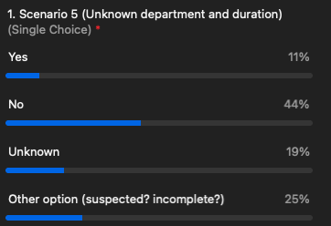
- Summary: This is much more of a no, which is not surprising.

Poll: Scenario 6 (unusual/unknown timing)
- We know they were an inpatient and they were there for 24 hours but the timing was wacky and it was several months later. Is that going to throw you off and make you not call it a hospitalization?
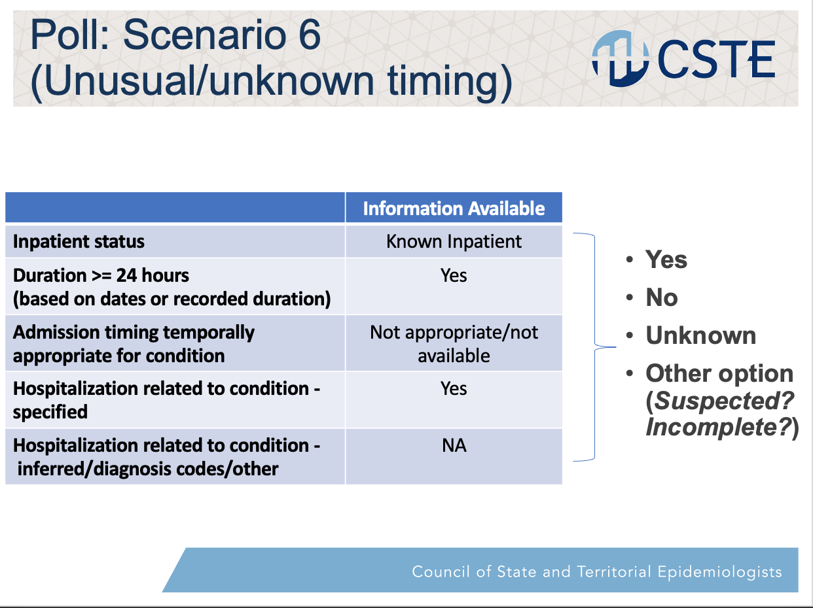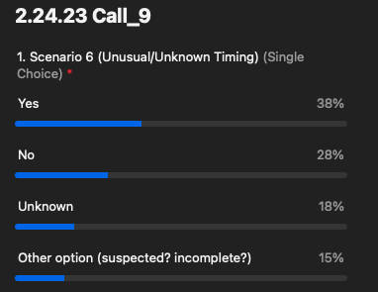
- Summary: Leaning towards yes but it is not quite as strong. The timing seems to be throwing people off and that is helpful to know.

Poll: Multiple Hospitalizations
- Right now, we only send one set of hospitalization information in Genv2. Thinking about your own surveillance system if someone has multiple hospitalizations and several times they meet the criteria we want to see, to call something a hospitalization, do you capture them all in your system or only certain ones? The next question is then, what do you think is appropriate to send to CDC? If you are able to send all of them, do you want to send all of them or is it more appropriate to only send the first or last hospitalization? Remember, this is future state or desired state. What do you think you should be able to send?
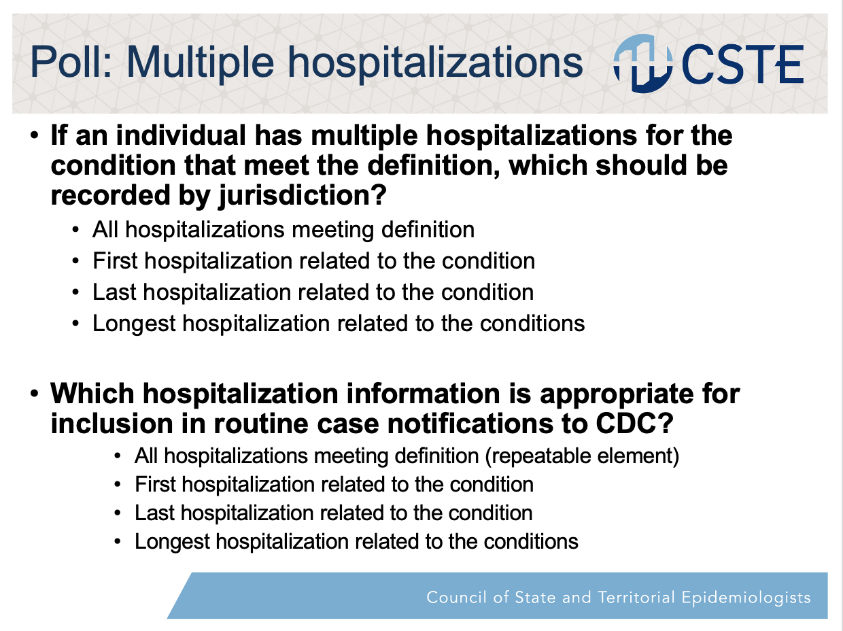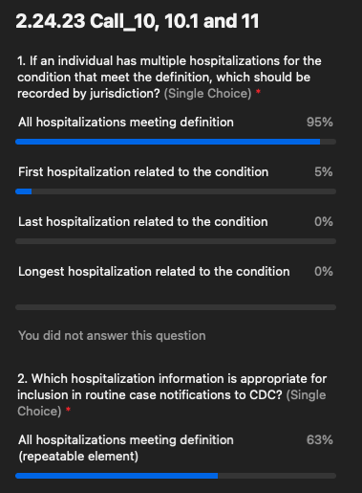
- Summary: It seems clear that people consider all the hospitalizations relevant.

General Wrap-Up
- Having touched on these data elements, it is obvious that there is a lot of nuance and complications here to consider. We will continue to tease this apart and look at the feedback with different types of information available.
- Laura E: We’ll meet again in a month and will be sending out additional polling questions before the next meeting. A few other pieces we’ll get into is where will this data come from, how will we incorporate eCR data and ELR data. How do we incorporate USCDI, how much do we need investigate these or look at medical records? This is a teaser for some of the other big questions coming!
Thanks for everyone’s input today!

