Meeting Title: | CSTE Data Standardization Workgroup Meeting
Date: | 3/31/2022
Location: | https://zoom.us/j/96601644340?pwd=WUloTEl6NmxWZkNpMFFacHFHb2NpZz09
Attendees: 78 (orange text indicates presence at the meeting)
Co-Chairs | PHAs
Laura Erhart (AZ) | Abhilasha Saxena (TN) | Dianna Hergott (WA) | Lei Zhang (NV) | Sherri Davidson (AL)
Molly Crockett (MA) | Abigail Collingwood (UT) | Dimple Patel (KY) | Lindsay Horn (WA) | Sophia Cantor (WA)
CSTE | Adrienne Erlinger (MA) | Doris McGinness | Lina Saintus (NC) | Stephanie Moburg (NM)
Annie Fine | Alex Cox (WA) | Eden Dietle (MO) | Liu Yang (MS) | Steve “Ike” Eichner (TX)
 |  |  |  | Suzanne Gibbons-Burgener
Becky Lampkins | Alexa Ling (CA) | Elizabeth Lando-King (MN) | Luke Dalton (MI) | Tanner Turley (MO)
Gillian Haney | Alexa Meinhardt (DE) | Ellen (EJ) Klingler (NYC) | Madison Wierzel | Teresa Jue
Janet Hamilton | Alexandra Gagner (Chicago) | Eman Addish (Philly) | Mara Larson (NC) | Tiffany Firestone (WA)
Meredith Lichtenstein | Alicia Lepp (ND) | Emily Holodnick | Marijoyce Naguit (CA) | Tracy Miller (ND)
Shaily Krishan | Allison LaPointe (MN) | Emily McGibbon (NYC) | Mary Kate Martelon (MA) | Trevor Maness (TX)
Taylor Pinsent | Amanda Korth (NB) | Emily Roberts (UT) | Mary McNeill (OH) | Tye Harlow (CO)
Grace Mallard (JMC) | Amanda Payne | Emily Augustini (JMC) | Meg Schaeffer | Vajeera Dorabawila (NY)
Laura Lane (JMC) | Amita Worasilpchai (JMC) | Erin Burdette | Melanie Epstein-Corbin (CA) | Yi Du (NE)
Susan Downer (JMC) | Amy Lai (AZ) | Genie Tang (CA) | Michael Bryan (GA) | Yvette Dominique
CDC | Amy Hyong (Riverside Univ) | Graham Crawbuck (WADOH) | Michael From (GA)
Allison Miller | Amy Bogucki (TN) | Gwendolyn Gallagher (NM) | Michael Eberhart (PA)
Alfonso Rodgriguez Lainz | Andy Tibbs (MDPH) | Hailey Vest (IN) |  | John Loonsk
Danielle Tack | Andrea Perez (RUHS-PH) | Hanna Chakoian (MN) | Misty Johnson (WI) | Charles Gabriel (FEHRM)
David Huang | Annalyse Bergman (AL) | Heather Crawford (OR) | Molly Howell (ND) | Dawn Nims
Erin Burdette | Andrey Avakov (NH) | Isaiah Francis (NM) | Morrow Toomey (AL) | Sarah Gaunt
Erin Conners | Andria Apostolou (HIS) | Jacki Griffin (BSDS) | Myron Lizak (NH) | Claudette McIntosh
Jane Yang | Angela Herbert (NB) | Jeff Van Ausdall (Shasta County) | Nancy Jingyi Li (CA) | Devra Barter
Kate Woodworth | Autumn Ward (KY) | Jeff Swanson (TX) | Nancy Barrett (CT) | Claire Stump (AK)
Katie Fullerton | Becca Mickels (MO) | Jenna Webb | Natalie Raketich (JMC) | Sonia Zhan (CDC)
Katherine DeBord | Benjamin Schram (ND) | Jennifer Lockhart (AK) | Nedra Garrett
Keaton Hughes | Benjamin Hornstein (AL) | Jennifer Ostubo (VT) | Nicole Turvey (CO)
Kevin Lan | Bill Morill | Jessica Mawdsley (VA) | Nora Alrubaie
Keydra Oladapo | Brooke Beaulieu (APHL) | Jill Krause (NB) | Paul Gillenwater (CO)
Kimberly Mace | Brooke Bregman (CA) | John Satre (IA) | Peter Binoj
Kristie Clarke | Caitlin Law | Jordan McBride (NH) | Rachel Corrado
Laura Conn | Candace Noonan-Toly (NY) | Joshua Bagley | Rachelle Boulton (UT)
Lesliann Helmus | Carly Babcock (MD) | Judie Huyn (MD) | Ramandeep Kaur
Loretta Foster | Carmela Smith (NM) | Julia Aiken (CO) | Ravi Kafle (WA)
Megan Swanson | Charlene Adams | June Bancroft (OR) | Rebecca Jackson (CA)
Melissa Pagaoa | Christy Crowley (ND) | Justine Maxwell (TN) | Rendi Murphree (Mobile County)
Michelle Hoover | Cliff Mitchell (MD) | Kacey Ingalls (WA) | Robert Arciuolo
Michelle Lin
Nicole Linsey | Collin Morris | Kadeen Okumu Camerra | Roselyn Thalathara (NM)
Nicolette Bestul | Corina Chung (San Mateo) | Karen Wong | Ruth Jajosky
Nikolay Lipskiy | Corinne Davis (TN) | Karene Thomas-Watts (CO) | Sai Kurmana (MS)
Noreen Kloc | Cristin Larder (Ingham County) | Kate Goodin (TN) | Seth Rothbard (WA)
Sandi Bulens | Cristina Wolff (NB) | Katie Jones (VT) | Shan Maxey
Sandy Price | Crystal Snare (U of Washington) | Kathy Turner | Shannon Lawrence (NB)
Sandy Roush | Danica Kuncio (Philly) | Katy Donovan (RI) | Shaun Wilhelm (VA)
Sara Johnston | Delicia Carey | Keegan McCaffrey (CO) | Sheila Malone (Jackson State Univ)
Sundak Ganesan | Desiree Mustaquim | Kelly Wallblay (Chicago)
Sydney Adams |  | Kiara Vicente (AL)
Umed Anji |  | Kristen Merrell (MT)
Zuzana Love
*Some individuals dialed in and names are unknown
High-Level Meeting Notes (refer to meeting slides for more detail as needed):
CSTE Data Standardization Workgroup Meeting
Welcome to new members/DSWG Core Group Introductions
Meeting Ground Rules
- Participation by everyone on the call is encouraged.

Hospitalization: In Scope
- Hospitalization as an indicator of the severity of disease
- What are the elements needed for routine data collection across all jurisdictions in a standard way for hospitalization (common definitions or value sets)
- This is for case-based surveillance.
- This is about the collection of data elements, not about the mechanism for sharing data with the CDC this is focused on state and local public health use; what do the jurisdictions want to collect
Hospitalization: Out of Scope
- Data for research purposes
- Condition-specific guidelines

Data Sources for Hospitalization
- This was covered in depth in the January 2023 meeting, and a spreadsheet was shared with some of the sources we have
- Some sources have been pulled in by hand over the years
- Can we make recommendations on how data is pulled from these data sources, is there a way we can promote automation
Hospitalization in eCR/RCKMS
- Special Presentation
  - John Loonsk, eCR lead with the Association of Public Health Laboratories
  - Sarah Gaunt from Lantana Consulting Group and part of the standards team for electronic case reporting
Hospitalization in eCR
- EHRs store data differently than public health is accustomed to getting information
- The EHR itself is manipulating the data and is not always in a standard format
- Standards are designed to transmit clinical data, which is not always in a yes/no format
- FHIR, Fast Health Interoperability Resources, is a newly developing standard. eCR has worked to develop implementation guides with CDA and FHIR to support transitioning to FHIR as jurisdictions move forward
- There is a federal regulatory apparatus in place to try to implement standards, but it is just beginning
- From an eCR standpoint, testing is increasing to develop metrics and standards

Hospitalization in CDA & FHIR eICR Standards
- Hospitalization in CDA and FHIR standards, the goal was to create a 1:1 between these standards
- Hospitalization is the class of encounter within the CDA, which is in the clinical document and the encompassing encounter code, and in FHIR, this is the Encounter.class
  - These elements use an HL7 value set
  - There are five values that point to the type of encounter (listed on the slides); if there are any types of these encounters used, then it can be considered that an individual was hospitalized
- EHRs generally have a yes/no question for whether or not a patient was hospitalized for a specific condition
  - The encounter diagnosis is located in the CDA/FHIR, and the diagnosis within this encounter is related to hospitalization as an indicator to determine if a person was hospitalized for a condition
Observed Data Example
- Initial eCRs were reviewed, and a sample was pulled for how well the hospitalization was pulled from the data
  - This looked at 54,282 eICRs
  - Of these records, 6772 were coded as an inpatient, and that was easy to calculate, and the rest of the data broke down into different categories (as listed in the slide)
  - 88% of the data was easily used to determine hospitalization and easily usable
  - Much of this work is still in process, and there is a working group that is working on rules and completeness criteria and applied for onboarding eCRs and the healthcare organizations they support. It is expected this will improve over time, but it is a work in progress
Discussion from the eCR presentation
The general discussion revolved around the promising results from the presentation and how derived data will a) continue improving and b) automation will provide a significant lift moving forward. If data can be derived to indicate hospitalization, inpatient, and outpatient, it will be plausible to add these to USCDI and USCDI+ and add this as a baseline element facilitating the exchange of information. There are concerns about data validation and the group would like to see more of that in the future as able.
Implementing Hospitalization in RCKMS (Shaily at CSTE, RCKMS content team lead)
- RCKMS uses criteria that are mapped to the encounter activity section, mentioned earlier
- For hospitalization, there are 3 value sets for CPT, HL7, and SNOMED codes
- Hospitalization by itself will not produce a case report to public health and the data comes in, in conjunction with a lab report or a diagnosis
- The sample on the slide was using COVID as an example, with six other conditions that have hospitalization as a criteria

Discussion from the RCKMS presentation
Concerns were expressed for chronic disease information given what appears to be a focus on infectious diseases. It was clarified the scope of eCR includes reportable conditions, of which, many are acute infectious diseases. There was also a concern raised regarding the completeness of the data. Again, it appears there is a lot of potential here for up-and-coming sources of data.
Core Data Elements
- A table was presented with a summary of data elements and concepts that have been reviewed previously and where the group is in defining what is part of core surveillance and the use of the notification level
- Today we’ll go through some polling to help on determinations on items that have had split results
Polling Process
- The Co-Chairs will give an opportunity for discussion before polls are launched and focus on yes/no responses
- There was no between-meeting poll
- If you do not feel comfortable answering a question just skip it and do not participate in the poll
---- In-Meeting Polling Began Here---
Question 1: Should admission to ICU/specialty care units be included as part of core surveillance?
- This question prompted a lot of discussion within the DSWG. Some questions and concerns included
  - Is this specific to hospitalization admission or receiving critical?
  - In some cases, admission becomes more complicated; you may be admitted to a unit but not an actual patient of that unit.
  - Reminder, hospitalization is reported based on a notifiable condition
  - Results: 55 ppl responded
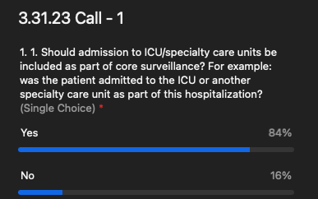
  - Summary: The group determined that admission to ICU/specialty care should be considered part of core
- Question 2: Is the admission to ICU/specialty care unites appropriate for inclusion in routine case notifications to CDC?
  - No pre-poll discussion was held for this question.
  - Results: 53 ppl responded
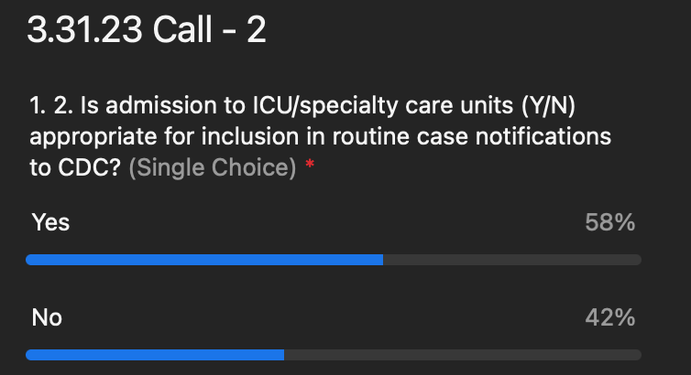
  - There was a post-poll discussion given the split results. The comments included,
    - There is a fine line between public health surveillance and healthcare. If collecting the information is not required or useful, we should not collect it.
    - It is critical in some situations to know how critical an illness is and who is getting the most severe illness; This is particularly crucial when something new is emerging as it helps us understand how severe the condition is.
    - There should be the capacity to collect and transmit but not a requirement.
    - Concerns for this group are to make a holistic determination of when certain data elements are required to be reported to the CDC.
    - This data element will most likely be missing and there is still confusion on the definition of core surveillance.
      - Core are elements that are available across all diseases but not required. There is some intersection between the work in the DSWG and emergent conditions.
- Question 3: Should the dates of ICU/special care unit admission/discharge be captured as part of core surveillance?
  - No pre-poll discussion was held for this question.
  - Results: 46 ppl responded
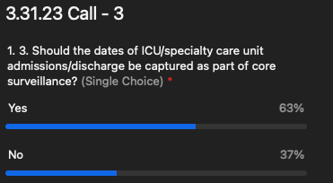

- Q4: Are the dates of ICU/special care unti admission/discharge appropriate for inclusion in routine case notifications to CDC?
  - This question was not polled, and assumptions will be made based on Q2 above.
- Q5: Are hospitalization admission and discharge dates appropriate for routine case notifications to CDC or are they core surveillance elements for jurisdictional use only
  - No pre-poll discussion was held for this question.
  - Results: 51 ppl responded
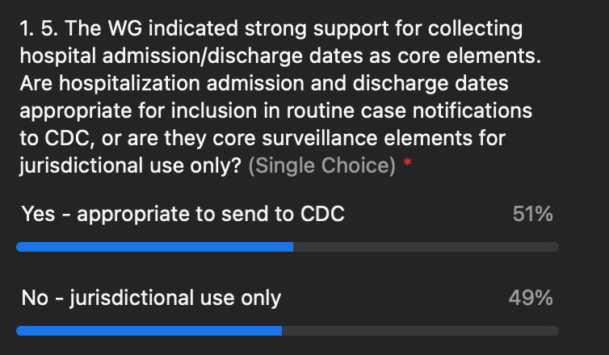
  - There was a post-poll discussion given the split results. The comments included,
    - When we are talking about core elements and asking follow-up with core surveillance, if it is core surveillance it means it is automatically available to CDC?
    - As the information is more identifiable data and likely not needed, also discharge dates are very hard to get.
- Next Month the DSWG will begin discussion of Travel Data
  - We expect to continue some of the conversation on Hospitalization but will also begin tackling travel
  - We will be putting together more information for the group to respond to and we understand there is more work to be done to define the core and what goes to CDC as part of routine surveillance.
Thanks for everyone’s input today!

