Meeting Title: | CSTE Data Standardization Workgroup Meeting
Date: | 8/25/2023
Attendees: 157 (orange text indicates presence at the meeting)
Co-Chairs | PHAs
Laura Erhart (AZ) | Aaron Ling (CA) | Emily Holodnick | Meg Schaeffer
Molly Crockett (MA) | Abigail Collingwood (UT) | Emily McGibbon (NYC) | Melanie Epstein-Corbin (CA)
CSTE | Adrienne Erlinger (MA) | Emily Roberts (UT) | Melissa Kealey (CA)
Annie Fine | Alex Cox (WA) | Emily Augustini (JMC) | Michael Bryan (GA)
Becky Lampkins | Alexa Ling (CA) | Erin Burdette | Michael From (GA)
Gillian Haney | Alexa Meinhardt (DE) | Genie Tang (CA) | Michael Eberhart (PA)
Janet Hamilton | Alexandra Gagner (Chicago) | Genny Grilli (MN) | Misty Johnson (WI)
Meredith Lichtenstein | Alicia Lepp (ND) | Graham Crawbuck (WADOH) | Mojisola Ojo (NJ)
Shaily Krishan | Allison LaPointe (MN) | Gwendolyn Gallagher (NM) | Molly Howell (ND)
Taylor Pinsent | Amanda Korth (NB) | Hailey Vest (IN) | Monique Birmiel (IN)
Erin Kough (JMC) | Amanda Payne | Hanna Chakoian (MN) | Morrow Toomey (AL)
Grace Mallard (JMC) | Amanda van Rest (NV) | Heather Crawford (OR) | Myron Lizak (NH)
Laura Lane (JMC) | Amita Worasilpchai (JMC) | Isaiah Francis (NM) | Nancy Jingyi Li (CA)
Samantha Spoto (JMC) | Amy Lai (AZ) | Jacki Griffin (BSDS) | Nancy Barrett (CT)
Susan Downer (JMC) | Amy Hyong (Riverside Univ) | Jeannie Woolston (ND) | Natalie Raketich (JMC)
CDC | Amy Bogucki (TN) | Jeff Van Ausdall (Shasta County) | Nedra Garrett
Abbey Wojno | Andy Tibbs (MDPH) | Jeff Swanson (TX) | Nereida Corral (CO)
Abhilasha Saxena | Andrea Perez (RUHS-PH) | Jenna Webb | Nicole Kikuchi (FL)
Alexandra Tuttle | Andrey Avakov (NH) | Jennifer Lockhart (AK) | Nicole Turvey (CO)
Allison Miller | Andria Apostolou (HIS) | Jennifer Otsubo (VT) | Nora Alrubaie
Alfonso Rodgriguez Lainz | Angela Herbert (NB) | Jessica Mawdsley (VA) | Paul Gillenwater (CO)
Angela Agunloye | Anita Valani (NC) | Jessica Romano (TX) | Peter Binoj
Anna Bratcher | Annalyse Bergman (AL) | Jill Krause (NB) | Rachel Abbey (ONC/HHS)
Ardath Grills | Annie Bergman (SD) | John Fosu (ND) | Rachel Corrado
Danielle Tack | Ashley Simmons (WV) | John Satre (IA) | Rachelle Boulton (UT)
Danielle Richard | Autumn Ward (KY) | Jordan McBride (NH) | Raid Mohaidat (VA)
David Huang | Becca Mickels (MO) | Joshua Bagley (GDIT) | Ramandeep Kaur
Delicia Carey | Benjamin Schram (ND) | Judie Huyn (MD) | Ravi Kafle (WA)
Erin Burdette | Benjamin Hornstein (AL) | Julia Aiken (CO) | Rebecca Fisher (LA County)
Erin Conners | Beth Isaac (NYC) | June Bancroft (OR) | Rebecca Jackson (CA)
Gonza Namulanda | Bill Morill | Justine Maxwell (TN) | Rendi Murphree (Mobile County)
Jane Yang | Brooke Beaulieu (APHL) | Kacey Ingalls (WA) | Robert Arciuolo
Kate Woodworth | Brooke Bregman (CA) | Kadeen Okumu Camerra | Roselyn Thalathara (NM)
Katie Fullerton | Caitlin Law | Karen Robinson (NJ) | Sai Kurmana (MS)
Katherine DeBord | Candace Noonan-Toly (NY) | Karen Wong | Seth Rothbard (WA)
Keaton Hughes | Carly Babcock (MD) | Karene Thomas-Watts (CO) | Shan Maxey
Kevin Lan | Carmela Smith (NM) | Kate Goodin (TN) | Shannon Lawrence (NE)
Kevin O’Laughlin | Charlene Adams | Katie Jones (VT) | Shaun Wilhelm (VA)
Keydra Oladapo | Charlotte Picard (IL) | Kathy Turner (ID) | Sheila Malone (Jackson State Univ)
Kimberly Mace | Christy Crowley (ND) | Katy Donovan (RI) | Sherri Davidson (AL)
Kristie Clarke | Cliff Mitchell (MD) | Keegan McCaffrey (CO) | Sophia Cantor (WA)
Kristin Delea | Collin Morris (WI) | Kelly Wallblay (Chicago) | Stella Tsai (NJ)
Laura Conn | Corina Chung (San Mateo) | Kiara Vicente (AL) | Stephanie Moburg (NM)
Laurie Barker | Corinne Davis (TN) | Kristen Merrell (MT) | Steve “Ike” Eichner (TX)
Lesliann Helmus | Cristin Larder (Ingham County) | Kyra Kofodimos (IN) | Suzanne Gibbons-Burgener
Logan Ray | Cristina Wolff (NB) | Lei Zhang (NV) | Tanner Turley (MO)
Loretta Foster | Crystal Snare (U of Washington) | Lindsay Horn (WA) | Tiffany Firestone (WA)
Luis Hernandez | Danica Kuncio (Philly) | Lina Saintus (NC) | Tiffany Smith (NV)
Marion Rice | Danny Power (MT) | Liu Yang (MS) | Tracy Miller (ND)
Madeline Stewart | Desiree Mustaquim | Luke Dalton (MI) | Trevor Maness (TX)
Megan Swanson | Dianna Hergott (WA) | Madison Wierzel | Tye Harlow (CO)
Melinda Thomas | Dimple Patel (KY) | Mara Larson (NC) | Vanessa Phuong (WA)
Melissa Pagaoa | Doris McGinness | Marijoyce Naguit (CA) | Vajeera Dorabawila (NY)
Michael Radwin | Ed Hartwick (MI) | Mario Beltran (MI) | Yi Du (NE)
Michelle Hoover | Eden Dietle (MO) | Mary Kate Martelon (MA)
Michelle Lin | Elizabeth Lando-King (MN) | Mary McNeill (OH)
Myrna Gonzalez-Montalvo | Elizabeth Schiffman (MN) | Mary-Margaret Fill (TN)
Nicole Lindsey | Ellen (EJ) Klingler (NYC) | Megan Crutchfield (ID)
Nicolette Bestul | Eman Addish (Philly)
Nikolay Lipskiy
Noreen Kloc
Peter Boersma | Guest Participants
Ruth Jajosky | Chris P | Dene’ Hall (MO) | Stephanie Pocius (UT)
Sandi Bulens | Jill Diesel | Sue Soliva (MA) | Rosanna Ortiz
Sandy Price | Claire Stump | Jessica Leung (CDC) | Ashley Bergeron (CSTE)
Sandy Roush | Marcia Goldoft | Simi Sowunmi (CDPH) | Paul Creswell (WI)
Sara Johnston | Kristen Ojo (MN) | Jerusha Barton | Yolande Moore
Stacy Marovich | Myrna del Mar Gonzalez (CA) | Erin Miller (CDC) | Devra Barter (CSTE)
Sonya Zhan | Juli Carlos-Henderson | Tia Falzarano | Jim Kent (MI)
Sundak Ganesan | DKhan | Caleb Lyu (LACDPH) | Kate McCoy
Sydney Adams | Alida Gertz | Bianca Perri | Joseph Paulini (Chexout)
Teresa Jue | Diba | Michael Brindamour | Li Kuang (NJ)
Umed Anji | Nancy Rose Senich | Alli Ertl | Jianning Luo
Yvette Dominique | Maddie Sankaran | Anne Straily | Cheryl Broussard (CDC)
Zuzana Love | RHenness (NYC) | Jamie Tappe (CDC) | Michael Pietrowski
 | Emily Waterman (Philadelphia) | Robin Hennessy (NYC) | Hazel Shah
 | Luis Vela (ID) | Shelby Lyons | Courtney Marshall (KY)
 | Hannah Guzzi (AK) | Bridget Teevan (CSTE) | Lindsey Webb
 | Anna Ostberg | Julie Lazaroff | Shawn Arshad (GDIT)
 | Arrie Morris (AR) | April Rideout | Meghan Lyman
 | Nikki Sigalo | Amanda Jones (CDC)
*Some individuals dialed in, and their names are unknown
High-Level Meeting Notes (refer to meeting slides for more detail as needed):
CSTE Data Standardization Workgroup Meeting (Co-Chair, Laura Erhart)
Meeting Ground Rules
- We welcome everyone's opinions and active participation from jurisdictions, CDC programs, CSTE membership, etc.
- As we work through data elements/classes, we strive for 80/20 consensus.
Core Data: In Scope for DSWG
- What we're most specifically doing for these meetings is identifying those core data elements for surveillance that we will look for transmission to the CDC.
- We are looking at the core overall, focusing on case surveillance, situational awareness, or routine surveillance but going across many conditions.
- The data elements we discuss don't have to be relevant for all conditions but should also not be something that's just in one or two specific places.
- We're looking at case-based surveillance again, so it's not syndromic, not aggregate reporting.
- As we go, we'll look at specific selected data classes. And again, the scope is identifying those common definitions, value sets, code sets, structure, and some interpretation notes.
- For the core data elements and where applicable, we will recommend some best practices on what we may need to collect within our surveillance systems.
Status update: Hospitalization and Travel
- For hospitalization, we are finalizing a draft of those recommendations, which should be coming out the last week of August.
- With the hospitalization draft document, a survey will be shared to collect feedback.
- We’re looking forward to your feedback and hearing from you!
- The draft of the travel document is still being worked on, and we will send it out in the same way when it’s ready for feedback.

DSWG Opportunities for Participation (Co-Chair, Laura Erhart)
Data Element-Specific Teams
- Everyone here is part of the DSWG and will continue to be part of that larger work group.
- We will break up each element into teams to better leverage DSWG members' expertise.
- Each team will focus on a pre-identified topic.
- We are encouraging all programs and agencies to participate from local to federal levels.
Data Element-Specific Teams (continued)
- If you join a team, you are expected to actively participate during and between meetings, including polling, providing input to draft documents, in-meeting discussion, and attending quarterly DSWG meetings.
- Data Element-Specific teams will be held monthly.
- Data element-specific teams will provide feedback on how your jurisdiction or program collects and uses the information related to that data element.
- Individuals are not expected to write documents, lead meetings, or prepare slides.
Team Topics
- We will send an interest survey next week; please submit interest if you want to join!
- First topics include Pregnancy, Industry and Occupation, and Sexual Orientation and Gender Identity (SOGI)
- Once the pregnancy team wraps up, industry and occupation will be next.
- Tracks will occur concurrently, but meetings will not occur simultaneously to allow people to participate in both topics as desired.
- Once recommendation documents are finalized, the topic will be sunset, and another will begin, and we’ll continue to repeat this process.
- There are approximately 15 topics slated for these teams.
- Determination for team membership is an opt-in survey that will be sent out next week.
DSWG
- The larger DSWG membership will convene quarterly, and the next meeting will be in early December; this group is not being dissolved.
- This broader group will continue to be a forum for input from the wider group. The information from the data element-specific teams will be brought to the broader DSWG for consideration, discussion, and input.
- Responsibilities in this broader work group haven't changed. So, attend the meetings as you're able.
- As always, please feel free to share our meeting information invites with colleagues so we can continue to work to get the right people to the discussion.
- The next quarterly meeting will occur at the beginning of December.

Discussion:
- Kate McCoy (chat): Hello! I'm with Occupational Health Surveillance (WI). Do you already have connections with the CSTE Occupational Health Subcommittee re: the Industry/Occupation group? I didn't see any of those names in the participant list today but may have missed them.
  - Gillian Haney (chat): we will be making announcements within the CSTE community- and yes, will be reaching out specifically to the Occ Health group!
  - Kate McCoy (chat): Excellent! Thanks, Gillian. I'm co-chair with Ken Rosenman of the Occ Health subcommittee. Looking forward to learning more! This is an exciting development. Email: katherinee.mccoy@dhs.wi.gov.
  - Kevin Lan (chat): sounds good, I was going to ask this as well. I’m new to NIOSH and needing to connect as well. Thanks Gillian.
- Gillian Haney: Important that CDC and jurisdictions participate in this process. We will be working with CDC in the upcoming weeks to get implementation strategies and plans. Once this workgroup has vetted data elements there will be additional processes at CSTE and likely CDC to socialize this and hopefully gain more engagement. We are working on this actively and will be shared as soon as we have this plan in place. I just wanted to add that so more to come on that but just wanted to make sure that people are aware about the importance of the work that's going to be accomplished here.
- Julie Lazaroff (chat): Have data standards for Race/Ethnicity already been finalized?
  - Laura Lane (chat) Hi Julie- No, those have not been addressed yet. During the interest survey process for these teams, we hope to share the data elements/classes that will be upcoming!
  - Gillian Haney (chat): To date, the DSWG has worked on key dates of PH importance, a case counting date, travel, and hospitalizations.
  - Laura Erhart (chat): We also want to make sure we align with the changes coming from OMB, so it will be valuable for that work to be finalized.
  - Gillian Haney (chat): excellent point Laura!

Pregnancy (CDC) (Danielle Tack, CDC)
Potential data elements related to pregnancy
- I’m Danielle Tack; I work within the CDC at the Office of Public Health. Data surveillance and technology, as an acting branch chief over public health data transmission, have been helping support some of the background as we look at standards.
- Across various information health information technology work groups and. The message mapping guides for what has been asked by the CDC. So first, as you can see, there's a lot when we look at pregnancy.
- What I wanted to show here is so that people can see the scope and talk a little bit about the nuances, or we can start to see the trends as potentially common. Moving from health care through the requests from CDC programs for helping understand the role of infectious disease in our pregnant population. So first, the bold pregnancy status has been that common data element that has been asked for.
- However, we recognize that status comes with other nuances that have been important depending on the condition. Often during responses or even for various conditions or public health actions.
Background Information: Pregnancy
U.S. Core Data for Interoperability (USCDI)
- Starting with USCDI, we have pregnancy status again as we saw that was the one that's been at least common in many of our data requests, at least from CDC and potentially through the pipeline since then.
- It is in version 3, so there is some level of expectation, potentially, as they start to work through a new policy. And regulatory items to this to be more consistent and available across our electronic health records. Additionally, you will see for those who are not as familiar with the levels in USCDI, it has to do with the level of standardization across systems and in practice, primarily within health care.
- Level 2 means there's a high level of agreement and use already out there.
- Level one usually means that it's a mixed agreement and that there's interest.
- Level 0 usually means an interest in this concept, but the work needs to be done, and documentation needs to be created.
- With that, the last menstrual period and gestational age are coming up at the level 2 evidence. So, from a USCDI perspective, these are the top ones that have been somewhat well-standardized.
U.S. Core Data for Interoperability (USCDI) continued
- Hopefully, you all can see some of the nuances and, when available, maybe some value set items, but I’m not going to go through each of these data elements.
Health Level 7 (HL7)
- Health level 7 is more generic, basically version 2, commonly used for our ELR and in the case of vacation for MMGs, but is also used broadly within the system landscape.
- Generally, as most have known, ELR is not commonly used for recording pregnancy-related information because there's no established field. During COVID, this was of interest, particularly because of the amount of lab data where we were trying to get some of that additional case information within our lab data. Such that it was added as an ask on order entry.
- It's an open text field, which leads to less-than-optimal data.
Electronic Case Reporting (eCR)
- With FHIR, we're looking at the initial electronic case reports and a pregnancy section.
- It is considered an optional field, so it is not expected to be reported.
- Using the US Public Health pregnancy status observation profile is also optional.
- This is the kind of Information we would like to have, and it can represent a current pregnancy and a pregnancy history.
- Outcome, which becomes very important, particularly if we're trying to look at what the condition is and if there's an adverse outcome to this pregnancy. So that's also built in there.
- And then, another observation related to the last menstrual period, which, of course, plays to status and estimated delivery dates in some cases.
Electronic Case Reporting (eCR) continued
- CDA is a pregnancy table again using the ECR lens.
- It is very similar to FHIR but with a slightly different build. Again, it is an optional section, but if they are providing it, they should use the pregnancy observation templates.
- You'll see a similar alignment. However, some templates are broken out versus messing, as you might see in FIHR, which has more to do with an alignment with the format.
Prior work on pregnancy
- Now we’ll talk about work groups and what people have done where we’ve talked through some of these standards, where recommendations have come from, and how they may have evolved.
- Some of this work started back in 2017 and was driven by what happened with Zika, with how much impact it had on a pregnant population with our high-risk population.
- From this task force, one of the biggest things they promoted was the expanded use of ELR for those who ask on order entries, which we saw leveraged during COVID-19.
- It also identified various mechanisms related to how we might move electronic case reporting forward.
- Some of where we are is a natural progression from these work groups.
- What is most interesting is specifically within that public health landscape, such as estimated delivery date and gestational age, which could be an alternative to delivery date. So again, it's not necessarily that you need to go with both, but one of these is informative and plays a similar role in understanding the data.
- Again, we see this outcome and related outcome dates to connect those current pregnancies versus what we might follow up on.
Prior work on pregnancy (continued)
- There was also in 2019, and started to broaden this.
- Work where there are specific data elements to really push through, called data harmonization as a surface.
- The focus was on pregnancy status for emergency response. And again, this was building on Zika, trying to kind across the case data ecosystem.
- There were seven idea elements identified as critical.
Prior work on pregnancy (continued)
- In 2020, work was taken from the division of birth defects to examine core variables for pregnancy and infant surveillance.
- They started to look at how healthcare partners are bringing in that information to align better, especially if we need a look at longitudinal data.
- They picked two-time points for data collection. One was maternal health history. Collected in that prenatal visit kind of focus.
- Additional recurrent themes emerged with the last menstrual period, estimated data delivery, and how that was determined.
- Pregnancy outcome again getting more at the neonatal assessment at delivery, including the pregnancy outcome. And then data delivery and the gestational age at delivery to capture if we have a live birth but they are premature.
Prior work on pregnancy (continued)
- Finally, the most recent workgroup, and for some of you who may have participated in yesterday's presentation, is the 2023 CSTE pregnancy status working group.
- It was formed to identify methods to improve capture pregnancy status, and again, it focused on COVID-19 and some of the lessons learned.
- They have provided some sample administrative codes and language for reportable conditions to aid pregnancy reporting. This included a minimum pregnancy status and estimated delivery date.
- It affirms some of the best practices for ELR.
- It also shared background difficulties, best practices, and available resources for that electronic case report and did make some recommendations on pregnancy observation, including possible pregnancy, not pregnant, and unknown.
Case Notifications to CDC: Message Mapping Guides (MMGs)
- So, how does this align with what CDC has been asking for? Primarily through the use of the message mapping guides.
- Again, we have pregnancy status, which tends to be common across the board.
- Some of these additional data elements are listed specifically where we have eyes on and have tried to work through case report forms
Case Notifications to CDC: Message Mapping Guides (MMGs) continued
- The blue indicates alignment between some of these work groups and see what's about to come out of other work groups.
- Not included is what I call a one-off, so there was one guide that had an additional question, and most of them with some level of additional specificity to make sure that they potentially were getting the information as intended or aligning with a specific condition.
- You can use the Excel spreadsheet to dig into specific linkages and resources.
Discussion:
- Annie Fine (chat): The key issue with birthweight is the ability to link mother and baby records since birthweight needs to refer to the infant, not to the mom
  - Melanie Epstein-Corbin (chat): We were recently looking into this within eICR for congenital syphilis and unfortunately, there was little to no mother information to link the case to the mother.
    - Annie Fine (chat): Agree and it is a tough issue!! But one which we could push the health care community on through requesting it in USCDI or USCDI+ (1- exclamation point)
      - Annie Fine (chat): A linking variable (1-thumbs up)
- June Bancroft (chat): This is not recommended for all Cases but just specific diseases? We collect this for only a handful of conditions - hep b, zika, listeria - and we do not get all these details
  - Annie Fine (chat): These data elements are meant to cross the diseases for which pregnancy is relevant. They would not need to be populated for ALL diseases. But these consensus data elements would need to be able to be captured and exchanged for the relevant diseases and for any new disease for which it was relevant. Something like stillbirth indicator would be captured by a generic pregnancy outcome variable.

Pregnancy – For Discussion (Co-Chair, Molly Crockett)
- A couple of reminders: We're discussing core data elements. Elements that really should generally be in there. They're generally information we would want to send to CDC for most diseases, most of the time. We acknowledge that for certain conditions, there is going to be additional information that's going to have to be gathered to a much different level of detail that may or may not be going to the CDC, but that is outside of the scope for today's discussion.
- The other reminder is that as we move into this new structure with the two tracks, the teams working on the different data elements, what we're going to try to do today is get through some initial discussion and some polling, get started, and then will be punting some of this discussion to the team. They'll take the work from today and move forward with that. So, we won't get into as deep a discussion as we might like.
Potential Core Data Elements
- We are proposing these elements as a group that makes sense as core.
- There will be three poll questions and enough information for the pregnancy team to kick off.
- We are considering elements that have come up frequently in other working groups and MMGs.
- This is being collected for the pregnant patient, not the infant.
- Think about what can be captured and what we might be able to get from ELR and eCR.
Potential Core Data Elements continued
- These are data elements that would be used for situational awareness. They should be commonly necessary.
- Pregnancy status is widely available in the NDSS system; it's a yes, no, or unknown.
- The time of the event might need to be more specific.
- There are conditions for which this is irrelevant, pregnancy doesn't come into play, or specific follow-up isn't done.
- We know we're not always getting in ECR, and ELR is questionable.
- Note the value set is different from ELR, ECR, which is pregnant, not pregnant, possibly pregnant, and unknown, whereas in NNDSS and MMGs have this as yes, no unknown.
- Estimated date of delivery: In the current guides, gestational weeks of gestation at the time of the event are more commonly captured. However, that does require it to be specific relative to a date. It's sent as an actual date, which is the estimated date of delivery, which is why that's what's included here. We know it's a little bit of a switch from NNDSS, but it cuts down on other information that needs to accompany it to be meaningful.
- Pregnancy outcome: Again, remember this is for the pregnant person’s events, so this would be the outcome of their pregnancy. The value sets for this one are all over the place and seem to be condition-specific depending on what some of the concerns are. It's not in the Current eCR that's out there, but it is included as we move into the eCR version 3.1.
Pregnancy Status Value Set
- This is one potential value set for public health, which is, yes, no, unknown, as we mentioned.
- SNOMED, let's use clinically as possible pregnancy, not pregnant, pregnant, and unknown. There are other potential answers here, but these are sort of the two values that we looked at, and we are stuck with what is in the message mapping guides now; that is something that we hope to get feedback on in the polling question.
Potential Core Data Elements
- Getting a little bit more information about the questions we're going to be touching on and how they may be presented as they come out of this workgroup would be, is this something directly pulled from either case investigation, ECR, ELR? Or is this information from multiple angles, using multiple pieces of information?
Polling process
- A reminder on the polling process: the questions will be shown first in case any clarification or questions are needed.
- The questions are mostly yes/no. Or, I think in this case, we’re trying to clarify whether the data element is good as proposed or the data elements are good, but the wording needs some thought or work.
- If the split is huge, we can discuss if there is time.

Pregnancy Polling Question 1: Pregnancy Data Elements
- Is pregnancy status a core data element, as defined in the table below? (Reference slide as needed)
- Remember this is data jurisdictions would be sent to the CDC and would need to collect more information in their systems for case investigations.
- This information will be used to pass on to the Pregnancy data team for them to use for discussion.
- Poll 1 Results
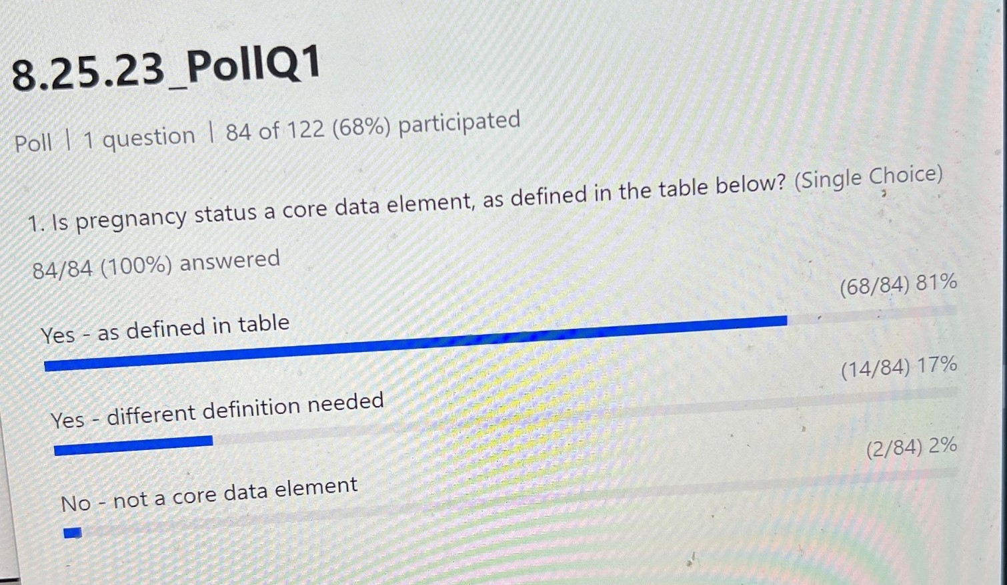
- Given the results, we are confident that this will be recommended for inclusion.
Pregnancy Polling Question 2: Estimated Date of Delivery
- Should the estimated data of delivery be a core data element across conditions for transmission to CDC?
- Poll 2 Results
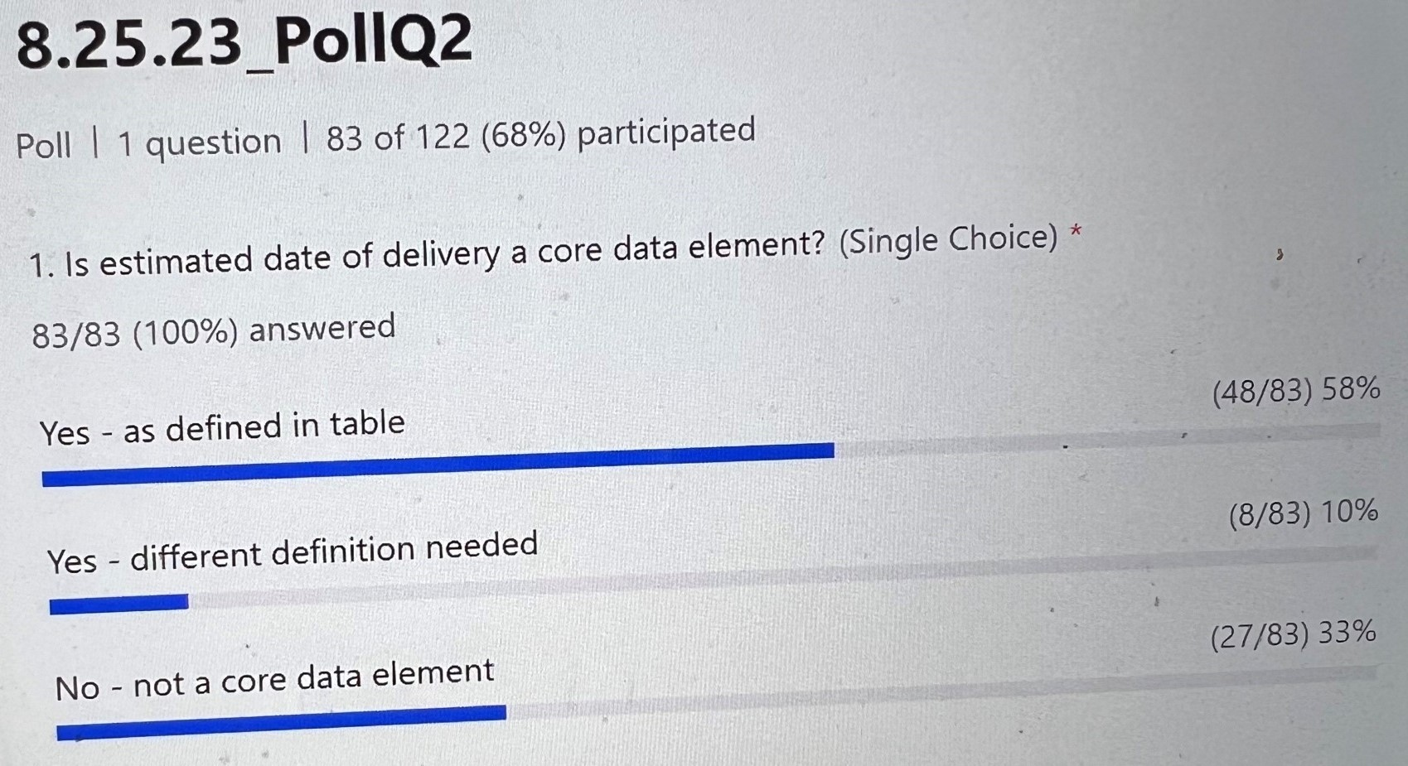
- There is more of a split in these results, but it appears to be important as a core data element, but the definition might need some work.
- If you feel passionate about this, please participate in that workgroup!
Pregnancy Outcome Value Sets – Bug or Feature
- Pregnancy outcome value sets are all over the map, so thinking again about core data elements, do you believe that pregnancy outcome is necessary as a core data element? Here, let's focus on if the case was pregnant at the time of the event and the outcome of that pregnancy.
Pregnancy Polling Question 3:
- Should the pregnancy outcome data element be considered part of core surveillance?
- Poll 3 results
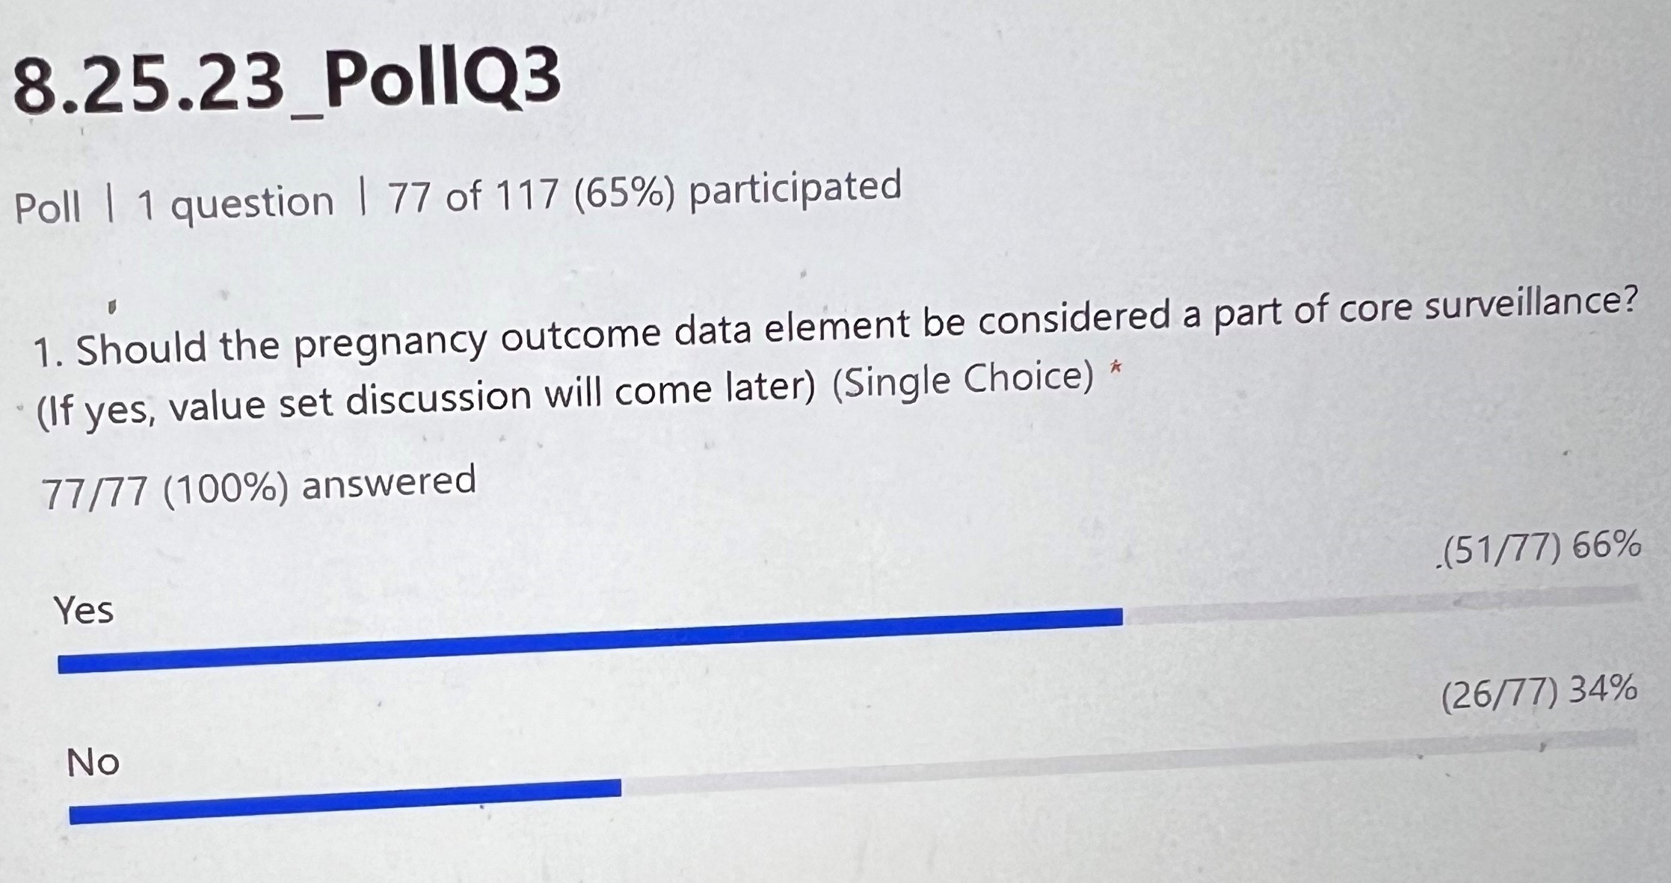
- Results are not as clear-cut as the pregnancy status.
- We’ll stop here to entice members to join the pregnancy team and appreciate everyone participating in the polls!
Discussion:
- Jerusha Barton (chat): In GA, we have a very tough time getting EDD, even in the medical record itself. Gestational age is a much more reliable variable to inform preterm birth and other adverse outcomes.
- Annie Fine (chat): Would the pregnancy status core variable include a date pregnancy status was recorded? Seems important to go with it
- Julie Lazaroff (chat): dates associated with pregnancy status and pregnancy outcome are critical. Gestational age also needs a date associated with it. If there is a single Pregnancy Status field, I think an option for the concept of 'Post-partum/Recently Delivered within the past x number of months'. If the patient already delivered, and Pregnancy Status is answered as 'No' and the report might not be received by the appropriate surveillance team that works on congenital or perinatal infections which needs post-partum reports. (5-thumbs up)
- Nicole Lindsey (chat): Agree about dates being needed. Wonder if there would be use in accepting either EDD or LMP
- Annie Fine (chat): Remember that this refers to data being sent TO cdc not from health care. Might need to be derived not abstracted - like if you know lmp.
- Julie Lazaroff (chat): Following poll #2. I chose not a core data element, because it only applies to diseases related pregnant/post-partum patients. But, it is a core data element for the latter. So, this poll is confusing. (1-thumbs up)
  - Annie Fine (chat): This conversation is pertaining to diseases for which pregnancy is relevant (1- thumbs up)
  - Julie Lazaroff (chat): Oh, that wasn't clear
- Sherri Davidson (chat): Would not know outcome at the time pregnant = yes (6- thumbs up)
  - Annie Fine (chat): One of the options can be still pregnant (1- thumbs up)
- Danielle Tack (chat): Using Zika as an example, do we always know if pregnancy is relevant?? There are traditional conditions, but one could argue that there could be a shift. MPOX showed us this with transmission patterns...could it have been detected sooner with a common question? (1- thumbs up)
  - Danielle Tack: My argument/question... Is pregnancy ever not relevant? (4- thumbs up)
- Steve Eichert: I want to raise a question quickly as we think about data standards. The USCDI version 6, with the due dates for material Coming up in September or October, is a pretty short turnaround. Is that a concern or something we’re keeping our eyes on? ONC released USCDI version 3 as a tool to be supported by vendors, so we’re looking at a year and a half to two years before the document is finalized for document specification.
  - Molly: That is a good point to consider.
- Diba (chat): will we get these slides in email?
  - Laura Erhart (chat): Yes, along with notes (2-thumbs up)
- June Bancroft (chat): Not sure why CDC needs pregnancy details? We collect it for case management.

Next Steps
- Look for a link to sign up for the data specific teams and indicate your areas of interest.
- Hospitalization draft will go out next week for input.
- Our next call will occur at the beginning of December,

