DRAFT ERHMS CSTE Template

- Overview of the Emergency Responder Health Monitoring and Surveillance (ERHMS™) System
Due in large part to the demonstrated need to better protect, equip, and promote the health and safety of emergency responders during previous emergency events, including the World Trade Center and 9/11 attacks and Hurricanes Katrina and Rita, the National Institute for Occupational Safety and Health (NIOSH) collaborated with federal agencies, state health departments, and unions to create the Emergency Responder Health Monitoring and Surveillance (ERHMSTM) System. ERHMSTM is a framework that allows an organization to monitor the health and safety of emergency responders throughout the pre-deployment, deployment, and post-deployment phases of a response. The goal of ERHMSTM is to prevent short-term and long-term illness and injury in emergency responders and to ensure workers can respond safely and effectively to future emergencies.
ERHMSTM aims to ensure specific activities to protect the health and safety of emergency response and recovery workers are conducted during each of the three phases of a response (Figure 1). During the pre-deployment phase, organizations should ensure workers are properly rostered, credentialed and trained, fit for duty, and can store this information in a secure manner. During the deployment phase, health monitoring and surveillance should be conducted while workers perform their job tasks to ensure the prompt identification of potential exposures, and so that appropriate corrective measures are taken to eliminate further exposure. This includes making sure workers have access to potable water, safe food, and secure housing. During the post-deployment phase, workers should be properly demobilized and it should be determined if long-term tracking is needed. After action meetings should be conducted and lessons learned documented in order to continually improve future responses.

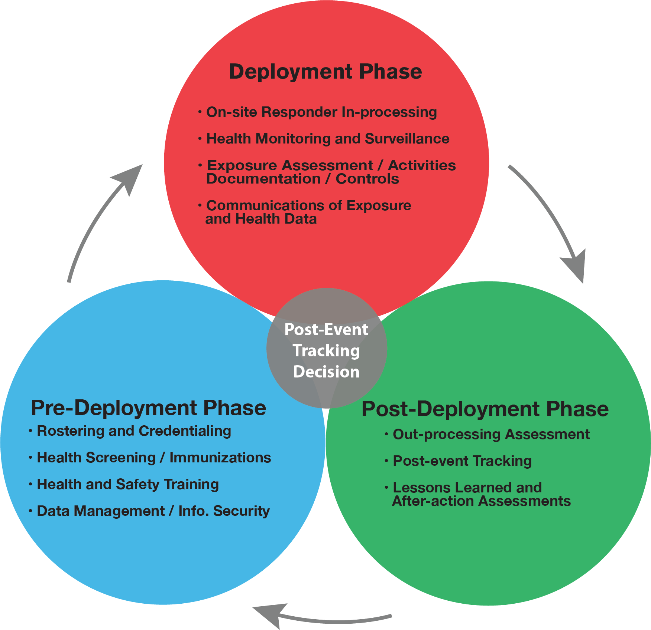
Figure 1: [Three Phases of ERHMSTM] (Attached)
Figure 1 Alt Text: [This diagram illustrates the three phases of ERHMSTM. The first phase is the Pre-Deployment Phase, which includes, rostering and credentialing; health screening and immunizations; health and safety training; data management and information security. The second phase is the Deployment Phase, which includes, on-site responder in-processing; health monitoring and surveillance; exposure assessment, activities documentation, and controls; communications of exposure and health data. The third phase is the Post-Deployment Phase, which includes, out-processing assessment; post-event tracking; lessons learned and after action assessments. The goal of ERHMSTM is to determine if long term tracking of responders is needed. This is shown by the center circle stating Post-Event Tracking Decision.]
NIOSH has led the effort to test ERHMS™ in a large-scale response. As a result of the Deepwater Horizon (DWH) disaster oil rig on April 20, 2010 resulting in 11 worker deaths and 17 worker injuries, NIOSH staff incorporated the ERHMS™ framework primarily by rostering all workers at the event and conducting health surveillance of workers during the pre-deployment phase and deployment phase of the response. NIOSH staff were able to manually roster over 55,000 workers working in three different states (AL, MS, and FL). NIOSH also analyzed and prepared reports of injury and illness data occurring among DWH responders in all locations.
As a result of these activities, NIOSH collected many lessons learned that included:
- Begin worker onsite rostering immediately and integrate it into response activities as soon as possible to ensure all workers have the opportunity to participate
- Have a ready to use roster form prepared that can be quickly adapted and cleared
- Direct the rostering program through the incident/unified command
- Explore the feasibility of incorporating rostering into existing response programs to improve efficiency
- Develop mechanisms to encourage and facilitate employer participation
- Maximum advantage should be taken of existing data streams that could be used for health surveillance of response workers during the response
- Federal, state and local agencies should give consideration to the development of standardized instruments for baseline occupational surveillance and post-event occupational data collection and analysis that could be easily adapted to specific events and used by various organizations
- Improved occupational injury and illness surveillance may be achieved through enhanced integration and coordination with other surveillance activities at the HHS/CDC and other agencies

- Examples of ERHMS™ Implementation
There is evidence that ERHMSTM can be implemented by organizations. For example, during the 2014 Ebola outbreak, NIOSH assisted the Centers for Disease Control and Prevention (CDC) with expanding their “Responder Readiness” program by implementing the ERHMSTM Framework into their response structure. Specifically, a pre-deployment coordinator position was established to work with responders before they deployed to ensure they met all of the health requirements and were properly trained. Several NIOSH staff served as safety officers in affected countries in order to conduct health and safety monitoring of staff during the deployment phase. Finally, a post-deployment coordinator was created in order to determine if any long-term monitoring should be conducted, including any mental health needs.
In 2016 as Hurricane Matthew was fast approaching, the Georgia Department of Public Health (GA DPH) adapted their existing Responder Safety, Tracking, and Resilience (R-STAR) system to incorporate ERHMSTM. GA DPH staff sent out surveys to responders to self-register their deployment activities and to complete a health and safety check. According to Funk (2017), feedback from participants indicated responders valued someone checking in on them during their deployment and supervisors could verify their responders were accounted for and unharmed. By incorporating ERHMSTM, the GA DPH would be able to meet capability 14 (Responder Safety and Health) as part of their CDC Public Health Emergency Preparedness (PHEP) cooperative agreement (CDC 2011). Any state receiving this funding can implement ERHMSTM as a way to complete tasks in capability 14 or 15 (Volunteer Management).
As a result of NIOSH staff providing ERHMS™ training at the West Virginia University in March of 2016, the Mongolia County Health Department was able to implement ERHMS™ during a multi-agency, statewide emergency drill, Operation Dawson Storm. The drill was conducted in July 2016 in Morgantown, WV with military, first responders, law enforcement and public health officials and focused on potential exposure to a radiological source. The health department focused on conducting health monitoring of first responders prior to the drill and after the drill and developed pre- and post-drill questionnaires. Data was obtained from 52 responders pre-drill and 33 responders post-drill.
- Tools and Resources
Resources and tools have been developed to assist organizations with implementing ERHMSTM during each of the response phases and include: free training both in-person and online and ERHMS Info ManagerTM software, user manual, and training videos (see below for specific links to the relevant online resources). Thus far, training has been conducted a total of nine health departments and 317 public health professionals were trained in NY, LA, VA, VT, NE, IL, KY, AZ, and GA from 2013-2016. This training was made possible by a successful CDC funding proposal in partnership with NIOSH, the Agency for Toxic Substances and Disease Registry’s (ATSDR) Assessment of Chemical Exposures (ACE) program (https://www.atsdr.cdc.gov/ntsip/ace.html) and the CDC’s Community Assessment for Public Health Emergency Response (CASPER) program https://www.cdc.gov/nceh/hsb/disaster/casper/training.htm).
In 2017, NIOSH staff was also able to train the following organizations per their request: the West Virginia Bureau for Public Health along with local public health staff at the West Virginia University in Morgantown, WV, Oregon Medical Reserve Corps unit in Portland, OR and at the professional development course (PDC) at the Tennessee Valley Section American Industrial Hygiene Association in Knoxville, Tennessee. More than 200 public health professionals were trained at these locations.
The guidance for how to implement these activities and specific tools that can be utilized during each phase of the response can be found in the National Response Team Technical Assistance Document (NRT 2012). In order to increase an organizations’ ability to implement and adopt ERHMSTM, NIOSH has recently developed ERHMS Info ManagerTM, a free custom-built software product that uses Epi InfoTM for all calculations and analyses. This product allows for the collection of data as outlined in ERHMSTM throughout all three phases of a response. For example, ERHMS Info ManagerTM will allow users to manage staff readiness by collecting information on rostering, training, and medical screening thus improving the organizations’ preparedness prior to an emergency. NIOSH has also developed a user’s manual and training videos to accompany the software and has partnered with Epi InfoTM to ensure technical support is available to all users. In addition, NIOSH has free training on ERHMSTM available online and by request in-person. Continuing education credits are available for these trainings.
Specific Resources:
National Institute for Occupational Safety and Health. (2011). Lessons Learned from the
Deepwater Horizon Response (DHHS (NIOSH) Publication No. 2012-117). Cincinnati, OH: U.S. Government Printing Office.
National Response Team. (2012). Emergency Responder Health Monitoring and Surveillance
Technical Assistance Document. Retrieved from https://www.nrt.org/sites/2/files/ERHMS_Final_060512.pdf
- Visit NIOSH ERHMSTM Topic Page website: https://www.cdc.gov/niosh/erhms/
  - ERHMSTM training opportunities
  - Access software, user manual, and training videos
- Email us: erhmsonline@cdc.gov
  - Request in-person ERHMSTM training
  - Ask questions about the program
Additional References:
Centers for Disease Control and Prevention. (2011). Public Health Preparedness Capabilities:
National Standards for State and Local Planning. Retrieved from
https://www.cdc.gov/phpr/readiness/00_docs/DSLR_capabilities_July.pdf

Funk, R. (2017). Responder Safety. Horney J. Editor, Disaster Epidemiology: Methods and
Applications, 1st Edition. Salt Lake City, UT: Academic Press

