Syndromic surveillance and disaster epidemiology
New York City Mini-Case Study:
Asthma surveillance following unexpected building collapses and fires

Smoke and dust from building fires and/or collapses of buildings are potentially hazardous to health [1,2]. Air pollution, including fine particulate matter (PM2.5), is known to exacerbate asthma conditions [3] and past studies have reported short-term associations between air pollution and asthma emergency department (ED) visits in New York City (NYC) and other cities [4,5].
The NYC Department of Health and Mental Hygiene’s (DOHMH) Bureau of Environmental Surveillance and Policy, in collaboration with the Bureau of Communicable Disease’s syndromic surveillance unit, conduct syndromic surveillance to inform situational awareness and support public messaging and response. We assessed potential respiratory health impacts following the collapse of two buildings (caused by a gas leak) in 2014, a 7-alarm fire and collapse of 3 buildings following a gas leak in 2015, as well as several large warehouse fires in 2014 and 2015.
Our analyses were conducted within days after the incidents occurred because we were able to utilize existing syndromic surveillance infrastructure [6]. Since 2002, DOHMH’s syndromic surveillance unit has collected daily data on ED visits. Syndromes to describe several major illness categories, including asthma, have been developed over the years. We also have a protocol in place, approved by the agency’s Institutional Review Board, which covers the surveillance methods and data.
We built times series models of daily asthma ED visits to determine whether there were increases in asthma visits as a result of the disasters (See Figure 1 below for an example from the 2015 East Village Fire). Asthma ED visits in NYC have strong seasonal (e.g., pollen impacts in the spring and school-opening related viral infection in the fall) and day-of-week patterns. Therefore, we first built a simple over-dispersed Poisson model with day-of-week and smooth functions (natural cubic splines) of day-of-year and year for the citywide asthma ED visits syndrome. The regression model was built on the past years’ data (e.g., 2002-2014 for the 2015 event) and predictions were made for about one month prior to and up to 10 days after the event. Because the syndromic data includes the residential zip code for each ED visit, we were also able to repeat the process for the “affected” zip codes and the rest of the city, with each area’s prior years’ data to build the models.
For all the fire and building collapse incidents, our models indicated that there was no increase in asthma ED visits citywide or in the affected areas. We found that the observed asthma ED visits for the day of the events and several days afterwards were within the prediction intervals of the model.
Our surveillance findings were shared with DOHMH agency leadership. For the 2015 building collapse, city leadership was able to respond to questions from the press regarding health impacts of local air quality. However, through this and other ad-hoc analyses of asthma ED visits syndrome data after fire/building collapse events, we also identified several limitations of the methods that need further improvement: (1) difficulty in defining an “affected area” due to the lack of spatially- and temporally-resolved near realtime exposure data; (2) larger prediction confidence bands due to smaller ED visits of sub-areas; (3) challenge in assessing the impacts of disaster events when they occur during strong seasonal peaks such as spring pollen and fall viral infection periods - the past events did not happen during these periods, but they might in the future.
To address these limitations and to better prepare for future disaster events, we are developing a routine asthma ED visits syndrome prediction models that will incorporate weather and air pollution data as predictors and with better estimation of the spring and fall peak impacts.

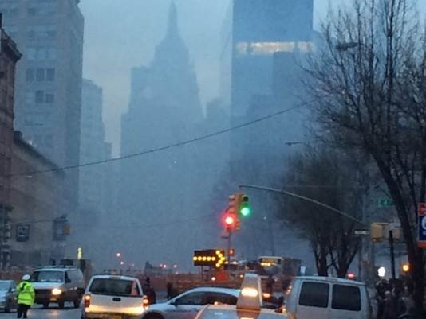
Figure 1. Neighborhood impacted during 2015 East Village Fire taken during response in New York City. Photo credit: Kazuhiko Ito.

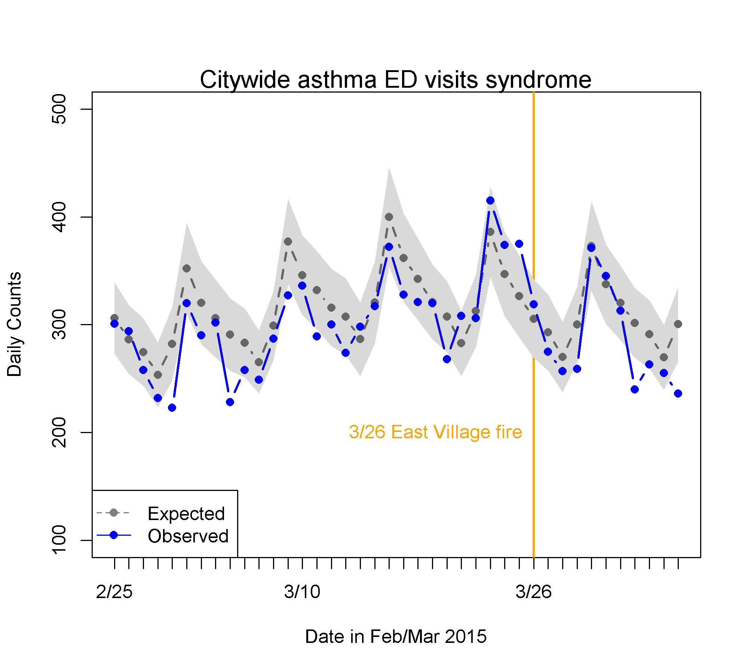

Figure 2. Figure produced during the 2015 East Village Fire response.
Y-axis: Daily counts of asthma emergency department (ED) visits syndrome for all city ZIP codes of residence. X-axis: Dates in late February through early April, 2015. Orange vertical line: The date of fire, March 26, 2015. Blue line: Observed asthma ED visits syndrome. Gray dotted line: Predicted asthma ED visits syndrome from day-of-week, day of year, and long-term trend. Gray shade: Estimated 95% confidence bands of daily predicted values.

Citations for Case Study 2
[1] Stefanidou, M., Athanaselis, S., & Spiliopoulou, C. (2008). Health impacts of fire smoke inhalation. Inhalation Toxicology, 20(8), 761-6.
[2] Centers for Disease Control and Prevention (CDC). (2003). Potential exposures to airborne and settled surface dust in residential areas of lower Manhattan following the collapse of the World Trade Center--New York City, November 4-December 11, 2001. Morbidity and Mortality Weekly Report, 52(7), 131-6.
[3] Koenig, J. Q. (1999). Current reviews of allergy and clinical immunology - Air pollution and asthma. The Journal of Allergy and Clinical Immunology, 104(4), 717-722.
[4] Peel, J. L., Tolbert, P. E., Klein, M., Metzger, K. B., Flanders, W. D., Todd, K., ... Frumkin, H. (2005). Ambient Air Pollution and Respiratory Emergency Department Visits. Epidemiology, 16 (2), 164-174.
[5] Spira-Cohen, A., Chen, L. C., Kendall, M., Lall, R., & Thurston, G. D. (2011). Personal Exposures to Traffic-Related Air Pollution and Acute Respiratory Health among Bronx Schoolchildren with Asthma. Environmental Health Perspectives, 119(4), 559-565.
[6] Heffernan R, Mostashari F, Das D, Karpati A, Kulldorff M, Weiss D. (2014) Syndromic surveillance in public health practice, New York City. Emerg Infect Dis. 10(5),858–64.

