Syndromic Surveillance and Disaster Epidemiology
Meredith Jagger¹, Laurel Boyd¹, Kazuhkio Ito², Kathryn Lane², Melissa Powell¹
- Oregon Health Authority, Public Health Division
- New York City Department of Health and Mental Hygiene
Syndromic surveillance systems are now available in many public health jurisdictions, and the combination of clinical and non-clinical data captured in such systems can enhance situational awareness before, during, and after a known or evolving event of public health importance. Such systems typically include medical records, such as emergency department (ED) visits, which are captured in near-real time, and they can include non-clinical data, such as prescription refills, school absenteeism, veterinary disease reports, or weather [1]. The concept of syndromic surveillance was developed in the late 1990s as a response to the increased awareness of and perceived potential for bioterrorism attacks [1, 2]. The theory is that by categorizing and monitoring the baseline levels of patients’ stated reasons for seeking medical care (i.e., my stomach hurts; rash on arms and itchy eyes; wheezing and coughing) aberrations in these trends, which might indicate a bioterrorism or a disease outbreak, could be identified more quickly than with traditional surveillance mechanisms [2]. These systems are thus tools to compliment, not replace, other public health data gathering techniques [2].
Today, the focus of syndromic surveillance has shifted and expanded beyond bioterrorism and epidemic detection. Primary uses now include situational awareness, outbreak characterization, and resource allocation [3]. The advent of Meaningful Use (a component of the American Recovery and Reinvestment Act of 2009) has incentivized submission of standardized data from hospital electronic health records to participating public health authorities [4]. A small number of jurisdictions had created syndromic surveillance systems before the advent of Meaningful Use (which began in 2012), but many more have had the opportunity to set up surveillance systems since then. The CDC’s National Syndromic Surveillance Program (NSSP) uses a version of ESSENCE, which was developed and is supported by The Johns Hopkins University Advanced Physics Lab [5]. Many state and local public health agencies also use commercially available platforms such as ESSENCE or RODS. Others like New York City and North Carolina use locally developed ones.
Regardless of location, the core of most syndromic surveillance systems is emergency department (ED) visit data [3, 6, 7]. Such systems receive automated data feeds with a 48- or 24-hour delay, while others get it hourly or even faster. These (Meaningful Use) data usually contain the patient’s chief complaint for the visit (i.e., why they are seeking care), date and time of visit, healthcare facility information (i.e., location, healthcare system, facility type), and patient demographics. As a patient progresses through their visit, other fields such as triage notes and eventually discharge diagnosis codes may be added to the visit record automatically [3].
For disaster epidemiologists, there are several important uses for syndromic surveillance data. First, before an event or incident, these data provide excellent baseline information. It is important to think about the underlying population demographics, know which facilities report, and understand the pre-existing queries or syndromes for categorizing types of visits. Reviewing known hazards for the region or season can help contextualize likely post-disaster outcomes.
During a known or evolving event of public health importance, monitoring total number and types of visits can help decision makers understand the extent of impact on the healthcare system and allocate limited resources wisely. There may be a delay in individuals seeking care or significant changes in care-seeking patterns (i.e., patients going EDs if urgent cares and primary care offices are closed), which will be important to know about during a response and into the recovery phase [6]. Comparing syndromic data with other data sources, such as information on hospital staffing capacity or available beds can help provide a better picture of a developing situation. After a disaster, continued monitoring of syndromic surveillance data are important because some health outcomes may be delayed (i.e., longer incubation period of some communicable diseases) or are more likely during a clean-up phase (i.e., injury or exposure to a toxic substance) [8]. A return to expected visit counts, types of complaints, and demographics mark an important milestone during a recovery phase.
There are many examples of syndromic surveillance being used for disaster epidemiology purposes. Fortunately, there have not been the largescale bioterrorism incidents that early developers of syndromic surveillance anticipated, but this type of data has been used after human-caused incidents. In Oregon, the state supported monitoring of visits made by residents of a rural area after an oil train derailed (for more see Case Study 1 below). Washington State Department of Health did surveillance after a tunnel collapsed at the Hanford nuclear site and shared the queries with Oregon, since there was concern about worried-well seeking care across state borders [9]. New York City Department of Health and Mental Hygiene tracked asthma visits after a large building collapse and fire (for more see Case Study 2 below).
Natural disasters also provide opportunities to use syndromic surveillance data. For climate-sensitive hazards, CSTE has recently published a comprehensive guidance document [10] and has workgroups developing syndrome definitions for heat [11] and cold exposure. The Kansas Department of Health and Environment has done retrospective analysis of storm- and tornado-related injuries [12]. The Florida Department of Health has significant experience using permanent and temporary data feeds after tropical storms and hurricanes [13]. The Oregon Health Authority has done significant work supporting local and state surveillance of wildfires and poor air quality. When Jackson County, Oregon was impacted by wildfires and wildfire smoke during August and September 2017, local public health monitored sudden or sustained increases in ED visits and PM 2.5. Surveillance findings were documented in The Wildfire Smoke and Health Impact Surveillance Report and shared with Jackson County Commissioners [14]. And the New York City Department of Health and Mental Hygiene has used syndromic data to track cold-related illness during periods of extreme winter weather and following Superstorm Sandy. They also use time series regression models to assess whether observed counts are higher than what it typically observed for time of year and weather conditions [15].
It should be noted that in situations where infrastructure at either the healthcare facility or the public health agency are damaged (i.e., catastrophic earthquake, prolonged power outage), syndromic surveillance is not a tool that would be immediately or even quickly available. In those cases, other data gathering techniques, like active surveillance, may be necessary. However, the opportunities for syndromic surveillance data use for disaster epidemiology are expansive. Collaboration between data system managers, users, and decision makers before a known or evolving event of public health importance is critical to timely and wise use of data.

Citations for Chapter:
[1] Lombardo, J., Burkom, H., Elbert, E., Magruder, S., Lewis, S. H., Loschen, W., ... Pavlin, J. (2003). A Systems Overview of the Electronic Surveillance System for the Early Notification of Community-Based Epidemics (ESSENCE II). Journal of Urban Health, 80(Suppl), i32–i42. doi: 10.1007/PL00022313.
[2] Henning, K. J. (2004, Sept 24). Overview of Syndromic Surveillance What is Syndromic Surveillance?. Morbidity and Mortality Weekly Reports. 53(Suppl), 5-11. Retrieved fromhttps://www.cdc.gov/mmwr/preview/mmwrhtml/su5301a3.htm.
[3] Yoon, P. W., Ising, A. I., & Gunn, J. E. (2017). Using Syndromic Surveillance for All-Hazards Public Health Surveillance: Successes, Challenges, and the Future. Public Health Reports, 132(Suppl), 3S-6S. doi: 10.1177/0033354917708995.
[4] Office of the National Coordinator for Health Information Technology. (2015). EHR Incentives & Certification: Meaningful Use Definitions & Objectives. Retrieved from https://www.healthit.gov/providers-professionals/meaningful-use-definition-objectives
[5] Centers for Disease Control and Prevention, Division of Health Informatics and Surveillance. (2017). National Syndromic Surveillance Program (NSSP). Retrieved from https://www.cdc.gov/nssp/index.html.
[6] Hughes, H. E., Hughes, T. C., Haile, A., Smith, G. E., McCloskey, B., & Elliot, A. J. (2017). Syndromic Surveillance Revolution? Public Health Benefits of Modernizing the Emergency Care Patient Health Record in England. Public Health Reports, 132(Suppl), 12S-15S. doi: https://doi.org/10.1177/0033354917706955.
[7] Lall, R., Abdelnabi, J., Ngai, S., Parton, H. B., Saunders, K., Sell, J., ... Mathes, R. W. (2017). Advancing the Use of Emergency Department Syndromic Surveillance Data, New York City, 2012-2016. Public Health Reports, 132(Suppl), 23S-30S. doi: https://doi.org/10.1177/0033354917711183.
[8] Endericks, T. (2015). Chapter 2: Legacy and Evaluation. In Public Health England and World Health Organization (Eds.) Public Health for Mass Gatherings: Key Considerations. Retrieved from http://apps.who.int/iris/bitstream/10665/162109/1/WHO_HSE_GCR_2015.5_eng.pdf?ua=1&ua=1.
[9] Harry C., Washington State Department of Health. Personal Communication. 2 November 2017.
[10] Harduar Morano L., Jagger M.A., Barrett E.C., Berisha V., Borjan M., Heitzinger K., … CSTE Climate and Health Syndromic Surveillance Workgroup. (2017). Syndromic Surveillance Climate and Health Guidance Document. Council of State and Territorial Epidemiologists. Retrieved from http://c.ymcdn.com/sites/www.cste.org/resource/resmgr/pdfs/pdfs2/Syndromic_surveillance_clima.pdf.
[11] Berisha, V., Braun C.R., Cameron, L., Hoppe B.O., Lane, K., Mamou, F., … Wurster, J. (2016). Heat-related Illness Syndrome Query: A Guidance Document For Implementing Heat-related Illness Syndromic Surveillance in Public Health Practice. Council of State and Territorial Epidemiologists. Retrieved from http://c.ymcdn.com/sites/www.cste.org/resource/resmgr/pdfs/pdfs2/CSTE_Heat_Syndrome_Case_Defi.pdf.
[12] Stein, Z. M. (2017). Creation of a Kansas Spring Extreme Weather Syndrome Definition and Unique Records. Online Journal of Public Health Informatics, 9, 1. Retrieved from http://www.syndromic.org/storage/documents/2016_Conference/abstracts/posters/isds16_pos_creation%20of%20a%20kansas_stein.pdf.
[13] Centers for Disease Control and Prevention, National Syndromic Surveillance Program. (2017). NSSP Update: Three Hurricanes with Difference Support Scenarios. Retrieved from https://www.cdc.gov/nssp/documents/nssp-update-2017-10.pdf
[14] Phillips T., Jackson County Health & Human Services. Personal Communication. 2 November 2017.
[15] Lane K., Lall, R., Wheeler, K. Ito, K., and Matte, T. Evaluating Utility of Cold-Injury Syndromic Surveillance Data in New York City. Online Journal of Public Health Informatics, 5, 1. Retrieved from https://www.ncbi.nlm.nih.gov/pmc/articles/PMC3692768/

Case Study 1: Oil Train Derailment in Mosier, OR
In the early afternoon on Friday June 3, 2016, a train carrying multiple cars filled with oil derailed within the town of Mosier, a small town on the Oregon side of the Columbia River Gorge (across the river from the state of Washington). An Oregon Public Health Division preparedness liaison immediately contacted the Preparedness Surveillance and Epidemiology Team at the Oregon Public Health Division for assistance monitoring regional public health using Oregon ESSENCE, Oregon’s statewide syndromic surveillance platform.
Oregon ESSENCE began accepting emergency department data in 2011 and now captures syndromic data from all 60 eligible hospitals in Oregon in addition to urgent care data, poison center data, and several other data sources. In 2016, Oregon ESSENCE had regional coverage with ED data, including this region of the state. Participating hospitals sign a data use agreement that allows for routine use of these data for situational awareness during emerging events by local and state public health professionals. Required data fields include basic demographic information, chief complaint, and diagnosis codes associated with the visit. These records do not include identifiers such as patient name, address, or date of birth.
Initial information about the accident indicated that at least some of the oil cars were on fire; by the afternoon, news reports began to indicate explosions from some of the cars. Interstate 84, the highway that runs parallel to the railway lines, was closed to traffic in both directions. What was not known on Friday afternoon was whether citizens were being evacuated, if the fire had damaged power lines, the extent to which the oil was leaking into the Columbia River or the municipal water supply, and also whether air quality was affected by either the fire or fumes. Based upon this initial information, Oregon epidemiologists developed a surveillance strategy on Friday afternoon to implement the following day (because data are delayed by one day). ESSENCE automatically highlights statistically significant increases in visits and can be used to create a daily report or dashboard, simplifying trend identification for users. Epidemiologists created queries in the ESSENCE interface and an event-specific report that was shared back with the liaison. The report displayed charts of total emergency department visits and those indicating:
- Asthma or headache potentially related to poor air quality due to fire or fumes
- Rash or exposure due to skin contact with crude oil
- Words such as “train” or “derailment” specific to the event
- Injuries related to evacuation or clean-up
- Motor vehicle accidents from evacuation or road closure
- Heat-related symptoms due to hot summer temperatures
Because this event occurred on the border with the state of Washington, Oregon epidemiologists also contacted colleagues on Friday afternoon to alert them and discuss the possibility of surveillance at a nearby Washington hospital.
These queries were monitored over the weekend and into the next week. Beginning on June 3 and stretching into June 8, this region experienced a heat wave, with temperatures ranging from 90-99°F (unseasonably warm for the region).
Surveillance findings in the several days after the accident did not identify trends related to the derailment. There are several reasons why the system may not have been able to identify increases. It could have been that the tools were not able to capture trends where they existed (increases in visits among residents from a small town may not have been apparent at local regional hospitals) or that residents sought care outside emergency departments (perhaps they chose to go to a primary care or outpatient care center not captured by syndromic surveillance in Oregon). It is also possible the residents were evacuated before they were exposed to the immediate effects of the event. Several days after the event, ESSENCE identified increases in visits for asthma and heat-related illness in this region as the temperatures increased in the region (a routine finding for heat waves). These increases did not appear to be directly related to the accident, but they did indicate the surveillance tool was likely sensitive enough to have captured increases in these types of visits had they occurred immediately after the accident.
Large scale accidents and evacuation can cause or exacerbate mental health issues, including Post-traumatic Stress Disorder [1, 2]. Syndromic surveillance at emergency departments may not be the best tool for this type of monitoring as visitors may have varied or non-descriptive reasons for seeking care, not easily classified with text parsing and long-term follow-up is not possible due to the lack of capture of patient identifiers. Nevertheless, this type of surveillance is routinely used for human-caused accidents, weather events, and for mass gathering surveillance in Oregon. Since 2016, this surveillance practice been refined and improved and is now routinely incorporated into the Oregon Public Health Division Incident Management Team and shared with the Public Health Director and other leadership. Often, a lack of an increase is as important to identify as is a sudden swell in visits related to emerging events. These findings add context to risk communications and can address rumors about events in nearly real-time.
Citations for Case Study 1
[1] Galea S, Nandi A, Vlahov D. The Epidemiology of Post-Traumatic Stress Disorder after Disasters. 2017; 27(November): 78–91.
[2] Dirkzwager A, Grievink L, Van der Velden P, Yzermans CJ. Risk factors for psychological and physical health problems after a man-made disaster Prospective study. Br J Psychiatry. 2006; 189: 144–9.

Case Study 2: Building Collapse and Fire in New York City
New York City Mini-Case Study:
Asthma surveillance following unexpected building collapses and fires

Smoke and dust from building fires and/or collapses of buildings are potentially hazardous to health [1,2]. Air pollution, including fine particulate matter (PM2.5), is known to exacerbate asthma conditions [3] and past studies have reported short-term associations between air pollution and asthma emergency department (ED) visits in New York City (NYC) and other cities [4,5].
The NYC Department of Health and Mental Hygiene’s (DOHMH) Bureau of Environmental Surveillance and Policy, in collaboration with the Bureau of Communicable Disease’s syndromic surveillance unit, conduct syndromic surveillance to inform situational awareness and support public messaging and response. We assessed potential respiratory health impacts following the collapse of two buildings (caused by a gas leak) in 2014, a 7-alarm fire and collapse of 3 buildings following a gas leak in 2015, as well as several large warehouse fires in 2014 and 2015.
Our analyses were conducted within days after the incidents occurred because we were able to utilize existing syndromic surveillance infrastructure [6]. Since 2002, DOHMH’s syndromic surveillance unit has collected daily data on ED visits. Syndromes to describe several major illness categories, including asthma, have been developed over the years. We also have a protocol in place, approved by the agency’s Institutional Review Board, which covers the surveillance methods and data.
We built times series models of daily asthma ED visits to determine whether there were increases in asthma visits as a result of the disasters (See Figure 1 below for an example from the 2015 East Village Fire). Asthma ED visits in NYC have strong seasonal (e.g., pollen impacts in the spring and school-opening related viral infection in the fall) and day-of-week patterns. Therefore, we first built a simple over-dispersed Poisson model with day-of-week and smooth functions (natural cubic splines) of day-of-year and year for the citywide asthma ED visits syndrome. The regression model was built on the past years’ data (e.g., 2002-2014 for the 2015 event) and predictions were made for about one month prior to and up to 10 days after the event. Because the syndromic data includes the residential zip code for each ED visit, we were also able to repeat the process for the “affected” zip codes and the rest of the city, with each area’s prior years’ data to build the models.
For all the fire and building collapse incidents, our models indicated that there was no increase in asthma ED visits citywide or in the affected areas. We found that the observed asthma ED visits for the day of the events and several days afterwards were within the prediction intervals of the model.
Our surveillance findings were shared with DOHMH agency leadership. For the 2015 building collapse, city leadership was able to respond to questions from the press regarding health impacts of local air quality. However, through this and other ad-hoc analyses of asthma ED visits syndrome data after fire/building collapse events, we also identified several limitations of the methods that need further improvement: (1) difficulty in defining an “affected area” due to the lack of spatially- and temporally-resolved near realtime exposure data; (2) larger prediction confidence bands due to smaller ED visits of sub-areas; (3) challenge in assessing the impacts of disaster events when they occur during strong seasonal peaks such as spring pollen and fall viral infection periods - the past events did not happen during these periods, but they might in the future.
To address these limitations and to better prepare for future disaster events, we are developing a routine asthma ED visits syndrome prediction models that will incorporate weather and air pollution data as predictors and with better estimation of the spring and fall peak impacts.

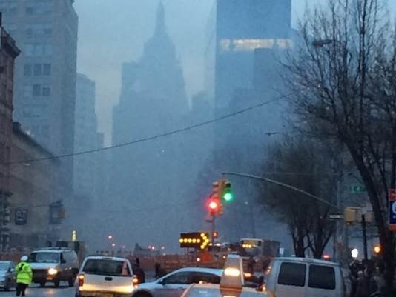
Figure 1. Neighborhood impacted during 2015 East Village Fire taken during response in New York City. Photo credit: Kazuhiko Ito.

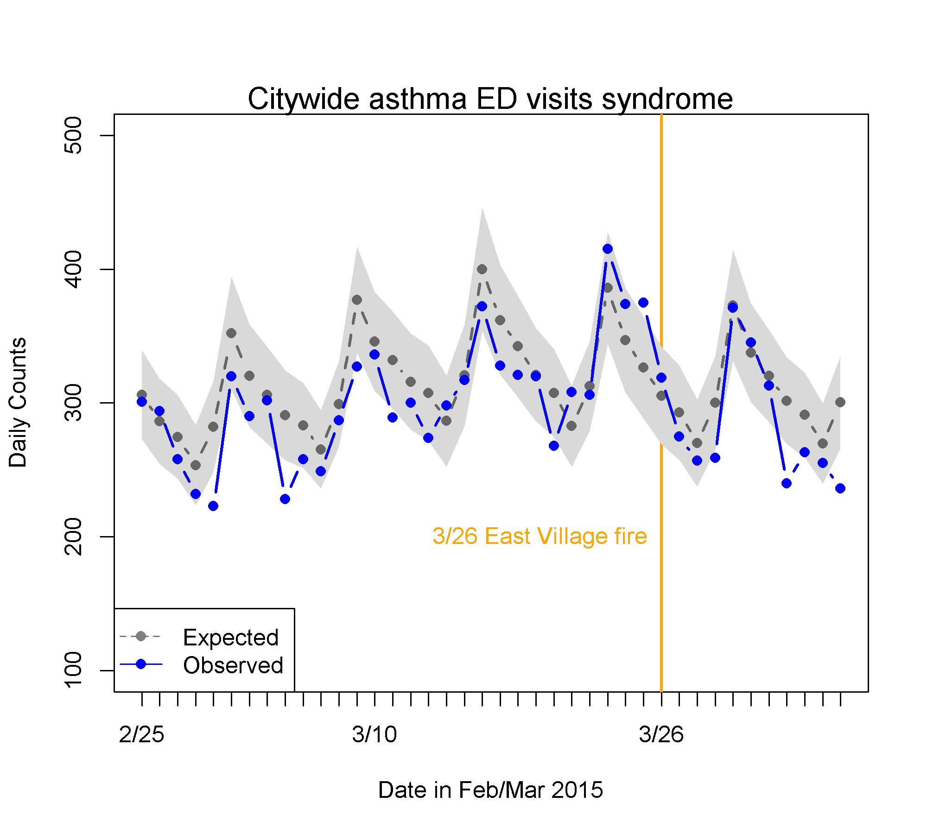
Figure 2. Figure produced during the 2015 East Village Fire response.
Y-axis: Daily counts of asthma emergency department (ED) visits syndrome for all city ZIP codes of residence. X-axis: Dates in late February through early April, 2015. Orange vertical line: The date of fire, March 26, 2015. Blue line: Observed asthma ED visits syndrome. Gray dotted line: Predicted asthma ED visits syndrome from day-of-week, day of year, and long-term trend. Gray shade: Estimated 95% confidence bands of daily predicted values.

Citations for Case Study 2
[1] Stefanidou, M., Athanaselis, S., & Spiliopoulou, C. (2008). Health impacts of fire smoke inhalation. Inhalation Toxicology, 20(8), 761-6.
[2] Centers for Disease Control and Prevention (CDC). (2003). Potential exposures to airborne and settled surface dust in residential areas of lower Manhattan following the collapse of the World Trade Center--New York City, November 4-December 11, 2001. Morbidity and Mortality Weekly Report, 52(7), 131-6.
[3] Koenig, J. Q. (1999). Current reviews of allergy and clinical immunology - Air pollution and asthma. The Journal of Allergy and Clinical Immunology, 104(4), 717-722.
[4] Peel, J. L., Tolbert, P. E., Klein, M., Metzger, K. B., Flanders, W. D., Todd, K., ... Frumkin, H. (2005). Ambient Air Pollution and Respiratory Emergency Department Visits. Epidemiology, 16 (2), 164-174.
[5] Spira-Cohen, A., Chen, L. C., Kendall, M., Lall, R., & Thurston, G. D. (2011). Personal Exposures to Traffic-Related Air Pollution and Acute Respiratory Health among Bronx Schoolchildren with Asthma. Environmental Health Perspectives, 119(4), 559-565.
[6] Heffernan R, Mostashari F, Das D, Karpati A, Kulldorff M, Weiss D. (2014) Syndromic surveillance in public health practice, New York City. Emerg Infect Dis. 10(5),858–64.

