NIOSH Emergency Preparedness and Response Resources
Authors: Lisa J. Delaney, MS, CIH, Jill Shugart, MSPH, REHS, Angela Weber, MS

Introduction
The National Institute for Occupational Safety and Health (NIOSH), established by the Occupational Safety and Health Act of 1970, is a research agency that focuses on the study of worker safety and health, including response and recovery workers. NIOSH is part of the Department of Health and Human Services (HHS), Centers for Disease Control and Prevention (CDC) and serves as the lead agency for occupational safety and health during emergency and incident responses. Response and recovery workers are a common denominator in any emergency response or incident regardless of type or size. Safeguarding the health and safety of these response and recovery workers is critical to ensure they can continue providing response and recovery support. Following the 2001 attacks on the World Trade Center and Pentagon and the anthrax letter attacks, NIOSH created a coordinated emergency preparedness and response program to ensure that occupational safety and health knowledge was adequately represented in federal planning and response efforts. Initially the program focused on terrorism events but it has subsequently broadened to address a range of incidents including major natural and chemical disasters, terrorist attacks or threats, nuclear accidents, and infectious disease outbreaks.
The NIOSH Emergency Preparedness and Response (EPR) Program is coordinated by the NIOSH Emergency Preparedness and Response Office (EPRO) located in Atlanta, GA. NIOSH EPRO staff are on call 24 hours a day, seven days a week, and 365 days a year to respond to emergencies. NIOSH is equipped to provide a broad range of field response and consultative expertise across a wide range of emergency types either during pre-event planning or during responses. Additionally, NIOSH has developed a robust Emergency Preparedness and Response Resources website that provides tools and communications materials on common hazards faced while responding, and guidance on how to protect response and recovery workers. For this chapter, NIOSH describes two priority areas of NIOSH EPR work: the Emergency Responder Health Monitoring and Surveillance™ (ERHMS™) Framework and the Disaster Science Responder Research (DSRR) Program. ERHMS™ is a framework that describes how an organization can monitor the health and safety of emergency responders and recovery workers throughout the phases of a response. The DSRR Program was stood up in 2014 to improve and support the conduct of occupational safety and health disaster research either before or during an emergency.

Emergency Responder Health Monitoring and Surveillance™ (ERHMS™) Framework
Due in large part to the demonstrated need to better protect, equip, and promote the health and safety of emergency responders and recovery workers during previous emergency events, including the 9/11 attacks and Hurricanes Katrina and Rita, NIOSH collaborated with federal agencies, state health departments, volunteer organizations and unions to create the ERHMSTM program. ERHMSTM is a framework that allows an organization to monitor the health and safety of emergency responders throughout the pre-deployment, deployment, and post-deployment phases of a response. The goals of ERHMSTM are to prevent short-term and long-term illness and injury in all emergency responders and recovery workers and to ensure workers can respond safely and effectively to current and future emergencies. Traditional groups of workers that typically respond to emergencies include law enforcement, fire, hazardous materials teams, emergency medical personnel and construction and utility workers. They may also include public health agency staff such as epidemiologists, environmental health specialists, industrial hygienists, and mental health professionals and volunteers such as the Medical Reserve Corps and the American Red Cross.

ERHMSTM aims to ensure specific activities are conducted to protect the health and safety of emergency response and recovery workers during each of the three phases of a response (Figure 1). During the pre-deployment phase, organizations should ensure workers are properly rostered, credentialed and trained, fit for duty, and that the organization can store this information in a secure manner. During the deployment phase, health monitoring and surveillance should be conducted while workers perform their job tasks to ensure the prompt identification of potential exposures, so that appropriate corrective measures are taken to eliminate further exposure. This includes making sure workers have appropriate personal protective equipment, access to potable water, safe food, and secure housing. During the post-deployment phase, workers should be properly demobilized and it should be determined if a referral for medical evaluation or long-term tracking is needed. After action meetings should be conducted and lessons learned documented in order to continually improve future responses.

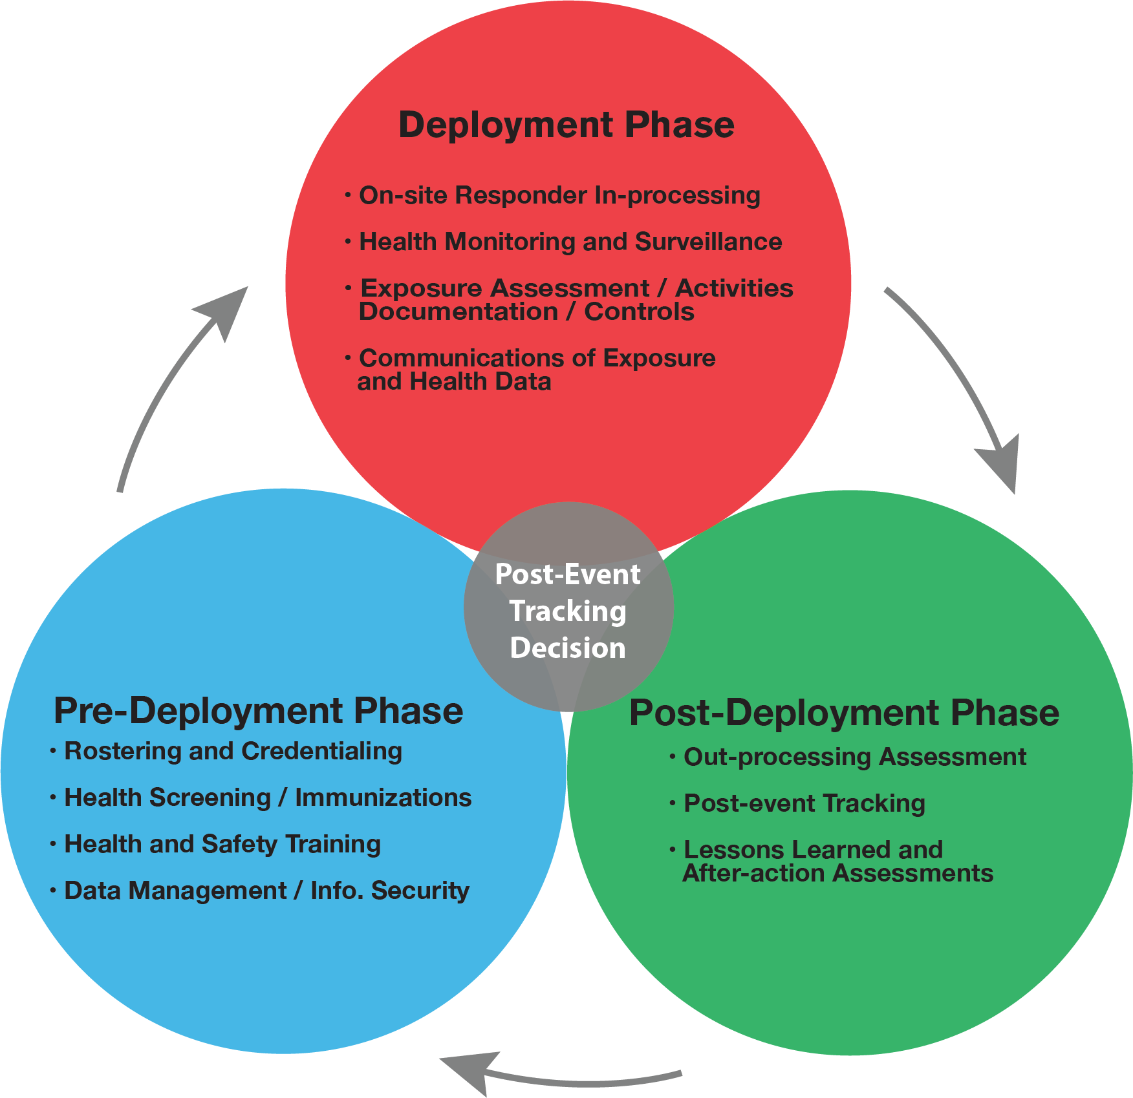
Figure 1: Three Phases of ERHMSTM

NIOSH led an effort to test ERHMS™ in a large-scale response during the 2010 Deepwater Horizon (DWH) oil spill. NIOSH staff incorporated the ERHMS™ framework primarily by rostering workers at the event and conducting health surveillance of workers during the pre-deployment phase and deployment phase of the response. NIOSH staff were able to manually roster over 55,000 workers working in three different states (Alabama, Mississippi, and Florida). NIOSH also analyzed and prepared reports of injury and illness data occurring among DWH responders in all locations and conducted exposure assessments of on and off-shore workers.
As a result of these activities, NIOSH collected many lessons learned that included:
- Begin worker rostering immediately and integrate it into response activities as soon as possible to ensure all workers have the opportunity to participate
- Have a ready to use roster form prepared that can be quickly adapted and cleared
- Direct the rostering program through the incident/unified command
- Explore the feasibility of incorporating rostering into existing response programs to improve efficiency
- Develop mechanisms to encourage and facilitate employer participation
- Maximum advantage should be taken of existing data streams that could be used for health surveillance of workers during the response
- Federal, state and local agencies should give consideration to the development of standardized instruments for baseline occupational surveillance and post-event occupational data collection and analysis that could be easily adapted to specific events and used by various organizations
- Improved occupational injury and illness surveillance may be achieved through enhanced integration and coordination with other surveillance activities at the HHS/CDC and other agencies
NIOSH published these lessons learned in a report (NIOSH 2011).

Examples of ERHMS™ Implementation
Organizations are implementing aspects of the ERHMSTM framework. For example, during the 2014 Ebola outbreak, NIOSH assisted the CDC with expanding their “Responder Readiness” program by implementing the ERHMSTM framework into their response structure. Specifically, a pre-deployment coordinator position was established to work with responders before they deployed to ensure they met all of the health screening requirements and were properly trained. Several NIOSH staff served as safety officers in affected countries in order to conduct health and safety monitoring of staff during the deployment phase. Finally, a post-deployment coordinator position was created in order to determine if any long-term monitoring should be conducted, including any mental health needs. Many of these activities were also continued during the 2016 Zika response at CDC.
In 2016 as Hurricane Matthew was fast approaching, the Georgia Department of Public Health (GA DPH) adapted their newly created Responder Safety, Tracking, and Resilience (R-STAR) system to incorporate ERHMSTM. GA DPH staff sent out surveys to responders to self-register their deployment activities and to complete a health and safety check. According to Funk (2018), feedback from participants indicated responders valued someone checking in on them during their deployment and that supervisors could verify their responders were accounted for and unharmed. By incorporating ERHMSTM, the GA DPH would be able to meet Capability 14 (Responder Safety and Health) as part of their CDC Public Health Emergency Preparedness (PHEP) cooperative agreement (CDC 2011). Any state receiving this funding can implement ERHMSTM as a way to complete tasks in Capability 14 or 15 (Volunteer Management).
As a result of NIOSH staff providing ERHMS™ training at West Virginia University in March of 2016, the Monongalia County Health Department was able to implement ERHMS™ during a multi-agency, statewide emergency drill, Operation Dawson Storm. The drill was conducted in July 2016 in Morgantown, WV with military, emergency medical personnel, law enforcement and public health officials and focused on potential exposure to a radiological source. The health department focused on conducting health monitoring of first responders prior to the drill and after the drill and developed pre- and post-drill questionnaires. Data were obtained from 52 responders pre-drill and 33 responders post-drill.
Between 2013–2016, the state of Idaho worked to implement ERHMS™ through the following incremental activities with sub-grants with Public Health Districts: 1. review PHEP Capability number 14 (Responder Safety and Health), 2. complete training for monitoring staff and leadership, and 3. pilot test ERHMS Info Manager™. In October 2016, Idaho’s preparedness field assignee from the CDC developed and facilitated a hands-on exercise to deepen ERHMS™ capabilities and share how the ERHMS™ framework and ERHMS Info Manager™ can be implemented among Public Health Districts. Participants included representatives from state and local epidemiology and preparedness programs. Data were obtained from 15 (79%) of the 19 participants (Arkin 2017).
For more information on how ERHMS™ was implemented in Oregon, see the Disaster Mental Health chapter __ in this Resource Guide.

Tools and Resources
Resources and tools have been developed to assist organizations with implementing ERHMSTM during each of the response phases and include free training and ERHMS Info ManagerTM software. Training has been conducted at a total of nine health departments and 317 public health professionals were trained across the United States from 2013-2016. The trainings were made possible by a successful CDC funding proposal in partnership with NIOSH, the Agency for Toxic Substances and Disease Registry’s (ATSDR) Assessment of Chemical Exposures (ACE) program and the CDC’s Community Assessment for Public Health Emergency Response (CASPER) program.
In 2017, NIOSH staff was also able to train the following organizations per their request: the West Virginia Bureau for Public Health along with local public health staff at West Virginia University in Morgantown, WV, Oregon Medical Reserve Corps unit in Portland, OR, and individuals attending a professional development course (PDC) at the Tennessee Valley Section American Industrial Hygiene Association in Knoxville, Tennessee. More than 200 public health professionals were trained at these locations.
The guidance for how to implement these activities and specific tools that can be utilized during each phase of the response can be found in the National Response Team Technical Assistance Document (NRT 2012). In order to increase an organization’s ability to implement and adopt ERHMSTM, NIOSH has recently developed ERHMS Info ManagerTM, a free custom-built software product that uses Epi InfoTM for all calculations and analyses. This product allows for the collection of data as outlined in ERHMSTM throughout all three phases of a response. For example, ERHMS Info ManagerTM will allow users to manage staff readiness by collecting information on rostering, training, and medical screening thus improving the organization’s preparedness prior to an emergency. NIOSH has also developed a user’s manual and training videos to accompany the software and has partnered with Epi InfoTM to ensure technical support is available to all users. In addition, NIOSH has free training on ERHMSTM available online and in-person on a case-by-case basis. Continuing education credits are available for these trainings.
For more information on ERHMS™ or ERHMS Info Manager™, visit the website at www.cdc.gov/niosh/erhms. We welcome you to share your experiences and successes with implementing ERHMS™ by emailing us at erhmsonline@cdc.gov.
References:
Arkin K (2017). Advancing implementation of emergency responder health monitoring and surveillance in Idaho. Paper presented at the 2017 Council for State and Territorial Epidemiologist (CSTE) Annual Conference, Boise, Idaho, June 6, https://cste.confex.com/cste/2017/webprogram/Paper7623.html.

Centers for Disease Control and Prevention. (2011). National standards for state and local planning. Atlanta, GA: U.S. Department of Health and Human Services, Centers for Disease Control and Prevention, Office of Public Health Preparedness and Response, https://www.cdc.gov/phpr/readiness/00_docs/DSLR_capabilities_July.pdf.

Funk, R. (2018). Applications: Emergency Responder Health Monitoring and Surveillance: Successful Application. In: Horney, J eds. Disaster epidemiology: methods and applications. San Diego, CA: Academic Press.
National Institute for Occupational Safety and Health. (2011). Lessons Learned from the
Deepwater Horizon Response. Cincinnati, OH: U.S. Department of Health and Human Services, Centers for Disease Control and Prevention, National Institute for Occupational Safety and Health, DHHS (NIOSH Publication No. 2012-117, https://www.cdc.gov/niosh/docs/2012-117/pdfs/2012-117.pdf.

National Response Team. (2012). Emergency Responder Health Monitoring and Surveillance: National Response Team Technical Assistance Document (TAD). Washington, DC: U.S. National Response Team, https://www.nrt.org/sites/2/files/ERHMS_Final_060512.pdf.

Disaster Science Responder Research (DSRR) Program
Conducting responder health and safety research in the disaster environment requires researchers to address many challenges unique to emergency response and recovery efforts. These challenges include the immediate emphasis on critical response activities, capabilities, and resources; limited access to emergency management leadership who would need to approve research activities involving the responders under their charge; and timely recognition of important occupational safety and health risks during the response or recovery operations. Issues related to conducting responder health and safety research during and following disasters have gained attention following such disasters as the World Trade Center attack, Hurricane Sandy, the Deepwater Horizon oil spill, and more recently, the global Ebola response. Each of these disasters could have benefited from timely responder safety and health research to characterize the unique risks associated with occupational exposure to disaster-related hazards.

In 2014 NIOSH established its Disaster Science Responder Research (DSRR) Program, located within EPRO, with the intent to develop an approach to timely, scalable, scientifically sound responder-based research that can feasibly be implemented before, during, and after a disaster without interfering with the response itself. Specifically, the goals of the DSRR Program are to identify important research gaps for emergency response and recovery workers, to inform approaches for conducting research during a disaster, and to create mechanisms for overcoming the associated logistical, technical and administrative burdens that researchers will encounter during an emergency response. The program also aims to identify critical topic areas to address research gaps that can be studied outside the scope of an ongoing response.

The DSRR Program’s strategic plan will address four major goals: 1) develop a NIOSH disaster research agenda to enhance responder safety and health, 2) address major challenges associated with conducting research during disasters such as rapid IRB protocols, 3) identify already existing data collection capabilities and information resources to be utilized for research purposes, and 4) ensure research findings and lessons learned are translated into practice. The DSRR Program considers disasters to include natural disasters, chemical and radiological emergencies; oil spills; pandemic influenza or other infectious diseases; and other mass casualty events. In addition to large-scale disasters, NIOSH is also focused on small-scale, novel incidents where emerging issues have been identified. NIOSH broadly defines disaster-related workers as anyone involved in the response and recovery effort. Therefore, law enforcement, fire, and emergency medical personnel, as well as other responder groups such as public health personnel, cleanup, and repair/restoration workers are included. This type of work is carried out by individuals from emergency management, fire service, law enforcement, emergency medical services (EMS), public health, construction and other skilled support, disaster relief and mental health teams, and volunteer organizations. It also includes auxiliary workers involved in the cleanup and recovery phases of an incident or emergency.

In the DSRR Program, “research” is defined broadly and includes both research during a disaster, but may also include studies that can be completed outside the scope of an actual incident. It may be a rapid assessment of what is already known about a given problem, rapid collection of data from the field to guide ongoing responder safety and health decisions, hypothesis-driven research needed to understand and address effectively the current incident, and developing and implementing improved approaches and responses to future incidents. The types of research conducted may include: the impact of a novel exposure, unexpected or severe health effects, the effectiveness of a proposed intervention, mental health/resilience issues, and disease outcomes with latency periods. By defining "research" in its broadest sense, the DSRR Program includes etiologic, intervention, applied, laboratory, comparative effectiveness, worker-based participatory, and survey research, and meta-analyses with the goal of providing a better understanding of the situations and risks responders face. Using clear, pre-event decision criteria (described below), the DSRR Program recommends that the need for longer-term studies should be assessed early in the course of the event by a committee of subject matter experts. The decision should also include the considerations that research efforts should not interfere with current response priorities.

Health studies conducted in conjunction with the response to emergency events may be divided into four basic types: (1) Baseline Activities that involve routine or baseline health monitoring, health surveillance, industrial hygiene or environmental assessments, responder interviews/focus groups, and roster/registry activities, optimally planned in a generic way prior to an event; (2) Public Health Investigations that investigate and respond to immediate health problems and exposures, and are designed to expeditiously provide useful and actionable information that directly affects the health and safety of current responders; (3) Pilot Investigations that are exploratory or preliminary in their approach, often to determine the need for or feasibility of a more comprehensive research study; and (4) Responder Health Research that entail a systematic and rigorous investigation, typically require peer-reviewed protocols, usually extend well beyond the duration of the emergency, and are designed to develop or contribute to generalizable scientific knowledge (Decker JA, et al. 2013).

The process for determining whether to conduct a research study may be informed by multiple inputs and considerations. Decker et al (2013) describes four “critical gatekeeper factors” that should be satisfied before embarking on a post-disaster research study: 1) the scientific query is clear and testable; 2) exposure is present and measurable; 3) the study design is sound and cost-effective; and 4) the study is feasible with respect to logistics, funding, and rapid regulatory clearances such as Institutional Review Board (IRB) approval.

To enable the most successful and scientifically valid disaster science research, the NIOSH DSRR Program recommends, whenever possible, routine collection of a core set of baseline data, such as exposure data, rosters of exposed individuals, and baseline health status. The ERHMS™ program is an excellent tool for these routine data collections. In addition, the DSRR Program recommends strong interagency communication and cooperation among federal, state, and local governmental agencies (e.g., health departments, labor departments, Federal Emergency Management Agency) in the jurisdiction of the disaster, as well as academic partners. Prior to an event, planning discussions are recommended with relevant umbrella organizations, such as the Council of State and Territorial Epidemiologists (CSTE) and the National Association of County and City Health Officials (NACCHO). Finally, the DSRR Program notes the important role of the response and recovery workers themselves as an asset in many projects, providing relevant knowledge and skills that can strengthen data collection efforts.

Website: https://www.cdc.gov/niosh/topics/disasterscience/default.html
References:
Decker JA, et al. Am J Disaster Med 2013 Jan/Mar; 8(1): 25-33).
Disclaimers
The findings and conclusions in this chapter are those of the author(s) and do not necessarily represent the official position of the National Institute for Occupational Safety and Health, Centers for Disease Control and Prevention.

In addition, citations to websites external to NIOSH do not constitute NIOSH endorsement of the sponsoring organizations or their programs or products. Furthermore, NIOSH is not responsible for the content of these websites. All web addresses referenced in this document were accessible as of the publication date.

