Syndromic Surveillance and Disaster Epidemiology
Meredith Jagger¹, Laurel Boyd², Kazuhkio Ito³, Kathryn Lane³, Melissa Powell²
- Austin Energy; Formerly Oregon Health Authority, Public Health Division
- Oregon Health Authority, Public Health Division
- New York City Department of Health and Mental Hygiene
Syndromic surveillance systems are now available in many public health jurisdictions, and the combination of clinical and non-clinical data captured in such systems can enhance situational awareness before, during, and after an event of public health importance. Sources of data for such systems typically include medical records, such as emergency department (ED) visits, which are captured in near-real time, and they can include non-clinical data, such as prescription refills, school absenteeism, veterinary disease reports, or weather [1]. The concept of syndromic surveillance was developed in the late 1990s as a response to the increased awareness of and perceived potential for bioterrorism attacks [1, 2]. The theory is that by categorizing and monitoring the baseline levels of patients’ stated reasons for seeking medical care (e.g., my stomach hurts; rash on arms and itchy eyes; wheezing and coughing) aberrations in these trends, which might indicate a disease outbreak, including one that stems from bioterrorism, can be identified more quickly than with traditional surveillance mechanisms [2]. These systems are thus tools to complement, not replace, other public health data-gathering techniques [2].
Today, the focus of syndromic surveillance has shifted and expanded beyond bioterrorism and epidemic detection. Primary uses now include situational awareness, outbreak characterization, and resource allocation [3]. The advent of Meaningful Use (a component of the American Recovery and Reinvestment Act of 2009) has incentivized submission of standardized data from hospital electronic health records to participating public health authorities [4]. A small number of jurisdictions had created syndromic surveillance systems before the advent of Meaningful Use (which began in 2012), but many more have had the opportunity to set up such systems since. The Centers for Disease Control and Prevention’s (CDC) National Syndromic Surveillance Program (NSSP) uses a version of the Electronic Surveillance System for the Early Notification of Community-Based Epidemics (ESSENCE), which was developed and is supported by The Johns Hopkins University Advanced Physics Lab [5]. Many state and local public health agencies also use commercially available platforms such as ESSENCE or Real-time Outbreak and Disease Surveillance (RODS). Others like New York City and North Carolina use locally developed ones.
Regardless of location, the core of most syndromic surveillance systems is emergency department (ED) visit data [3, 6, 7]. Such systems receive automated data feeds with a 48- or 24-hour delay, while others get it hourly or even faster. These (Meaningful Use) data usually contain the patient’s chief complaint for the visit (i.e., why they are seeking care), date and time of visit, healthcare facility information (e.g., location, healthcare system, facility type), and patient demographics. As a patient progresses through their visit, other fields such as triage notes and eventually discharge diagnosis codes may be added to the visit record automatically [3].
For disaster epidemiologists, there are several important uses for syndromic surveillance data. First, before an event or incident, these data provide excellent baseline information. It is important to think about the underlying population demographics, know which facilities report, and understand the pre-existing queries or syndromes for categorizing types of visits. Reviewing known hazards for the region or season can help contextualize likely post-disaster outcomes.
During an event of public health importance, monitoring total number and types of visits can help decision makers understand the extent of impact on the healthcare system and allocate limited resources wisely. There may be a delay in individuals’ seeking care or significant changes in care-seeking patterns (e.g., patients going EDs if urgent cares and primary care offices are closed), which will be important to know about during a response and into the recovery phase [6]. Comparing syndromic data with data from other sources, such as information on hospital staffing capacity or available beds, can provide a better picture of a developing situation. After a disaster, continued monitoring of syndromic surveillance data is important because some health outcomes may be delayed (e.g., with longer incubation periods of some communicable diseases) or are more likely during a clean-up phase (e.g., injury or exposure to a toxic substance) [8]. A return to expected visit counts, types of complaints, and demographics mark an important milestone during a recovery phase.
There are many examples of syndromic surveillance being used for disaster epidemiology purposes. Fortunately, the large-scale bioterrorism incidents that early developers of syndromic surveillance anticipated have not materialized, but this type of data has been used after human-caused incidents. The State of Oregon supported monitoring of visits made by residents of a rural area after an oil train derailed (for more see Case Study 1 below). The Washington State Department of Health did surveillance after a tunnel collapsed at the Hanford nuclear site and shared the queries with Oregon, as there was concern about the worried well seeking care across state borders [9]. The New York City Department of Health and Mental Hygiene (DOHMH) tracked asthma visits after a large building collapse and subsequent fire (for more see Case Study 2 below).
The governmental response to natural disasters can also benefit from syndromic surveillance data. For climate-sensitive hazards, CSTE has recently published a comprehensive guidance document [10] and has workgroups developing syndrome definitions for heat [11] and cold exposure. The Kansas Department of Health and Environment has retrospectively analyzed storm- and tornado-related injuries [12]. The Florida Department of Health has significant experience using permanent and temporary data feeds after tropical storms and hurricanes [13]. The Oregon Health Authority has supported local and state surveillance of wildfires and resultant hazardous air quality. When Jackson County, Oregon was afflicted by wildfires and wildfire smoke during August and September 2017, local public health monitored sudden or sustained increases in ED visits and PM_{2.5} (particulate matter ≤2.5 microns in diameter). Surveillance findings were documented in The Wildfire Smoke and Health Impact Surveillance Report and shared with Jackson County Commissioners [14]. The New York City DOHMH has used syndromic data to track cold-related illness during periods of extreme winter weather and following Superstorm Sandy. They also use time-series regression models to assess whether observed visit counts are higher than typically observed for time of year and weather conditions [15].
It should be noted that in situations in which infrastructure at either the healthcare facility or the public health agency are damaged (e.g., in a catastrophic earthquake or prolonged power outage), syndromic surveillance would not be immediately or even quickly available. In such cases, other data-gathering techniques, like active surveillance, may be necessary. However, the possibilities for syndromic surveillance data use for disaster epidemiology are expansive. Collaboration among data-system managers, users, and decision makers before an event of public health importance is key to timely and wise use of data.

Citations for Chapter:
[1] Lombardo, J., Burkom, H., Elbert, E., Magruder, S., Lewis, S. H., Loschen, W., ... Pavlin, J. (2003). A Systems Overview of the Electronic Surveillance System for the Early Notification of Community-Based Epidemics (ESSENCE II). Journal of Urban Health, 80(Suppl), i32–i42. doi: 10.1007/PL00022313.
[2] Henning, K. J. (2004, Sept 24). Overview of Syndromic Surveillance What is Syndromic Surveillance?. Morbidity and Mortality Weekly Reports. 53(Suppl), 5-11. Retrieved fromhttps://www.cdc.gov/mmwr/preview/mmwrhtml/su5301a3.htm.
[3] Yoon, P. W., Ising, A. I., & Gunn, J. E. (2017). Using Syndromic Surveillance for All-Hazards Public Health Surveillance: Successes, Challenges, and the Future. Public Health Reports, 132(Suppl), 3S-6S. doi: 10.1177/0033354917708995.
[4] Office of the National Coordinator for Health Information Technology. (2015). EHR Incentives & Certification: Meaningful Use Definitions & Objectives. Retrieved from https://www.healthit.gov/providers-professionals/meaningful-use-definition-objectives
[5] Centers for Disease Control and Prevention, Division of Health Informatics and Surveillance. (2017). National Syndromic Surveillance Program (NSSP). Retrieved from https://www.cdc.gov/nssp/index.html.
[6] Hughes, H. E., Hughes, T. C., Haile, A., Smith, G. E., McCloskey, B., & Elliot, A. J. (2017). Syndromic Surveillance Revolution? Public Health Benefits of Modernizing the Emergency Care Patient Health Record in England. Public Health Reports, 132(Suppl), 12S-15S. doi: https://doi.org/10.1177/0033354917706955.
[7] Lall, R., Abdelnabi, J., Ngai, S., Parton, H. B., Saunders, K., Sell, J., ... Mathes, R. W. (2017). Advancing the Use of Emergency Department Syndromic Surveillance Data, New York City, 2012-2016. Public Health Reports, 132(Suppl), 23S-30S. doi: https://doi.org/10.1177/0033354917711183.
[8] Endericks, T. (2015). Chapter 2: Legacy and Evaluation. In Public Health England and World Health Organization (Eds.) Public Health for Mass Gatherings: Key Considerations. Retrieved from http://apps.who.int/iris/bitstream/10665/162109/1/WHO_HSE_GCR_2015.5_eng.pdf?ua=1&ua=1.
[9] Harry, C., Washington State Department of Health. Personal Communication. 2 November 2017.
[10] Harduar Morano, L., Jagger, M. A., Barrett, E. C., Berisha, V., Borjan, M., Heitzinger, K., … CSTE Climate and Health Syndromic Surveillance Workgroup. (2017). Syndromic Surveillance Climate and Health Guidance Document. Council of State and Territorial Epidemiologists. Retrieved from http://c.ymcdn.com/sites/www.cste.org/resource/resmgr/pdfs/pdfs2/Syndromic_surveillance_clima.pdf.
[11] Berisha, V., Braun, C.R., Cameron, L., Hoppe, B.O., Lane, K., Mamou, F., … Wurster, J. (2016). Heat-related Illness Syndrome Query: A Guidance Document For Implementing Heat-related Illness Syndromic Surveillance in Public Health Practice. Council of State and Territorial Epidemiologists. Retrieved from http://c.ymcdn.com/sites/www.cste.org/resource/resmgr/pdfs/pdfs2/CSTE_Heat_Syndrome_Case_Defi.pdf.
[12] Stein, Z. M. (2017). Creation of a Kansas Spring Extreme Weather Syndrome Definition and Unique Records. Online Journal of Public Health Informatics, 9, 1. Retrieved from http://www.syndromic.org/storage/documents/2016_Conference/abstracts/posters/isds16_pos_creation%20of%20a%20kansas_stein.pdf.
[13] Centers for Disease Control and Prevention, National Syndromic Surveillance Program. (2017). NSSP Update: Three Hurricanes with Difference Support Scenarios. Retrieved from https://www.cdc.gov/nssp/documents/nssp-update-2017-10.pdf
[14] Phillips, T., Jackson County Health & Human Services. Personal Communication. 2 November 2017.
[15] Lane, K., Lall, R., Wheeler, K. Ito, K., and Matte, T. Evaluating Utility of Cold-Injury Syndromic Surveillance Data in New York City. Online Journal of Public Health Informatics, 5, 1. Retrieved from https://www.ncbi.nlm.nih.gov/pmc/articles/PMC3692768/
Case Study 1: Oil Train Derailment in Mosier, OR
In the early afternoon of Friday June 3, 2016, a train carrying multiple cars filled with oil derailed within Mosier, a small town on the Oregon side of the Columbia River Gorge (across the river from the State of Washington). An Oregon Public Health Division preparedness liaison immediately contacted the Preparedness Surveillance and Epidemiology Team at the Oregon Public Health Division for assistance in monitoring regional public health consequences using Oregon ESSENCE, Oregon’s statewide syndromic surveillance platform.
Oregon ESSENCE began accepting emergency department data in 2011 and now captures syndromic data from all 60 eligible hospital EDs in Oregon in addition to data from urgent care centers, the Oregon Poison Center, and several other sources. In 2016, Oregon ESSENCE had regional coverage with ED data, including this region of the state. Participating hospitals sign a data-use agreement that allows for routine use of these data for situational awareness during emerging events by local and state public health professionals. Required data fields include basic demographic information, chief complaint, and diagnosis codes associated with the visit. These records do not include identifiers such as patient name, address, or date of birth.
Initial information about the incident indicated that at least some of the oil cars were on fire; by the afternoon, news media began to report explosions from some of the cars. Interstate 84, the highway that runs parallel to the railway lines, was closed to traffic in both directions. What was not known on Friday afternoon was whether citizens were being evacuated, whether the fire had damaged power lines, the extent to which the oil was leaking into the Columbia River or the municipal water supply, and whether air quality was affected by fire or fumes. Based upon this initial information, Oregon epidemiologists developed a surveillance strategy on Friday afternoon to be implemented the following day (because data are delayed by one day). ESSENCE automatically highlights statistically significant increases in visits, and it can create a daily report or dashboard, simplifying trend identification. Epidemiologists created queries in the ESSENCE interface and an event-specific report that was shared back with the liaison. The report displayed charts of total emergency department visits and those indicating:
- Asthma or headache potentially related to poor air quality due to fire or fumes
- Rash or exposure due to skin contact with crude oil
- Words such as “train” or “derailment” specific to the event
- Injuries related to evacuation or clean-up
- Motor vehicle accidents from evacuation or road closure
- Heat-related symptoms due to hot summer temperatures
Because this event occurred near the Washington-Oregon border, Oregon epidemiologists contacted Washington colleagues on Friday afternoon to alert them and discussed the possibility of surveillance at a nearby Washington hospital.
These queries were monitored over the weekend and into the next week. Beginning June 3 and stretching into June 8, this region experienced a heat wave, with temperatures ranging from 90–99°F (unseasonably warm for the region).
Surveillance findings in the several days after the incident did not identify ED visit trends related to the derailment. For several reasons, the system may not have been able to identify increases. The tools may not have been able to capture trends where they existed, because increases in visits among residents from a small town may not have been apparent at local regional hospitals; or because residents might have sought care outside emergency departments—e.g., in primary-care or outpatient-care centers—visits to which are not captured by Oregon’s ESSENCE. It is also possible the residents were evacuated before they were exposed to event-associated hazards. Several days after the event, ESSENCE identified increases in visits for asthma and heat-related illness in this region as the temperatures increased (a routine finding for heat waves). These increases did not appear to be directly related to the train derailment, but they did indicate that the surveillance tool was sufficiently sensitive to have captured increases in these types of visits in the wake of the incident.
Large-scale incidents and evacuations can cause or exacerbate mental health issues, including post-traumatic stress disorder [1, 2]. Syndromic surveillance at emergency departments may not be the best tool for this type of monitoring, as visitors may have varied or non-descriptive reasons for seeking care, not easily classified with text parsing, and with long-term follow-up impossible for ESSENCE because it does not capture patient identifiers. Nevertheless, this type of surveillance is routinely used for human-caused incidents, weather events, and mass-gathering surveillance in Oregon. Since 2016, Oregon epidemiologists have refined and improved this surveillance, which is now routinely incorporated into the Oregon Public Health Division Incident Management Team and shared with the Public Health Director and other leadership. Often, the absence of an increase in health events is as important to identify as is a sudden swell in visits. These findings add context to risk communications and can address rumors about events in nearly real time.

Citations for Case Study 1
[1] Galea, S., Nandi, A., Vlahov, D. The Epidemiology of Post-Traumatic Stress Disorder after Disasters. 2017; 27(November): 78–91.
[2] Dirkzwager, A., Grievink L., Van der Velden, P., Yzermans, C. J. Risk factors for psychological and physical health problems after a man-made disaster Prospective study. Br J Psychiatry. 2006; 189: 144–9.

Case Study 2: Asthma Surveillance Following Unexpected Building Collapses and Fires
Smoke and dust from building fires or collapses of buildings are potentially hazardous to health [1, 2]. Air pollution, including fine particulate matter (PM_{2.5}), is known to exacerbate asthma, [3] and studies have reported short-term associations between air pollution and asthma emergency department (ED) visits in New York City (NYC) and other cities [4, 5].
The NYC Department of Health and Mental Hygiene’s (DOHMH) Bureau of Environmental Surveillance and Policy, in collaboration with the Bureau of Communicable Disease’s syndromic surveillance unit, conducts syndromic surveillance to inform situational awareness and support public messaging and response. The health department assessed potential respiratory health effects following the collapse of two buildings (caused by a gas leak) in 2014, a 7-alarm fire and collapse of three buildings following a gas leak in 2015, and several large warehouse fires in 2014 and 2015.
Our analyses were conducted within days after the incidents because we were able to utilize existing syndromic surveillance infrastructure [6]. Since 2002, DOHMH’s syndromic surveillance unit has collected daily data on ED visits. Syndromes representing several major illness categories, including asthma, have been developed over the years. We also have a protocol in place, approved by the agency’s Institutional Review Board, that covers the surveillance methods and data.
We built time-series models of daily asthma ED visits to determine whether asthma visits increased as a result of the disasters. (See Figure 1 below for an example from the 2015 East Village Fire). Asthma ED visits in NYC have strong seasonal (e.g., pollen reactions in the spring and school-opening-related viral infections in the fall) and day-of-week patterns. First, a simple over-dispersed Poisson model was built with day-of-week and smooth functions (natural cubic splines) of day-of-year and year for the citywide asthma ED visits syndrome. The regression model was built on the past years’ data (e.g., 2002–2014 for the 2015 event) and predictions were made for about one month before and up to 10 days after the event. Because the syndromic data include the residential zip code for each ED visit, it was possible to repeat the process for the “affected” zip codes and the rest of the city, with each area’s prior years’ data to build the models.
For all the fire and building-collapse incidents, our models demonstrated that ED visits for asthma did not increase, either citywide or in the affected areas. We found that asthma ED visits for the day of the events and for several days afterwards were within the prediction intervals of the model.
Surveillance findings were shared with DOHMH agency leadership. For the 2015 building collapse, city leadership was able to respond to questions from the press regarding health impacts of local air quality. Through this experience and ad-hoc analyses following other building collapse and fire events, however, we also identified several methodological limitations that require addressing: (1) difficulty in defining an “affected area” due to the lack of spatially- and temporally-resolved near-real-time exposure data; (2) larger prediction confidence bands due to smaller numbers of ED visits in sub-areas; (3) challenges in assessing the health effects of disaster events that occur during strong seasonal peaks, such as during spring pollen and fall viral-infection periods: previous events did not happen during these periods, but they might in the future.
To address these limitations and to better prepare for future disaster events, we are developing a routine asthma ED visits syndrome prediction model that will incorporate weather and air-pollution data as predictors and with better estimation of the spring and fall peak impacts.
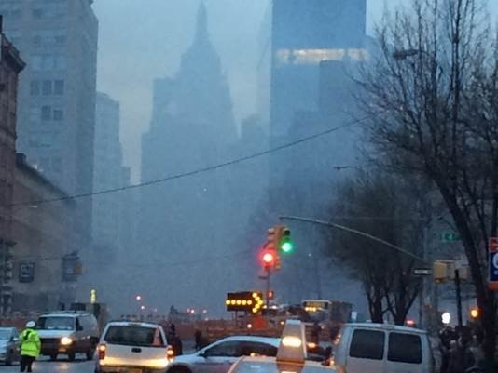
Figure 1. Neighborhood affected by the 2015 East Village Fire; taken during the response in New York City. Photo credit: Kazuhiko Ito.

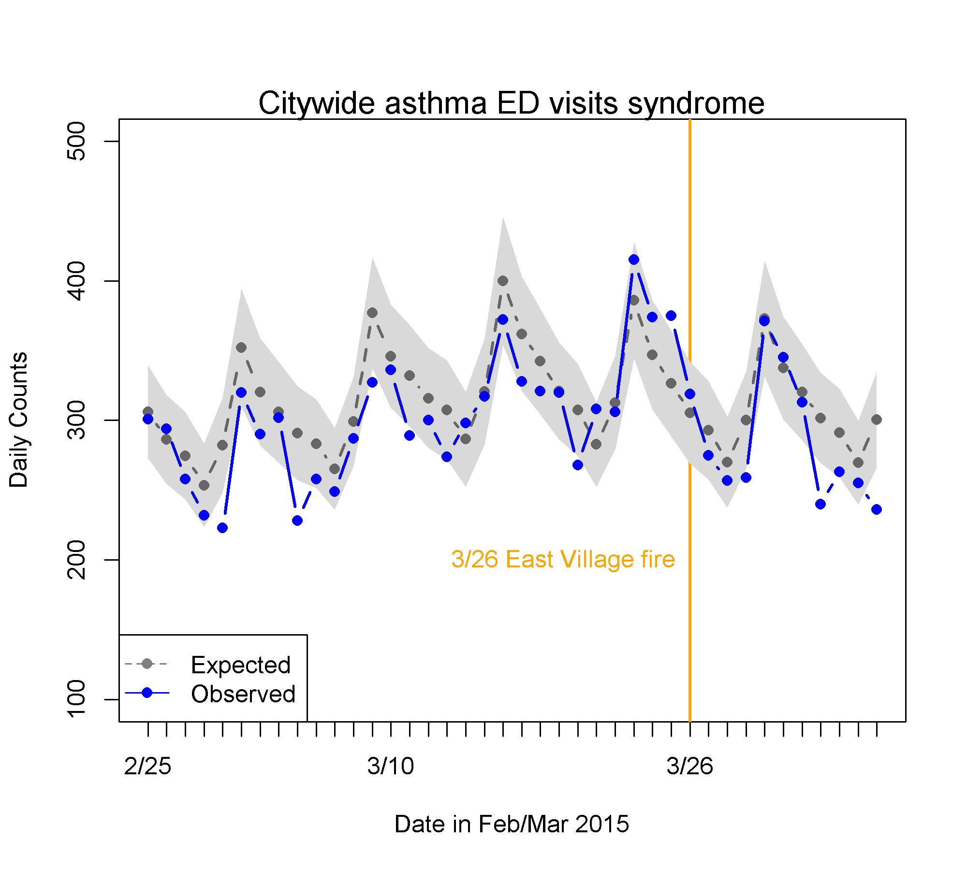
Figure 2. Figure produced during the 2015 East Village Fire response.
Y-axis: Daily counts of asthma-syndrome ED visits for all city ZIP codes of residence. X-axis: Dates in late February through early April 2015. Orange vertical line: March 26, 2015 (the date of the fire). Blue line: Observed “asthma-syndrome ED visits. Gray dotted line: “asthma-syndrome ED visits predicted from day of week, day of year, and long-term trend. Gray shade: Estimated 95% confidence bands of daily predicted values.

Citations for Case Study 2
[1] Stefanidou, M., Athanaselis, S., & Spiliopoulou, C. (2008). Health impacts of fire smoke inhalation. Inhalation Toxicology, 20(8), 761-6.
[2] Centers for Disease Control and Prevention (CDC). (2003). Potential exposures to airborne and settled surface dust in residential areas of lower Manhattan following the collapse of the World Trade Center--New York City, November 4-December 11, 2001. Morbidity and Mortality Weekly Report, 52(7), 131-6.
[3] Koenig, J. Q. (1999). Current reviews of allergy and clinical immunology - Air pollution and asthma. The Journal of Allergy and Clinical Immunology, 104(4), 717-722.
[4] Peel, J. L., Tolbert, P. E., Klein, M., Metzger, K. B., Flanders, W. D., Todd, K., ... Frumkin, H. (2005). Ambient Air Pollution and Respiratory Emergency Department Visits. Epidemiology, 16 (2), 164-174.
[5] Spira-Cohen, A., Chen, L. C., Kendall, M., Lall, R., & Thurston, G. D. (2011). Personal Exposures to Traffic-Related Air Pollution and Acute Respiratory Health among Bronx Schoolchildren with Asthma. Environmental Health Perspectives, 119(4), 559-565.
[6] Heffernan, R., Mostashari, F., Das, D., Karpati, A., Kulldorff, M., Weiss, D. (2014) Syndromic surveillance in public health practice, New York City. Emerg Infect Dis. 10(5), 858–64.

Contact Info and Revision History
Author | Email | Agency Review
Meredith Jagger | jagger.meredith@gmail.com | No, defer to OHA
Laurel Boyd | laurel.boyd@state.or.us | APPROVED
Kazuhkio Ito | kito1@health.nyc.gov | APPROVED
Kathryn Lane | klane1@health.nyc.gov | APPROVED, NYC DHMH primary contact
Melissa Powell | melissa.e.powell@state.or.us | APPROVED, OHA primary contact

Compiled by Meredith Jagger 8/21/2018
Oregon edits received from Melissa Powell, reviewed by Meredith Jagger, and shared with CSTE workgroup 9/28/2018
NYC edits received from Katie Lane and shared with CSTE workgroup 10/3/2018

