Disaster Epidemiology Tool: Community Assessment for Public Health Emergency Response (CASPER)

Tesfaye Bayleyegn, David Zane, Svetlana Smorodinsky, Katie R. Kirsch, Bonnie F. Morehead, Tracy Haywood, Russell Jones, Jennifer A. Horney

INTRODUCTION

Community Assessment for Public Health Emergency Response (CASPER) is a method and a set of specific tools designed to provide household-based information about an affected community’s needs in a disaster quickly, at low cost, and in a simple format to decision-makers (1). CASPER is a form of rapid needs assessment, also called a rapid epidemiologic assessment or a rapid health assessment. CASPER helps public health practitioners and emergency management officials determine community preparedness levels, community health status, and basic needs of an affected community after a disaster. CASPER is valuable in a disaster preparedness and response because data are collected rapidly and response leadership receives a preliminary report within one week (2). Response leadership during response can use this rapid information on community needs to target resources and take more effective actions (3).

CASPER uses a two-stage cluster sampling methodology. In the first stage, 30 clusters are selected from the affected area (sampling frame) with probability of selection proportional to the number of housing units in the cluster. In the second stage, field teams select seven households to interview in each cluster using systematic random sampling (4). The goal is use a standardized questionnaire and interview a representative sample of 210 (30x7) households.

The primary objectives of CASPER are to
- Assess the emergency or disaster preparedness level of a community.
- Determine the critical health needs and assess the impact of the disaster on a community.
- Produce household-based estimates data or projections for evidence-based public health action.
- Evaluate the effectiveness of actions taken.

CASPER is versatile and has many uses in both disaster and non-emergency settings (5). CASPER has been used in all phases of the disaster cycle: preparedness, response, recovery, and mitigation. This chapter provides three case studies that demonstrate different uses of CASPER.

References
- Centers for Disease Control and Prevention. Community Assessment for Public Health Emergency Response (CASPER) Toolkit. 2nd ed. http://emergency.cdc.gov/disasters/surveillance/pdf/CASPER_Toolkit_Version_2_0_508_Compliant.pdf. Published 2012. Accessed April 4, 2017.
- Malilay J, Flanders WD, Brogan D. A modified cluster-sampling method for post-disaster rapid assessment of needs. Bull World Health Organ. 1996;74(4):399-405.
- Malilay J. Public health assessments in disaster settings: recommendations for a multidisciplinary approach. Prehosp Disaster Med. 2000;15(4):167-172.
- Zane DF, Bayleyegn TM, Haywood TL, et al. Community assessment for public health emergency response following Hurricane Ike—Texas, 25-30 September 2008. Prehosp Disaster Med. 2010;25(6):503-510.
- Bayleyegn TM, Schnall AH, Ballou SG, Zane DF, Burrer SL, Noe RS, Wolkin AF. Use of Community Assessments for Public Health Emergency Response (CASPERs) to rapidly assess public health issues — United States, 2003-2012. Prehosp Disaster Med. 2015;30(4):1-8.

CASE STUDIES

CASE STUDY 1-PREPAREDNESS: Assessing Preparedness Planning Using CASPER: Oakland, Michigan, 2012

Background
Michigan is at risk for both natural and human-induced disasters such as floods, tornados, and radiological emergencies. Past incidents in Michigan have highlighted the importance of emergency planning and public health response to disasters (1).
- In June 2008, a tornado and associated severe weather affected several counties in the state (2).
- In July 2010, an oil pipeline ruptured and released an estimated 844,000 gallons of heavy crude oil into surrounding waterways near Marshall, Michigan (3).
In addition to these events, approximately 1.2 million people in Oakland County, Michigan, live less than 50 miles from the Unit 2 of the Fermi Nuclear Power Plant, making them at risk if an emergency occurs at the plant. Michigan is also located near the Great Lakes, making it susceptible to extreme weather events, including ice and snow storms and tornadoes (4).

In September 2012, the Oakland County Health Division (OCHD) and Michigan Department of Community Health (MDCH) asked CDC for help conducting a CASPER to assess household emergency preparedness in Oakland County. The CASPER provided a valuable opportunity for OCHD and MDCH to receive training and field experience conducting a CASPER. It would also strengthen local and state capacity in preparedness and response and continue to develop disaster epidemiology capabilities in the state.

OCHD and MDCH developed a two-page questionnaire to address five objectives of the CASPER (1):
- Determine the types of emergency preparations in place in Oakland County households.
- Determine the frequency of households with residents who may have special medical needs in an emergency because of their health conditions.
- Identify the most trusted and main sources of information for households during a radiation emergency.
- Assess the likelihood that households in Oakland County would follow public health instructions in a disaster involving radioactive material.
- Identify the frequency of households that would need to care for a pet
- Identify the frequency of households that a dependent not living in the household during an emergency.

CDC staff provided just-in-time training to the field interview teams, which primarily consisted of state and local public health staff. The teams gave all potential respondents an information sheet with contact telephone numbers for OCHD, educational materials from OCHD on emergency preparedness, a bag to store emergency supplies, and other timely local public health information on West Nile virus and flu shots. OCHD alerted the community to the presence of interviewers in Oakland County through a news announcement.

Geographic Information System (GIS) tool application
CDC used the GIS CASPER tool to select the 30 clusters and create maps with census block level-data for each cluster. The Health Studies Section (formerly known as Health Studies Branch) and the CDC Geospatial Research, Analysis and Service Program (GRASP) created the GIS CASPER tool to enhance the cluster sampling and mapping methods used for a CASPER. The tool automatically generates the cumulative number of housing units in each cluster (e.g., census blocks) in the sampling frame and then selects 30 clusters with probability proportional to size. Using the tool, clusters can be selected more rapidly than through manual methods.

With the GIS CASPER tool, users can also incorporate a variety of base maps and data from local and cloud-based sources, including US Census, street network providers, hydrography, and local landmarks (5). In this example, CDC used data files for Oakland county boundaries, population, and housing units. The GIS CASPER tool also generates a detailed map containing geographic orientation information showing streets, highways, water bodies, and landmarks for each selected cluster. CDC staff printed street maps of clusters showing geographic identifiers in PDF format for OCHD and MDCH. The GIS CASPER tool also automatically creates KMZ files to display the selected cluster maps in Google Earth, allowing for a more detailed aerial view of the selected clusters. If field teams have the capability, KMZ files can also be made available for field interview teams to use on their smart mobile devices with Google Earth or another mapping app to augment the printed PDF maps.

Results
Interview teams completed 192 surveys—a completion rate of 91.4%. Two-thirds of Oakland County households reported having 3 days of basic supplies for an emergency. Over one-third of households had a dependent outside of the home who they would need to help in an emergency. Almost half of households had a pet that would need to be accounted for in an emergency. A majority of households (>90%) would follow instructions from officials in the event of a “release of radioactive material” that could affect their community. Respondents were willing to go to a radiation screening center (93%), willing to evacuate (96%), and willing to shelter in place (92%) if officials told them to. More than half of the households said they would rely on the television for updates during a radiation emergency and that their most trusted source of information would be the local public health department (1).

Using the CASPER findings, CDC identified three areas of focus for OCHD and MDCH:
- Establishing community preparedness goals and objectives for Oakland County and Michigan based on baseline data from the CASPER.
- Developing radiation emergency communication plans based on the community’s spokesperson and sources of information.
- Developing public health emergency preparedness education materials for areas of focus identified in the CASPER (1).

Lessons Learned
It is essential to train local and state public health partners to conduct CASPER. During the week of the assessment, CDC staff provided group and one-on-one training to MDCH staff on the process and analysis aspects of administering a CASPER. CDC analyzed data with three MDCH staff for knowledge transfer purposes. The CASPER generated useful information for public health response planning. It also strengthened local- and state-level preparedness and response capability; because OCHD and MDCH participated in the training, development, and implementation of this assessment, they developed disaster epidemiology knowledge and capacity.

Integrating the CASPER methodology with GIS helps facilitate the assessment process. Use of the GIS CASPER tool for sampling and mapping dramatically shortened the time spent on this stage. The tool’s capacity to generate detailed maps and KMZ files makes it more useful than manual sampling and mapping methods described elsewhere (6). The combination of paper maps and Google Earth aerial views of the clusters provided detailed information of the assessment area. The GIS CASPER tool is flexible and easy to use. The tool generates quality maps with various ways to display cluster information, which gives teams a better understanding of the selected area and facilitates navigation to and inside the clusters.

However, using GIS software as part of a CASPER is dependent on equipment availability and practical and appropriate methodologies for field use. Staff knowledge of GIS principles and expertise with software is vital. When evaluating GIS technologies and applications for CASPER, agencies should consider whether the selected software requires a licensing fee and whether there are any data source restrictions. Overall, GIS is a valuable tool for planning and implementing a CASPER.

References
- Household Emergency Preparedness Oakland County, Michigan September 2012: Available at: http://www.michigan.gov/documents/mdch/MI_CASPER_Report_FINAL_02112013_413612_7.pdf
- Fordyce, James. Governor widens storm state of emergency to other counties. The Michigan Messenger. [Online] 06 20, 2008. [Cited: 08 29, 2012.] http://michiganmessenger.com/1445/governor-widens-storm-state-of-emergency-to-other-counties.
- Office of Public Health Preparedness. Public health and medical preparedness: a decade of achievement in Michigan. Lansing : Michigan Department of Community Health, 2011. Available at http://www.michigan.gov/documents/mdch/Commemorative_Brochure_Final2_362709_7.pdf. Accessed August 29, 2012.
- Steiger SM, Hamilton R, Keeler J, Orville RE. Lake-effect thunderstorms in the lower Great Lakes. Journal of Applied Meteorology and Climatology. 2009;48(5):889-902.
- American Fact Finder: Census 2010 Oakland, Michigan Summary File. Available at; https://factfinder.census.gov/faces/nav/jsf/pages/searchresults.xhtml?refresh=t#none Accessed on March 20, 2017
- Department of Health and Human Services, Centers for Disease Control and Prevention. Community Assessment for Public Health Emergency Response (CASPER) Toolkit. Atlanta, GA: CDC; 2012. Available at: https://www.cdc.gov/nceh/hsb/disaster/CASPER_elearning/CASPER%20Toolkit%20Version%202%200_FINAL%20CLEARED.pdf. Accessed on October 20, 2018

CASE STUDY 2-RESPONSE: Mental Health Needs Assessment after the 2010 Gulf Oil Spill

Background
On April 20, 2010, the Mobile Offshore Drilling Unit Deepwater Horizon exploded 40 miles south of the Louisiana coast. This event resulted in 11 deaths, 17 injuries, and the worst marine petroleum release in U.S. history. Over the next 3 months, the Deepwater Horizon oil spill event released over 4.9 million barrels of oil into the Gulf of Mexico. Although the oil well was capped on July 15, 2010, stopping the flow of oil into the ocean, the released crude oil has prolonged negative effects on marine biota. This released oil has detrimental consequences for the fishing industry; coastal attractions; and estuarine, marsh, and protected ecosystems of the Gulf States of Louisiana, Alabama, and Mississippi (1).

After the oil spill, officials from the Alabama Department Public Health (ADPH) and Mississippi Department of Public Health (MDPH) were concerned that some health effects, particularly mental health outcomes, were not adequately captured by routine surveillance systems. To address these concerns and assess the mental health status of the community, ADPH and MDPH in association with their state departments of mental health asked CDC to conduct a CASPER in Gulf Coast counties. The CASPER goals were to determine the general and mental health needs of the community after the oil spill and to provide state and local public health officials with information to guide their response and allocate resources.

The sampling frames in Gulf Coast counties of Alabama and Mississippi were divided into three areas for the purpose of this assessment:
- Baldwin County, Alabama (only the coastal portion).
- Mobile County, Alabama (only the coastal portion).
- Coastal Mississippi (all three of its Gulf Coast counties: Hancock County, Harrison County, and Jackson County).

The team developed a two-page data collection instrument in coordination with the Alabama and Mississippi departments of mental health, the state health departments, and CDC’s Division of Behavioral Surveillance. The questionnaire included questions on dermatologic and other physical signs and symptoms in the previous 30 days; standardized questions on quality of life, mental health, and social context; and individual and household level exposure questions related to the oil spill. CASPER instruments normally ask questions at the household level. Some questions in this questionnaire were asked at the individual level, so this CASPER included individual- and household-weighted cluster analyses, where the results of each interview question were weighted based on whether the question referred to the individual or to the household.

Results
The proportion of respondents reporting ≥14 days of poor physical health, mental health, or limited activity in the past 30 days was greater in all three assessment areas than was reported by state estimates in the 2009 Behavioral Risk Factor Surveillance System. The highest percentage of individuals (22%) reporting ≥14 days of poor physical health in the previous 30 days were residents of the areas surveyed in Mississippi. More respondents in Mississippi were worried/stressed about money for housing and meals and reported symptoms of anxiety than in the two Alabama assessment areas.

Lessons Learned
The CASPER leadership team highlighted the major findings and recommendations in a meeting with stakeholders at the end of the assessment. The findings and recommendations were also distributed to emergency managers, state epidemiologists, and state and local health department authorities within 48 hours of assessment completion to support evidence-based public health decision-making. This assessment was unique because it demonstrated for the first time the usefulness of the CASPER methodology in mental health response and planning. This CASPER was a successful collaboration of state-, local-, and federal-level health agencies and provided an opportunity to engage with the community and improve mental health outreach programs.

References
- Community Assessment for Public Health Emergency Response (CASPER) after the Gulf Coast oil spill: Alabama, 2010: Available at: http://www.adph.org/CEP/assets/CASPER_report.pdf
- Buttke D, Vagi S, Bayleyegn T, Sircar K, Strine T, Morrison M, Allen M, Wolkin A. Mental health needs assessment after the Gulf Coast oil spill—Alabama and Mississippi, 2010. Prehosp Disaster Med. 2012;27 (5):1-8.

CASE STUDY 3-RECOVERY: Longitudinal Community Assessment for Public Health Emergency Response to Wildfire, Bastrop County, Texas, 2011 and 2015

Background
On September 4, 2011, a wildfire ignited in Bastrop County, Texas. The wildfire was the most destructive wildland urban interface wildfire in Texas history; it burned 34,068 acres of land, destroyed 1,669 residential structures, and caused 2 deaths.¹ To assess public health impacts from the fire, Health Services Region 7 of the Texas Department of State Health Services conducted a CASPER on September 24-25, 2011, with the Bastrop County Office of Emergency Management.²

The objectives of the 2011 CASPER were to
- Determine the immediate public and mental health needs of the community.
- Provide an overview of key public health issues to with assist local officials with response and resource allocation issues as recovery operations commenced.
- Assess sources of information and communication preferences during the immediate disaster response and ongoing recovery.

Nearly three and a half years later, in 2015, a follow-up CASPER was conducted to
- Measure progress in recovery and preparedness,
- Assess long-term health and mental health status,
- Identify useful means of communication, and
- Ascertain new concerns or unmet needs to be shared with Bastrop County officials.

CASPER can be effectively used in both disaster and non-disaster settings; therefore, it could be applied to both the 2011 assessment immediately after the wildfire and the 2015 assessment focusing on recovery and preparedness.

The survey instruments used in both CASPERs consisted of questions addressing several areas of concern for local emergency management and public health officials involved in the disaster response and recovery efforts. Longitudinal data were collected on several topics in the 2015 CASPER (see Table 1) to learn more about the long-term effects of the 2011 wildfire and the trajectory of disaster recovery in Bastrop. The survey instrument used in the 2015 CASPER included 33 questions addressing several areas of interest for local emergency management and public health officials, including preparedness, physical and mental health status, communication, and recovery. It included questions about residence at the time of the 2011 wildfire, home damage as a result of the wildfire, preparedness, physical and mental health status, preferred communication methods, and concerns related to the continued recovery of the Bastrop community.

Table 1. Domains of Knowledge Assessed during 2011 and 2015, Texas Wildfire CASPER

 | 2011 | 2015
Number of questions | 34 | 33
Domains of knowledge
Structural damage to the residence | x | x
Access to basic services, e.g., utilities | x
Access to medical care | x | x
Physical and mental health status among adults and children | x | x
Evacuation behaviors | x
Wildfire-related communications | x | x
Pet and livestock issues | x
Preparedness |  | x
Recovery | x | x
Residence at the time of the 2011 wildfire | x | x
Intention to rebuild | x
Rebuilding |  | x
Evacuation locations* | x  (actual) | x  (intended)
Inclusion of 5 important elements in a household emergency plan | x | x
Awareness of available mental health services | x | x
* “Actual” is the location respondents evacuated to during the 2011 wildfires. “Intended” is the preferred location the respondents would go to if they had to evacuate during future wildfires.

The GIS CASPER tool referenced in the 2012 Oakland, Michigan, CASPER was used for the cluster sampling and mapping activities. Assessments were conducted in census blocks within, overlapping, or touching the perimeter of the Bastrop County Complex Wildfire. In both assessments, 35 census blocks were selected, for a target of 245 surveys. Detailed maps of selected blocks were generated. The clusters chosen for the 2015 CASPER were selected using the 2011 fire perimeter to allow for comparison of some responses.

Results
In 2011, survey teams completed 135 household interviews, with a cooperation rate of 91.2% and a contact rate of 43.5%. In the follow-up CASPER conducted in 2015, survey teams completed 185 household interviews, with a cooperation rate of 78.1% and a contact rate of 53.9%.³

The vast majority (91%) of households living in wildfire-affected structures surveyed in 2015 indicated that residential structures had been repaired or rebuilt.

The reported lodging types used during the 2011 evacuation were consistent with the stated preferences in the 2015 assessment. The majority of households ranked neighbors, friends, and family first as the preferred lodging type during evacuation. In 2015, households exposed to the 2011 wildfires were significantly more likely to
- Have established a family meeting place and evacuation route,
- Have confidence in the local government's ability to respond to disaster, and
- Report symptoms of depression and higher stress.

Lessons Learned
The Bastrop CASPERs demonstrated the utility of rapid needs assessments for developing effective strategies for recovery in communities affected by a major wildfire. The opportunity to conduct a longitudinal assessment of the long-term effects of a major wildfire disaster using the CASPER method is unique.³ Having an established partnership between emergency management and public health officials, who recognized the value of CASPER and wanted to see how post-fire recovery was progressing, was essential to the success. The assessment provided actionable information for improved planning, preparedness, and recovery to public health and emergency management agencies and community residents. Findings were widely shared with and used by local public health and emergency management officials. The results lead to changes in planning, notification, health education, resource allocation, and implementing additional recovery activities.

References
¹ National Climatic Data Center (NCDC). (2011). Storm events database: event details. NOAA website. 2011. http://www.ncdc.noaa.gov/stormevents/eventdetails.jsp?id=349876. Accessed March 3, 2016.
² Zane D, Jones R, Huss J, Sanches K, Hoogheem J, Clements B. Public Health Emergency Response to a Massive Wildfire in Texas (2011), Texas Public Health Journal 2012; 64(4): 6-10.
³ Kirsch KR, Feldt BA, Zane DF, Haywood T, Jones RW, Horney JA. Longitudinal Community Assessment for Public Health Emergency Response to Wildfire, Bastrop County, Texas. Health Security. 2016 Mar-Apr;14(2):93-104.

CASE STUDY 4-INCIDENT COMMAND SYSTEM (ICS) IN CASPER IMPLEMENTATION: Assessing the Public Health Impacts of Drought in Mariposa and Tulare Counties, California, 2015

Background
California’s unprecedented drought began in 2012. Since then, thousands of private wells have gone dry, reducing access to potable water; and millions of trees have died or succumbed to bark beetle infestation in drought-stricken forests, resulting in increased risk of wildfires, landslides, and costs to property owners. Governor Edmund G. Brown Jr. proclaimed a State of Emergency in January 2014 (https://www.gov.ca.gov/news.php?id=18368) and, by the end of 2015, California recorded 63 Emergency Proclamations from city, county, tribal governments, and special districts (http://drought.ca.gov/pdf/archive/WeeklyDroughtUpdate(11-25-15).pdf).

A severe drought is a slow-onset disaster with far-reaching impacts on the economy, environment, and communities. Drought-associated adverse outcomes might be the result of long exposures, leading to both direct and indirect health consequences. Drought-impacted households may lack running or potable water, experience physical and mental health effects, and face financial losses related to the drought. However, little has been reported on the public health impacts of drought.

The California Department of Public Health (CDPH) collaborated with two severely impacted counties in 2015 to conduct CASPERs to better quantify drought-related population impacts and to inform public health decisions and action. Tulare County, a largely agricultural county in the heart of California’s Central Valley, has had the majority of reported private well failures in the state. Mariposa County, located at the foothills of the Sierra Nevada Mountains, had the most affected forests, with an estimated 30%–50% mortality of pine, fir, and oak. These CASPERs assessed
- Knowledge, attitudes, and practices regarding the drought,
- Access to and use of water,
- Water conservation practices,
- Perceived impacts of the drought on health, mental health, and finances,
- Preferred emergency communication methods, and
- Household demographics.

Tulare County conducted two simultaneous CASPERs, one in the northern part of the county and one in the southern part. The two sampling frames were designed to augment the sample with households on private wells. Mariposa County chose a single countywide sampling frame. The complete results of the assessments are available at CDPH website (https://www.cdph.ca.gov/Programs/CCDPHP/DEODC/Pages/Emergency-Preparedness-Team.aspx). Both Tulare and Mariposa counties implemented Incident Command System (ICS) to conduct the drought CASPERs. Additionally, Tulare used its Emergency Operations Center (EOC) location as the Incident Command Post and Mariposa exercised its Public Health Emergency Preparedness (PHEP) capabilities.

In this case study example, we discuss how CASPER fits with the ICS infrastructure, how ICS can benefit CASPER implementation, and how local jurisdictions can leverage both to fulfill their PHEP requirements.

Incident Command System and CASPER
ICS enables effective and efficient incident management by integrating personnel, equipment, procedures, and communications in a common organizational structure. The common structure has five major functional areas: Command, Operations, Planning & Intelligence, Logistics, and Finance & Administration (for more information: https://www.fema.gov/incident-command-system-resources).

While CASPER itself is a specific epidemiological method, the overall process necessary for its implementation—from selecting a sampling frame to designing a questionnaire to managing field interview teams to data entry and analysis—largely fits with the ICS structure (Figures 1-3). Potential benefits of conducting a CASPER using an ICS structure include
- Partnering with emergency management and other agencies to reduce costs and increase efficiency
- Having an opportunity to conduct PHEP-mandated training and exercise in a real public health application.
- Assigning roles and responsibilities in a standardized manner.
- Creating a clear chain of command and communication flow among all the partners and volunteers.
- Keeping interview teams safe in the field.
- Having standard templates and forms for keeping track of activities, expenditures, and equipment.

Figure 1. Example of CASPER ICS Structure*
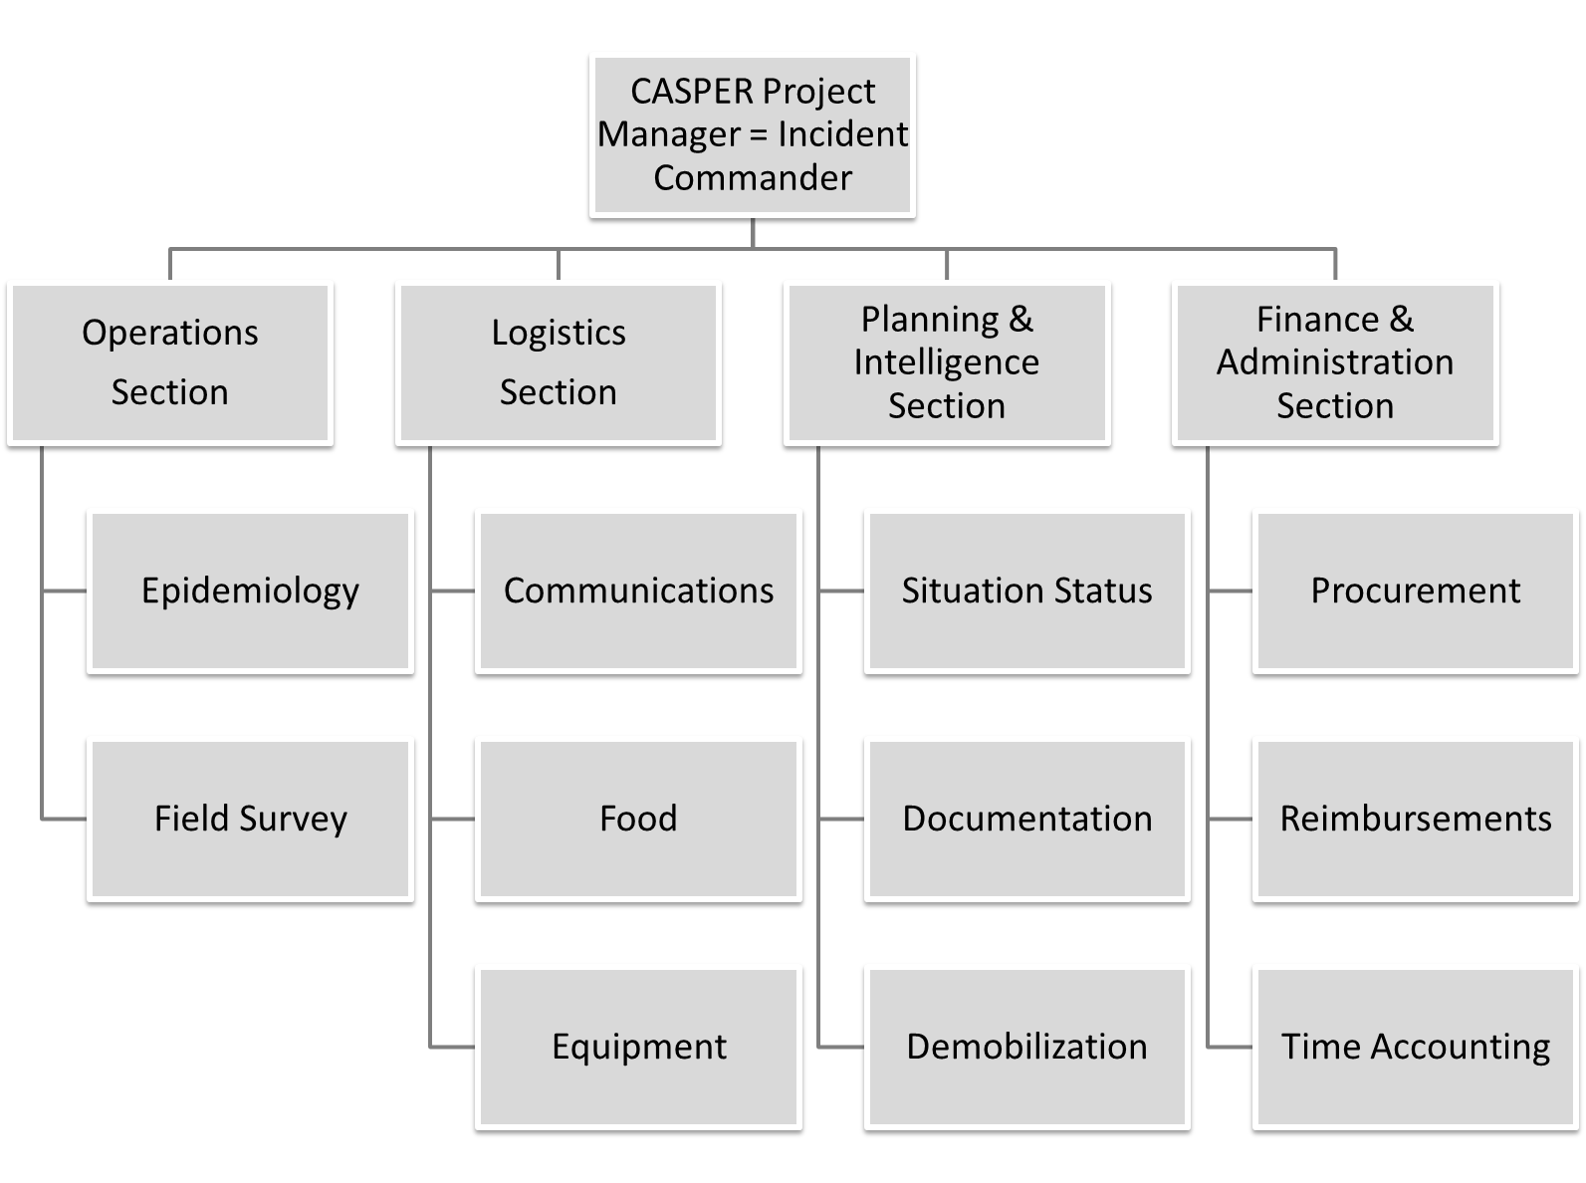
*Example created by the CDPH Environmental and Occupational Emergency Preparedness Team.

Figure 2. Example of an Operations Section’s CASPER Activities*
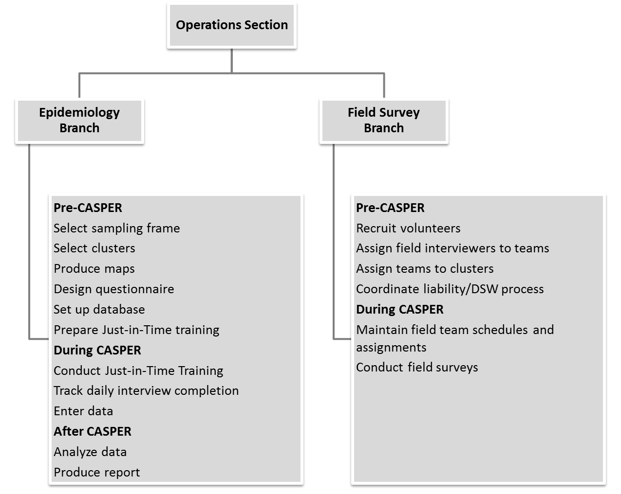
*Example created by the CDPH Environmental and Occupational Emergency Preparedness Team.

Figure 3. Example of a Planning & Intelligence Section’s CASPER activities*
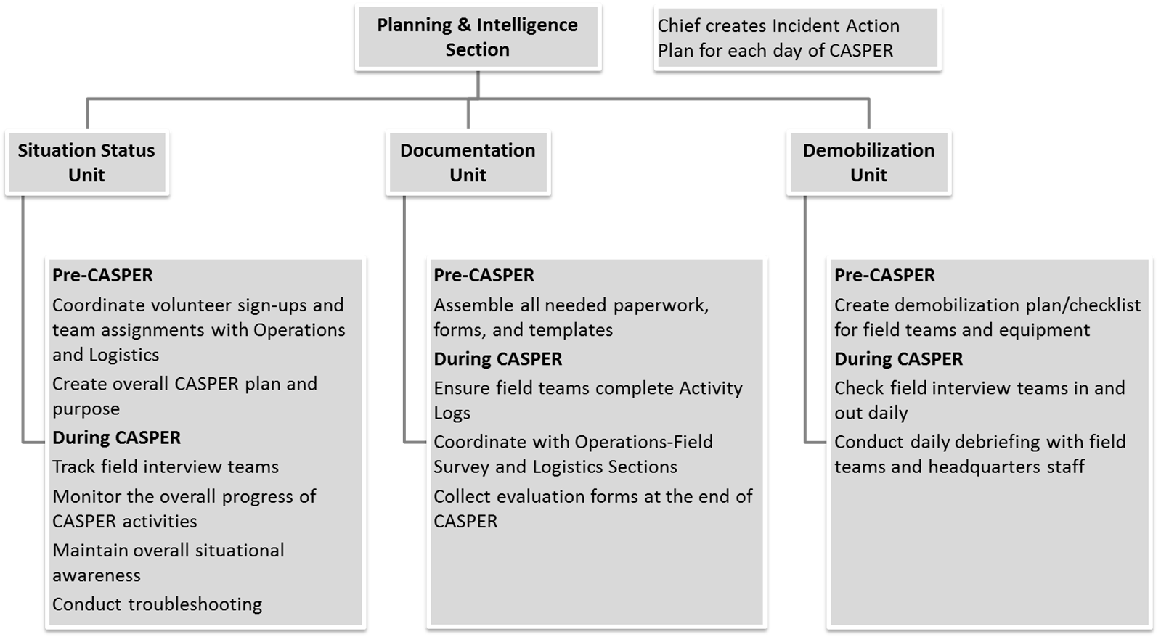
*Example created by the CDPH Environmental and Occupational Emergency Preparedness Team.

Public Health Emergency Preparedness (PHEP) and CASPER
CDC developed 15 capabilities to serve as national public health preparedness standards (https://www.cdc.gov/phpr/capabilities/) to guide state and local health departments in preparing for and responding to public health emergencies and incidents. PHEP capabilities are at the intersection of public health essential services and emergency management, and they include CDC requirements for training and exercises (https://www.cdc.gov/phpr/capabilities/dslr_capabilities_july.pdf).

In 2015, the Council of State and Territorial Epidemiologists published a crosswalk document illustrating how disaster epidemiology tools, such as CASPER, can be used to meet PHEP capabilities (http://c.ymcdn.com/sites/www.cste.org/resource/resmgr/PDFs/Crosswalk_5.28.15.pdf). Conducting a CASPER allows a jurisdiction to collect valuable data. It also provides an opportunity to train and exercise various PHEP capabilities by engaging multiple partners, directly interacting with the affected communities, implementing an organizational management system (i.e., ICS), evaluating specific plans and processes, and formulating and executing improvement strategies.

Tulare County CASPER
The Tulare County Health and Human Services Agency partnered with the Tulare County Office of Emergency Services (OES) and Tulare County Fire Department. The Tulare County PHEP Manager served as Incident Commander; the county Health Officer served as a Deputy Incident Commander. The vast majority of field teams were volunteers from local community organizations or county departments. The County’s EOC facility was used as the Incident Command Post and call center to manage all aspects of the two simultaneous CASPERs. The EOC facility was the just-in-time training site on the first day, then became the hub for logistics and communications. To maintain the ICS concept of span of control over the geographically large operating area, the Operations section was split into Northern and Southern branches that corresponded to the sampling frames. In each sampling frame, a fire station was designated as a forward operating base (Figure 4). Field supervisors from Tulare OES and scientific staff from CDPH staffed the fire station bases to handle field team check-in, check-out, meal breaks, and end-of-day debriefs. All teams checked in at their respective fire station base to collect their materials and receive instructions at the beginning of the day, returned to the base to eat lunch and turn in questionnaires completed in the morning round, and checked out at the end of the day after a daily debrief. At the end of the 3-day CASPER period, forward operating base staff demobilized the interview teams.

Every field team received a UHF radio that operated on one of the Sheriff’s channels as a backup to cell phones. Teams either radioed or called in their whereabouts as they progressed through their CASPER clusters and reported each completed questionnaire. Using Google Fusion Tables* (https://support.google.com/fusiontables/answer/2571232?hl=en), command staff monitored teams through the call center, allowing for universal awareness of team whereabouts at the Incident Command Post and forward operating bases. Incident Command Post staff watched for teams with long out-of-contact times. To help teams that had gotten lost and to ensure the safety of all teams in the field, Command Post or forward operating base staff called teams with long out-of-contact times to determine status. Forward operating base staff had county vehicles to respond to unreachable teams or those in need of assistance.

*Use of trade names is for identification only and does not imply endorsement by the Centers for Disease Control and Prevention, the Public Health Service, or the U.S. Department of Health and Human Services.
Figure 4. Tulare County CASPER Sampling Frame, Emergency Operations Center Headquarters, and Forward Operating Bases Locations 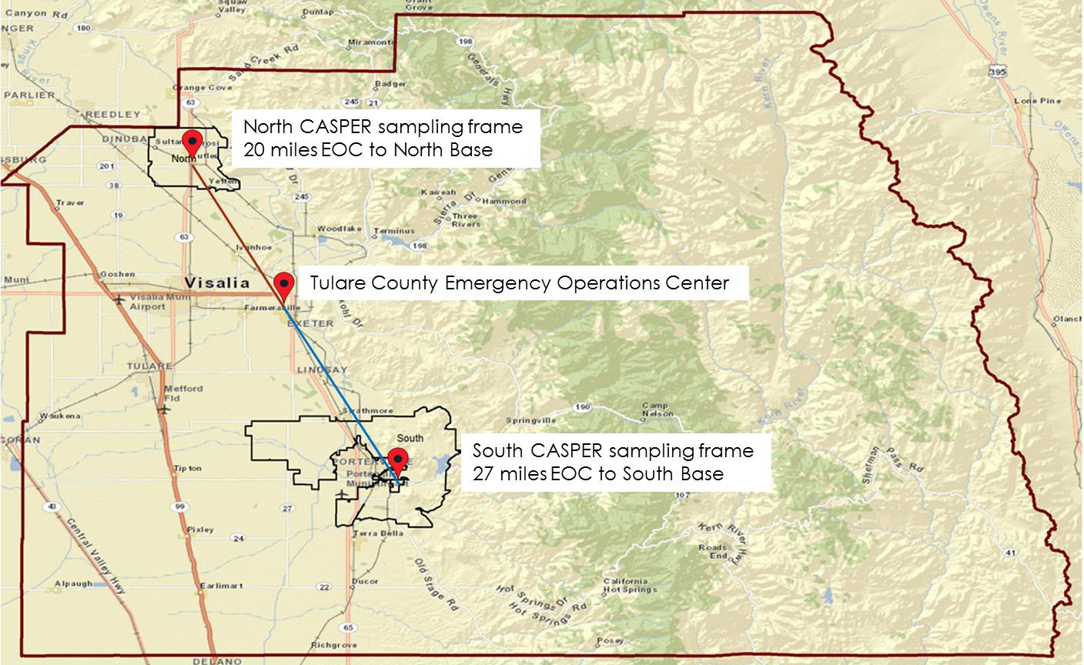

Mariposa County CASPER
The Mariposa County Health Department (MCHD) partnered with the Mariposa Amateur HAM Radio Group and Mariposa County OES. The Mariposa County PHEP Coordinator served as the Incident Commander; the acting county Health Officer participated as a field interviewer. Field team membership included county agency staff, local volunteers, and a small number of out-of-the-area volunteers. Mariposa County did not use its EOC for the CASPER; a fire station was designated as the headquarters. Various county personnel and scientific staff from CDPH staffed the headquarters to handle field team check-in, check-out, meal breaks, and end-of-day debriefs. Operations Section included Divisions based on geographical areas within the county; each field interview team was assigned to a Division. All teams checked in at the fire station to collect their materials and receive instructions at the beginning of the day, returned to headquarters to eat lunch and turn in questionnaires completed in the morning round, and checked out at the end of the day after a daily debrief. At the end of the 3-day initial CASPER period, headquarters staff demobilized interview teams. However, because of the small number of field interview teams, the CASPER had to be extended, and several teams operated out of the MCHD office for another 2 weeks to complete the necessary number of interviews.

Mariposa County has poor cellular phone coverage and a robust local Amateur HAM Radio Group, which chose CASPER as an opportunity to exercise its procedures and equipment. The radio operators integrated into the ICS structure, developed the communications plan, and managed the Communications Unit within the Logistics Section. Roving radio operator teams were assigned to CASPER field teams in various regions of the county; they were essential to relay radio transmissions from survey areas to the Communications Unit to keep track of team status and assure safety. Every field team received a radio as the primary communication method. Teams radioed (called or texted in areas with cell coverage) their whereabouts as they progressed through their CASPER clusters. Roving radio operators were dispatched to locate teams with long out-of-contact times in their assigned areas.

ICS Forms
FEMA offers templates for all ICS forms, such as the Incident Action Plan (ICS 201) and Activity Log (ICS 214), that can be used to document CASPER operations. This information is especially critical for reimbursements after a declared emergency (https://training.fema.gov/emiweb/is/icsresource/jobaids.htm).

Both Tulare and Mariposa counties took advantage of existing ICS form templates to create drought CASPER implementation plans and to document their activities. The incident commanders generated an Incident Action Plan (ICS form 201) for each day and compiled incident objectives (ICS form 202, Figure 5). Command staff in both counties used an Assignment List (ICS form 204) to manage field teams. Recognizing the rural and remote nature of the sampling frame, Mariposa’s Safety Plan (ICS Form 208, Figure 6) listed important safety messages to share with the field teams during the just-in-time training. The Finance Section in Mariposa County required all field interview teams to fill out Activity Logs (ICS form 214) for mileage and other reimbursement calculations. Tulare County used a sophisticated Excel spreadsheet to manage all of its ICS forms in a centralized document.

Figure 5. Example of ICS 202 Incident Objectives Forms from Tulare and Mariposa Drought CASPERs

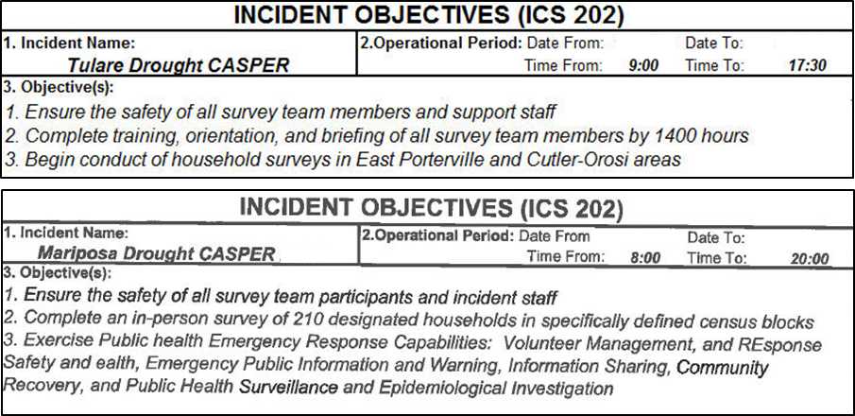

Figure 6. Example of ICS 208 safety plan form from Mariposa drought CASPER.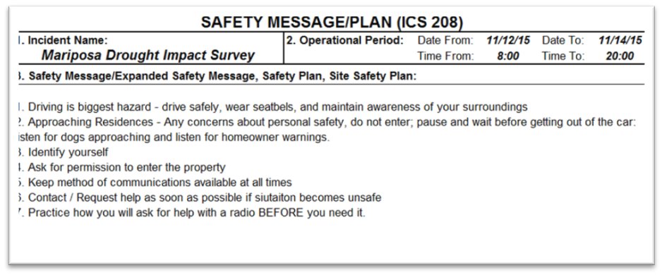

Exercise of PHEP Capabilities
As part of PHEP funding, all local health jurisdictions in California are required to participate in an annual statewide health and medical exercise. In lieu of the exercise, Mariposa County used the drought CASPER to test the following PHEP capabilities and their functions (1): Community Preparedness (Capability 1); Community Recovery (Capability 2); Emergency Operations Coordination (Capability 3); Emergency Public Information and Warning (Capability 4); Responder Safety and Health (Capability 14); and Volunteer Management (Capability 15). At the conclusion of all CASPER activities, the county developed an After Action Report (AAR) and Improvement Plan (IP).

Following is a detailed example of how CASPER and use of ICS tested Capability 3 in Mariposa County:
- For Function 1 (Conduct preliminary assessment to determine need for public activation), CDPH and MCHD defined knowledge gaps and priority topics for assessing the public health impact of the drought, gathered appropriate stakeholders (e.g., radio operators) for the incident command operations, and established lead and supporting roles.
- For Function 2 (Activate public health emergency operations), the county engaged its resources (human, technical, physical space, and physical assets) to address CASPER in accordance with the National Incident Management System and consistent with jurisdictional standards and practices (e.g., MCHD opened its Department Operations Center; the county PHEP Coordinator assumed the Incident Commander role; county staff were pulled from their daily jobs to assume ICS roles at CASPER headquarters or as field interviewers).
- For Function 3 (Develop incident response strategy), the Mariposa PHEP Coordinator in the role of the Incident Commander produced an Incident Action Plan (IAP) for each operational period, disseminated the plan to all staff, and revised the plan as necessary based on CASPER interview progress.
- For Function 4 (Manage and sustain the public health response), Mariposa County and CDPH had to extend field interview activities past the planned 3 days because of the county’s large geographic area and the small number of volunteers able to dedicate 3 full days to the CASPER. IAP and other activities were adjusted accordingly.
- For Function 5 (Demobilize and evaluate public health emergency operations), all field interview teams were debriefed and demobilized at the end of the CASPER, all deployed equipment (e.g., radios, safety kits, map atlases) was collected and inventoried, Activity Logs were turned over to Finance, and the AAR and IP were produced. The AAR and IP addressed every exercised capability and provided recommendations for improving county procedures. For example, as discovered during the field team debrief, the check-in process on the first day was unclear and chaotic. Therefore, the IP included specific recommendations for developing a smoother check-in process, which was successfully implemented during the 2016 follow up drought CASPER in Mariposa.

Administration of any CASPER directly fulfills two functions of Capability 14, Responder Safety and Health (identify responder safety and health risks; identify safety and personal protective needs) and the four functions of Capability 15, Volunteer Management (coordinate volunteers; notify volunteers; organize, assemble, and dispatch volunteers; demobilize volunteers). Therefore, jurisdictions conducting CASPERs could account for those activities in their PHEP deliverables as well.

Conclusion
Following an ICS while preparing for and conducting drought CASPERs in Tulare and Mariposa counties worked very well. The major advantages included clear roles, responsibilities and accountability among all partners, awareness of where field interview teams were at all times, and more efficient use of the resources (staff, equipment, questionnaires, and expenditures). Use of the EOC facility as an Incident Command Post in Tulare allowed for centralization of resources and communications in a single command center; operation of the bases in each of the sampling frames benefitted field teams that otherwise would have very long drives to headquarters. Mariposa exercised its PHEP capabilities and successfully partnered with the local Amateur HAM Radio Group, whose members provided critical communications for the CASPER field teams and filled in as interviewers when necessary. In addition to providing important public health impact data, the drought CASPERs in both counties stressed that maintaining a close working relationship among public health, emergency management, and community organizations is crucial for overall community preparedness and building of local resilience.

Reference

- Center for Disease Control and Prevention (CDC),. Public Health Preparedness Capability: National Standard for State and Local Planning. March 2011. Available at https://www.cdc.gov/phpr/readiness/00_docs/DSLR_capabilities_July.pdf

Disclaimer

The findings and conclusions in this chapter are those of the authors and do not necessarily represent the official position of the Centers for Disease Control and Prevention.

Additional Resources
The following CASPER resources can provide details of the assessment procedures and help state, tribal, local, and territorial health departments and public health professionals develop local capacity for disaster response:

- Center for Disease Control and Prevention (CDC).
  - The National Center for Environmental Health’s Health Studies Section (HSS) at the Centers for Disease Control and Prevention (CDC), Emergency Management, Radiation and Chemical Branch (EMRCB) is the response section for the Center (https://www.cdc.gov/nceh/ehsp/default.html) HSS helps state, tribal, local, and territorial health departments conduct CASPERs in the field or provides remote technical assistance on topics such as sampling and mapping or reviewing a questionnaire and analysis method. The CASPER toolkit and the web-based training resources are available at (https://www.cdc.gov/nceh/hsb/disaster/casper/default.htm)

- Council of State and Territorial Epidemiologist (CSTE)
  - The CSTE Disaster Epidemiology (DE) subcommittee identified the need to share information among state, local, and federal epidemiologists on disaster-related methods, tools, and lessons learned. To meet this need, the DE subcommittee created a repository of DE tools including CASPER and related guidance on their uses. Subcommittee members created a crosswalk of disaster epidemiology and public health preparedness to provide resources to health departments on disaster epidemiology tools to help meet the capabilities. https://www.cste.org/group/disasterepi

- National Institute of Health (NIH)
  - The NIH Disaster Research Response Program (DR2) is the national framework for research on the medical and public health aspects of disasters and public health emergencies. The DR2 website, provided by the National Institute of Environmental Health Sciences and the National Library of Medicine, supports disaster science investigators by offering data collection tools, research protocols, and disaster research news and events. https://dr2.nlm.nih.gov/

- North Carolina Health and Human Services (NCHHS)
- North Carolina's disaster epidemiology program created advanced CASPER tools to conduct community-based surveys. NCHHS provides disaster epidemiology consultation, technical assistance and training to the state's public health agencies and largest hospital systems to ensure preparedness and response capabilities that meet community needs, national standards, and state health department accreditation requirements. https://epi.publichealth.nc.gov/phpr/

- Texas Department of State Health Services (TXDSHS)
TXDSHS at Austin has established a CASPER Team to assist and partner with local and regional health departments in responding to public health emergencies in their communities. https://www.dshs.texas.gov/commprep/disasterepi/casper.aspx
- California Department of Public Health (CDPH)
  - The CDPH, Division of Environmental and Occupational Disease Control (DEODC) Emergency Preparedness (EP) Team conducted several investigation using the CASPER methodology and has developed a California-specific CASPER toolkit. The EP Team also provides disaster epidemiology consultations and technical assistance to local jurisdictions. https://www.cdph.ca.gov/Programs/CCDPHP/DEODC/Pages/Emergency-Preparedness-Team.aspx

CASPER learning resources

- CDC course (60-120 min, CEU available)
http://www.cdc.gov/nceh/hsb/disaster/CASPER_elearning/

- UNC course (25min, CEU available)
https://nciph.sph.unc.edu/tws/HEP_CASPER/certificate.php

CASPER videos

- Lake County, California, 2012
9 minutes, https://www.youtube.com/watch?v=vf12bE-pdu0
- Fort Bend, Texas, 2015
5 minutes, https://www.youtube.com/watch?v=37mWBZ83aQE
- Ysleta Del Sur Pueblo Indian Nation (El Paso), Texas, 2015
7 minutes, https://www.youtube.com/watch?v=pQtpKoAaV_w
- Harris County, Texas, 2015
3 minutes, https://www.youtube.com/watch?v=lDgna5xyG4c
10 minutes, https://www.youtube.com/watch?v=GwB9jtTbrKU
- Harris County, Texas , 2017
21 minutes, Just-in-time-training, CASPER overview
https://www.youtube.com/watch?v=d4VK4VeER0k
18 minutes, Just-in-time-training, Clusters and systematic random sampling
https://www.youtube.com/watch?v=nGh9SIVnuuM&index=2&list=PLOBJgqWGHBJG_rYakEIVZovcgjOGW9Rxm
Nine 1-minute videos on different CASPER aspects
https://www.youtube.com/playlist?list=PLOBJgqWGHBJEcdrJhS22AL3cvumFxtVWz
- CDC Response to Hurricanes using CASPER, 2018
5 minutes, https://www.youtube.com/watch?v=bTc91V1Xexg

