Turnt Thursday
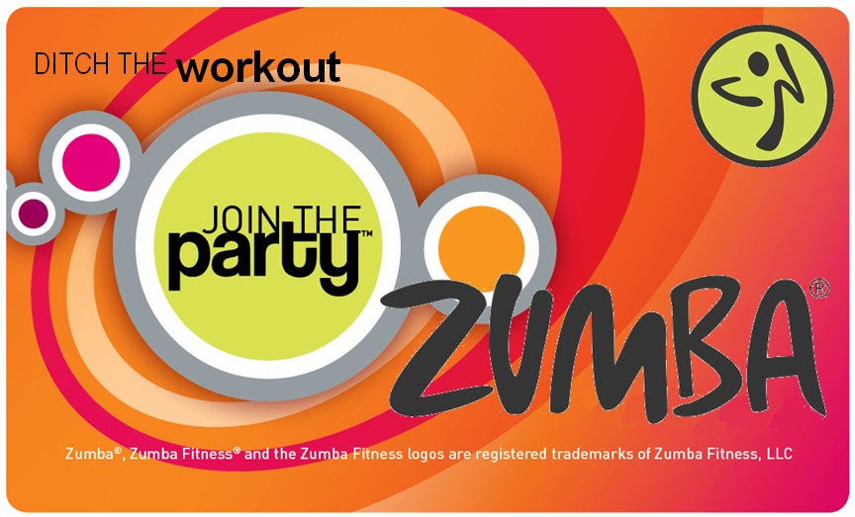
___________________________________________________________________________
What: Zumba
When: Thursday, October 5th at 3:00 pm E.T.
Where: All Hands Conference Room
____________________________________________________________________________
Put on your workout gear and join me in the All Hands conference room for a 15 minute Zumba Workout Demo! You don’t even have to know how to dance, just move your body and follow my lead. You’ll be having so much fun moving to the music that you won’t even notice that you are burning calories.

Did you know that 1 in 10 deaths could be prevented by getting enough physical activity? (CDC)

Benefits of Physical Activity for Adults
- Lowers risk of high blood pressure
- Lowers risk of stroke
- Improves aerobic fitness
- Improves mental health
- Improves cognitive function
- Reduces arthritis symptoms
- Prevents weight gain

See the links below for more information regarding the benefits of physical activity and recommendations:
Physical Activity Builds a Strong Healthy America (CDC)
American Heart Association's Recommendations for Physical Activity in Adults

Nikka Sorrells
Licensed Zumba Instructor
http://nikkas.zumba.com/

