Cucumber lemon infused water

You need a medium cucumber (in slices), a lemon (in slices) and approximately ten mint leaves. Mix all ingredients in a huge 2-quart water carafe. Let it steep over night and drink it through the day.
The lemon in this drink strengthens your immune system and helps to flush toxic waste. The cucumber acts anti-inflammatory and aids to control the water balance. Mint supports digestion and the lemon again gives your drink a natural sweetness without added sugar.

Basil detox water
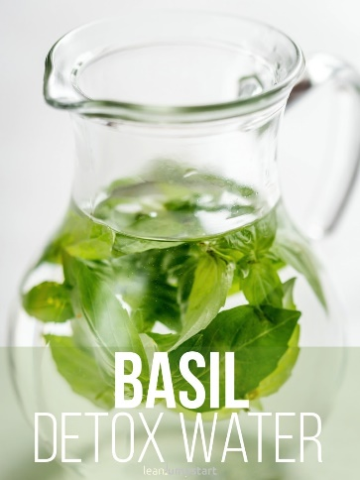
This herb infused water is a no brainer as most of you might have fresh basil sitting on the windowsill. You need a 1-quart pitcher with very cold water and 12 plucked, large basil leaves. Fold the leaves 1- 2 times to activate its flavors and add them to the water. Let the drink sit in your fridge for at least 1/2 an hour. Serve it with ice cubes.
Basil’s oils provide antibacterial and anti-inflammatory properties. Basil water can help alleviate feelings of fullness and sooth indigestion. The ultimate benefit though, it tastes amazing!

Blueberry orange vitamin bomb

Take the blueberry detox drink to the next level and add some orange slices to it (make sure it is organic and not waxed). It is best to use a 2-quart pitcher. If you wait one day you will be surprised how the water and orange change to a blue color.
Oranges help with healthy blood circulation and contain tons of vitamin A, C and antioxidants. Together with the blueberries they will aid you feel energized and boost your metabolism.

Raspberry lime detox water

Mix two tablespoons fresh or frozen raspberries and slices of one organic lime in a 1-quart mason jar. Fill it up with water and let it settle for half an hour.
Raspberries have strong anti-oxidative properties that support your kidneys, liver and colon to purify. Limes contain flavonoids that increase the secretion of acids and bile and stimulate the digestive system.
And not to forget the huge amount of vitamin C in limes… Did you know that one lime supplies almost 50% of your daily vitamin C?
On top of that this citrus fruit provides a tangy sweetness that makes this vitamin water recipe especially delicious.

Cranberry lemon detox water

Pop a cup of cranberries in a 2-quart water pitcher and add some slices of lemon. Top it with a spring of rosemary. Cranberries strengthen especially the bladder-renal tract and hence can prevent urinary infections.

