CSTE Infectious Complications of Injection Drug Use Workgroup
Basecamp Tutorial
1. Log-in to access your Basecamp Home Site. You will receive an automated email from notifications@3.basecamp.com. Click on the “Join (XX) in Basecamp” Button.
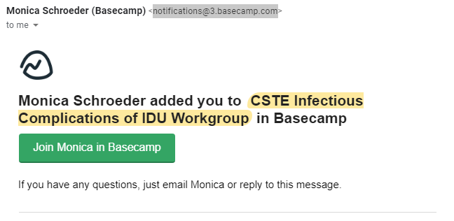
Already a Member of Basecamp? Log-in using your email address and password or Google Account information.
First time using Basecamp? Sign up for a new account using the instructions provided on your screen.
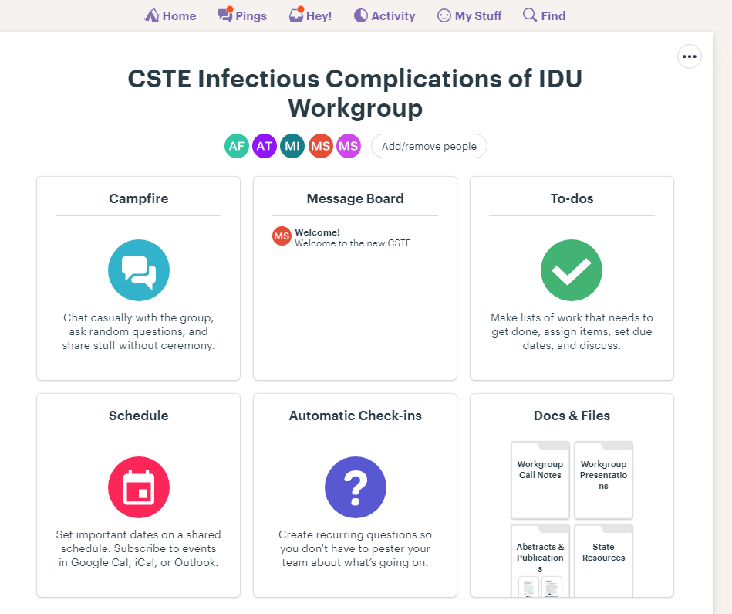
2. From your Basecamp Home Site, click on the ‘CSTE Infectious Complications of IDU Workgroup’ Project, if not automatically redirected.

3. Familiarize yourself with the Basecamp Site. Our Basecamp project has four main parts:
- Message Board: Forum for folks to discuss specific issues-- all are welcome to post
- Docs and Files: Place for all documents, files, emails communications
- To-Dos: WG to-dos and activities
- Schedule: Timeline and key deadlines
4. To adjust your notification settings - including what type of notification you receive, how they arrive, and when - click on your avatar in the upper right corner. Click "change your settings" and you'll be able to adjust how notifications work for your account.
