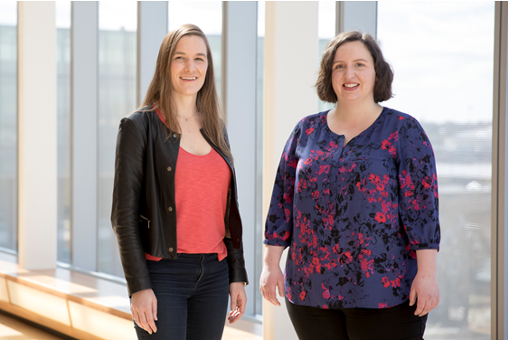

Kara Davidson (right) and Stephanie Judd (left), founders of Wolf & Heron, help driven professionals increase their impact through the skills of inspirational influence and facilitation. With a deep knowledge of the psychology of leadership and organizational behavior, they deliver skill-building workshops, offer one-on-one coaching, and speak about how to inspire others to think and act differently.

Kara
Kara draws her expertise in behavior change and leadership from a background in environmental activism and positive organizational scholarship. Her approach to one-on-one coaching is that of powerful listening and support where she aims to create a space to reflect on what is and imagine what could be.

In her free time, Kara enjoys being a puppy Mom, hanging out with family and friends in upstate New York, and listening to podcasts.

Stephanie
Stephanie Judd pulls her expertise in inspiration and behavior change from a background in technology and public health. Her approach to one-on-one coaching is anchored in visioning, self-motivation, and strong accountability.

In her free time, Stephanie likes to rock climb, snowboard, and listen to TED talks in her home in the Colorado Rocky Mountains.

