New Hampshire Grant Funding for Epidemiology and Laboratory Capacity
and Public Health Preparedness Case Study

By reading this case study and discussing the questions, learners will be able to:
- Identify and discuss approaches for strategic partnerships for grant funding.

Background
CDC provides funding to states through the Epidemiology and Laboratory Capacity for Prevention and Control of Emerging Infectious Diseases (ELC) and the Public Health Emergency Preparedness (PHEP) Cooperative Agreements (CoAgs) as primary mechanisms to help health departments build and strengthen their abilities to detect, respond to, control, and prevent infectious diseases, and respond to a range of other public health threats. The ELC CoAg is focused on supporting three core areas of infectious disease control including 1) Surveillance, Detection, and Response; 2) Prevention and Intervention; and 3) Communications, Coordination, and Partnerships. The PHEP CoAg helps health departments build and strengthen their abilities to effectively respond to a range of public health threats, including infectious diseases, natural disasters, and biological, chemical, nuclear, and radiological events, with the goal of developing of emergency-ready public health departments that are flexible and adaptable. While CDC funds these programs across all 50 states, several local jurisdictions, and most US territories, recipients are able to administer their own programs in a way that best meets their needs while working to fulfill the broader CDC program objectives.

The State of New Hampshire created a partnership to align the ELC and PHEP programs through shared and overlapping leadership. The partnership grew organically out of a realization that each of the two programs had individual components that added value to the department and could be leveraged for other public health programs. Both programs have leadership teams that oversee the grant funding and program activities. For the PHEP program, the leadership team was created because of the broad involvement of related health department program areas (infectious disease, environmental health, laboratory services, community preparedness, emergency preparedness, hospital preparedness) and the value it provided in understanding program stakeholders’ needs and the way the PHEP program was managed. For the ELC program, the leadership team was created due to the CDC mandate that the ELC have a governance team, consisting of specific members from different areas of the health department to oversee the federal grant award. Out of these realizations, a multi-faceted partnership evolved.

Initiating the Partnership
When initially developing the partnership, it was natural to follow the organizational model of the PHEP program’s existing leadership team, because of its broad reach across many state agencies and the success it had in building partnerships external to the health department. Members of the ELC team had seen value in the way the PHEP was managed for years, involving many different programmatic and agency stakeholders, and decided to create a structure similar to what the PHEP program had done. Both the PHEP and ELC teams developed charters to define roles and responsibilities (Table 1), outline practices around their leadership teams, and how decisions would be made. Key stakeholders from areas of public health laboratories, epidemiology, emergency services unit, health information systems, hospital-acquired infections, homeland security, and the emergency management agency collaborate to achieve the objectives of the PHEP and ELC grants.

Table 1. Grant Leadership Team Membership
Role | Responsibilities | PHEP | ELC
PHEP Director | Provides senior leadership to public health and hospital preparedness activities in NH. Liaisons with state and federal agencies. Collaborates with the PHEP & HPP Grant Administrator and Financial Administrator to ensure grant applications, progress reports, and budget items are submitted as required. Reports PHEP and HPP activities to the DPHS Director. The PHEP Director title is currently assigned to the Chief of the Bureau of Infectious Disease Control, which may be reassigned at the discretion of the DPHS Director. | X
PHEP & HPP Grant Coordinator | Ensures grant applications, progress reports, and budget items are submitted as required. Liaisons with preparedness staff and external partners to improve preparedness activities and reports to the PHEP Director. | X
Emergency Services Unit Representative | Represents the preparedness and response activities carried out by the DHHS Emergency Services Unit. This representation on the Leadership Team is typically provided by the Director of the Emergency Services Unit, who serves as the ESF 6 & 8 lead (health, medical, and sheltering) within the State Emergency Operations Plan. | X
Public Health Laboratories Representative | Represents laboratory-related preparedness and response capabilities and activities. This representation is typically provided by the Public Health Laboratory Director. | X | X
Infectious Disease Control Representative | Represents infectious disease-related preparedness and response capabilities and activities. This representation is typically provided by the Chief of the Bureau of Infectious Disease Control, who currently also serves as the PHEP Director. | X | X
Environmental Health Representative | Represents environmental health-related preparedness and response capabilities and activities. This representation is typically provided by the Chief of the Bureau of Public Health Protection. | X
Community Preparedness Representative | Represents community health-related preparedness and response capabilities and activities. This representation is typically provided by the Administrator of the Community Health Development Section. | X
HSEM Representative | Represents broader all-hazard preparedness and response capabilities and activities as a designee of the Department of Safety’s Homeland Security and Emergency Management agency. | X
PHEP & HPP Grant Financial Administrator | Works with the Leadership Team to develop grant applications, progress reports, and budget items as required. Supports PHEP and HPP administrative processes such as hiring, purchasing, and contracting. Liaisons with other financial staff and reports to the PHEP Director. | X
Health Information Systems Representative | Represents health information systems capabilities and activities. This representation is typically provided by the Bureau of Public Health Informatics and Statistics Chief. |  | X

The Director of Public Health is also a stakeholder in that this person who is positioned at the top of the organizational hierarchy also engages with both governance groups and can be called in to make decisions if needed. The health department organizational chart (Table 1) illustrates the grant funding sources and cross-program roles of individual positions within the organization. Many key roles in the organization receive funding from both the PHEP and ELC grants, further strengthening collaboration between the two programs.

Operationalizing the Partnership
The operations of the partnership are intentionally designed to contribute to their success. Considerations of the partnership design include:
- Governance structures established for both ELC and PHEP-HPP through program charters, outlining the leadership teams, decision-making authority and practices, expectations of the group, etc.
- Cross-program teams, with broad representation of health department programs.
- Dual leaderships roles held by individuals across the program areas (i.e., the PI on the ELC grant is also on the PHEP-HPP grant governance team; the epidemiology lead for the ELC and Deputy State Epidemiologist is also the PHEP Director), Figure 1.
- Succession and continuity and planning for leadership positions to sustain the partnership across time.
- Dedicated financial managers for the grants and programs they support.
- Shared staffing across grants in the areas of health information systems, finance, and others, Figure 3.
Figure 1.
- Support of the collaboration from the finance director of the health department.
Dual PHEP-HPP and ELC Leadership and Staffing Roles
- PHEP Director; Infectious Disease Control Chief;
Deputy State Epidemiologist; ELC Epidemiology Lead
- Director, Public Health Laboratories;
ELC Principal Investigator; PHEP Governance Team
- Health Information Systems Data Manager

- Training short course for program managers on Introduction to Finance.

Working through Challenges
The partnership assures ongoing collaboration through regular meetings of the governance teams to review different issues including expenditures, potential for redirecting funds, and meeting the grants’ significant reporting requirements. The meetings follow agreed upon ground rules as defined in the charter, Figure 2. While straightforward, given the often sensitive nature of the leadership team discussions (e.g. budgeting decisions including potential cuts to leadership team member programs), they are important to establish.
Figure 2.
Grant Program Charters Meeting Ground Rules
- Members will refrain from interrupting others and will speak one at a time.
- All members who wish to have an opportunity to speak will be afforded a chance to do so.
- Members will actively participate in meetings.
- Members will maintain a respectful stance towards one another and any other attendees.
- Members should remain flexible and open-minded.
One core challenge experienced by the teams is the limited funding compared to program needs. Both charters include language that specifies that one focus of the leadership and governance teams is “to assure cost-efficient and appropriate use of limited funding and other resources to maintain and improve public health and health care systems preparedness in order to protect and improve the health of residents and visitors to New Hampshire” and to “make strategic recommendations and decisions about ELC resources.” These strategic recommendations and decisions about resources include how to handle expenditures and how to redirect funds, if necessary. This became a very real issue for the programs with the realization that they had $6.0-6.5M in needs, but only $5M in available funding. Everyone had to give up something when it came to program budgeting and funding trade-offs, and balance the needs of the programs, the human (employee) needs, and still be able to work within their budgets. They are able to make these trade-offs and do it collegially, so that they can get their budget to where it needs to be. This requires the leadership team members to see beyond their own program needs to the larger picture of what the programs are supposed to accomplish.

Another challenge is when they have to balance the need to protect the current workforce with how they want to use funds in the future. Because the funding is limited, and needs of the organization change over time, sometimes there’s a desire to use a position in a different way (repurpose) or to phase out a position (eliminate). Rather than moving toward a layoff, they will often wait for that position to become vacant. This was described as balancing their business needs with recognizing that all their staff are human beings and they want to honor their employees and care about them as people while at the same time staying within their budgets.

The groups have always been able to come to consensus as a team and with a strong sense of how their decisions will impact other programs. Because of the strong connections and collegial relationships built between the two teams, New Hampshire has avoided some of the tensions that programs in other states have experienced. For instance, it is common in other states for the epidemiology and preparedness programs to not communicate with each other. This lack of collaboration had led some preparedness programs to stop funding epidemiology roles altogether, or fund only certain positions.

Sustaining the Partnership
The formal charters established for the PHEP and ELC programs are important elements in sustaining the partnership. The charters established the purpose and goals of the teams, memberships and authorities, roles and responsibilities, operating guidelines, decision-making, and conflict resolution strategies. Having a formal, coded charter establishes who would fill which roles, independent from the specific person who might be currently filling that role. For example, the PHEP Charter specifies that “the PHEP Director title is currently assigned to the Chief of the Bureau of Infectious Disease Control.” This ensures that in the future, regardless of which individuals are involved, there will be cross-functional roles in the governance teams for the grants.

Partnership is also sustained is through continuity planning. There are currently two persons filling the roles of epidemiologist, laboratorian, and health information systems, one a lead, and one a back-up. If someone were to leave one of those roles, the other person would be ready to step in immediately, providing continuity of service to the governance team and program.

The Value of Relationships
The program leaders attribute their success with this collaborative to several things, some of which may be specific to smaller states. The New Hampshire Division of Public Health Services has many long-term employees who over the years have built personal relationships with their colleagues and provided continuity to their programs. They are all located in one city, in one building, and have become accustomed to making decisions together. Communication among the employees and teams happens consistently through regular meetings, and the State Health Officer, program managers, and grant program staff are all able to communicate easily and effectively because of their close relationships and participation on the cross-program teams. Because of the personal and professional connections felt with each other there’s a lot of support provided, and a willingness to work through issues to a resolution built on consensus.

This team-based collaborative model requires that individuals approach decisions from a systems thinking perspective – it’s not just about you, the work you do, and your program – it’s about the organization as a whole. It’s also important to use good facilitation skills to work through making difficult decisions, and to be inclusive in the decision-making process so that everyone is heard and understands the choices faced by the governance teams and the ramifications of their decisions. Although the Director of Public Health has the final decision-making authority, there has never been a time when the governance teams couldn’t work out a consensus decision on their own. And this, more than anything is what defines a successful collaboration for the PHEP and ELC governance teams and programs in New Hampshire.

Figure 3.
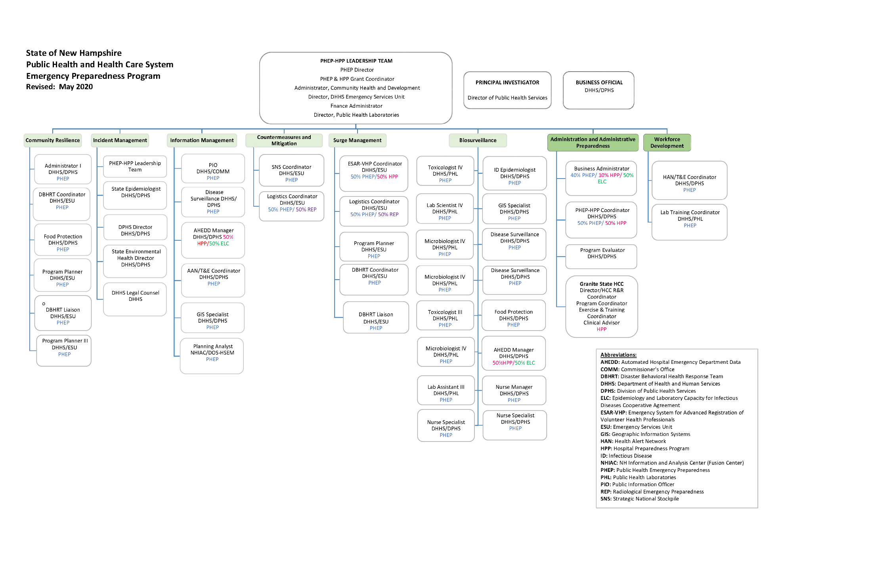

Questions for Discussion:

Q1. How do the drivers of this collaboration in New Hampshire relate to drivers present in your agency?

Q2. Which groups or programs within your agency do you think could collaborate on a future grant submission?

Q3. What does the phrase “to get something, you have to give something” mean in the context of this collaboration?

Q4. What activities would you need to undertake to plan for a joint grant submission to share resources and services similar to what New Hampshire did?

