Dear state and territorial partners:

Thank you for your continued partnership in the ongoing emergency response to the novel coronavirus, COVID-19. As we presented at the 50-state CSTE call on Wednesday, February 19th, we will begin to transition today, February 25th, to ‘Phase 2’ of jurisdictional identification and reporting of persons under investigation (PUI) and laboratory-confirmed cases of COVID-19.

This transition to Phase 2 will occur for all reporting jurisdictions that are able to do the following:
- Assess ill persons and determine PUI status
- Assign unique identifiers to PUI and cases using the specified format (Figure 1, below)
- Report PUI and laboratory-confirmed cases to CDC using a brief, combined, report form

For the purposes of COVID-19 PUI and case reporting, a ‘reporting jurisdiction’ refers to any jurisdiction that submits data directly to the National Notifiable Disease Surveillance System. A complete list of the 59 jurisdictions included as reporting jurisdictions is contained below (Figure 2). Although COVID-19 is not a nationally notifiable disease, limiting reporting to only these jurisdictions will provide greater assurance of unique ID assignment and ensure higher data quality during this rapidly evolving outbreak.

If your reporting jurisdiction is able to meet criteria to move to Phase 2, please email the State Coordination Unit of the CDC COVID-19 Epidemiology Task Force at eocevent118@cdc.gov to confirm your readiness.

Jurisdictions in Phase 2:
Jurisdictions in Phase 2 will have processes in place to determine an individual person’s PUI status without first contacting CDC. CDC staff remain available via the CDC EOC (770-488-7100) to consult on whether a person meets criteria for being a PUI. We recognize that many jurisdictions will choose to centralize this type of PUI assessment at the state level while others may develop systems that use a more decentralized approach.

Reporting jurisdictions will also assign unique identifiers (nCoV IDs) for each PUI and laboratory-confirmed case at the reporting jurisdiction level. To ensure that nCoV IDs are truly unique, reporting jurisdictions must use the ID format described in Figure 1, below.

As of Monday, February 24th, a single, combined form for reporting PUIs and Cases (PUI and Case Report Form) is available on CDC’s novel coronavirus website. The data dictionary and instructions for completing the form are available on the same website. For convenience, we are attaching copies of the report form, the data dictionary, and the form instructions to this email. PDF copies of the PUI and Case Report Form remain available on CDC’s website for local use but should not be used to transmit data to CDC.

Before shipping specimens to CDC, jurisdictions in Phase 2 should enter data on PUIs directly into the DCIPHER data platform, unless other arrangements have been made and approved by CDC. Data entered into DCIPHER will be used to identify laboratory samples for testing and to link specimens and their results back to individual PUIs and cases. Data must be entered into DCIPHER in order for laboratory specimens to be tested by CDC.

While CDC encourages all reporting jurisdictions to provide updated information on PUIs and cases as it becomes available, the following variables are those considered minimally-acceptable for initial data submission to CDC:
- CDC 2019-nCoV ID (cdc_ncov2019_id) (required field)
- Reporting jurisdiction (state) (required field)
- Current status of the person as PUI or laboratory-confirmed case (current_status)
- Report date of PUI to CDC (pui_cdcreport_dt)
- Report date of case to CDC (case_cdcreport_dt)
- Sex (sex)
- Age (age) and Age Units (ageunit)
- Symptoms present during course of illness (sympstatus)
- If symptomatic, onset date (onset_dt)
- Hospitalization status (hosp_yn)
- ICU Admission status (icu_yn)
- Death (death_yn)
- If female, currently pregnant (pregnant_yn)
- Travel to mainland China (exp_China)
- Travel to other non-US country (exp_othcountry)
- Travel to other non-US country, specify (exp_othcountry_spec)
- Household contact with a COVID-19 case patient (exp_house)
- Community contact with a COVID-19 case patient (exp_community)
- Any healthcare contact with a COVID-19 case patient (exp_health)
- Healthcare contact with a COVID-19 case patient, healthcare worker (exp_health_hcw)
- Exposure to a cluster of patients with ARDS with unknown etiology (exp_cluster)
- Specimen type (see series on specimen type)
- Specimen ID (see series on specimen ID)
- Specimen sent to CDC (see series on specimen sent to CDC)

Variable names are contained in parentheses and can be found in the data dictionary (attached and on CDC’s website).

Specimens should be packaged and shipped to CDC using the attached instructions for labelling and shipping novel coronavirus specimens. All specimens should include the CDC 2019-nCoV ID in the box specified in CDC’s shipping instructions, which will facilitate timely testing of laboratory specimens.

Jurisdictions in Phase 1:
Jurisdictions that are not in Phase 2 should continue to follow previously established processes. This includes calling the CDC EOC (770-488-7100) to consult with CDC staff on determining whether a person meets criteria for being a PUI, receiving a CDC-issued CDC2019-nCoV ID, and working with CDC to complete the PUI and Case Report Form.

CDC is available to answer questions about the PUI and laboratory-confirmed case-reporting process. For inquiries, please email eocevent118@cdc.gov. We appreciate your continued efforts.

Best,
CDC COVID-19 Epidemiology Task Force

Figure 1.
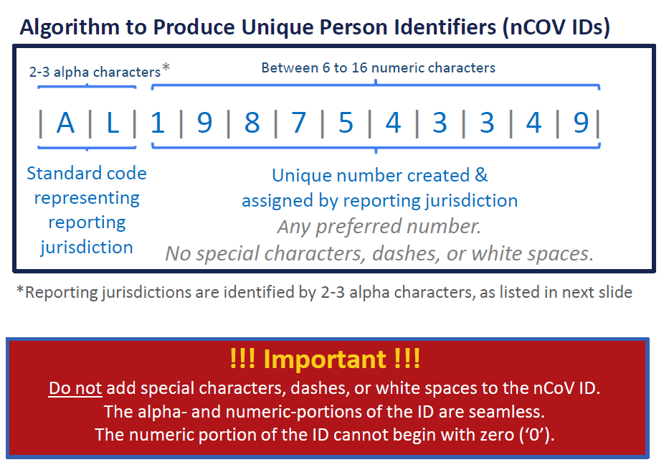

Figure 2.
