High-Level Presentation Notes:
- The strategy for sequencing has evolved over the past two years. At the federal level, there are several large surveillance activities:
  - CDC SARS-CoV-2 Strain Surveillance (NS3) program: Jurisdictions are supported through ELC and submit a random selection of specimens to CDC for sequencing and characterization.
  - Contracts with larger multi-state labs that submit sequence data from a broad geography to CDC.
  - Support sequencing at the state and local level: Many jurisdictions conduct routine surveillance for variants that are circulating within the region, often focused on clusters/outbreaks and emergence of unusual variants and patterns of disease.
  - Efforts at the federal level provide the 10,000-foot view. Efforts at the state and local level provide a much more granular view.
- The pandemic has mobilized resources from the academic and research community in a way that is relatively unprecedented. About 90% of sequencing that was occurring through Spring of 2020 was occurring in academic and clinical labs, which were not optimally connected to public health. The SPHERES model attempts to connect all the independent efforts to public health, in effect forming a national surveillance system.
- Consensus sequences are housed in a database called GISAID. Public health labs are also asked to submit to NCBI, both to GenBank and if able, the raw sequence data to the Sequence Read Archive (SRA). The goal is for the sequencing data to be interoperable and highly accessible.
- Progress: At the end of 2020, labs had sequenced and submitted just over 57,000 sequences (relatively small proportion to the number of total cumulative cases). In the past year, that number has increased markedly to over 1.8 million sequences submitted (and rapidly climbing). The number of sequences per day is about the same as all of 2020.
- Who is sequencing and where are the data coming from? Over the past year:
  - Federal labs/surveillance: ~48% of sequences
  - State, territorial, local, and tribal public health labs: ~25% of sequences
  - Academic and clinical labs: ~25% of sequences
  - Private sector labs: ~2% of sequences
- What data get put into these public repositories? Attempts have been made to standardize as much as possible, but given the number of entities involved, data standardization remains an important challenge.
  - Pango-lineages are determined by the sequencing lab. These identifications can change.
  - Submissions to public repositories are checked at the submitting lab and also curated by the repository.
- Examples from both GISAID and NCBI are shown next.

- GISAID record example:

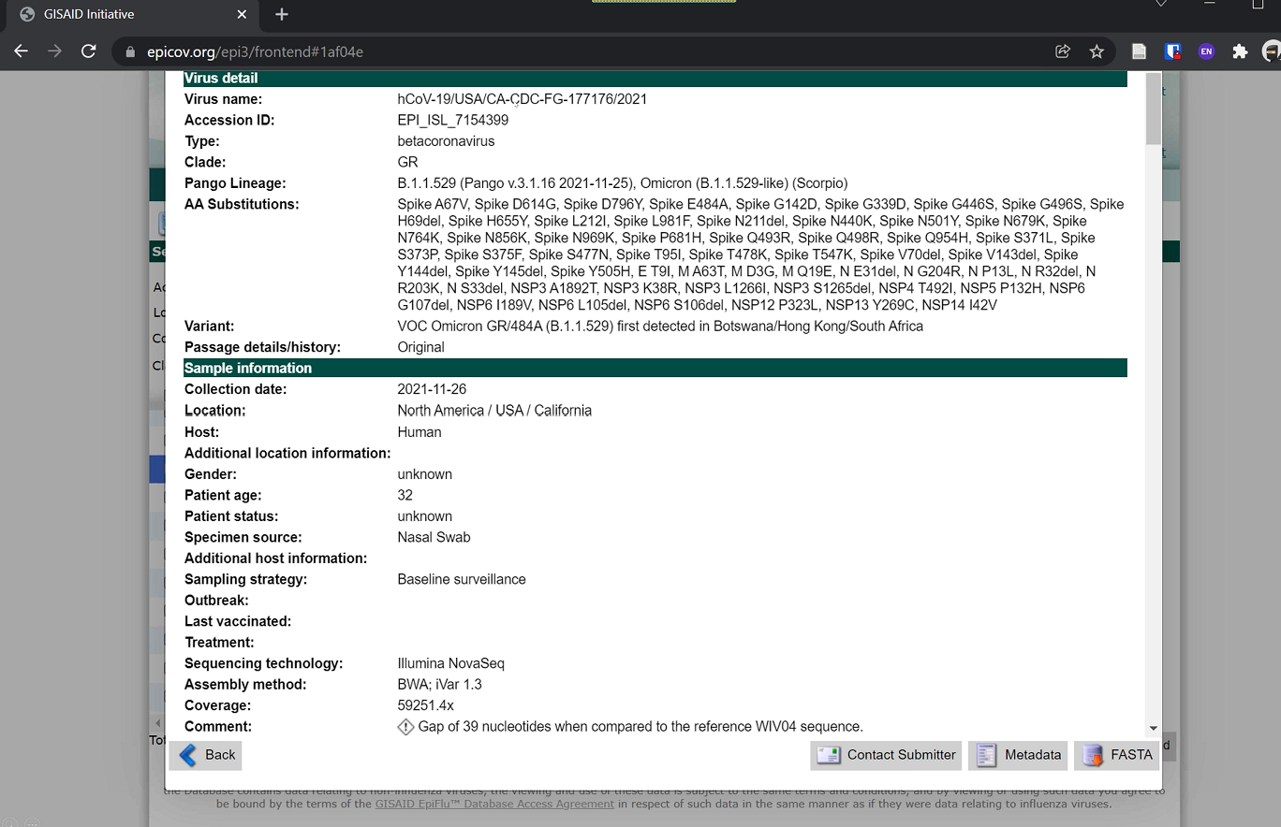

- The way that GISAID represents the Virus Name is different than standard taxonomic convention. However, the segment in the middle of the Virus Name is important and was made a standard format, and is fairly consistent across repositories. Virtually all US viruses will have: 2-letter abbreviation for the state or territory of origin-identifying or sequencing lab-unique identifier for the virus itself. In the example record above, this is captured as the ‘CA-CDC-FG-177176’ segment within the longer Virus Name. The lab-number portion is unique for each virus name.
- GISAID ID is assigned by GISAID after the submission is curated.

- NCBI record example:
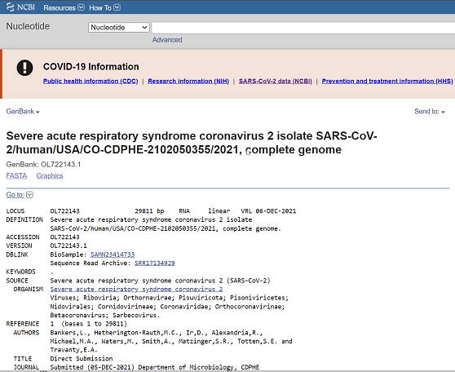

  - Cross-walking between repositories can be challenging. CDC submits to NCBI first to get an accession number, and then subsequently submits those data to GISAID. CDC has created a Github site containing excel files that facilitate some mapping between repositories. The Github is updated approximately every two weeks.

Discussion and Questions:
- What does NCBI stand for?
  - The National Center for Biotechnology Information, a subgroup of the NIH National Library of Medicine (NLM).
- In the GISAID Example - what does the data element Patient Status cover?
  - Patient Status is included within the standard meta-data from a GISAID record (under Sample Information in the example GISAID record). There isn’t necessary a controlled vocabulary for many of these variables; these are typically open-text. CDC is working to develop consistent meta-data standards that works across different repositories. For Patient Status, this may include “deceased,” “recovered,” and in some cases brief clinical notes. In sum: it varies.
- For the Virus Name (GISAID), is that naming structure followed only when the sequence is coming from a CDC-contracted lab? I.e., do other labs have their own naming conventions?
  - Almost all US records use that naming convention.
- Within the Virus Name (GISAID), where can we find the abbreviations for the submitting/sequencing labs? Is there a table or file that compiles which abbreviation corresponds to which lab?
  - For example, LabCorp would show up as LC####### (no dash). This is known as the LC identifier, which is sent as the study sequence identifier. You could type LC####### if the database and it would bring up the record.
  - Meta-data could also help to triangulate and identify the submitting lab if you don’t know what the prefix stands for.
- What is the relationship between the GISAID Virus Name and the Lab assigned Genetic Sequence Identifier that is to be included in the ELR?
  - Sequences that are submitted to both repositories (GISAID and NCBI) have the sequence data itself, a Virus Name, and an accession ID. The GISAID record also contains the Pango Lineage classification, which may change over time (moving target). Once sequences are accepted by the repository, they are assigned accession numbers. For GISAID, it would be the ‘EPI_ISL_#’ (EPI_ISL_7154399 in example record above). For NCBI it would be the GenBank ID (OL722143 in example record above).
  - If you are trying to include that accession ID in an ELR record, there is an important time delay to note. You will have the sequence information, you may have an initial Pango designation or classification, but you may not yet have the accession number for another day or more depending on turnaround time (and how backed up the repositories are).
- What kind of information should public health agencies be looking for labs to send so that when we put the data into our surveillance system, the epis are able to subsequently use it?
  - In an ideal world, the lab would include the consensus sequence itself as part of the messaging payload. However, that is usually not something that is possible with most HL7 messages.
  - Including the Pango classifications can be useful, although these classifications can change over time. Therefore, it is helpful to include some versioning or context around the currency of that Pango classification. The most useful record that should be included is an accession number (either to NCBI GenBank or GISAID).
- Regarding guidance to labs, should public health agencies advise that labs report using the sequence study number that was included when submitting to the repository, or should the labs wait and use the accession ID they get back from the repository?
  - The sequence study identifier is probably the better option. In the case of the GISAID example record, within the Virus Name, the segment with the 2-letter abbreviation for the state or territory of origin-identifying or sequencing lab-unique identifier (e.g., ‘CA-CDC-FG-177176’) should be fairly consistent and searchable across databases, allowing you to link an ELR record to a specific sequence in either repository (assuming that the repository has accepted that submitted sequence). That middle segment is a good searchable term.
- For labs just starting to perform sequencing, how will they know what lab identifier prefix to use such that it would not be the same as what another lab is using? Are there recommendations for lab sequence ID consistency across GISAID and NCBI in cases where the data corresponds to the same sequence? And is this identifier totally unique? Or does it depend on the submitter doing due diligence there?
- This prefix is largely created by self-designation. Currently, there is not a great way to ensure duplicate prefixes. However, the information included within the record would be different.
- What determines the value of the year at the end of the virus name? Is it the year of the specimen collection date? That year represents collection year.

