ESSENCE Occupational Subsyndrome.
When you are in the Query Portal, under the Available Query Fields scroll down to “Syndrome Subsyndrome CCDD Combined Category”. When you click on it a list of values will pop up on the right and if you scroll down you will find “SUBSYNDROME Occupational”.

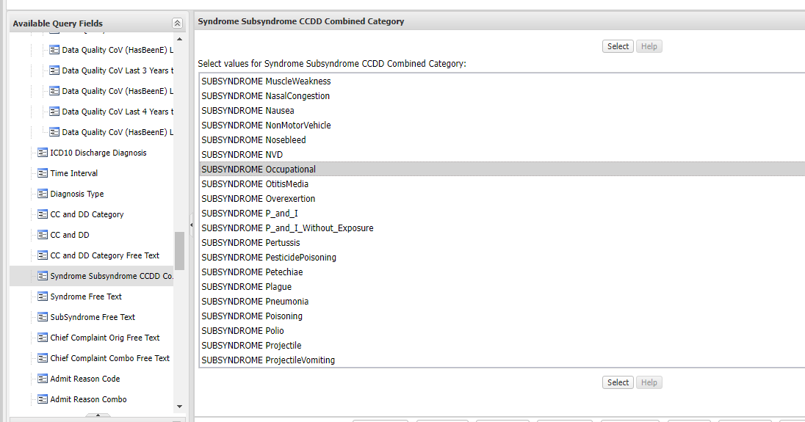

If you go to the “More” tab at the top and click on “Syndrome Definitions” then “Subsyndromes” under either NSSP or DoD a list of subsyndromes will come up and if you scroll down you will see “Occupational”. When you click on it you will see the keywords for that syndrome definition. See below.

