ESSENCE Occupational Subsyndrome

Response from CDC/NSSP:

The occupational subsyndrome was created quite a number of years ago when ESSENCE was just starting, pre-NSSP.

I believe the background on it is a number of experts worked on very large labeling datasets and these were used to create the syndromes and subsyndromes in ESSENCE, including this occupational subsyndrome. All syndromes and subsyndromes use the parsed Chief Complaint field and can include fuzzy matching and modifying negative terms as well. The below screenshot includes the terms in this subsyndrome. The numbers next to each term are point values and a visit must have a point value of 6 or greater to be labeled with the subsyndrome. Keep in mind that if a Chief Complaint has a negative term like “Denies Workplace” then the value is changed to a negative 10.

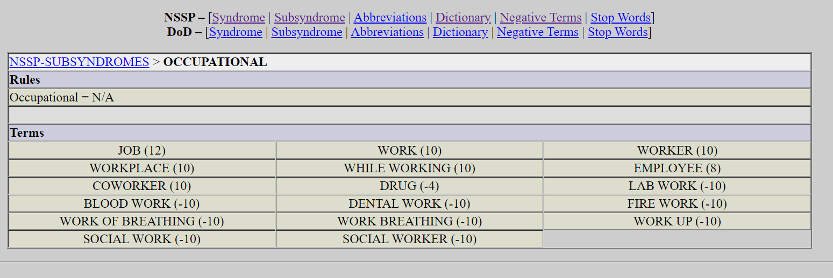

Response about updating the subsyndrome after we analyze it:

For subsyndromes, they technically can be changed but changing one requires a very intense amount of re-processing data. I would encourage you to submit any recommendations to the NSSP Helpdesk via the “Suggest a New Feature or Improvement” option Service Desk - Jira Service Management (atlassian.net). We currently keep a list of recommendations to address. If changes are made, it’s best to save up multiple ones so re-processing can happen simultaneously.

That said, we do have ways to add custom definitions via the CCDD Categories and custom free-text queries can be shared among the community. That would allow you to write a fine-tuned query to meet your needs. For example, you can start with an approximation of the existing subsyndrome:
^job^,or,^work^,ANDNOT,(,^blood work^,or,^work of breathing^,or,^social work^,or,^work breathing^,or,^dental work^,or,^while working^,or,^lab work^,or,^fire work^,or,^work up^,),or,^employee^,or,^workplace^,or,^worker^

