Getting started:
Texas created this excellent user guide for ESSENCE which goes through the basics and more advanced topics:
https://www.dshs.texas.gov/sites/default/files/txs2/documents/TxS2-User-Guide.pdf

CDC NSSP resources:
Free-text Coding in NSSP–ESSENCE: Part 4 | CDC
ESSENCE Online Training Course: broken into 7 components, includes an overview, basics, advanced, and scenario-based example
NSSP ESSENCE 101 course: 2021 SyS Symposium Day 1 - Training: ESSENCE 101 on Vimeo

Steps to running the query
- Select “Query Portal” in the top ribbon
- Select your Datasource. You will likely be choosing Patient Location (Full Details) or Chief Complaint Query Validation (CCQV). At CDC I only have access to the Chief Complaint Query Validation and Patient Location (Limited Details by HHS Region), so I usually use CCQV because this source gives chief complaint, discharge diagnosis codes, combined CC and DD field, etc.
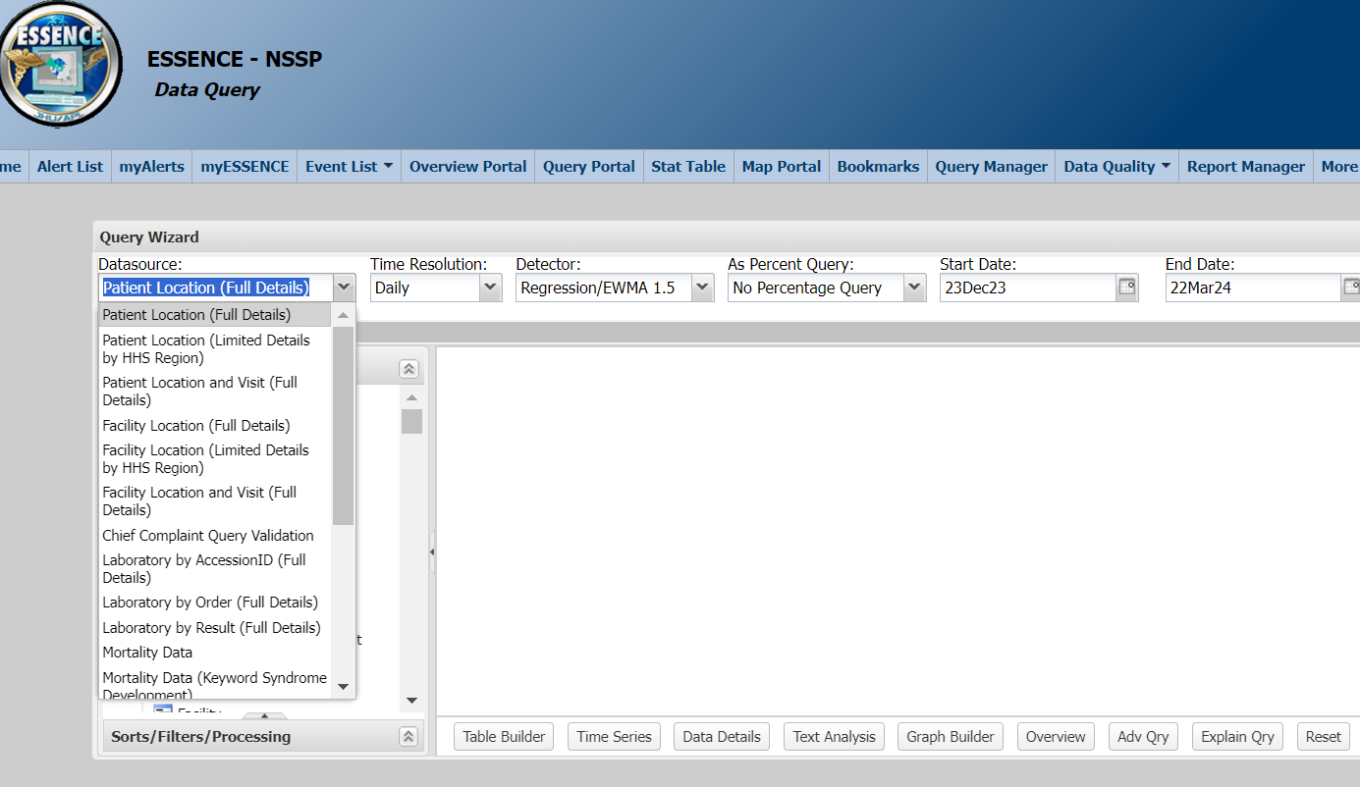

- Now looking within the Query Wizard, the row of drop-down options across the top.
  - Time Resolution: Select what resolution with which you want to view cases. In the Chief Complaint Query Validation, only weekly and longer is possible.
  - Detector: I learned from NSSP staff that the Weekly resolution won't show alerts by default, because usually you would look at Daily resolution to see alerts. To see alerts with Weekly resolution, choose CDC C2 (to learn more, go under the More tab in the top ribbon -> detector algorithms). With Daily resolution, you can keep the default detector.
  - Start and End Date: select timeframe that you want to query (e.g. past 12 weeks, 90 days, etc.). When testing out new free-text queries it’s recommended to start with smaller chunks of time first (rather than 1+ years for example) to not overload the server since you don’t know the volume of cases it will return.

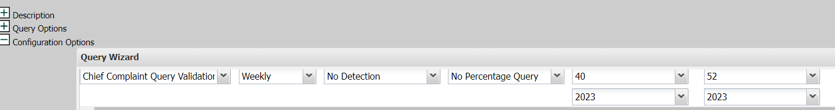

- Available Query fields (left pane): Has Been Emergency
  - If you want to subset to only emergency room cases (patient has ever been in the ED for this encounter), select “Has Been Emergency” -> Yes.

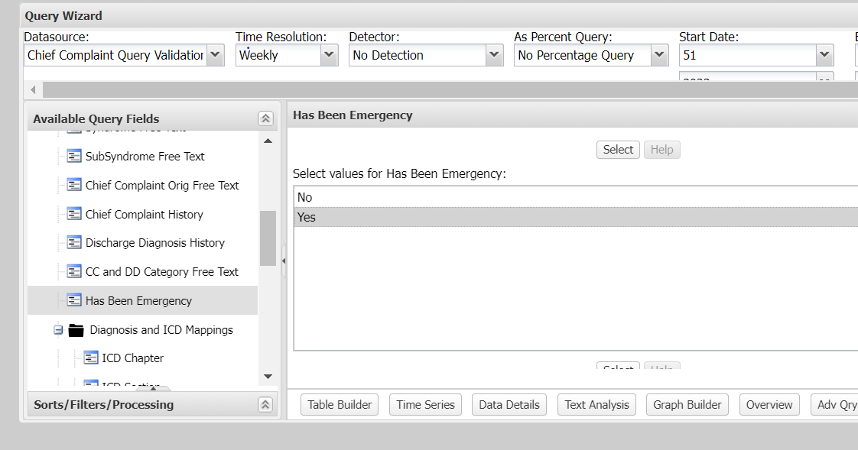

- Available Query Fields: Diagnosis and ICD Mappings
  - Select the field you want to query. The occupational needlestick query was developed for the CC and DD Parsed Free Text field, since it includes free-text coding for both chief complaint keywords and discharge codes. Parsed means the this field has removed punctuation (such as slashes, periods/decimals, semicolons, and expands words - for example w/ becomes with, w/c becomes wheelchair; also, for diagnosis codes, you just need a semicolon preceding it, and not the full brackets like in the regular DD field: ^[;/ ]^ ). The Parsed field is newer and tends to be used more from my understanding as it tends to produce cleaner results.
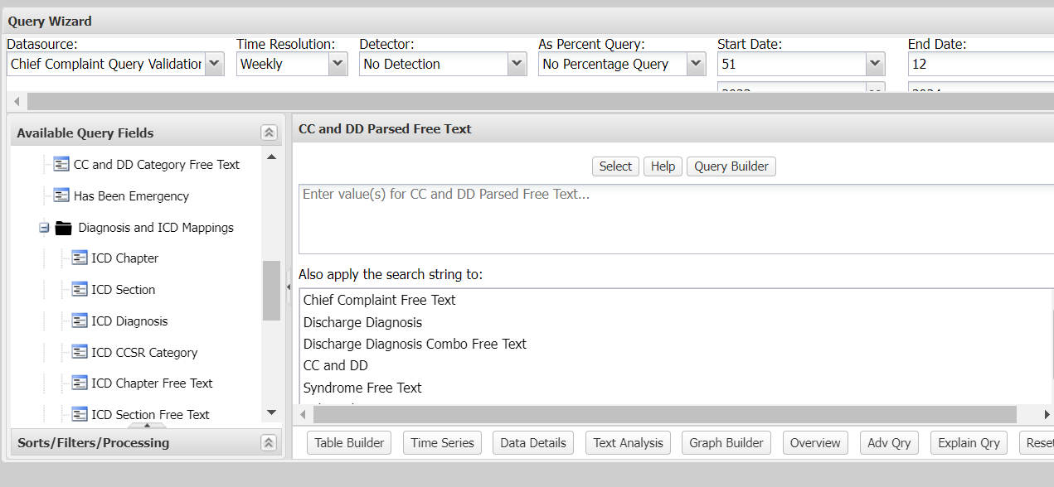

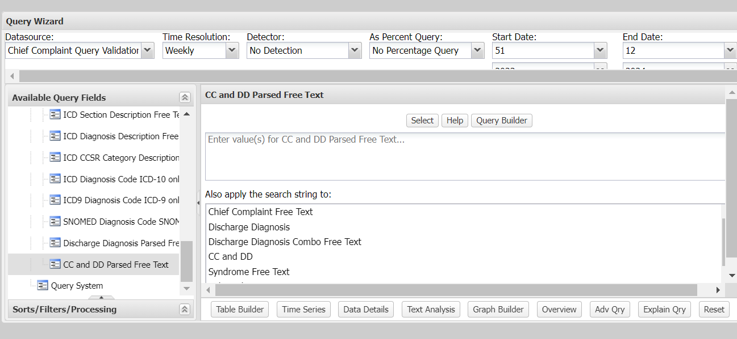

- Paste the query into the box in the middle.
- Click the “select” button above this box to populate the “Selected Query Fields” pane on the right with your ESSENCE code.

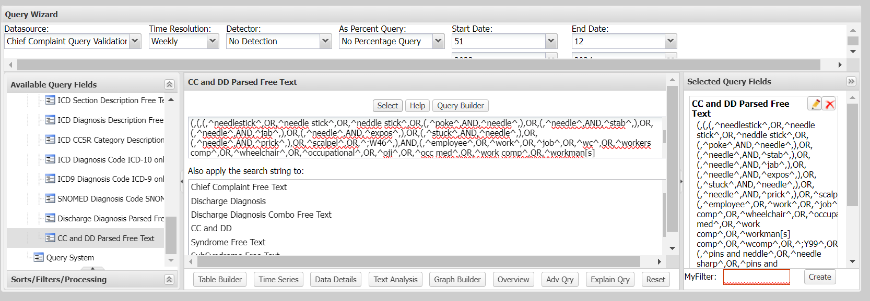

- You can check to make sure your code is capturing what you intended by clicking the “Query Builder” button above the box where you pasted the code.

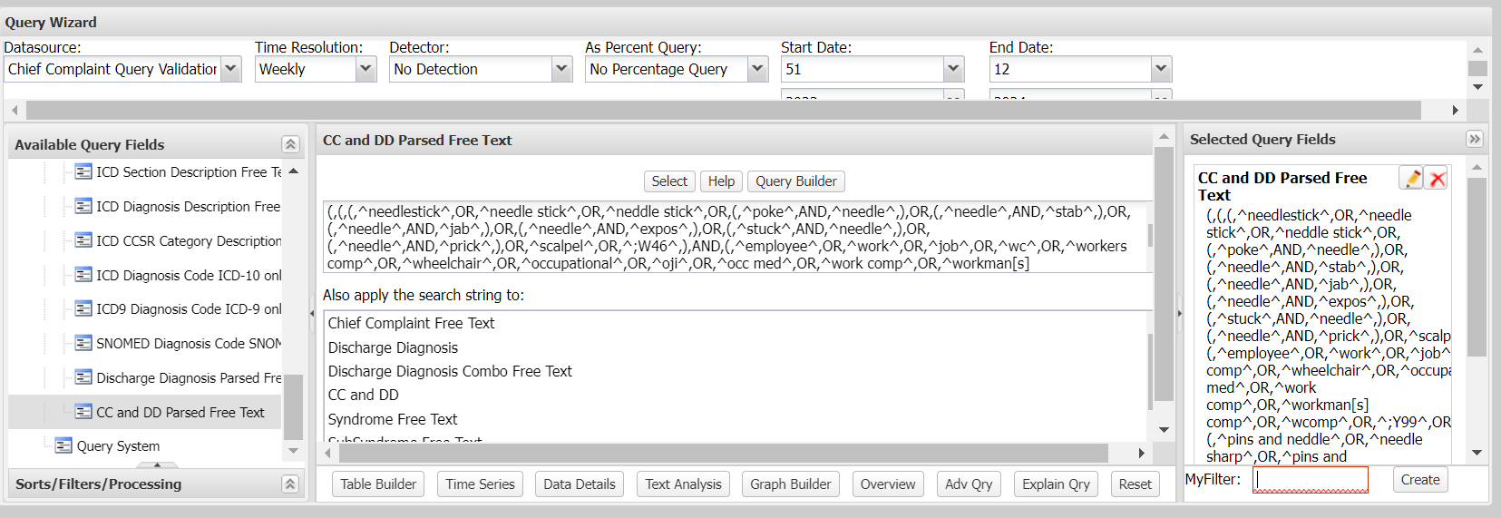

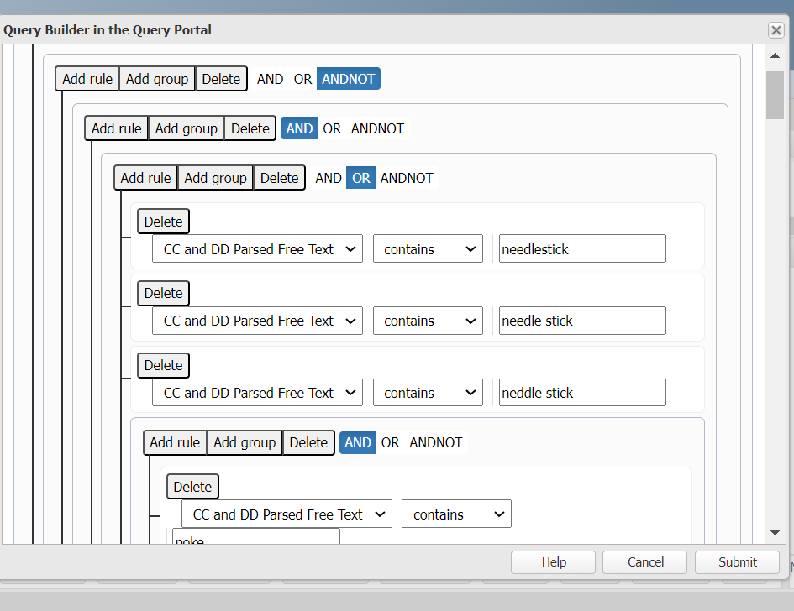

- Run your code. You have a few options for the output. The basic ones you will use most to start:
  - Time Series: this will display a graph
  - Data Details: this gives a line listing table of visits
  - Text analysis: gives a text breakdown, including unigrams and bigrams, of the most common terms and diagnosis codes that appear for the visits captured by your query. This tool can help you refine your queries by seeing which words appear most, how they appear together, etc.

Example of Time Series:
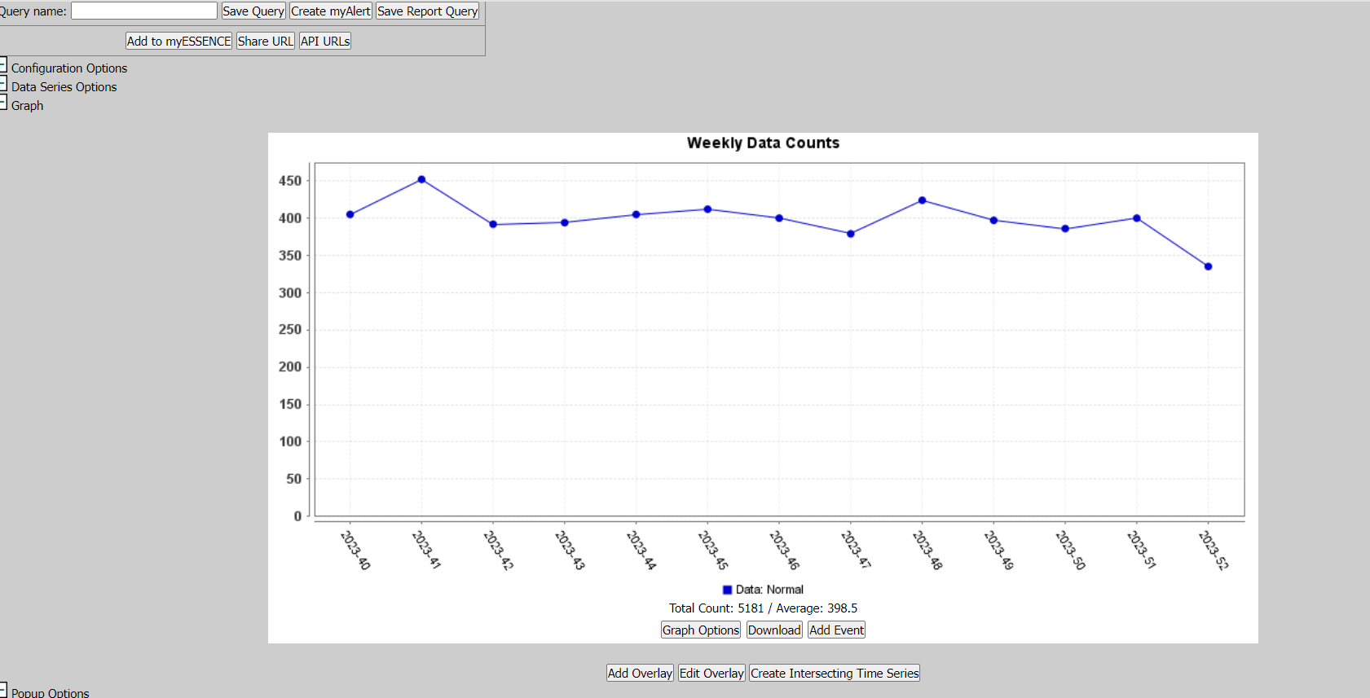
Troubleshooting: if your query returns 0 visits that likely means there was an issue with your code. Select “configuration options” at the top left to edit your query.
Also, to choose a different output once you’ve already run one, click “configuration options” and re-run the query with a different output.

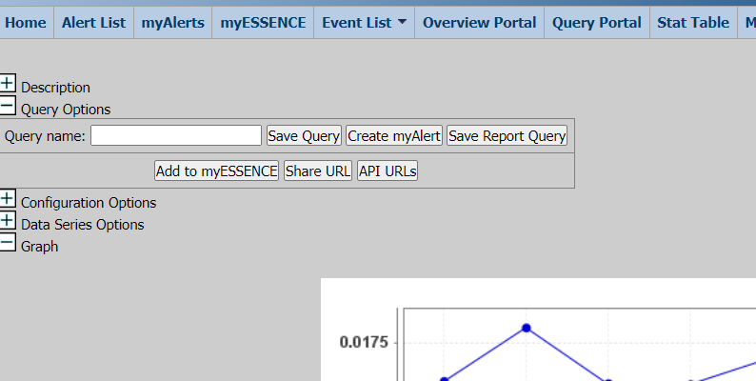

If you choose Data details, you can download an excel file of the line listing of visits:
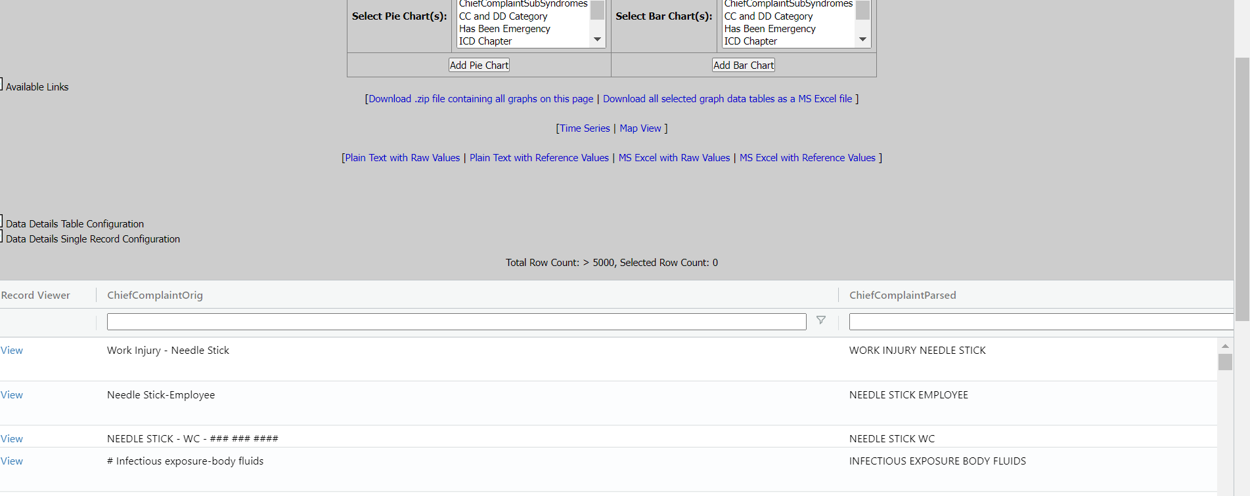

You can save your query a couple different ways (Texas user guide has more details, page 14)
- Give your query a name in the box next to “Query name” at the top left.
  - Save Query -> it will be saved under the “Query Manager” tab in the top blue ribbon. I believe this is a good option if you need to share with other users
  - Add to myESSENCE -> it will be saved in a tab under the “MyESSENCE” tab in the top blue ribbon. When you save them here it will display a time series graph for your saved query and automatically update when you click on that tab. It’s recommended not to save queries in the “Home” tab since this is a load on the server – create new tabs within myESSENCE (next screenshot)

