Documentation of COVID outbreak data by state – July 2022

California

NonhelathEmployers required to report outbreaks to local public health, which reports to the state. Outbreak defined as 3 or more cases in 14 days. Healthcare have different reporting reuirments directly to state.

https://www.cdph.ca.gov/Programs/CID/DCDC/Pages/COVID-19/COVID-19-Outbreak-Data.aspx

All Settings including health care coded by Census Industry Classifications, 2012. . Presented by year, sector, 4 digit industry, # outbreaks, # cases.

This dataset contains numbers of COVID-19 outbreaks and associated cases, categorized by setting, reported to CDPH since January 1, 2021. Under AB 685 (Chapter 84, Statutes of 2020) and... https://data.chhs.ca.gov/dataset/covid-19-outbreak-data/resource/165980a2-ecb7-464a-980e-f432701d77ef
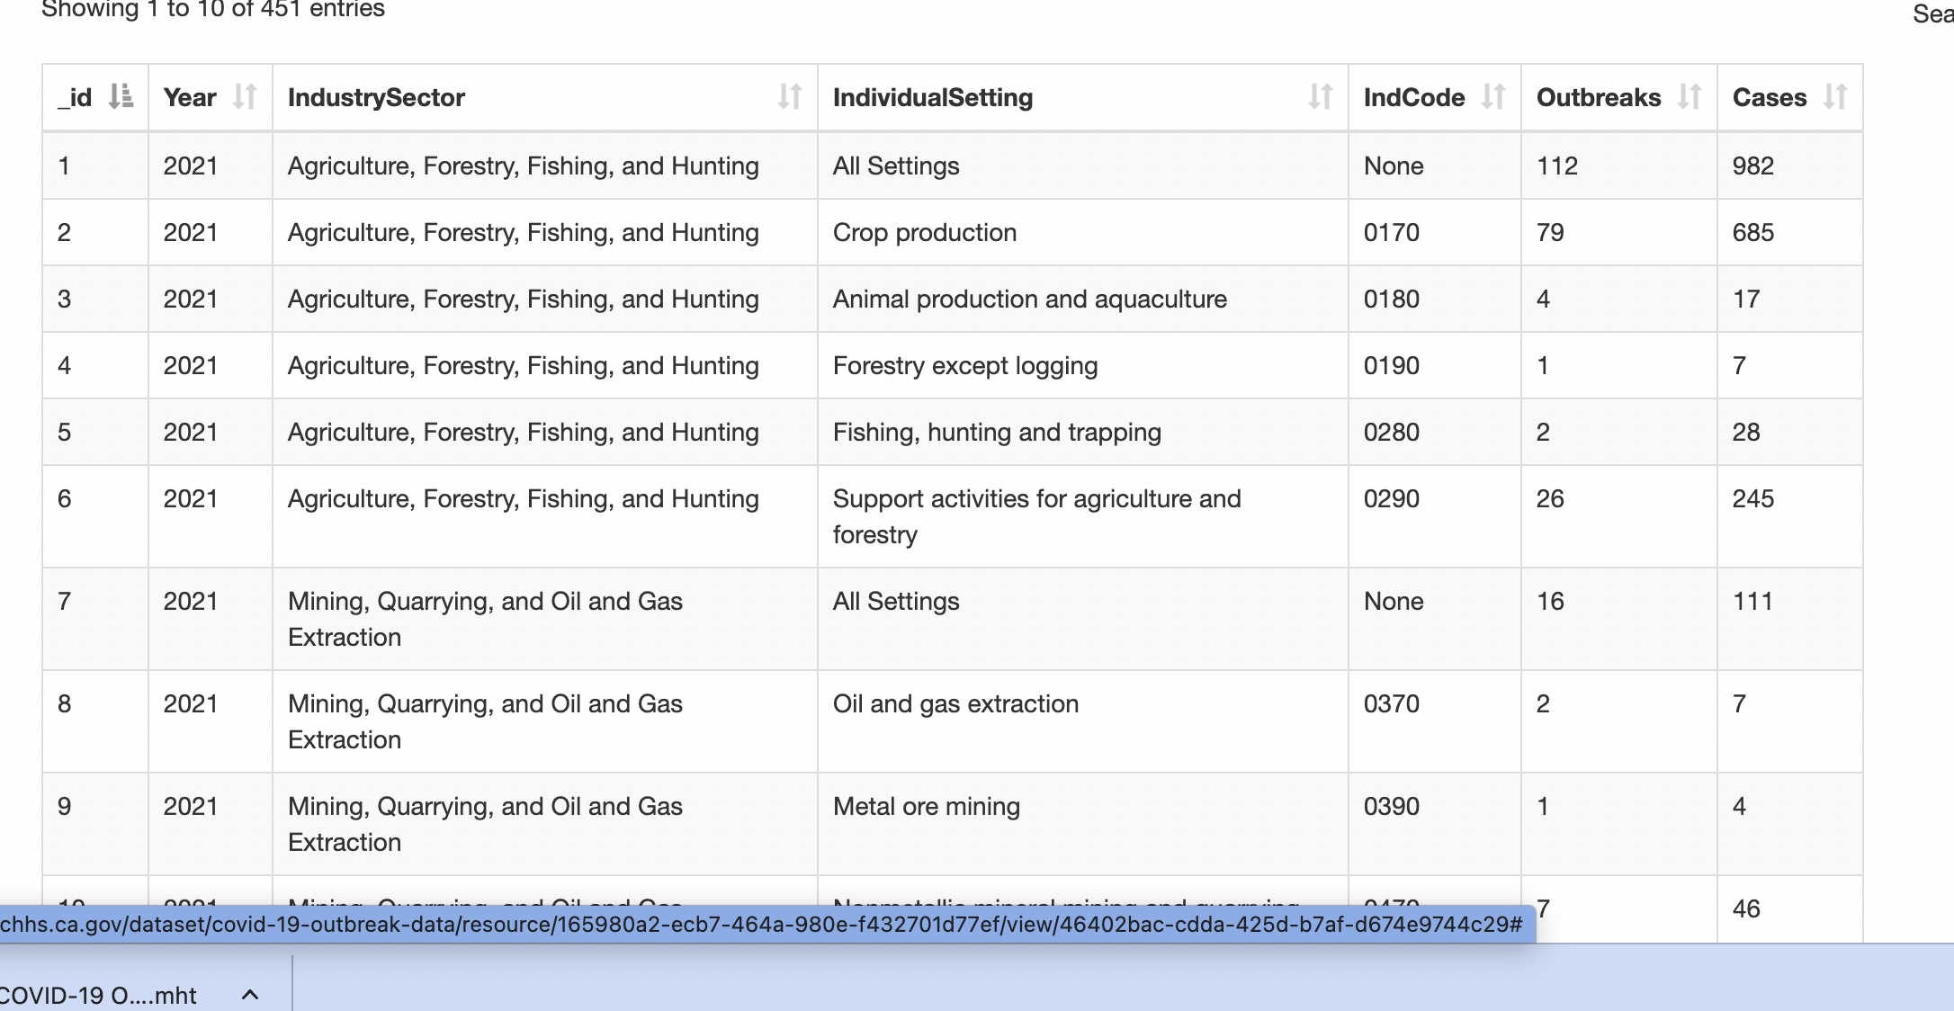

While many of these settings are workplaces, cases may have occurred among workers, other community members who visited the setting, or both. Accordingly, these data do not distinguish between outbreaks involving only workers, outbreaks involving only residents or patrons, or outbreaks involving both.

DATA Caveats
Several additional data limitations should be kept in mind:
- Outbreaks are classified as “Insufficient information” for outbreaks where not enough information was available for CDPH to assign an industry code.
- Some sectors, particularly congregate residential settings, may have increased testing and therefore increased likelihood of outbreak recognition and reporting. As a result, in congregate residential settings, the number of outbreak-associated cases may be more accurate.
- However, in most settings, outbreak and case counts are likely underestimates. For most cases, it is not possible to identify the source of exposure, as many cases have multiple possible exposures.
- Because some settings have been at times been closed or open with capacity restrictions, numbers of outbreak reports in those settings do not reflect COVID-19 transmission risk.
- The number of outbreaks in different settings will depend on the number of different workplaces in each setting. More outbreaks would be expected in settings with many workplaces compared to settings with few workplaces.
Reporting requirement
https://www.cdph.ca.gov/Programs/CID/DCDC/Pages/COVID-19/ab685.aspx

Note CA has template for employer reporting that differentiates setting from industry. CDPH required to report by industry – not employer name.
- Key fields to complete for workplace outbreaks:
Information | Field in CalREDIE | Field in CalCONNECT | Additional information
Outbreak status | Outbreak form: Outbreak Resolution Status | Outbreak Summary Information: Outbreak Resolution Status | Please set to "Confirmed" for all confirmed outbreaks.
Location of outbreak | Outbreak Report form: Name and Address of facility/school/setting | Location Account: Location address | In Cal CONNECT, please be sure to enter the location address in the associated Location Account.
Type of setting where outbreak took place | Outbreak Report form: Setting type | Location Account: Location Type | Please select the most appropriate choice from the list of settings.
Workplace status | Outbreak Report form: Did this outbreak take place in a workplace? | Workplace Information section: Were workers present at this outbreak? | Most locations where staff are present are considered workplaces. Outbreaks associated with private gatherings are generally not considered workplaces.
Industry of workplace | Outbreak Report form: What is the industry of this workplace? | Workplace Information section: What is the industry of this workplace? | Free text field. Please enter the type of workplace (ex: grocery store, restaurant, homeless shelter).
Industry code of workplace | Outbreak Report form: What is the NAICS code of this workplace? | Workplace Information section: NAICS code of workplace | 6-digit numeric code that employers must report when reporting outbreaks.
Cases among workers | Respiratory OB form:  - Known cases among workers? (Y/N/Unknown)  - If yes, number of cases | Workplace Information section:  - Any known cases among workers? (Y/N/Unknown)  - If yes, number of cases | Please be sure to include cases among temporary or contract workers in addition to permanent employees.
Occupations of workers with COVID-19 | Outbreak Report form: Occupation of affected workers, and number of workers in each occupation. | Workplace Information section:  Occupation of affected workers, and number of workers in each occupation. | Occupation is the type of work someone performs (ex: janitor, nurse, cashier). Please enter this as a free text along with total number of workers with COVID in each occupation category. Up to five different occupations may be listed.
Total number of workers at the workplace | Respiratory OB form: Total number of staff at time of outbreak | Outbreak summary Information: # Total Staff at Time of Outbreak | Please include temporary and contract staff as well as permanent employees. In CalCONNECT, please complete manually if the auto-calculated number does not reflect the actual number of staff at the workplace.

What information about workplace outbreaks are health departments required to share publicly?
- AB 685 requires CDPH to share statewide information about workplace outbreaks by industry. This information is posted on the CDPH website and Department of Health and Human Services Open Data Portal.
- Local health departments are required to provide a link to this information on the CDPH website on their own websites.
- Local health departments are not required to publicly post information about outbreaks by industry within their own jurisdictions, but may choose to do so voluntarily.

Here is list of setting types they choose from . 