MASS COVID data reporting

Under Chapter 93 report cases/deaths among staff and residents for each assisted living residence, Intermediate Care facility for individuals, nursing home, rest homes. Data reported by institutions in Chapter 93 red cap reporting system. Confirmed cases – reported when they have first positive test. Can be counted again in reinfected more than 90 days after first infection. Data is self-reported and represented new reports from the day of data extract.
Total cases staff and separately residents and distribution by gender, Race, ethnicity langauge.

COVID Cluster by exposure setting started in Nov 202. First presented weekly. Then in June 2021 presented daily. In July 2022 returned to weekly reporting – not clear if any outbreaks now being reported, Have to check next report.. https://www.mass.gov/info-details/archive-of-covid-19-cases-in-massachusetts#july-2022-Never summarized anywhere – most cases household. 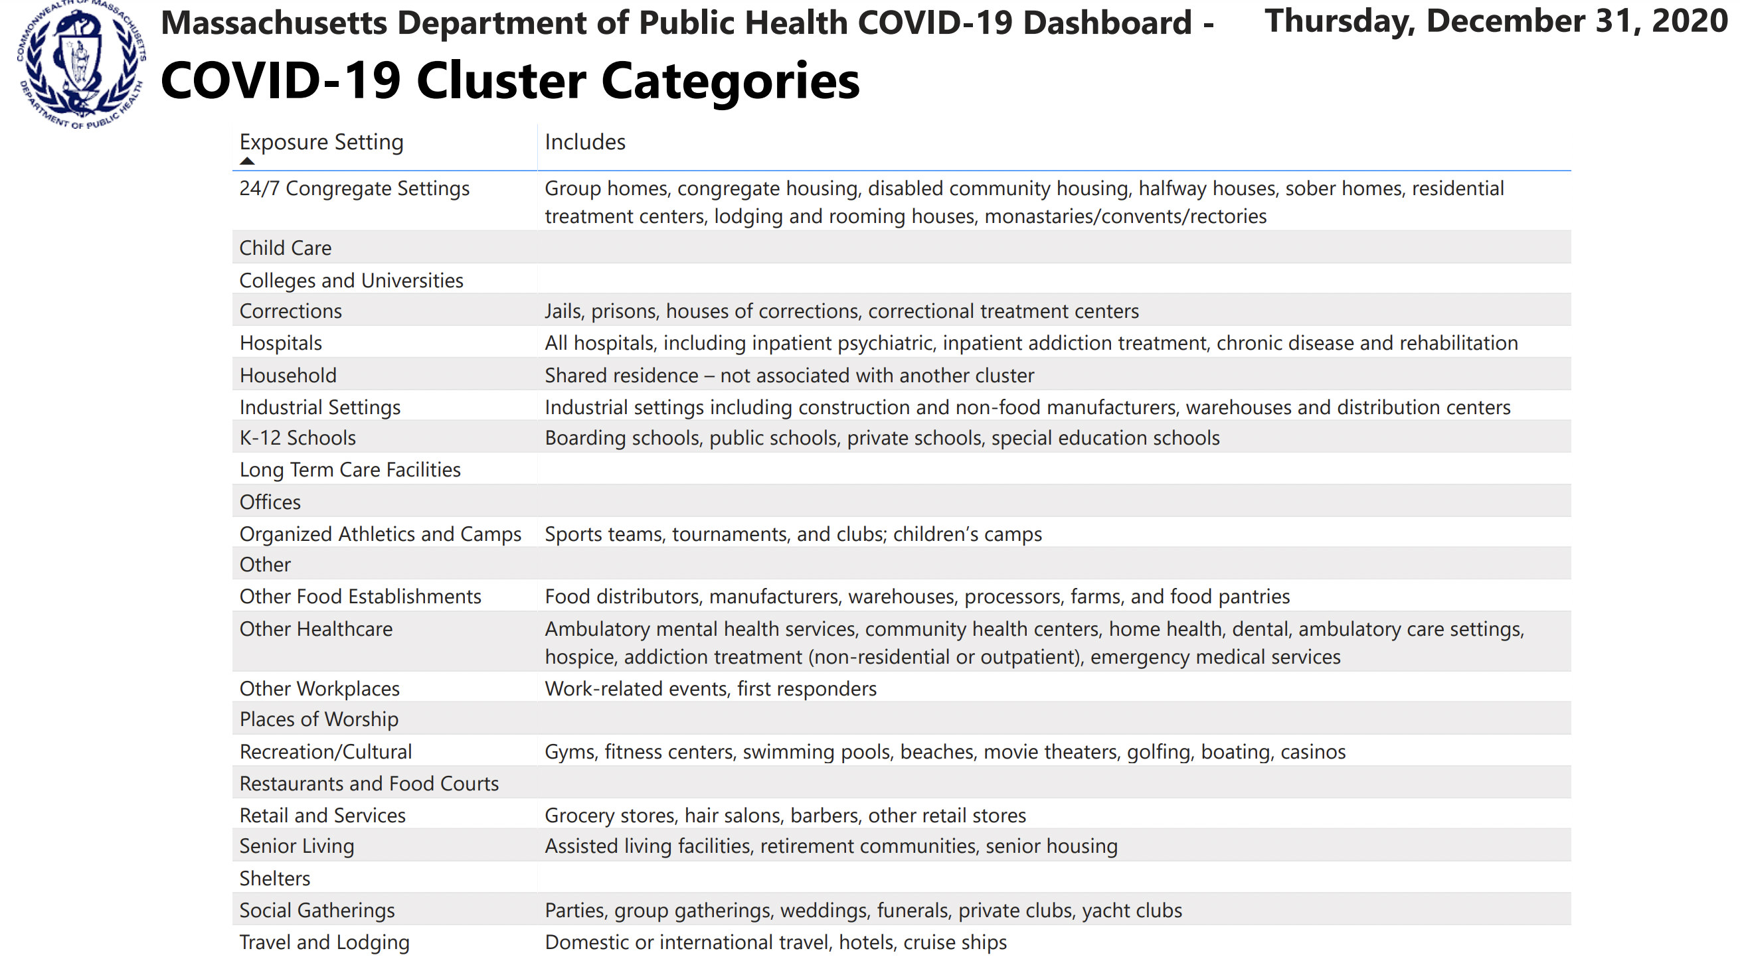r 