Acknowledgments___________________________

This document is the result of work completed by the Council of State and Territorial Epidemiologists (CSTE) Shelter Surveillance Workgroup, part of the CSTE Disaster Epidemiology Subcommittee. The workgroup included the following members:

Mary Casey-Lockyear, MHS, BSN, RN, CCRN
Disaster Health Services Program Development
American Red Cross

Miguel Cruz, PhD, MPH
Senior Public Health Emergency Operations Officer
Centers for Disease Control and Prevention

Alicia Lepp, MPH, CPH
Epidemiologist
North Dakota Department of Health

Hayleigh McCall, MPH
Program Analyst
Council of State and Territorial Epidemiologists

Tracy K. Miller, PhD, MPH
State Epidemiologist
North Dakota Department of Health

Melissa Ann Morrison, MPH
CDC Career Epidemiology Field Officer
Alabama Department of Public Health

Nicole Nakata, MPH
National Center for Environmental Health
Centers for Disease Control and Prevention

Amy Schnall, MPH
National Center for Environmental Health
Centers for Disease Control and Prevention

Doug Thoroughman, PhD, MS
CDC Career Epidemiology Field Officer
Kentucky Department for Public Health

Jessica Wurster, MPH
Associate Research Analyst
Council of State and Territorial Epidemiologists

Table of Contents____________________________

Introduction………………………………………………………………………………………………………………………………..1
Operations and Logistics Considerations…………………………………………………………………………………….2
Staffing and Resources…………………………………………………………………………………………………..3
How to Gather Data…………………………………………………………………………………………………………………….5
Readiness……………………………………………………………………………………………………………………….5
Partners to Engage…………………………………………………………………………………………………………5
Starting and Stopping Data Collection………………………………………………………………………….…6
Process in the Shelter………………………………………………………………………………………………….…7
Data Collection………………………………………………………………………………………………………….…..8
Types of Data Collection…………………………………………………………………………………………………9
Challenges and Solutions………………………………………………………………………………………….….11
How to Get Data to Appropriate People…………………………………………………………………………………..13
Receiving the Data…………………………………………………………………………………………………..…..13
Data Transfer………………………………………………………………………………………………………..……..14
Timing of Data Transfer………………………………………………………………………...……………………..15
Challenges and Solutions………………………………………………………………………………………………16
How to Analyze and Interpret the Data……………………………………………………………………..……………..17
Data Entry………………………………………………………………………….…………………………………………17
Analysis……………………………………………………..…………………………………………………………………17
Epi Info……………………………………………………………………….………………………………………….…...21
Interpreting Results for Action (When do we pull the trigger?)……………………………….…..21
Challenges and Solutions……………………………….…………………………………………………………….22
How to Communicate Results……………………………………………………………………………………………………24
Audience…………………………………………………………………………………………...…………………………24
Writing a Report on the Results………………………………………………………………………..………….25
Dissemination Methods…………………………………………………………………….…………………………25
Challenges and Solutions………………………………………………………………………………………………26
Appendix
A – C-MIST Form……………………………………………………………………………….………………………….28
B – Natural Disaster Morbidity Surveillance Individual Form………………………………………..30
C – Natural Disaster Morbidity Surveillance Line List…………………………………………………….31
D – Natural Disaster Morbidity Surveillance Tally Sheet……………………………………………….32
E – Natural Disaster Morbidity Surveillance Summary Report………………………………………33
F – Environmental Health Assessment Form for Shelters……………………………………………..34

Introduction_________________________________
Disasters are complex events that can have a significant impact on the health status of the affected populations. Temporary relocation of the population to shelters due to evacuation or loss of housing introduces multiple environmental and medical factors, such as adequate restroom and handwashing facilities and lack of prescription medications, that may impact the health of the population residing in the shelter, making the need for monitoring the affected population a public health priority. Conducting health surveillance of the shelter population provides essential information on the health of residents and situational awareness of conditions and resources for emergency management and public health decision makers. Information collected through shelter surveillance may be used to identify outbreaks, injuries resulting from potential safety concerns, and the need for resources for behavioral health and chronic disease management.
This document was developed through a collaborative effort with the intent to assist health departments and other response partners in planning for the implementation of shelter surveillance and incorporating the information into the public health response. While this document focuses solely on shelter surveillance, additional components of disaster epidemiology should be considered to inform the overall response; a suggested resource is https://www.cdc.gov/nceh/hsb/disaster/epidemiology.htm .
Purpose, Definitions and Scope
The purpose of this document is to provide a resource to assist state and local health departments with the development and implementation of shelter surveillance through the presentation of potential approaches, methods, and best practices and lessons learned from previous experience.
For the purpose of this document, the following definitions are used:
Shelter surveillance is the systematic collection, management, analysis and interpretation of data of potential public health concern among the residents and staff in shelters during operations for the purpose of rapidly implementing control measures, contributing to situational awareness of the response and developing recommendations to improve future disaster planning and response.
Shelters are defined as any facility to which individuals are temporarily relocated due to a natural disaster, radiologic event, or other emergency due to which they may not reside in the their homes, within the jurisdiction of the public health authority or for which Emergency Support Function #8 is providing public health support to Emergency Support Function #6 as part of the response and recovery. Shelters may be established and managed by a variety of public and private entities, including the American Red Cross, Emergency Management Agencies, churches and community organizations.
This document is limited in scope to the approaches, logistics and methods used for data collection, management, analysis, and reporting of public health surveillance in shelters. While the focus of this document is general population shelters that provide food, lodging and basic first aid and referral services to medical care, shelters may vary widely in the size the of population and services offered. The intent of this document is to provide recommendations and tools that may be selected and adapted by state and local public health departments to effectively conduct shelter surveillance given local conditions and resources. Finally, the focus of this document is limited to the surveillance of issues of potential public health concern; the assessment of needs for case management or medical care at the individual level is beyond the scope of this document.

Operations and Logistics Considerations__
Public health epidemiology methods used during disasters include health surveillance activities intended for monitoring the health status of all shelter occupants and workers. Collecting this information under disaster conditions may pose significant operational, safety, or resource challenges to the agencies involved. However, it is important to have access to morbidity and mortality information to identify, monitor, and respond to potential health threats in the affected populations., The process for organizing a shelter surveillance operation following a small or locally manageable event may require local coordination and assistance only from neighboring public health agencies (i.e., state, tribal, territorial, local). However, in the case of a large or more complex disaster, the shelter surveillance effort may require additional support from other public health jurisdictions, including state-to-state or federal government assistance and resources. National or local organizations that may request assistance in conducting shelter surveillance activities in their facilities include large and small non-governmental organizations, large utility or disaster worker base camps, and faith-based groups.
No disaster shelter will be successful without support from other agencies involved in the management of the disaster response. When standing up such efforts, the local or state incident command (IC) at the Emergency Operations Centers (EOC) should be made aware of these public health field activities. EOCs, which serve as the central point for coordination, share information, and maintain situational awareness, can be useful in facilitating requests for assistance and resources needed to support shelter surveillance efforts. It is important to ensure that the public health component is adequately represented in the IC to ensure that agencies are aware of public health preventive efforts. Shelter surveillance activities and reports of findings can be shared with incident command and other agencies in Emergency Support Functions (ESFs) in the EOC through daily briefings or a daily situation report. Public health activities fall under ESF-8 (Public Health and Medical Services, while shelters fall under ESF-6 (Mass Care, Emergency Assistance, Housing, and Human Services), so close coordination of shelter activities must be maintained between the two ESFs.³
Shelter facilities are often relocated, closed, or consolidated. Disaster shelter surveillance teams must have access to the most current information or lists of facilities for logistical and planning purposes. For accuracy, these lists should be validated using information available from the two existing national shelter systems (NSS) maintained by FEMA and the Red Cross and by ensuring that non-affiliated shelters are also included., The development of agreements with shelter providers in advance of a disaster will ensure the shelter surveillance teams will have access to the facilities during a response.
Important safety challenges can affect a public health agency’s efforts to collect information: ability to access sites during dangerous weather conditions, road and debris hazards, damaged structures, restricted access to affected areas during curfews, and limited or lost basic services including access to public safety services or hospitals. Planning for these challenges should include procedures to notify public safety officials of entry and exit from restricted areas, requesting team safe passage and escort and having access to reliable communication equipment such as phones and radios, global positioning equipment, maps, safety vests, and personal protective equipment necessary to ensure the safety and success of the shelter surveillance effort.²

Staffing and Resources
To avoid unnecessary delays in implementing the shelter surveillance system, have an adequate number of workers with experience in disaster surveillance methods. The number of personnel will affect the type or amount of surveillance that can be done. For instance, fewer personnel may result in a less detailed surveillance system. Certain factors may affect the ability to have an adequate pool of personnel to run a surveillance system. For example, public health staff or their families may be among the victims of the disaster and, thus, may not be available to assist in the public health response. Therefore, staff may need to use volunteers from public health, nursing or medical schools, registered retired health professionals, or the local chapter of the Medical Reserve Corps.,,
If despite these efforts staff shortages still exist, assistance may be requested through several mechanisms: state-to-state assistance through Emergency Management Assistance Compacts (EMAC), federal-to-state assistance through a Stafford Act Declaration, or via the U.S. Centers for Disease Control and Prevention (CDC) Epidemiological Assistance (Epi-Aid) mechanism.^{,3,}

How to Gather Data_________________________

Readiness
The need for and ability to do shelter surveillance may not be common knowledge amongst those running disaster relief services, local volunteer organizations and non-governmental organization (NGO) chapters, emergency management, and even local and county governments. Conduct readiness activities on a routine basis before a disaster occurs so they can be implemented quickly when needed. Readiness activities should include establishing partnerships with groups that conduct shelter surveillance such as individual Red Cross chapters and regions; training on disease surveillance and communicating the health department’s authority to collect this information; and developing tools for shelter surveillance data collection, plans for what data to collect, and collection logistics.

Partners to Engage
During the shelter surveillance planning phase, identify necessary partners to improve data collection. The partners engaged will vary from state to state. Local health departments must be involved, along with local or state emergency management, to ensure a collaborative response. Emergency management and local public health departments can be coordinated through the EOCs within ICS. Working within the ICS can help identify shelter facilities and operators, ensure that public health ESF-8 and mass care ESF-6 desks are in the EOC, and that the leads of each are aware of any shelter activities. The agency running ESF-8 and ESF-6 will vary in each state. Share shelter surveillance information with ESF-8, who can then coordinate with the rest of the EOC. Engage the state public heath jurisdiction to help coordinate information flow.
Another organization that supports data collection in shelters is the Red Cross and its local chapters. In a disaster, the Red Cross operates emergency shelters, and its health services collect morbidity surveillance data from these shelters. However, local Red Cross chapters and shelter managers may not be aware that they are able to share data collected in their shelters with local and state health departments, so engagement at the jurisdictional level during the planning phase will minimize barriers to data collection and sharing during a response.
Surveillance requires a large amount of human resources. Partners who can help fill this need include public health staff, volunteers, medical reserve corps, and other formal and informal organizations who may be working in or operating shelters. These partners can help collect surveillance data, or they can identify others to do so. Just-in-time training may be useful to provide to volunteers or staff who may not be trained in data collection. Training helps standardize data collection and provide a pool of trained volunteers who can assist as the disaster event evolves. In addition, training can help staff understand the need for surveillance and grasp public health principles, thereby reducing anxiety and stress levels.
Organizing a designated shelter surveillance team using public health staff during the planning phase may be useful. This team can be deployed to shelters to collect public health surveillance data when a disaster occurs. Each team may cover one or several shelters, depending on the scale of the disaster and the number of facilities in operation.
Identify and engage with partners, regardless of who they are, early in the shelter surveillance planning phase to ensure that relationships and roles are well established.

Starting and Stopping Data Collection
Shelter operators notify the health department when their shelter is activated. Conducting shelter surveillance only in shelters that will be open for at least three days is recommended. State and local jurisdictions may already have protocols established regarding when to begin surveillance; follow already established protocols if they exist.
Once the decision has been made to conduct shelter surveillance, it should be initiated within 24 hours of shelter activation. Conduct shelter surveillance the entire time that the shelter is open or the EOC remains activated. Be aware that, because of resource constraints, conducting surveillance at all shelters for an extended period of time may not be possible. You may need to prioritize shelters (i.e., the largest) or modify the surveillance plan (i.e., move from daily to weekly).
Shelter surveillance may need to adapt to the needs of the responding authorities, situational dynamics, and the changing shelter population. Active surveillance, where shelter staff interview residents of the shelter to document new health issues on a regular basis, is considered the most desirable and successful approach. However, shelters may have limited resources to conduct active surveillance and may choose a passive approach to surveillance. This approach can lead to decreased accuracy and completeness of data and a delay in identifying disease clusters. Adapt a blend of surveillance approaches if needed, to fit the shelter needs.¹

Process in the Shelter
  - Who Implements Surveillance
Trained public health staff or volunteers should conduct surveillance in shelters. Provide just-in-time training for all volunteers, including information on interacting with shelter residents, how to gather health surveillance data, and the specifics of the disaster. In the planning phase, designate a shelter surveillance coordinator who will oversee surveillance implementation and work with the staff in the shelters to complete the following forms:
- Demographic data forms
- Communication Maintaining Independence Safety, Support Services, and Self-Determination, and Transportation (C-MIST) process (Appendix A)
- Natural disaster morbidity surveillance individual forms (Appendix B)
- Natural disaster morbidity surveillance summary report (Appendix E)
- Shelter survey/Environmental health assessment form (Appendix F)
Instructions should be provided to shelter staff on contacting the appropriate public health authorities to report possible outbreaks, notifiable conditions and cases of potential public health importance.

Data Collection
Once a shelter is opened, trained public health staff or volunteers will complete demographic and individual assessment forms at intake. Additionally, staff should identify a shelter resident’s primary language and record when it is not English to make sure that information is communicated appropriately. Medical staff located at the shelter could be supplied with stool collection kits for viral and bacterial pathogens, instructed to use them, and sent into the public health laboratory if three or more shelter residents have diarrhea and vomiting.
Morbidity data collection and C-MIST can be conducted by trained staff and volunteers making rounds of family units at the same time each day or during each reporting period (i.e., 12, 24 hrs.) at the shelter. Conducting data collection during dinner time or in the evening helps ensure that shelter residents will be present. The timing for collecting data after initial intake may vary and will be determined based on the resources available, size of the population, potential health concerns present, and whether there is an active outbreak going on in the shelter. Suggestions for consideration include the following: How frequently will the shelter collect data? Will it be multiple times per day or per week? How will data collection fit into the staff rhythm at the shelter? When in the day will the data be collected? Will each shift tally data for the next shift, or will there be continuous collection throughout the day?
If a shelter is operated by the Red Cross, the Red Cross will conduct surveillance activities using Red Cross processes and forms. Working with the Red Cross is important to ensure that public health surveillance data are collected and shared with the local and state public health jurisdictions.

Figure 1. Data Flow
- Shelters are encouraged by ESF 6/8 to get ready to conduct shelter surveillance and complete a shelter survey (also known as the Environmental Assessment Form)
Pre-Event
- Collect information from shelter residents at intake
- Complete the Individual Form when residents go to First Aid/Medical Unit for care.
- Complete the Summary Report From and shelter survey (also known as the Environmental Assessment Form) each operational period.

Shelter Open
- Communicate findings to local public health and local emergency management/ESF-8.
- Send the completed Summary Report Form to the appropriate recipients.

Communicate

Types of Data Collection
  - Demographic Data and C-MIST
In its shelters, the Red Cross uses a Disaster Health Services Aggregate Morbidity Report Form and a tally sheet that captures information on demographics and morbidity. The tally sheet also contains a section to record each of the C-MIST functional or access needs groups (i.e., communication, maintenance of health, independence, safety and security, and transportation). Always respect an individual’s independence and right to self-determine the level of assistance they require. Since the form is a tally sheet, it provides summary-level data. The data are aggregated and therefore cannot be separated by individual.
C-MIST is a model that can help shelters identify a person’s functional needs, regardless of their specific diagnosis or status, to help ensure these needs are met by the shelter. The Red Cross uses the model to collect demographic data from individuals with access and functional needs, including people with disabilities. C-MIST is an acronym for the following functional areas:
C – Communication
M – Maintaining Health
I – Independence
S – Safety, Support, and Self-Determination; and
T – Transportation.

Each functional area can be broken down into specific needs. Communication includes hearing, vision, cognition/understanding, and English as a second language. Maintaining health can include acute and chronic health issues as well as support for medication. Independence may include assistive technology and physical access to all services. Safety, Support, and Self-Determination includes having host a caregiver, change in condition during the evacuation or displacement, or the need for more direct support. Transportation may include the need for transportation to dialysis, physical therapy, or other appointments.
For an example of a Red Cross C-MIST form, see appendix A.
  - Morbidity Forms
CDC has several morbidity surveillance forms available that are useful for conducting shelter surveillance. Which form should be used depends on the resources available and situation. For instance, the tally form may work best if resources are limited or a large population is in the shelter. If resources are not limited or a small population is in the shelter, the individual form may work best.
Natural Disaster Morbidity Surveillance Individual Form
The individual form captures individual-level data and is completed for each person who visits the first aid or Medical unit at the shelter. The individual form is useful because it provides very detailed information on many medical conditions (i.e., acute syndromes, injury, mental health, chronic disease, follow-up, and disposition). However, this form is resource intensive and requires sufficient staffing to collect the data. See Appendix B.

Natural Disaster Morbidity Surveillance Line List
The line list is an abbreviated version of the individual form and can be used if summary or less-detailed information is sufficient or when the burden of collecting detailed, individual information is substantial. This form will be useful if resources are limited. Individual level data are collected, but in less detail. See Appendix C.

Natural Disaster Morbidity Surveillance Tally Sheet
The tally sheet is an abbreviated version of the individual form and is similar to the form used by the Red Cross. This form provides summary-level data. While individual-level data are captured, those data are aggregated and cannot be separated by individual. One form is completed per facility per reporting period. These forms require minimal staffing and are valuable if limited resources are available. This form does not contain personal identifiers. See Appendix D.

Natural Disaster Morbidity Surveillance Summary Report
The summary report form collects aggregate data and is used for reporting purposes. The form, which does not capture individual-level data and does not contain personal identifiers, provides situational awareness on the health and well-being of shelter residents for a specific shelter. The form, populated with data gathered through other forms (e.g., individual form, line list, tally sheet), is completed for each predetermined reporting period and is submitted to the EOC and public health jurisdiction. See Appendix E.

  - Shelter Survey/Environmental Health Shelter Assessment
The Shelter Survey, or Environmental Health Shelter Assessment Tool, aids environmental health practitioners in conducting a rapid assessment of shelter conditions. An example is the Environmental Health Shelter Assessment tool developed by CDC. The assessment tool covers 14 general areas of environmental health, ranging from basic food and safety and water quality to pet (companion animal) wellness. The tool allows for the documentation of immediate needs in shelters. Complete a Shelter Survey each operational period by an environmental health specialist. The tool can be easily modified to meet local needs. See Appendix F.

Challenges and Solutions
  - Resources
Limited resources may be available to public health jurisdictions and shelter operators to conduct shelter surveillance depending on the scale of the disaster, including issues with material resources as well as trained volunteers and staff to implement shelter surveillance. To ensure sufficient human resource, establish partnerships with volunteers such as the local medical reserve corps and train volunteers and staff in data collection before a disaster occurs. Once a disaster happens, just-in-time training can be provided to shelter volunteers and public health staff.
  - Competing Priorities
The primary role of shelters is generally to provide meals, medical and other services, goods, facilities, and a safe space for people affected by a disaster to sleep or rest. Conducting public health surveillance may often be considered a secondary role in shelters. Establishing partnerships with shelter operators before a disaster occurs or early in the disaster and providing technical and resource assistance for conducting surveillance can help ensure that data can be collected. Consider creating shelter surveillance teams from public health staff and volunteers who can be deployed to shelters to collect public health surveillance data when an event occurs. This step can aid in overcoming resource constraints and competing priorities.
  - Infrastructure Damage
Damage to shelter or surrounding areas may affect data collection. For instance, power outages could affect data collection, so provide alternative methods for collecting data, especially if using electronic collection devices.

How to Get Data to Appropriate People ___

Receiving the Data
During the shelter surveillance planning phase, identify who at the health department will receive the data from the shelters and who will analyze the data. Three different types of data may be submitted by shelters: census data with basic demographic information, environmental data, and morbidity data. Identify who will be conducting the analysis on these types of data and whether the analysis will be handled by one individual or department, or multiple individuals located in different departments. The shelter surveillance plan should include who these individuals are with contact email addresses, fax numbers, or phone numbers so they can receive the data from the shelter. Verify this list on a routine basis and update as needed. It may be best to identify one individual in the state or local health department to whom the shelter can send the data and who will be responsible for disseminating the data to the appropriate people for analysis, or have a dedicated agency email that is continuously monitored during a disaster event.
Figure 2. Data Transfer Options from Shelter to Health Department
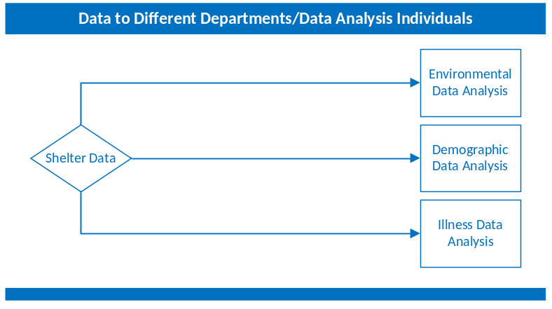

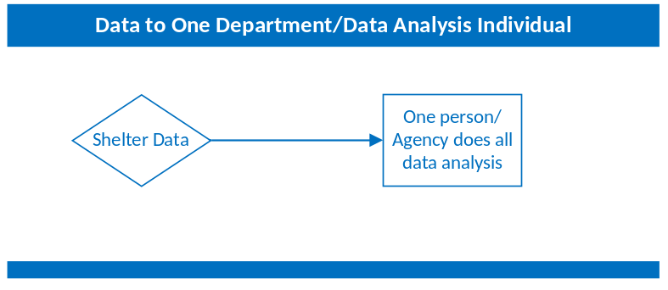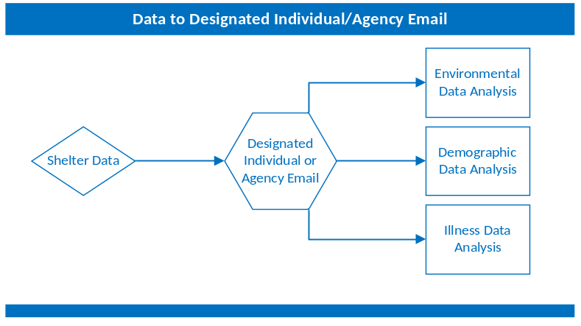

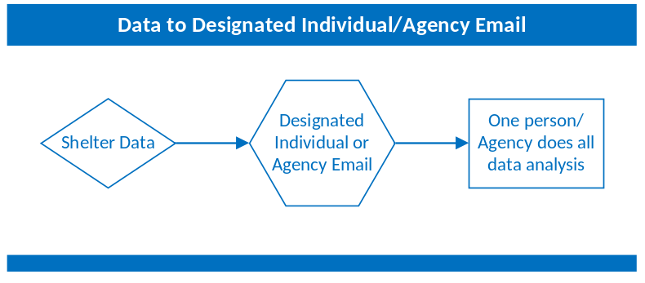

Data Transfer
During the shelter surveillance planning phase, identify how the data will be transferred to the appropriate people. Options for how data may be sent could include sending aggregate line list data or raw data to one individual identified at the state or local health department, or to a dedicated agency email which will then in turn be sent to the appropriate people for analysis. The shelter surveillance plan should include email addresses, fax numbers, phone numbers, and personal/work cell phone numbers with calling and texting capabilities for each individual identified to receive the data or the email address for the dedicated agency email to be used during a disaster event. Verify this list on a routine basis and update as needed. Include the preferred method of data transfer in the shelter surveillance plan and include additional methods in the event that the preferred method is down or is not working. Remember, if using the telephone to gather data, identifying and contacting staff at shelters may be difficult because turnover may be frequent, data received may be incomplete, and staff members may be reluctant to share confidential medical information by telephone. The New York City Department of Health and Mental Hygiene (DOHMH) found after conducting shelter surveillance following Hurricane Sandy in November 2012 that sending DOHMH staff to shelters to gather the data improved data completeness and reliability. Sending health department staff to visit shelters also aided in understanding the layout of the shelters, in investigating reported clusters, and in working with shelter managers to implement control measures. Additionally, site visits can increase awareness among shelter staff about the importance of reporting any illness clusters to the health department. Site visits, however, may not be feasible because of resource constrictions.²⁰ You may not be able to gather data from every shelter each day and may have to prioritize which shelters on which days health department staff should visit.

Timing of Data Transfer
Identify how frequently the data will be transferred from the shelter to the appropriate person(s) at the state or local health department during the shelter surveillance planning phase. The different data types may be sent at different intervals. For example, only census and environmental data most likely would be sent daily, whereas morbidity data may be sent at each shift change. Identify the needs of partners and stakeholders and how frequently they may require the data. For example, if the public health environmental division is performing inspections in the morning, receiving the environmental data at the end of the previous day to share with them prior to their inspection may be best, rather than later that morning after investigations. The operational period of the ICS is another consideration. If the most up-to-date information is requested during briefing, you may want to request that data be sent prior to the briefing.

Challenges and Solutions
  - Logistics
Identify back-up reporting methods in the event of a power outage or issues with cell phone service. Include a number of contact methods in the plan for individuals identified for receiving data. A HAM radio may be used; however, information reported should be over a secure channel.
  - Confidentiality / Personal Identifiable Information
There may be different data transfer methods required for aggregate data and data containing personally identifiable information. During the shelter surveillance planning phase, the health department should consult with information technology and legal personnel on the security of the data transfer methods and address any concerns. Given that established systems may not be available during a response, such as a secure fax line or online reporting forms, determination of the acceptability of alternative methods of data sharing, such as email and phone, should be made.

The health department should also discuss the plans for data collection and transfer with the shelter during the planning phase to ensure that the shelter staff will be educated on the importance of sharing the level of information requested and the appropriate application of to the Health Insurance Portability and Accountability Act of 1996 (HIPPA) Privacy Rule to public health entities. While aggregate or de-identified data may be adequate for routine surveillance, if a potential outbreak or case of potential public health importance is identified, rapid sharing of individual-level information will be critical to an effective public health response. Discussions with shelter leadership during the planning phase will provide the opportunity to establish expectations and address any concerns about sharing personal information with the health department. It may be helpful to have the health department legal counsel provide a general letter that may be presented to shelter managers during a response that explains the health department authority to collect HIPPA-protected information and the requirements for the shelter to provide that information in the context of public health practice.

How to Analyze and Interpret the Data____

Data Entry
Once the surveillance data has been gathered, it will need to be prepared for analysis. Data entry will depend on the method used to collect the data. The table below provides considerations for data entry, depending on whether paper or electronic formats were used.
Table 1. Considerations for Data Entry
Data Collection Format | Data Entry
Paper Form Collection | - Enter data into an electronic dataset using software that is familiar, easily accessible, and maintainable.  - Build the data entry platform prior to conducting field work.  - Train data entry staff so they are familiar with the software and use proper techniques to promote quality and accuracy during entry.
Electronic Device Collection | - Merge collected data into a single file for analysis

Analysis
Determine the data analysis approach in the preparedness phase. Things to consider include the technical capacity for analysis available, how complex the analysis will be, and how frequently the data will be tabulated and analyzed., Incidence and prevalence are useful measures for analyzing the frequency of injury or illness.,
Incidence measures the occurrence of new cases of death, disease, or injury in a population. Prevalence measures the existing cases of death, disease, or injury.,23 Incidence and prevalence are usually simple and easy to understand measures. They can identify clusters of disease, aid in health planning, and also may be useful for identifying the number of beds or doses of medication required in a shelter.^{,23}
Rates are measures of risk that allow you to compare the frequency of morbidity and mortality in different places, times, or population groups. For example, you can compare the rates of illness in two different shelters and investigate if children under five years are affected more than other age groups.
In situations where data collection extends over several days, trend analysis can be conducted. More in depth analysis can be conducted if unexpected results occur and the resources are available.
The table below provides definitions for different measures. Before a disaster, come up with simple definitions for what is considered a “new case” and an “existing case.” Make sure volunteers are trained to identify and record both when collecting data.

Table 2. Definitions for Common Surveillance Parameters
Measure | Definition
Incident cases† | The occurrence of new cases of disease or injury in a population over a specified period
Prevalent cases† | The existing cases of disease or injury in a population over a specified period
Incidence rate (new cases)‡ | The number of new cases of a disease or injury that occur during a specified period per unit of person-time at risk (can be stratified by age and sex)
Prevalence or prevalence rate (total existing cases)† | The proportion of people in a population who have a particular health condition at a specified point in time or over a specified period
Age-specific morbidity rate‡ | A morbidity rate limited to a particular age group (e.g., under-5 mortality rate [U5MR] is the rate of death among children younger than 5 years in a population)
Incidence proportion (attack rate, generally used for infectious conditions)† | The proportion of an initially disease-free population that develops disease, becomes injured, or dies during a specified (usually limited) period
Proportional morbidity§ | The proportion of all new or existing cases in a specified population over a period attributable to a specific cause
Health facility utilization rate‡ | The number of outpatient visits per person per year (if possible, distinguish between new and old visits and use new visits to calculate the rate)
Number of consultations per clinician per day‡ | The average number of total consultations (new and repeat cases) seen by each clinician per day
† CDC 2012c
‡The Sphere Project 2011
§ Abdallah and Panjabi 2008

Table 3. Tracking Form Template
Reporting Period  Start  MM/DD/YYYY  HH:MM (12hr)  AM/PM  End  MM/DD/YY  HH:MM  (12hr)  AM/PM | Facility  Name | State | Zip  Code | Date  and  Time Received | Reporting Person/ Contact | Total Shelter Pop. at Start | No. Persons Seen/ Treated | No. Pregnant Females Seen/ Treated | No.  ≤1 years Seen/  Treated | No.  ≥ 65 Seen/ Treated | Total Referred to Hospital | Illness/  Injury  Report  (Y/N) | Describe  Illness/ Injuries (include percent and if cases reported in residents or workers/volunteers)
Reporting Period  Start  MM/DD/YYYY  HH:MM (12hr)  AM/PM  End  MM/DD/YY  HH:MM  (12hr)  AM/PM | Facility  Name | State | Zip  Code | Date  and  Time Received | Reporting Person/ Contact | Total Shelter Pop. at Start | No. Persons Seen/ Treated | No. Pregnant Females Seen/ Treated | No.  ≤1 years Seen/ Treated | No.  ≥ 65 years Seen/ Treated | Total Referred to Hospital | Illness/  Injury  Report  (Y/N) | Describe  Illness/ Injuries (include percent and if cases reported in residents or workers/volunteers)

Epi Info
Many different statistical analysis packages are available to analyze data. Use tools that are available and familiar to staff. Epi Info™ software is useful because it is user-friendly and available free of charge (http://wwwn.cdc.gov/epiinfo/7/). The Epi Info™ Website provides tutorials in creating databases, entering data, and running analyses.

Interpreting Results for Action (When do we pull the trigger?)
Before a disaster occurs, make sure to determine what surveillance data will trigger public health intervention. These “triggers” may vary depending on the situation, shelter, and event type. Useful recommendations for when surveillance results trigger public health action include the following:
- Changes in trends of illness in the shelter
- Two or more cases, from different family groups, with similar symptoms
- Two or more cases, with similar symptoms, that are linked (e.g., similar activities, what and where they ate)
- Symptoms or syndromes indicating the potential communicable disease outbreaks
Table 4 lists several examples of symptoms/syndromes that may indicate an individual has a communicable disease according to the Association for Professionals in Infection Control and Epidemiology (APIC).

Table 4. Symptoms and Syndromes relating to Communicable Disease
Respiratory
- Cough, runny nose, water eyes
- Fever (Temp >101.1⁰F) and cough in adults
- Fever (Temp >101.1⁰F) and cough in children
- Fever (Temp >101.1⁰F), cough with bloody sputum, and weight loss
Diarrhea or Vomiting
- Vomiting
- Loose or unformed stools
  - Water or explosive stools, with or without blood
Skin
- Fever (Temp >101.1⁰F) and rash
- Fever (Temp >101.1⁰F), upper chest rash, and stiff/sore neck
- Eye infections (drainage from eye)
- Draining wound/lesion
- Itchy rash without fever

The Mississippi Department of Health and the American Red Cross piloted a shelter surveillance system using telephone hotlines. Symptoms and syndromes that initiated reporting included “fever in an ill-appearing person, severe respiratory symptoms, cough with blood, three or more episodes of watery diarrhea with blood, and severe skin infection.”
Flag results such as these for follow-up investigation to gather more nuanced information. Follow up investigation will help determine what further action, if any, should be taken.

Challenges and Solutions
  - Denominator Data
Gathering denominator data to calculate rates of illness and injury in a shelter may prove to be difficult. During a disaster, a shelter’s population will change. Traditional census or population data may not reflect the population in the shelter because people in the shelters may come from different parts of the state, or even from other states. Setting up a system for recording daily or weekly population counts to keep track of the denominator may be useful. This could include counting “heads in beds” every evening, as shelter residents may leave the shelter during the day.
  - Baseline Data
Baseline health information helps determine if there is a true increase in a disease or worsening health status. It can also help assess population risk and vulnerability. Baseline data are often missing or non-existent when large portions of a population are displaced, the health care infrastructure is severely damaged, or no previous surveillance system collected the information needed. This scenario is often the case in shelters. Gathering data early can help set a baseline for what is occurring in the shelter. If you know shelter residents are coming from one geographic area or city, using existing surveillance system data for the baseline may be possible.
  - Competing Priorities
Public health staff will have many tasks during a disaster and may have limited time to analyze and interpret shelter surveillance data. Those in the shelters may be busy providing care and health services to shelter residents. Limiting analysis to the most essential information needed and using the least labor intensive analysis methods can help to prevent overloading volunteers and public health staff. Designating people with statistical or epidemiology backgrounds at the health department to analyze and interpret data may also be considered.

How to Communicate Results______________

Audience
Results of the data analysis need to be shared to maintain situational awareness among those involved in the response. Communicating results provides information on the status of a shelter population’s health, on the resources available to protect the health of residents and staff in the shelters, and on forecasting future needs to ensure proactive decision-making and efficient allocation of resources.
Many parties involved in the response effort will need to receive results of the data collected during shelter surveillance for situational awareness: local and state public health, local and state governments, emergency managers, response organizations, politicians, and/or the media. When planning shelter surveillance, develop a list of all critical local, state, and public health authorities along with emergency manager personnel and response organization contacts. Routinely verify this list to keep up to date and distributed as necessary.
Figure 2. Communication Flow
Incident Command System Structure

Interorganization
Interorganization
Interorganization
Shelter Surveillance Information
(Agency/Department 2)
Shelter Surveillance Information
(Agency/Department 1)

Public / Media
Government officials, emergency managers, response organizations

Writing a Report on the Results
Before writing the report, know who the intended audience is. This will help determine what format to use, how much information to include, and the technical level of the writing. Designate an individual responsible for writing the report. The report author should be someone familiar with the process of the data gathering and analysis. Critically review the data and ensure that the necessary statistical calculations were performed to produce shelter population estimates. Based on the intended audience and information to be shared, decide what format to report in (e.g., bullets or a full written report with tables and charts). Write the report clearly and avoid any internal jargon or acronyms; other organizations may also use the information and clear information will minimize errors interpreting the findings. Present results in a simple, easy-to-read format to help partners better understand the needs and health status of the shelters and to prompt action. Actions may include, but are not limited to, prioritization of resources, public health messaging, enhanced health surveillance, or public health interventions. When appropriate, indicate in the report that this interpretation of available data is preliminary and note important limitations. The reports should be timely to ensure that partners can make quick decisions to address any needs. Information in daily reports include the number of shelters reporting, clusters of illnesses, gastrointestinal illnesses (i.e., one episode of vomiting or diarrhea), febrile respiratory illnesses (i.e., fever and cough), fever and rash, and the total number of patients that were sent to an emergency department.²⁰

Dissemination Methods
Include in the planning process how reports and information will be shared. To share reports with emergency managers, response organizations, and other agencies involved, work within ICS through the EOC to coordinate dissemination. Reports and shelter surveillance information can be shared with the ESF-8 desk in the EOC, who can then coordinate with the rest of the EOC and share information with both internal and external partners.
Share data and information highlights and trends in a situation report to be disseminated to the governor and other leaders and decision makers. Additionally, share highlights of data and trends, which can be disseminated through the ESF-6 or ESF-8 desk, with the shelters. If an increasing trend of illness at a shelter is noted or there is a concern about a communicable disease, notify a public health nurse or infectious disease epidemiologist. At this point they may decide to start an investigation. If the investigation reveals a potential outbreak, send a team to the shelter to conduct a site visit.
Figure 3. Data Dissemination Flow

Additional ways to disseminate data and information on a periodic or real-time basis relevant stakeholders include meetings, phone calls, or web pages. Mass media, such as up-to-date website postings, television, and radio can keep the public informed. Social media such as Facebook and Twitter can be used for situational awareness among the public.

Challenges and Solutions
  - Controlling Media Rumors
Sending a unified message is important. Designate a spokesperson to work with public affairs or the public information/press officers when the media requests data and reports. Agency public information/press officers should communicate with the spokesperson about the availability of data and reports from their agencies. Having one designated spokesperson reduces confusion and helps to unify messages coming out of multiple agencies.
The growth of social media, such as Twitter and Facebook, increases opportunities for individuals and organizations to connect with each other and to access and use information. However, it can also facilitate the spread of rumors and misinformation. Health security leaders and other stakeholders must ensure proper cybersecurity, understand how to frame communications effectively, and know how to optimally manage and use social media.

Conclusion_________________________________
Shelter surveillance is an important aspect of disaster epidemiology. The lack of adequate health and preventive services, compounded with safety and environmental conditions and hazards of a disaster, makes the need for monitoring the effected population a public health priority. Therefore, conducting shelter surveillance provides essential information on the health of residents and situational awareness of emergency management and public health professionals. It can be used to monitor for outbreaks, injuries, and the need for resources for behavioral health and chronic disease management. Many aspects should be considered when conducting shelter surveillance: operations, logistics, partners, analysis, and dissemination of the data. This document is intended to help guide planning for shelter surveillance by discussing various barriers and solutions to implementing shelter surveillance.

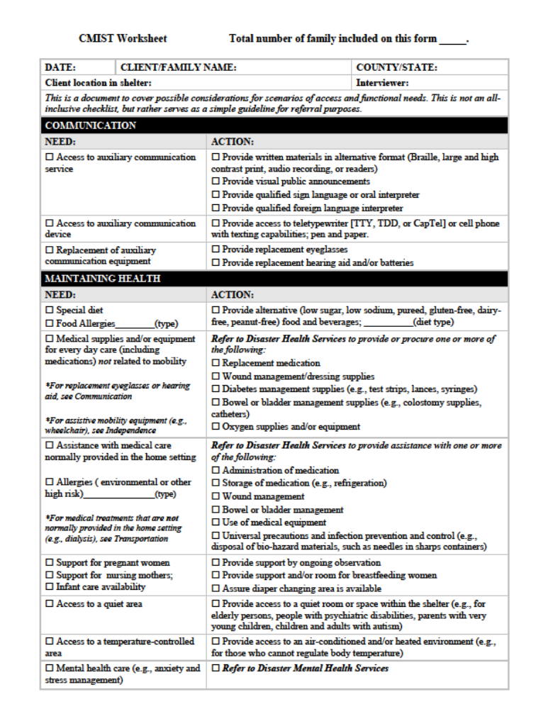

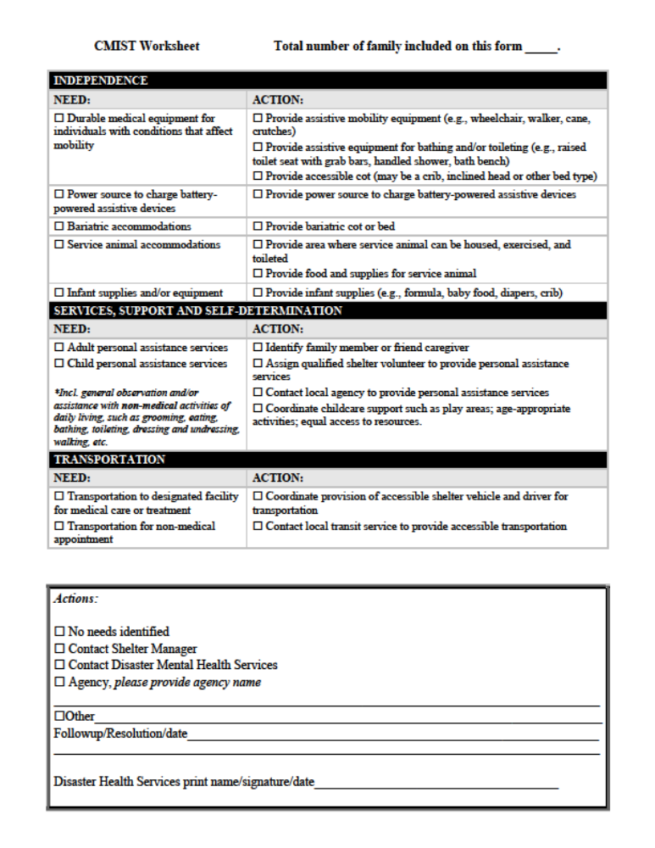

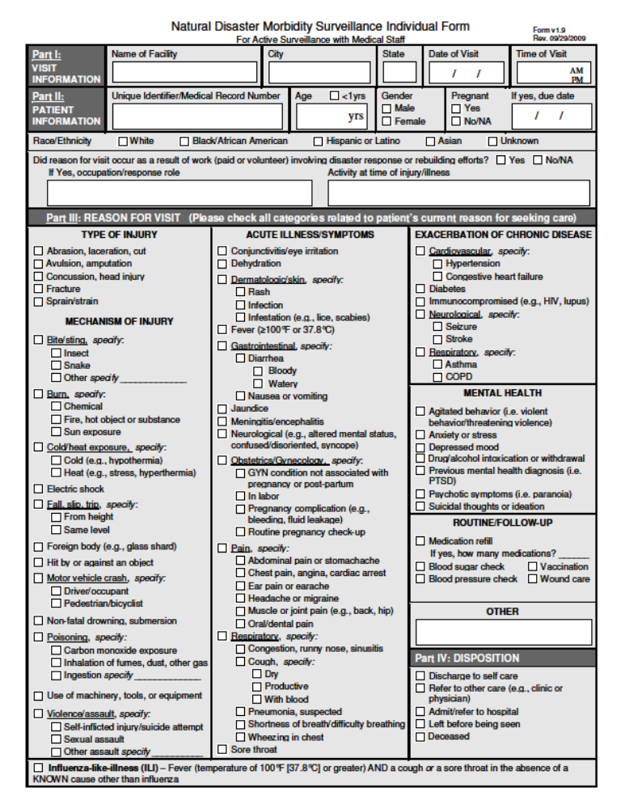

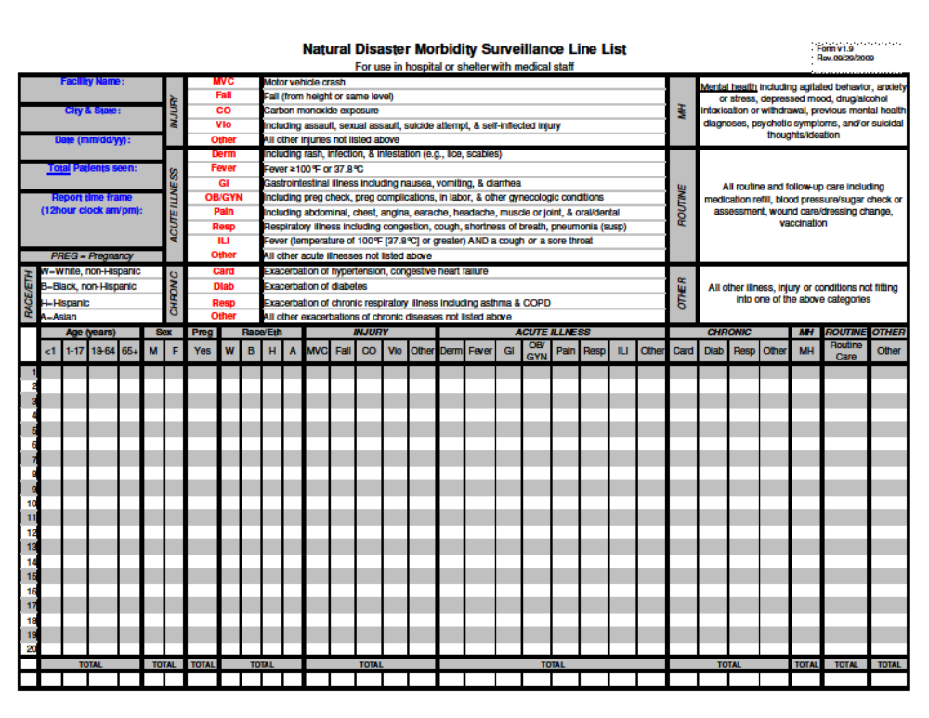

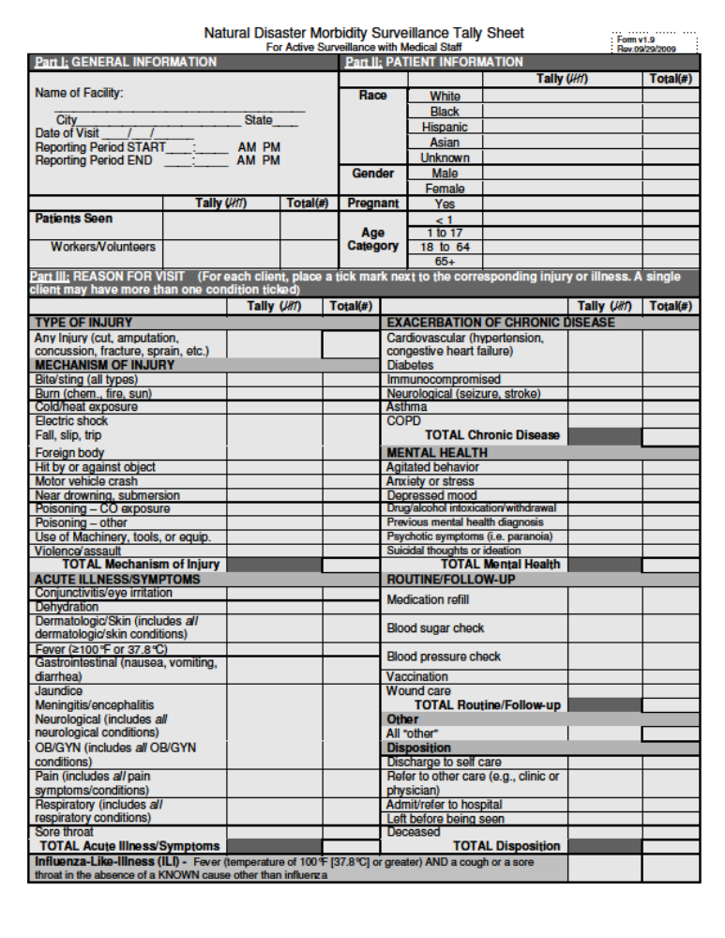
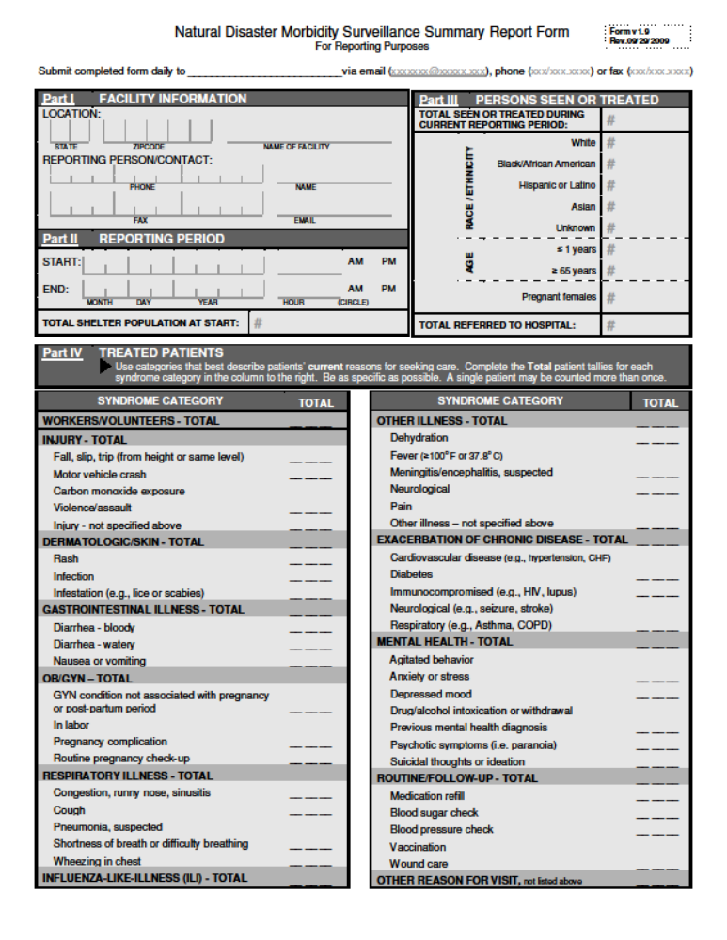

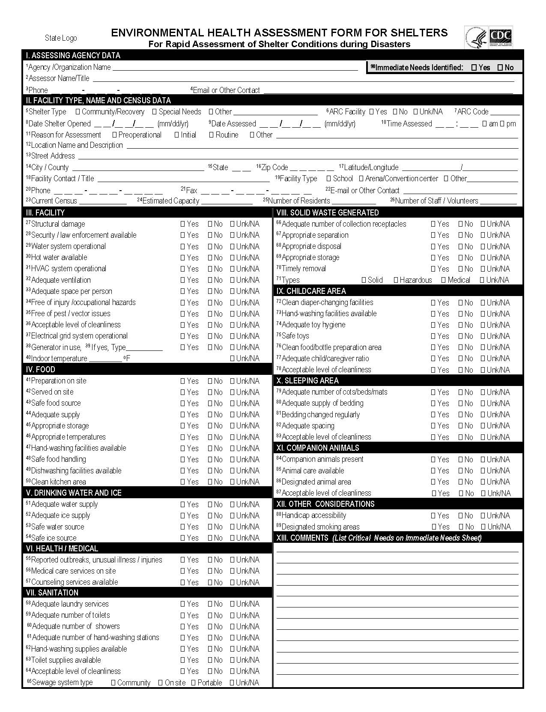



Malilay J, Heumann M, Perrotta D, Wolkin AF, Schnall AH, Podgornik N, Cruz MA, Horney JA, Zane D, Roisman R, Greenspan JR, Thoroughman D, Anderson HA, Wells EV, Simms. The role of applied epidemiology methods in the disaster management cycle. Am J Public Health 2014;104:2092-2102
Pesik N, Keim M. Logistical considerations for emergency response resources. Pac Health Dialog 2002;9:97-103
Waring SC, Brown, BJ. The threat of communicable diseases following natural disasters: a public health response. Disaster Management and Response 2005; 3:41-47
Aghababian RV. Infectious disease following major disasters. Annals of Emergency Medicine 1992;21:362-367.
National Response Framework.Federal Emergency Management Agency (FEMA) website. https://s3-us-gov-west-1.amazonaws.com/dam-production/uploads/20130726-1914-25045-246/final_national_response_framework_20130501.pdf.
Mignone AT, Davidson R. Public health response actions and the use of emergency operations centers. Prehosp Disast Med 2003;18:2017-218
ICS Resource Center. FEMA website. http://training.fema.gov/emiweb/is/icsresrouce/index.htm.
National Shelter System Fact Sheet. FEMA website. www.fema.gov/pdf/media/factsheets/2001/fema_national_shelter_system.pdf.
The National Shelter System. American Red Cross Website. https://nss.communityos.org/sms/
Berkowitz MR. Occupational and public health considerations for work-hour limitations policy regarding public health workers during response to natural and human-caused disasters. American Journal of Disaster Medicine 2012;7:189-198
Griffies WS. Health care infrastructure post-Katrinia: disaster planning to return health care workers to their home communities. Psychiatr Serv 2010;61:70-73
Charney RL, Rebman T, Flood RG. Hospital employee willingness to work during earthquakes versus pandemics. J Emerg Med. 2015;49:665-674
Stier DD, Goodman RA. Mutual aid agreements: essential legal tools for public health preparedness and response. American Journal of Public Health 2006;97(S):62-68
Centers for Disease Control and Prevention (CDC). Epi-Aid – Epidemiologic Assistance Fact Sheet. CDC Website: http://www.cdc.gov/eis/downloads/epi-aid-fact-sheet.pdf
Brahmbhatt, D., Chan, J.L., Hsu, E.B., Mowfai, H, Kirsch, T.D., Quereshi, A. & Greenough, P.G. (2009). Public health preparedness of post-Katrina and Rita shelter health staff. Prehospital & Disaster Medicine, 24(6).
Ridpath, A.D., Bergman, B., Jones, L., Reddy, V., Waechter, H., & Balter, S. (2015) Challenges to implementing communicable disease surveillance in New York City evacuation shelters after Hurricane Sandy, November 2012. Public Health Reports, 130(1).
Isaacson KJ. Moving beyond “special needs”. J Disability Policy 2007;17:230-237
Adapted from CDC. Community Assessment for Public Health Emergency Response (CASPER) Toolkit: Second edition. Atlanta (GA): CDC; 2012.
Garcia-Abreau A, Halperin W, Danel I. Public health surveillance toolkit: a guide for busy task managers. Washington, DC: The World Bank; 2002.
Teutsch SM. Considerations in planning a surveillance system. In: Lee LM, Teutsch SM, Thacker SB, St. Louis ME, editors. Principles and practices of public health surveillance. New York (NY): Oxford University Press; 2010.
Sullivan PS, McKenna MT, Waller LA, Williamson GD, Lee LM. Analyzing and interpreting public health surveillance data. In: Lee LM, Teutsch SM, Thacker SB, St. Louis ME, editors. Principles and practice of public health surveillance. New York (NY): Oxford University Press; 2010.
Centers for Disease Control and Prevention (CDC). A Primer for Understanding the Principles and Practices of Disaster Surveillance in the United States: First edition. Atlanta (GA): CDC; 2016.
Abdallah S, Panjabi R. Epidemiology and surveillance. In: Christensen Rand E, editor. The Johns Hopkins and Red Cross Red Crescent public health guide in emergencies. 2nd ed. Geneva: International Federation of Red Cross and Red Crescent Societies; 2008. Available from: http://www.jhsph. Edu/research/centers-and-institutes/center-for-refugee-and-disaster-response/publications_tools/publications/_CRDR_ICRC_Public_Health_Guide_Book/Forward.pdf
CDC. Principles of epidemiology in public health practice: an introduction to applied epidemiology and biostatistics. 3rd ed. Atlanta (GA): CDC; 2012c. Available from: http://www.cdc.gov/ophss/csels/dsepd/SS1978/SS1978.pdf
CDC. Principles of epidemiology in public health practice: an introduction to applied epidemiology and biostatistics. 3rd ed. Atlanta (GA): CDC; 2012c. Available from: http://www.cdc.gov/ophss/csels/dsepd/SS1978/SS1978.pdf
Centers for Disease Control and Prevention (CDC). A Primer for Understanding the Principles and Practices of Disaster Surveillance in the United States: First edition. Atlanta (GA): CDC; 2016.
Adapted from CDC. A Primer for Understanding the Principles and Practice of Disaster Surveillance in the United States: first edition. Atlanta (GA): CDC; 2016.
Adapted from Appendix D in http://www.apic.org/Resource_/TinyMceFileManager/Practice_Guidance/Emergency_Preparedness/Shelters_Disasters.pdf
http://www.jhsph.edu/research/centers-and-institutes/center-for-refugee-and-disaster-response/publications_tools/publications/2009/PDM_Kirsch.pdf
Wetterhall SF, Noji EK. Surveillance and epidemiology. In Noji EK, editor. The public health consequences of disasters. New York (NY): Oxford University Press; 1997.
Centers for Disease Control and Prevention (CDC). A Primer for Understanding the Principles and Practices of Disaster Surveillance in the United States: First edition. Atlanta (GA): CDC; 2016.

