How to Get Data to Appropriate People ___

Receiving the Data
During the shelter surveillance planning phase, identify who at the health department will receive the data from the shelters and who will analyze the data. Three different types of data may be submitted by shelters: census data with basic demographic information, environmental data, and morbidity data. Identify who will be conducting the analysis on these types of data and whether the analysis will be handled by one individual or department, or multiple individuals located in different departments. The shelter surveillance plan should include who these individuals are with contact email addresses, fax numbers, or phone numbers so they can receive the data from the shelter. Verify this list on a routine basis and update as needed. It may be best to identify one individual in the state or local health department to whom the shelter can send the data and who will be responsible for disseminating the data to the appropriate people for analysis, or have a dedicated agency email that is continuously monitored during a disaster event.
Figure 2. Data Transfer Options from Shelter to Health Department
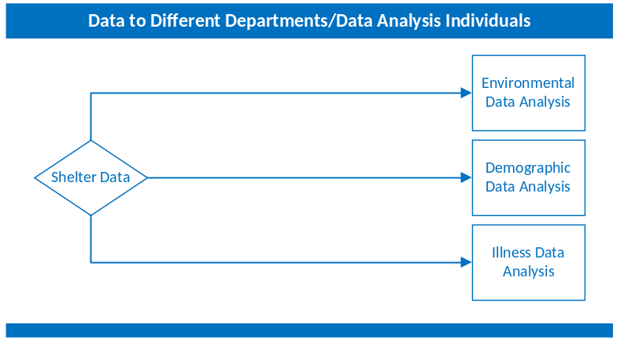

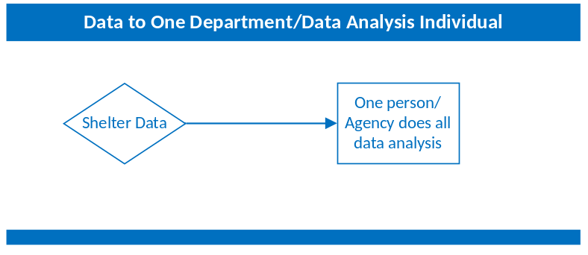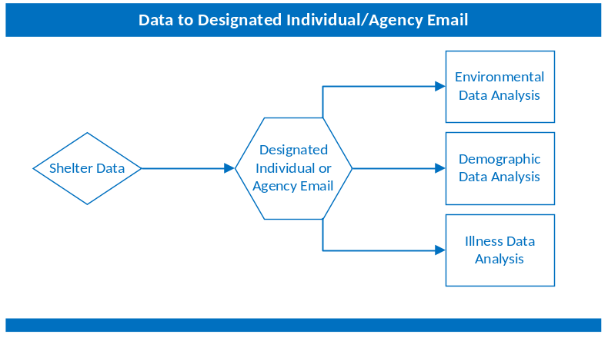

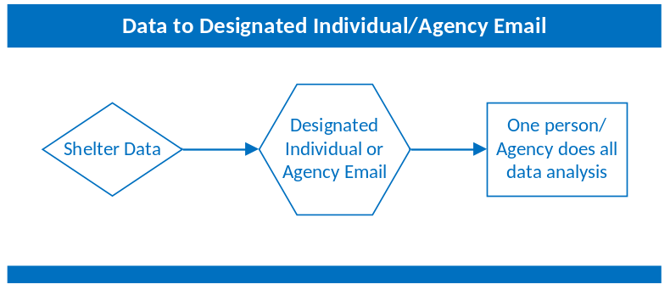

Data Transfer
During the shelter surveillance planning phase, identify how the data will be transferred to the appropriate people. Options for how data may be sent could include sending aggregate line list data or raw data to one individual identified at the state or local health department, or to a dedicated agency email which will then in turn be sent to the appropriate people for analysis. The shelter surveillance plan should include email addresses, fax numbers, phone numbers, and personal/work cell phone numbers with calling and texting capabilities for each individual identified to receive the data or the email address for the dedicated agency email to be used during a disaster event. Verify this list on a routine basis and update as needed. Include the preferred method of data transfer in the shelter surveillance plan and include additional methods in the event that the preferred method is not working. Remember, if using the telephone to gather data, identifying and contacting staff at shelters may be difficult because turnover may be frequent, data received may be incomplete, and staff members may be reluctant to share confidential medical information by telephone. The New York City Department of Health and Mental Hygiene (DOHMH) found after conducting shelter surveillance following Hurricane Sandy in November 2012 that sending DOHMH staff to shelters to gather the data improved data completeness and reliability. Sending health department staff to visit shelters also aided in understanding the layout of the shelters, in investigating reported clusters, and in working with shelter managers to implement control measures. Additionally, site visits can increase awareness among shelter staff about the importance of reporting any illness clusters to the health department. Site visits, however, may not be feasible because of resource constrictions.²⁰ In the event of limited resources, it may be necessary to prioritize and rotate shelter visits based on level of priority.

Timing of Data Transfer
Identify how frequently the data will be transferred from the shelter to the appropriate person(s) at the state or local health department during the shelter surveillance planning phase. The different data types may be sent at different intervals. To determine the transfer interval, identify the needs of partners and stakeholders. For example, if the public health environmental division is performing inspections in the morning, receiving the environmental data at the end of the previous day to share with them prior to their inspection may be best, rather than later that morning after investigations. It is also important to take in consideration the operational period of the ICS. If the most up-to-date information is requested during briefing, you may want to request that data be sent prior to the briefing.

Challenges and Solutions
  - Logistics
Identify back-up reporting methods in the event of a power outage or issues with cell phone service. Include a number of contact methods in the plan for individuals identified for receiving data. A HAM radio may be used; however, information reported should be over a secure channel.
  - Confidentiality / Personal Identifiable Information
There may be different data transfer methods required for aggregate data and data containing personally identifiable information. During the shelter surveillance planning phase, the health department should consult with information technology and legal personnel on the security of the data transfer methods and address any concerns. Given that established systems may not be available during a response, such as a secure fax line or online reporting forms, determination of the acceptability of alternative methods of data sharing, such as email and phone, should be made.
The health department should also discuss the plans for data collection and transfer with the shelter during the planning phase to ensure that the shelter staff will be educated on the importance of sharing the level of information requested and the appropriate application of to the Health Insurance Portability and Accountability Act of 1996 (HIPPA) Privacy Rule to public health entities. While aggregate or de-identified data may be adequate for routine surveillance, if a potential outbreak or case of potential public health importance is identified, rapid sharing of individual-level information will be critical to an effective public health response. Discussions with shelter leadership during the planning phase will provide the opportunity to establish expectations and address any concerns about sharing personal information with the health department. It may be helpful to have the health department legal counsel provide a general letter that may be presented to shelter managers during a response that explains the health department authority to collect HIPPA-protected information and the requirements for the shelter to provide that information in the context of public health practice.

