Story Map SOP
Objective: High level overview of how to create a Story Map in ArcGIS online, beginning with the data you wish to bring in and the subsequent generation of a Web Map, on through until the creation of the Story Map itself.

Steps:

- Format your CSV. Make sure that all numeric columns are formatted as numeric, and all text columns are formatted as text. Having precise location data (x,y coordinates) are helpful but not necessary—at the very least, you will need a column with state/county/town names that can later be joined to a feature layer. For this exercise, however, we will be providing the dataset.
- Import your CSV into ArcGIS online. You can do this by logging into ArcGIS online, and selecting the “map” tab. That should bring you to a blank map where you can begin your work. Import the CSV by clicking “Add” “Layer from file” browse for file on local computer select file “Import Layer”.
- Choose a basemap. Click the ‘basemap’ icon towards the top left of the page:
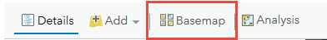

A basemap gallery will launch where you can select the basemap you would like to use. For this exercise, select “Dark Gray Canvas”

- Choose a map layer to join your CSV table to. You can do this by clicking the “Add” dropdown, click “Search for Layers”, then under the “My Content” dropdown, select “ArcGIS Online”
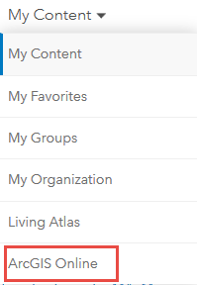

Once ArcGIS Online is selected, goto the search field and type in “MA Municipalities” for this exercise. In the search results, you should find the “MA Municipal Boundaries” layer created by MA_EOPSS_PSBO. Click the “+” sign to add the layer to your map. The map extent may not zoom to the map extent of the added feature layer (ie: Massachusetts), so you may need to zoom into Massachusetts in order to see the added feature layer.
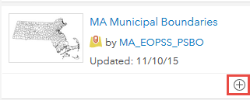

- Join your CSV table with your new MA Municipal Boundaries feature layer. To do so, click the “Analysis” icon towards the top of the page:
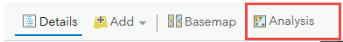

From there, select “Summarize Data”
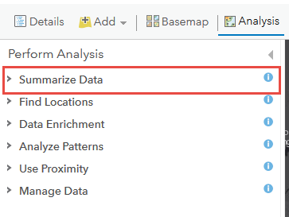
Then “Join Features”
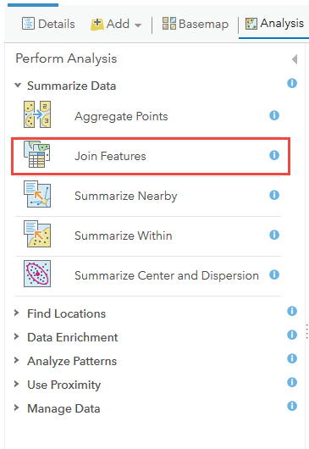
After selecting “Join Features,” a menu will open. Select your “Choose Target Layer” as “MA Municipal Boundaries”, and your “Choose layer to join to target layer” as the CSV table you imported at the beginning. Under “Select the Type(s) of Join,” select “Choose the Fields to Match.” Under “Target Field” select “TOWN” and under “Join Field” also select “TOWN.” These are the common attributes that the two layers share. Whenever you are joining two layers in this way, you must choose an attribute that is shared by both layers. From there, under “Choose Join Operation,” select “Join one to one.” This is the default selection. Once that is completed, enter a “Result Layer Name,” then click “Run Analysis” at the bottom. See below for an image capturing how all of these parameters will look once set.

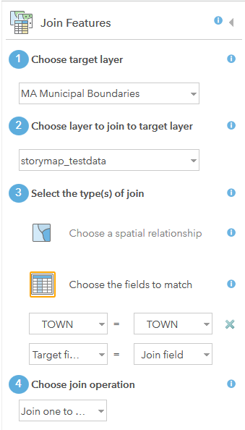
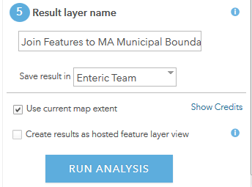

The process of running the analysis could take up to a minute, but once done, you will see an additional feature layer pop up in your map, which is the joined feature layer. This is the layer you will be symbolizing on.
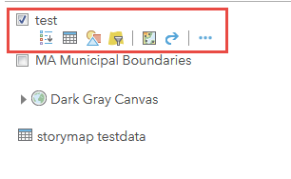
- Symbolize your data. You can do this by first clicking on the “Change Style” icon under your newly created joined feature layer
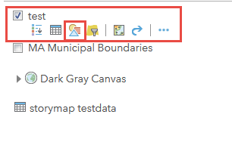
From there, select “RATE” under “Choose attribute to show,” then under “Select a drawing style,” Choose “Options” under “Counts and Amounts (Color)”
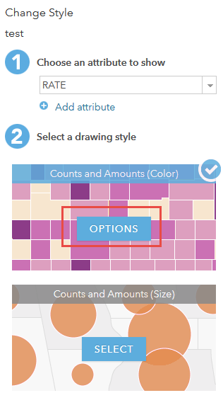
Here you can select your color ramps (under Symbols), whether you want your data to be continuous or discrete (by selecting or unselecting “Classify Data”), and what theme you want your data to follow (high to low, above and below, centered on, etc.). Choose a theme and color ramp that you would like, and determine whether you want classified (discrete) data ramps. Once done, click “OK.”
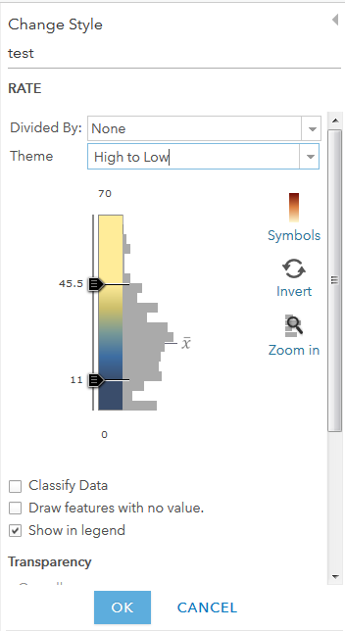

- Create your Story Map. Once you have finished symbolizing your data, click “Share” at the top of the map

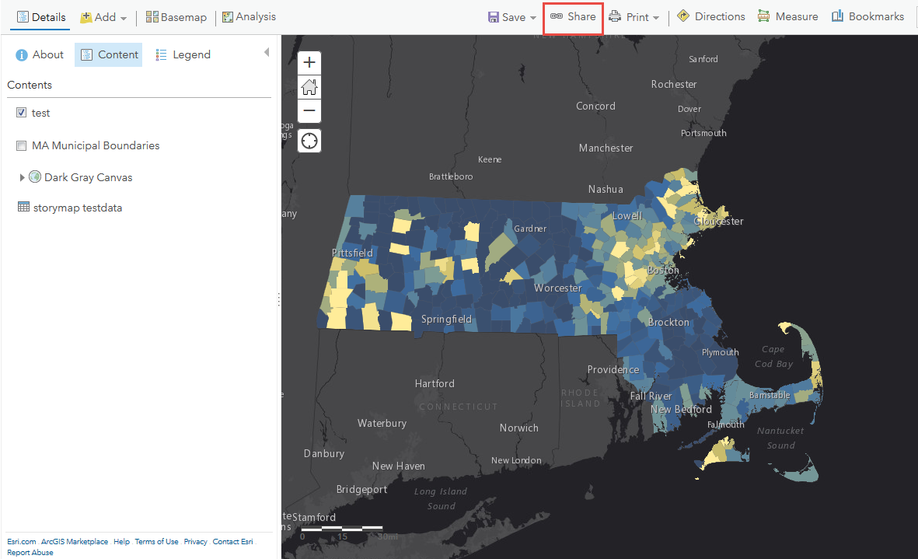

Click “Create A Web App”

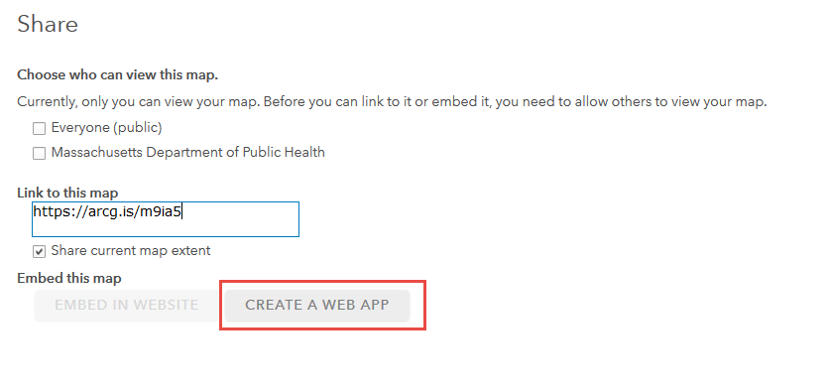
Select “Build a Story Map” then choose “Story Map Series.”

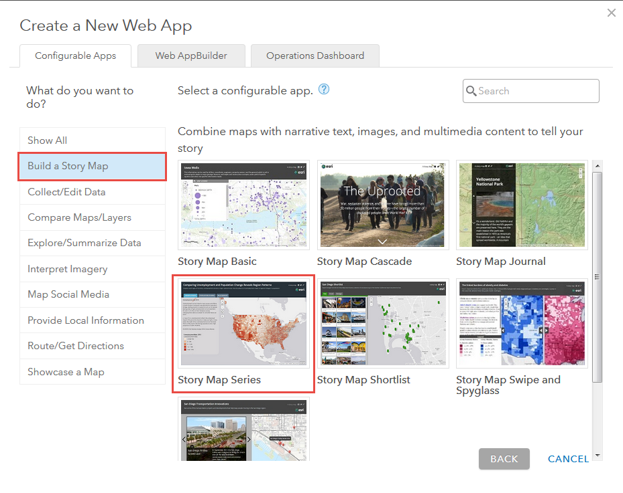

Select “Create a Web App,” then add a title, tags, a summary, and a folder to save it to. Then, click “Done.”

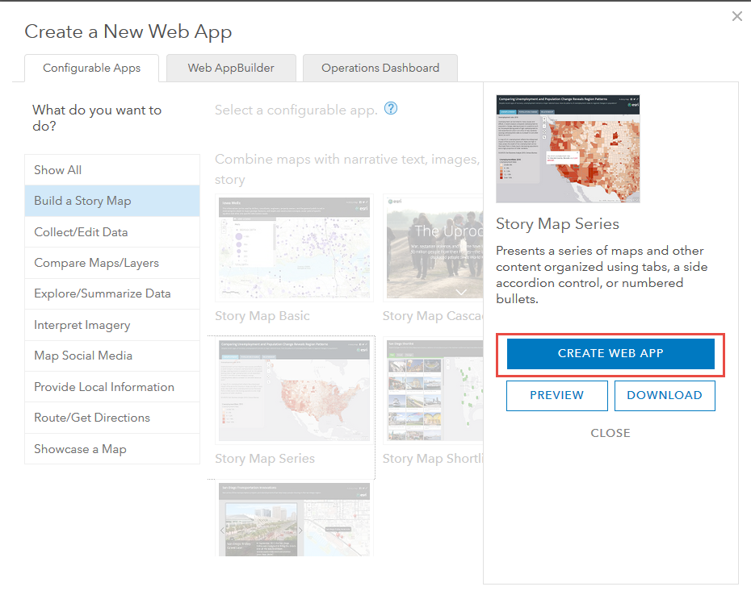
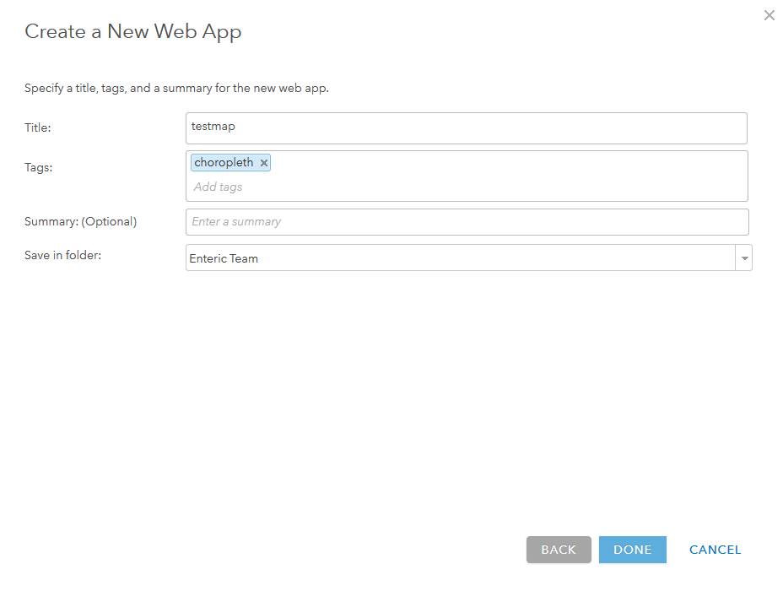
Under “Select a Layout” choose “Tabbed” then click “Start”
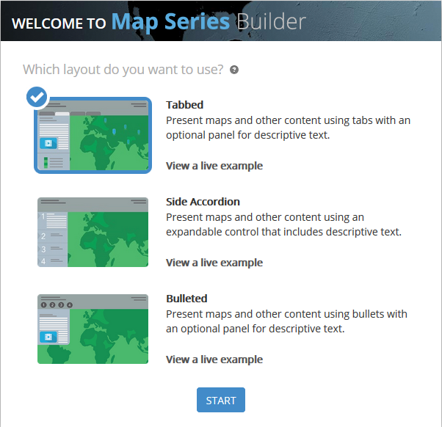

Choose a title for your Tabbed Map Series then click the blue/white arrow to the right.
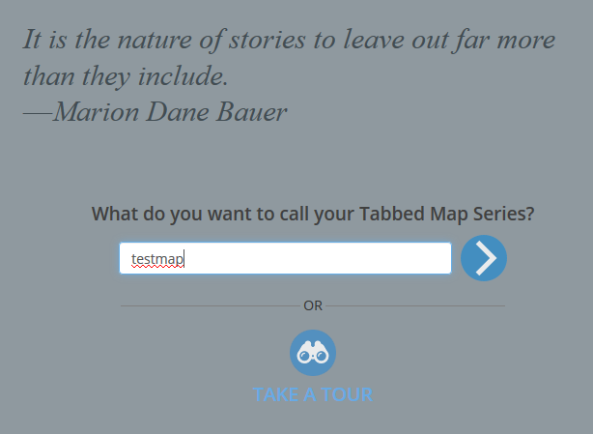

Add a tab title, and under “Content” select “Map.” Under the “Map” dropdown, select the map you created, check off “legend” and keep all other parameters the same. Once finished, click “Add” at the bottom.

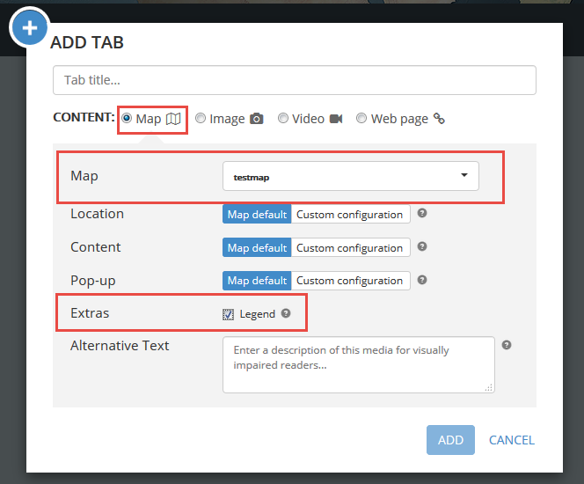

This will create your storymap. You will see your map pop up with a blank panel on the left side where you can add content.

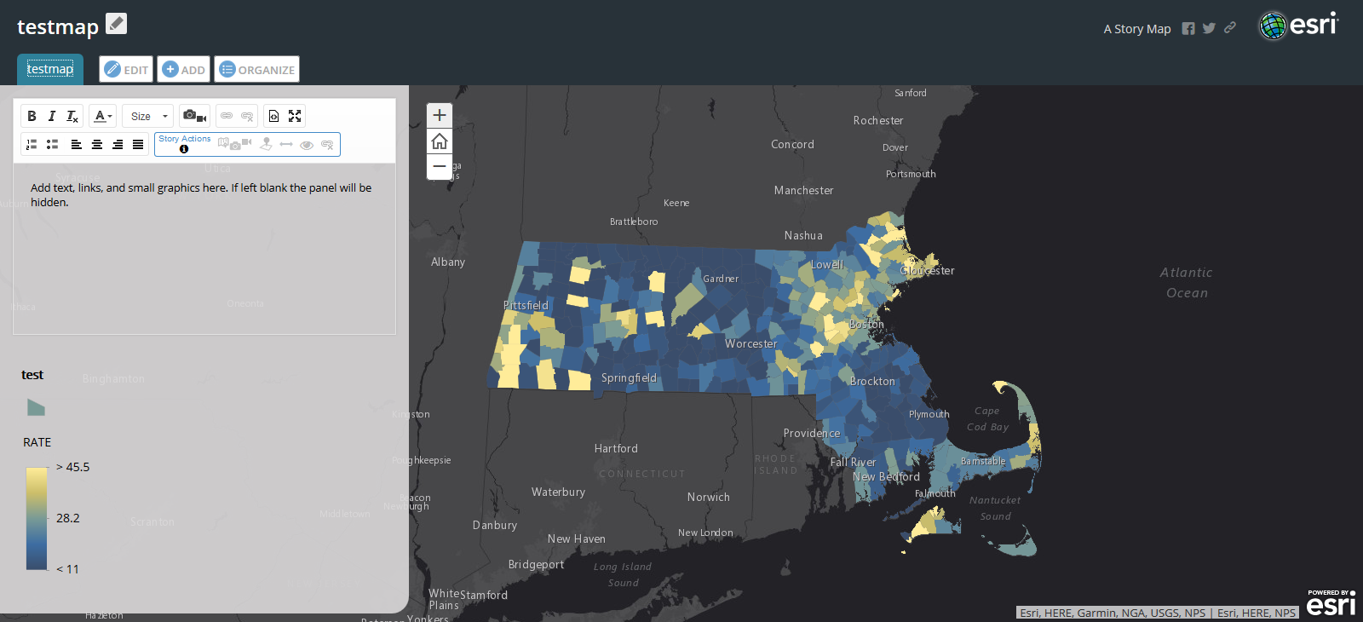

- Add content to your storymap. You can do this by clicking on the left panel where the default text is, and entering in any text that you would like. You can also click on the film/camera icon to embed pictures, or highlight text and click the hyperlink icon to hyperlink text. You can adjust font/font size as needed.
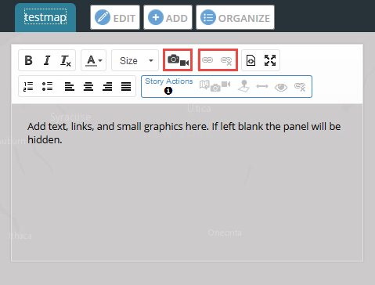

Once you are done with populating the panel with text, images, or links, you can add additional tabs (containing maps with their own side panel content) by clicking the “Add” button. Add as many additional tabs as you need.

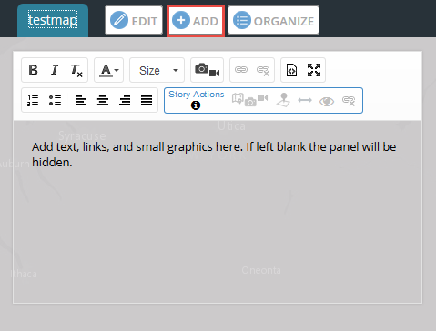

Congratulations, you have created your first Story Map in ArcGIS Online!

