CSTE Wildfire SyS Workgroup Query Validation Guide

Results Due Friday March 5, 2021

Process Outline

Step 1: Time Series Visualization [1]
- Document: Wildfire Season
  - Brief description
  - Time period
  - Geography (jurisdiction-wide and region(s) impacted)
- Query: wildfire/smoke (in CC/DD field, if other, specify)
  - Time series visualization (review data details, save data table)
  - Summary statistics (reporting facilities, top words)
  - Optional: Stratify by age group (explore interactive view)
  - Optional: Stratify by syndrome (explore interactive view)
  - Document observations (from data details, summary statistics, review of stratification results, etc.)
- Query: respiratory (in CC/DD field, if other, specify)
  - Time series visualization (review data details, save data table)
  - Summary statistics (reporting facilities, top words)
  - Optional: Stratify by age group (explore interactive view)
  - Optional: Stratify by syndrome (explore
  - Document observations (from data details, summary statistics, review of stratification results, etc.)
Step 2: Compare to AQ [2]
- Document: Wildfire Event
  - Brief description
  - Time period
  - Geography (limit to region(s) impacted and nearest AQ monitor)
- Query: wildfire/smoke
  - Time series visualization with PM2.5 overlay (save data table for AQ)
  - Document observations, include correlation
- Query: respiratory
  - Time series visualization with PM2.5 overlay
  - Document observations, include correlation
Step 3: Compare Queries to Each Other
- Document: Wildfire Season (Same as Step 1)
- Query: wildfire/smoke AND respiratory together
  - Time series visualization
  - Document observations, include correlation
Step 4: Document Final Thoughts
- Wildfire/smoke
  - Recommended changes to proposed query
  - Overall opinion of utility
  - Questions or concerns for workgroup
- Respiratory
  - Recommended changes to proposed query
  - Overall opinion of utility
  - Questions or concerns for workgroup
Step 5: Submit Findings
- Document validation using this guide as a template
- Save data tables with observed and expected counts for two proposed queries and AQ data for time period and geographies tested - please label intuitively
- Submit validation template and data tables to Meredith (mph.jagger@use.startmail.com) by Friday March 5, 2021

Validation References
- Developing, Evaluating, and Dissemination Definitions for Syndromic Surveillance in Public Health Practice: A Guidance Document, January 2019
- Heat-related Illness Syndrome Query: A Guidance Document for Implementing Heat-Related Illness Syndromic Surveillance in Public Health Practice

Proposed Queries

Wildfire and Smoke Definition - ESSENCE Syntax CC/DD

(,^[;/ ]J70.5^,or,^[;/ ]J705^,or,^[;/ ]X08.8^,or,^[;/ ]X088^,or,^[;/ ]X01.1^,or,^[;/ ]X011^,or,^[;/ ]T59.81^,or,^[;/ ]T5981^,or,^[;/ ]423123007^,or,^wild fire^,or,^wildfire^,or,(,^ ash ^,andnot,(,^dr ash^,or,^pcp ash^,or,^ash wed^,or,^ash cath^,),),or,(,^smoke ^,andnot,(,^ a smoke^,or,^ to smoke^,or,^alarm^,or,^can smoke^,or,^denies smoke^,or,^detector^,or,^did smoke^,or,^does not smoke^,or,^does smoke^,or,^go and smoke^,or,^go smoke^,or,^he smoke^,or,^husband smoke^,or,^n_t smoke^,or,^never smoke^,or,^no smoke^,or,^or smoke^,or,^out and smoke^,or,^outside and smoke^,or,^smoke bomb^,or,^smoke shop^,or,^smoke week^,or,^smoke[drs]^,or,^smoke^a lot^,or,^they smoke^,or,^upstairs and smoke^,or,^was smoking^,or,^wife smoke^,or,^without smoke^,or,^blunt^,or,^joint^,),),),andnot,(,^canab^,or,^cannab^,or,^cig^,or,^crack^,or,^her[io][oi]n^,or,^ k2 ^,or,^marij^,or,!meth!,or,!pot!,or,^spice^,or,^tobac^,or,^weed^,or,^normal saline^,or,^ on fire^,or,^cooking^,or,^kitchen^,or,^motor [bc]^,or,^motor[bc]^,or,(,^motor vehicle^,and,(,^collision^,or,^accident^,or,^crash^,),),)

Respiratory Definition - ESSENCE Syntax CC/DD

(,^[;/ ]J20^,or,^acute bronchitis^,or,^[;/ ]J43^,or,^emphysema^,or,^[;/ ]J44^,or,^ COPD^,or,^chronic obstructive airway disease^,or,^chronic obstructive lung disease^,or,^chronic obstructive pulmonary disease^,or,^[;/ ]J45^,or,^asthma^,or,^bronchasthma^,or,^ RAD ^,or,^reactive airway disease^,or,^[;/ ]J80^,or,^difficulty breath^,or,^breathing problem^,or,^chest tightness^,or,^chronic cough^,or,^[;/ ]R06.0 ^,or,^[;/ ]R060 ^,or,^[;/ ]R06.02^,or,^[;/ ]R0602^,or,^dyspnea^,or,^shortness of breath^,or,^ SOB ^,or,(,^wheez^,andnot,(,^cough^,or,^cold^,or,^congestion^,),),andnot,(,^[;/ ]R50.9^,or,^[;/ ]R509^,or,^febrile^,or,^fever^,or,^high temp^,),)

Example - Wildfire/Smoke Only

Note: Sections where participating validator will expand on example are highlighted in yellow.

Step 1: Time Series Visualization

- Document: Wildfire Season
  - Brief description: Here you will write 1-3 sentences about the fire season you are using for this validation exercise.
  - Time period: Aug 1 - Oct 31, 2020
  - Geography (jurisdiction-wide and region(s) impacted): DHHS region 10, limited details

- Query: wildfire/smoke
  - Time series visualization
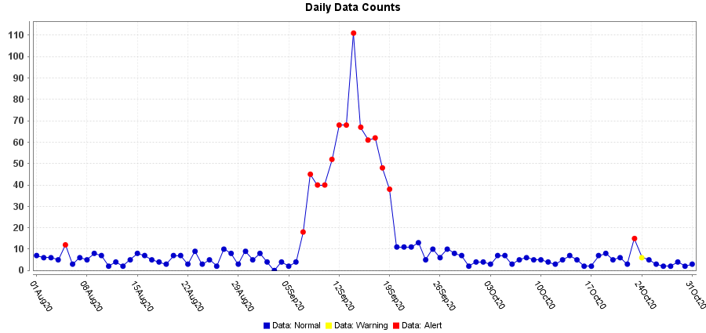

Additional actions:
- Review data details
- Save data table, label intuitively
  - Summary statistics

    - Check number of facilities reporting for anomalies
    - Review top 50 words

  - Stratify by age group

Additional action: Explore anomalies in interactive view

  - Stratify by syndrome

Additional action: Explore anomalies in interactive view
  - Document observations: Here you will briefly describe findings from data details, summary statistics, review of stratification results, etc.

Step 2: Compare to AQ

- Document: Wildfire Event
  - Brief description: Here you will write 1-3 sentences about the fire event you are using for this validation exercise.
  - Time period: Aug 1 - Oct 31, 2020
  - Geography limit to region(s) impacted and nearest AQ monitor): DHHS region 10, limited details; Air quality PM2.5 24 hour, time and station MAX from Oregon

- Query: wildfire/smoke
  - Time series visualization with PM2.5 overlay

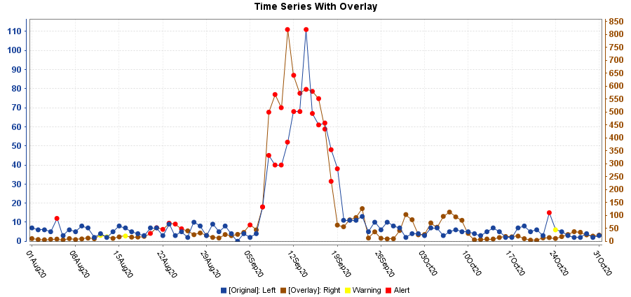

Additional actions:
- Save AQ data table, label intuitively
- Document observations, include correlation

Step 3: Compare Queries to Each Other

- Document: Wildfire Season (Same as Step 1)
  - Brief description: Here you will write 1-3 sentences about the fire season you are using for this validation exercise.
  - Time period: Aug 1 - Oct 31, 2020
  - Geography (jurisdiction-wide and region(s) impacted): DHHS region 10, limited details

- Query: wildfire/smoke AND respiratory together
  - Time series visualization
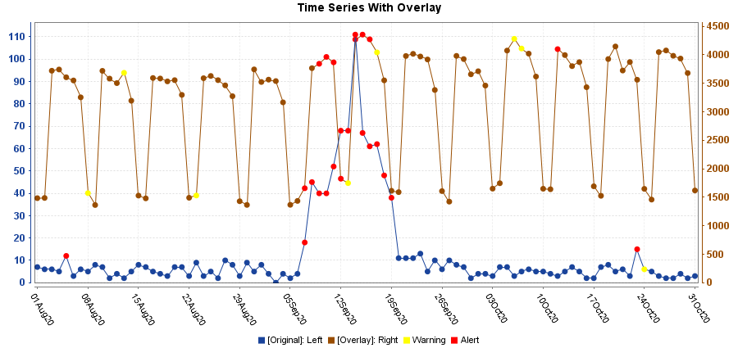

Additional action: Document observations, include correlation

Step 4: Document Final Thoughts
- Wildfire/smoke
  - Recommended changes to proposed query
  - Overall opinion of utility
  - Questions or concerns for workgroup
- Respiratory
  - Recommended changes to proposed query
  - Overall opinion of utility
  - Questions or concerns for workgroup

Step 5: Submit Findings
- Document validation using this guide as a template
- Save data tables with observed and expected counts for two proposed queries and AQ data for time period and geographies tested - please label intuitively
- Submit validation template and data tables to Meredith (mph.jagger@use.startmail.com) by Friday March 5, 2021

“How To” Tips

Step 1: Time Series Visualization
- Query
  - Go to [Query Portal]
  - Select your datasource, resolution, and dates
  - Under Available Query Fields (Left sidebar) -> CC and DD
  - Enter in proposed query text
  - [Select]
  - Check Selected Query Fields (Right sidebar)
  - [Time Series]

- View Summary Statistics
  - Under Time Series visualization, Summary Statistics
  - [Select]

- View Data Details
  - Under Time Series visualization
  - [Data Details]

- Save Data Table
  - Under Time Series visualization
  - [Download to Excel]

- Stratify by age group
  - From Time Series visualization
  - [+] Data Series Options
  - Across Graph Stratification = Age Group
  - [Update]

- Stratify by syndrome
  - From Time Series visualization
  - [+] Data Series Options
  - Across Graph Stratification = Syndrome
  - [Update]

Step 2: Compare to AQ
- Time series visualization with PM2.5 overlay
  - From Time Series visualization of proposed query
  - [Add Overly]
  - Query Portal for Overlay is displayed
  - Select Datasource = Air Quality
  - -> Air Quality Station (pick closest to fire event)
  - Use PM 2.5-24hr Max
  - Select the SAME resolution and dates as query 1
  - [Add Overlay]
  - Use default configurations
  - [Display Overlay]

Note: For the example, I used statewide Oregon data since health data were from DHHS region 10.

Step 3: Compare Queries to Each Other
- Time series visualization with second query overlay
  - From Time Series visualization of wildfire/smoke
  - [Add Overly]
  - Query Portal for Overlay is displayed
  - Select the SAME datasource, resolution, and dates as query 1
  - Under Available Query Fields (Left sidebar) -> CC and DD
  - Enter in proposed query text for respiratory
  - [Select]
  - Check Selected Query Fields (Right sidebar)
  - [Add Overlay]
  - Use default configurations
  - [Display Overlay]

