Existing language/descriptions of the Rebaseline

[From CDC – general introduction on the rebaseline]:
The year 2015 marked the start of the new five-year (2015-2020) goals of the HAI Action Plan and a time of important updates and improvements for NHSN. This provided an opportunity to assess prevention progress while strategizing about the best way to move forward as a country.
One element of the updates and improvements to NHSN was resetting the baseline used to measure HAI progress. Before 2015, the baselines, or reference points, varied among the different HAI measures (e.g. several infections had different baselines). Also, because so much progress was made and norms for HAI prevention were more advanced, it no longer made sense to compare recent progress against older baselines. Periodic rebaselining is and will continue to be important to help continue the progress of preventing HAIs.
Due to several modifications to NHSN surveillance protocols since the historical baseline time periods, as well as changes in the size and service characteristics of facilities reporting to NHSN since that time, CDC updated the SIR baselines and risk models for all HAI and facility types using 2015 data reported to NHSN. “Rebaseline” is a term that CDC’s National Healthcare Safety Network (NHSN) staff is using to describe updates to original HAI baselines. The 2015 rebaseline updates both the source of aggregate data and the risk adjustment methodology used to create the original baselines. Risk adjustment refers to the processes used to account for the differences in risk that may impact the number of infections reported by a hospital, such as type of patient care location, bed size of the hospital or patient age. When the data are risk-adjusted, it makes it possible to fairly compare hospital performance. In this report, the SIRs are adjusted for risk factors.
(consumer friendly): Aggregated data reported to the National Healthcare Safety Network (NHSN) by all facilities during a baseline period that is used to “predict” the number of infections expected to occur in a hospital, state, or in the country. In this report, the number of predicted infections is an estimate based on infections reported to NHSN during the 2015 national baseline for all facility types. Moving forward, HAI prevention progress for (2016) and subsequent years will be measured in comparison to infection data from 2015.
The standardized infection ratios (SIRs) published in this report compare the observed number of infections reported to NHSN during 2015 to the predicted number of infections based on the updated 2015 national baseline and risk adjustment calculations, which apply to all HAI and facility types. The risk adjustment methodology[696 KB] used to produce the CLABSI, CAUTI, VAE, SSI, MRSA bacteremia, and C. difficile SIRs for all facility types are summarized in NHSN’s SIR Guide.

Rebaseline website:
https://www.cdc.gov/nhsn/2015rebaseline/

[From Hawaii’s state HAI report]:
Executive Summary:

(Hawaii continued):
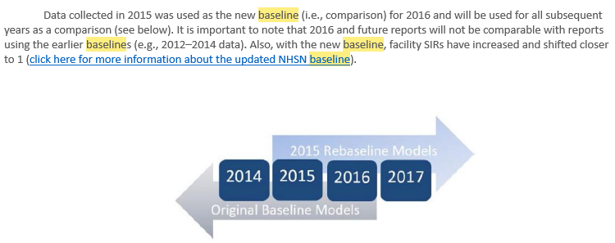
Limitations:

[From Wisconsin’s state HAI report]:

[From Illinois Dept of Health]
Prior to 2015, the SIR was calculated using a single statistical model for all facility types (acute care and critical access) and national data collected during 2010-2011. In 2015, the CDC modified the risk adjustment factors that are used to calculate the predicted number of infections in the SIR and updated the national referent population (see MRSA Risk Adjustment Factors below). Under the 2015 baseline, NHSN started using four separate statistical models based on facility type: acute care hospital, critical access hospital, inpatient rehabilitation facility, and long-term acute care hospital. In addition to the change to risk adjustment factors, SIRs under the new 2015 baseline are calculated using the national data collected during 2015.

Due to the difference in baseline data and risk adjustment factors, SIRs from 2012 – 2014 are not directly comparable to those from 2015 and beyond. The 2012-2014 SIRs under the previous baseline are included and displayed in this report for contextual purpose only and as an indicator of past progress. Starting with 2015 data, SIRs under the new baseline will be used in the current and future trend report updates.

[From Virginia Dept of Health]
…In addition to the updated baseline, new risk models were developed for more HAIs and settings than previously existed. The rebaseline improved risk adjustment over previous models and methods as the new models use the most current surveillance definitions for each infection type and with more timely national HAI incidence. Unfortunately, SIRs calculated based on the new baseline cannot be compared to SIRs calculated based on the original baseline because of the different risk adjustment methods and the different referent population.
The number of predicted infections in this report is calculated based on the 2015 national aggregate data and adjusted for each facility using variables found to be significant predictors of HAI incidence. NHSN uses a logistic regression model when there is an opportunity for a single outcome for each exposure (e.g., SSI following a procedure). Negative binomial regression models are used when estimating incidence from a summarized population (e.g., CLABSI, CAUTI, MRSA, and CDI).

Graphical display of both baselines (CDC):

