Displaying data under multiple baselines
NHSN users are able to calculate SIRs using original baselines on previously entered data. Original baselines are available for data entered for 2016 and earlier. The 2015 rebaseline is available for data entered for 2015 and later. This means there are two years of data (2015 and 2016) that can be analyzed using the original baseline OR the 2015 rebaseline. When reviewing data from these periods, it is important to note whether the SIR was calculated using the original baseline or the 2015 rebaseline.
There are several options for trending data over time in light of the rebaseline. These are described below.
Option A. Do not trend data under original and rebaseline
Under this option, SIRs calculated under the original and rebaseline are not displayed together. Rather, data is trended under the original baseline until a specified stopping point (i.e., 2014, 2015, or 2016) and trended under the rebaseline thereafter (i.e. 2015, 2016, 2017, respectively).
Some considerations include the existence of previously published reports. Data that is presented in separate reports under the original baseline and the rebaseline may confuse audiences if it is not clear in the reports what baseline was used to calculate SIRs. Jurisdictions may decide to specify a stopping point for trending to avoid confusion. This specific stopping point means that trending will begin after the specific stopping point, which may be a limitation for some jurisdictions.

Option B. Trend data under original and rebaseline on the same graph
Under this option, SIRs calculated under the original and rebaseline are displayed together on the same graph. Similar to Option A, a stopping point is identified under which data before the stopping point is calculated using the original baseline, and data after the stopping point is calculated using the rebaseline. It is especially important to clearly distinguish what data is calculated under which baseline. Some ways to do this are to not connect points between different baselines (see example 1, below); clearly demarcate the stopping point on the graph, such as by using a dotted or jagged line (see example 1, below); and using different colors to designate data calculated under different baselines (see examples 1 and 2, below). It is also important to note, either on the graph or in the figure legend, that SIRs under the new baseline cannot be compared to SIRs from the original baseline.
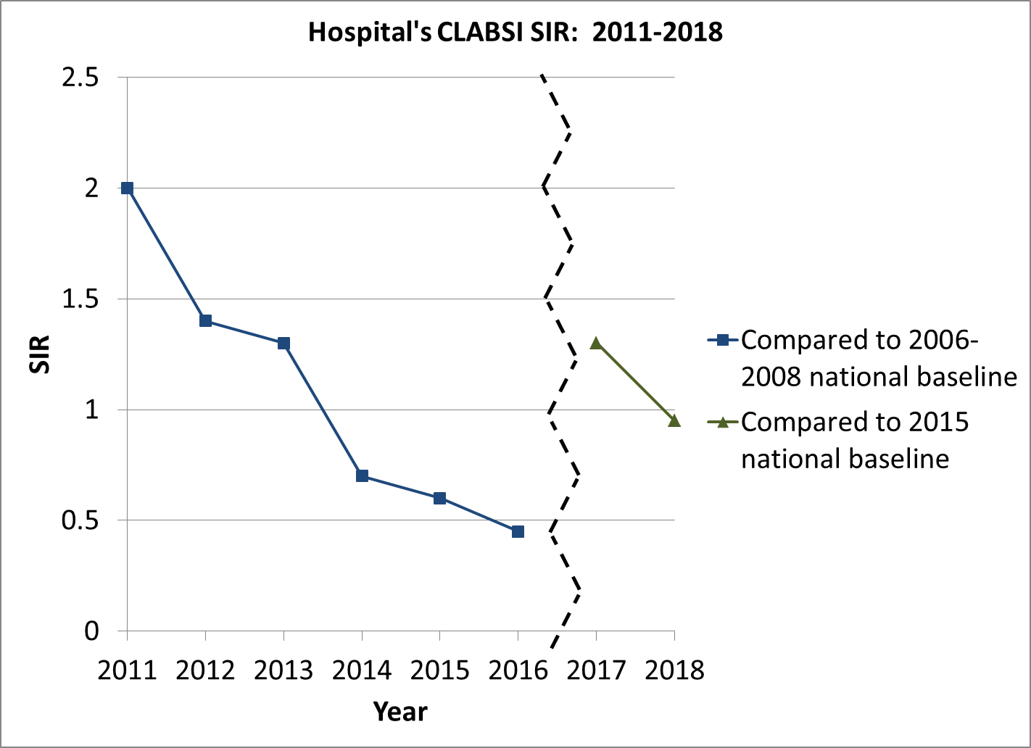
Example 1. Note the use of not connecting points between different baselines, clearly demarcating the change from one baseline to another by using a dotted or jagged line, and using different colors to designate data calculated under different baselines (also indicated in the figure legend).

Figure : Standardized Infection Ratios (SIR) for Central Line-Associated Bloodstream Infections(CLABSIs) for Adult and Pediatric Intensive Care Units (ICUs) by Quarter, Excluding Burn and Trauma ICUs, Tennessee, 01/01/2008–12/31/2016
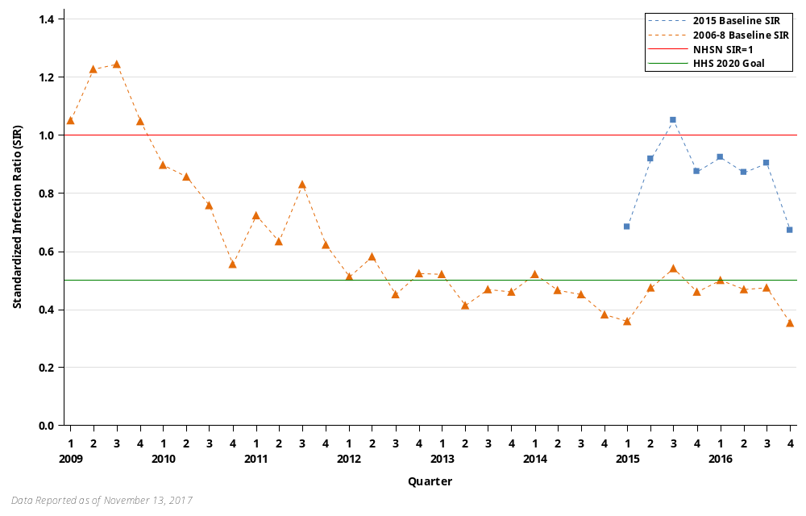
Example 2. Note the use of different colors (and symbols) to designate data calculated under different baselines with clear labeling in the figure legend.

Option C. Trend data under the original and rebaseline on separate graphs
Under this option, SIRs calculated under the original and rebaseline are displayed together but on separate graphs. Similar to option B, it is important to clearly distinguish what data is calculated under which baseline. One way to do this is to use different colors to designate data calculated under different baselines (see example 3, below). The baseline used could also be incorporated into the figure title or legend. It is also important to note, either on the graph or in the figure legend, that SIRs under the new baseline cannot be compared to SIRs from the original baseline.
Figure. Temporal Changes in CLABSI in US Hospitals, NHSN.
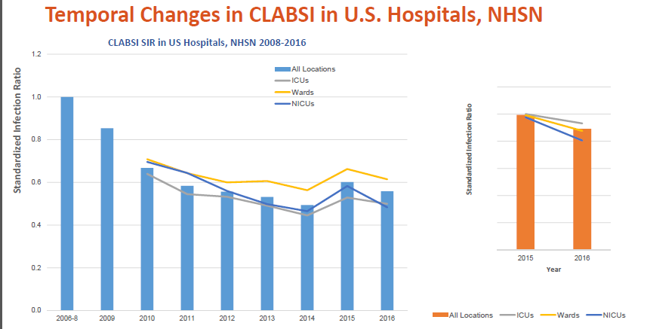
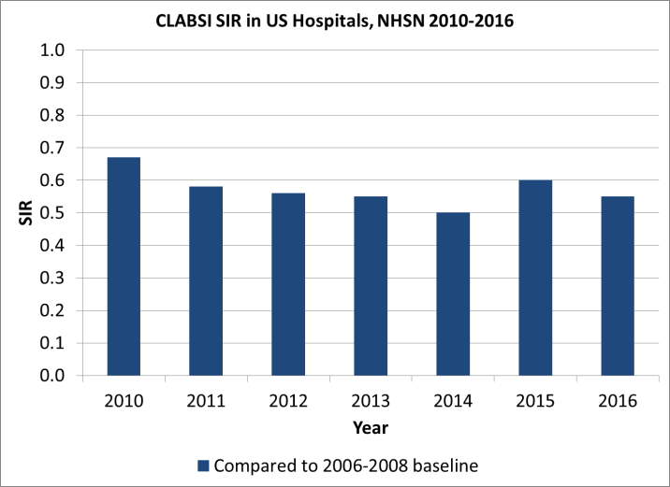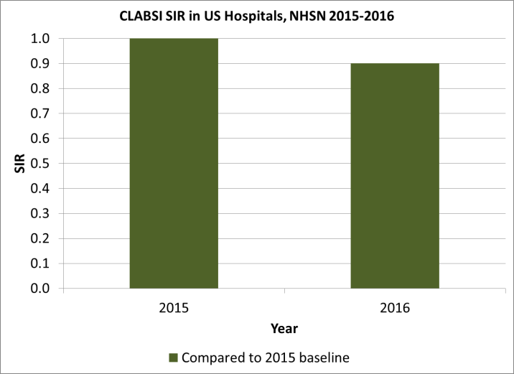
Example 3. Note the use of different colored bars to designate data calculated under different baselines.

