Additionally, I did download Diksha’s R code and it’s showing up in my desktop R Studio. I’d like to load it to NSSP too, the configuration on the NSSP ESSENCE would be different.

Resource Partner Plan for opioid cluster detection:
OD2A Grant Prevention Contacts are below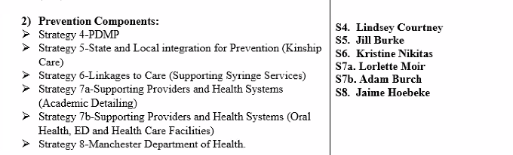

- Strategy 4 - Prescription Drug Monitoring Program (PDMP) is in OPLC - Mark Cioffi – Heads PDMP (Mark.J.Cioffi@oplc.nh.gov, Office of Professional Licensure and Certification), Lindsey Courtney – Executive Director OPLC (Lindsey.B.Courtney@oplc.nh.gov)– Mark may be taking over for Michelle Ricco Jonas?
- Strategy 5 – Kinship Care – 603-224-1279– Jill Burke, Joelyn Drennan
- Strategy 6 – Syringe Services – Lauren McGinley (NHHRC Contract Lead/Linkage to Care/SSPs, Lauren.McGinley@nhhrc.org), Kerry Nolte - Kerry.Nolte@unh.edu, Kristine Nikitas –Infectious Disease Care Coordinator and Syringe Services Program Coordinator, Linkage-to-Care Program, BIDC, DPHS (603-271-5720, Kristine.O.Nikitas@dhhs.nh.gov)
  - NHHRC – Harm Reduction for drug use and misuse includes syringe service programs (SSPs) (reference strategy 6 above)
    - NHHRC engages in policy advocacy, multi-sector education, resource and policy development, coalition and capacity building, and direct services
    - Utilizing best practices and advocating for human rights
- Strategy 7 – Harm Reduction – Kerry Nolte (Kerry.Nolte@unh.edu, previously has historic knowledge of NHHRC Contract), 7a – Academic Detailing – Lorlette Moir (historically – Kerry Nolte), 7b – Oral Health, ED and Health Care Facilities – Adam Burch
- Strategy 8 – Manchester Health Department - Jamie Hoebeke, Anthony Wang
- Other – Joseph Harding, Manager of Substance Misuse Planning and Evaluation, Bureau of Program Quality (BPQ), Contact Information – Joseph.P.Harding@dhhs.nh.gov/work phone 603-271-9426/cell 603-742-4838
- NH EHTP

Cluster Analysis detail regarding WI R code for OUD spike alert detection:
- Diksha’s (WI) code for opioid cluster detection uses data from NSSP ESSENCE with ESSENCE APIs, R, and SaTScan
- WI is using the build-in definitions as recommended by the CDC OD2A team
- WI is using the default detector (Regression/EWMA 1.2) for daily alerts since it takes into account the weekly visit trends inherent to syndromic ED data

WI future plans for opioid cluster detection:
- Plan is to shift to percent alerts using this detector with a 0.05 threshold for county-level alerts
- Count-based alerts will be provided based on local need
- We are in the process of conducting a pilot to understand the differing needs of our local partners

