Disaster Epidemiology Tool: Community Assessment for Public Health Emergency Response (CASPER)

The Community Assessment for Public Health Emergency Response (CASPER) – also referred to as Rapid Need Assessment (RNA), Rapid Epidemiologic Assessment, and Rapid Health Assessment (RHA), contains a specific set of tools designed to provide quickly and at low cost, household-based information about an affected community’s needs after a disaster in a simple format to decision-makers (1). CASPER will assist public health practitioners and emergency management officials in determining community readiness and preparedness level, health status and basic needs of the affected community following a disaster. The advantage of using the CASPER is that within a few days of deploying personnel, response-leadership will have a preliminary report that provides a snapshot of the community health needs (2). Rapidly identifying the needs of a community, and providing that information to response management invokes more effective and appropriately-targeted response efforts (3)

The sampling method used for a CASPER is a two stage cluster sampling with probability of selection proportional to the number of housing units. In the first stage, “30” clusters will be selected from the affected area (sampling frame) and then “7” houses in each cluster will be selected for interview (30X7) systematically by the field team (4). The goal is to interview a representative sample of 210 households. The selected houses are visited by interview teams who conduct a standardized interview/questionnaire.

The primary objectives of CASPER are to:
- Assess emergency or disaster preparedness level of the community
- Determine the critical health needs and assess the impact of the disaster on the community.
- Produce household-based estimates of topics of interest for evidence-based public health action
- Evaluate the effectiveness of relief efforts by conducting follow-up CASPER

There are many uses of CASPER and its use continues to expand and diversify throughout the United States (5). CASPER has been used during the four phases of disaster; preparedness, response, recovery and mitigation. The following examples (case studies) demonstrate four of the many different uses of CASPER.
Reference:
- Centers for Disease Control and Prevention. Community Assessment for Public Health Emergency Response (CASPER) Toolkit. 2nd ed. http://emergency.cdc.gov/disasters/surveillance/pdf/CASPER_Toolkit_Version_2_0_508_Compliant.pdf. Published 2012. Accessed April 4, 2017.
- Malilay J, Flanders WD, Brogan D. A modified cluster-sampling method for post-disaster rapid assessment of needs. Bull World Health Organ. 1996; 74(4):399-405.
- Malilay J. Public health assessments in disaster settings: recommendations for a multidisciplinary approach. Prehosp Disaster Med. 2000;15(4):167-172.
- Zane DF, Bayleyegn TM, Haywood TL, et al. Community assessment for public health emergency response following Hurricane Ike—Texas, 25-30 September 2008. Prehosp Disaster Med. 2010;25(6):503-510.
- Bayleyegn TM, Schnall AH, Ballou SG, Zane DF, Burrer SL, Noe RS, Wolkin AF. Use of Community Assessments for Public Health Emergency Response (CASPERs) to rapidly assess public health issues — United States, 2003-2012. Prehosp Disaster Med. 2015;30(4):1-8.
Preparedness CASPER
Assessing Preparedness Planning by Using Community Assessment for Public Health Emergency Response (CASPER) Methodology, Oakland, Michigan 2012

Background

The state of Michigan is at risk for both natural and human-induced disasters such as flood, tornado and radiological disaster. Recent events in Michigan have highlighted the importance of emergency planning and public health response to disasters (1). In June 2008, tornado and associated severe weather affected several counties in the state (2). In July 2010, an oil pipeline ruptured near Marshall, Michigan, releasing an estimated 844,000 gallons of heavy crude oil into the surrounding waterways (3). Approximately 1.2 million persons in Oakland County, Michigan alone reside less than 50 miles from the Fermi Nuclear Power Plant, Unit 2. The proximity of Michigan to the Great Lakes makes it susceptible to extreme weather events, including lake-effect storms (rain or snow1) (4). In 2010, Michigan conducted a large scale response to assess health risks from the oil exposure and to issue warnings and take other public health measures to reduce the risk of exposure.

As part of the ongoing efforts to develop disaster epidemiology capabilities in Michigan, the Oakland County Health Division (OCHD) and MDCH requested the assistance of the CDC in conducting an assessment of household emergency preparedness in Oakland County, in September 2012.

The objectives of this assessment were to provide knowledge transfer and capacity building for the state and local public health partners in terms of disaster preparedness and response epidemiology and to fulfill the specific objectives of the CASPER, which were as follows: 1) to determine the types of emergency preparations households in Oakland County have in place; 2) to identify the most trusted and main sources of information for Oakland County households during a radiation emergency; and 3) to assess the likelihood that households in Oakland County would follow public health instructions following a disaster involving radioactive material.

To accomplish these objectives, OCHD and MDCH with assistance from CDC conducted a CASPER in Oakland County on September 10-12, 2012. OCHD, MDCH and CDC developed a two-page data collection instrument. The questionnaire addressed household needs, emergency preparedness, response to a radiation emergency, and sources of information in emergencies.
Sample selection
On the basis of information obtained from OCHD and MDCH, all housing units in Oakland County, comprising 527,255 recorded by the 2010 US Census, were included in defining the sampling frame. We used the recommended two stage cluster sample methodology to select the clusters by using the geographic information systems (GIS) CASPER tool.

GIS tool application
To obtain a block level (cluster) map with streets, highway and water body information, we applied the GIS CASPER tool (a set of program developed by CDC-GRASP and HSB to enhance the cluster sampling and mapping method) in Environmental Systems Research Institute (ESRI) ArcMap 10.1 software and selected the 30 clusters during the preparation phase of CASPER. The ArcMap 10.1 software package comes with a library of map files that could be downloaded from the Bureau of Census website (5) and from other data sources (e.g. gdt). The data files needed were the Oakland county shape files, population, and the housing units. The GIS CASPER tool automatically generated the cumulative number of housing unit and excluded blocks with “0” housing unit from the sampling frame. Based on the cumulative house number of the clusters, 30 clusters were selected randomly (first stage of sampling). Printed street maps of clusters showing geographical identifiers in PDF format were generated using a GIS Map Book. In Addition, KMZ files were created in GIS to see the selected clusters map in Google earth that shows the aerial view of the selected clusters.
We provided Just in Time (JIT) training the interview teams. There were a total of 17 teams on the first day and 15 teams on the second day, which primarily consisted of state and local public health staff, with assistance provided by CDC staff.
All potential respondents approached were given an information sheet with contact telephone numbers for OCHD, educational material from OCHD regarding emergency preparedness, an OCHD bag to store emergency supplies and other timely OCHD information on West Nile virus and flu shots. Further, the OCHD alerted the community to the presence of interviewers in Oakland County through a news announcement.
Result:
Interview teams completed 192 surveys over three days for an overall completion rate of 91.4. Teams completed interviews in 37.1% of houses approached. Of the households with an eligible participant answering the door, 56.5% completed an interview
Most households reported having basic supplies to last three days in an emergency including non-perishable food (85.4%), water (1 gallon/person/day) (64.7%), and a way to cook food without utilities (76.4%).
Households in Oakland County had a very high willingness to follow instructions from officials in the event of “release of radioactive material that could affect your community.” Most households were willing to go to a radiation screening center (93.3%), evacuate (96.0%), and shelter-in-place (91.8%) if told to do so by officials
More than half of the households said they would rely on the television (55.8%) to keep up-to-date during a radiation emergency. Radio (18.4%) was the next most common source of information,
Discussion
During the week of the assessment, CDC staff provided group and one-on-one CASPER training to MDCH staff regarding the process and analysis aspects of administering a CASPER. Data analysis was conducted with three MDCH staff for knowledge translation purposes. The participation of OCHD and MDCH in the training, development and implementation of the assessment enabled disaster epidemiology knowledge translation and capacity development to strengthen the local and state level preparedness and response capability.
Similarly, the GIS CASPER tool for sampling and mapping, used to create the clusters map in the first steps of CASPER, dramatically shortened the processing time. Futures of GIS –CASPER tool such as computerized random selection of the 30 clusters and the capacity to generate clusters map in PDF and KMZ format, makes more useful this tool than sampling and mapping method using census 2010 described elsewhere (6). The MI CASPER map developed using the GIS CASPER tool along the aerial view of the selected clusters map developed by linking the KMZ files to Google Earth provided detail information of the assessment area. In addition the GIS CASPER tool is flexible, easy to customize and generate better quality map than census 2010 block map. At the virtue of the GIS map, the MI CASPER field teams had better understanding of the selected clusters in advance and were able to navigate easily to their respective clusters.

Integrating the CASPER methodology in GIS is important to enhance the assessment process; however, GIS application in CASPER is dependent upon equipment and methodologies being practical and appropriate for field use. In Addition application of this technology requires license to maintain the software, basic GIS training, and access to ESRI and ESRI data.
The results of this CASPER provided a rapid assessment of household emergency preparedness in Oakland County from which OCHD and MDCH can further develop their public health emergency plans.
References:
- Household Emergency Preparedness Oakland County, Michigan September 2012: Available at: http://www.michigan.gov/documents/mdch/MI_CASPER_Report_FINAL_02112013_413612_7.pdf
- Fordyce, James. Governor widens storm state of emergency to other counties. The Michigan Messenger. [Online] 06 20, 2008. [Cited: 08 29, 2012.] http://michiganmessenger.com/1445/governor-widens-storm-state-of-emergency-to-other-counties.
- Office of Public Health Preparedness. Public health and medical preparedness: a decade of achievement in Michigan. Lansing : Michigan Department of Community Health, 2011. Available at http://www.michigan.gov/documents/mdch/Commemorative_Brochure_Final2_362709_7.pdf. Accessed August 29, 2012.
- Steiger SM, Hamilton R, Keeler J, Orville RE. Lake-effect thunderstorms in the lower Great Lakes. Journal of Applied Meteorology and Climatology. 2009;48(5):889-902.
- American Fact Finder: Census 2010 Oakland, Michigan Summary File. Available at; https://factfinder.census.gov/faces/nav/jsf/pages/searchresults.xhtml?refresh=t#none Accessed on March 20, 2017
- Department of Health and Human Services, Centers for Disease Control and Prevention. Community Assessment for Public Health Emergency Response (CASPER) Toolkit. Atlanta, GA: CDC; 2012. Available at: https://www.cdc.gov/nceh/hsb/disaster/CASPER_elearning/CASPER%20Toolkit%20Version%202%200_FINAL%20CLEARED.pdf. Accessed on March 20, 2017
Response CASPER:

Mental Health Needs Assessment After 2010 Gulf Oil Spill

On April 20, 2010, the Mobile Offshore Drilling Unit (MODU) Deepwater Horizon exploded 40 miles south of the coast of Louisiana. This event resulted in 11 deaths, 17 injuries, and the largest marine petroleum release in history. Over the following 3 months, over 4.9 million barrels of oil were released into the Gulf of Mexico. Although the oil well was capped on July 15, 2010, stopping the flow of oil into the ocean, the released crude oil has prolonged negative effects on marine biota. This released oil has detrimental consequences for the fishing industry, coastal attractions; and estuarine, marsh and protected ecosystems of the Gulf States of Louisiana, Alabama, and Mississippi and placed these resources in jeopardy of destruction (1).

Following the oil spill, the Alabama Department Public Health (ADPH), and Mississippi Department of Public Health (MDPH) officials, were concerned that some health effects, particularly mental health outcomes, were not adequately captured by routine surveillance systems. To address these concerns and assess the mental health status of the community, the ADPH and MDPH in association with the Alabama and Mississippi Department of Mental Health requested CDC assistance in conducting a Community Assessment for Public Health Emergency Response (CASPER) in Gulf coast counties. The goals of these assessments were to determine the general and mental health needs of the community following the oil spill, and to provide the state and local public health officials with information to guide responses and allocate resources.

The sampling frame in Gulf Coast counties of Alabama and Mississippi were divided into three areas for the purpose of this assessment: (1) Baldwin County, Alabama; (2) Mobile County, Alabama; and (3) coastal Mississippi. The first two assessment areas consisted of only the coastal portions of Mobile and Baldwin counties in Alabama. The assessment area in coastal Mississippi included all three of its Gulf Coast counties: (1) Hancock County; (2) Harrison County; and (3) Jackson County. These three counties (hereinafter referred to as ‘Mississippi’ [2])

A two-page data collection instrument was developed in coordination with Alabama and Mississippi Departments of Mental Health, the state health departments, and the CDC’s Division of Behavioral Surveillance of the Public Health Surveillance Program Office. The questionnaire included questions regarding dermatologic, and other physical symptoms and signs that had arisen or worsened in the previous 30 days, standardized questions on quality of life, mental health, and social context, as well as individual and household level exposure questions related to the oil spill

Result:
In Alabama, interview teams completed 128 of the goal of 210 interviews in Mobile County (61% response rate) and 168 interviews in Baldwin County (72% response rate). In Mississippi, 173 interviews (67% response rate) were completed (Table 1)

The proportion of respondents reporting ≥14 days of poor physical health, mental health, or limited activity in the past 30 days was greater in all three assessment areas than was reported somewhere (2009 BRFSS state estimates). The highest percentage of individuals (21.6%) who reported ≥ 14 days of poor physical health in the previous 30 days was noted in the residents of the area surveyed in Mississippi.

Table 1. Health Quality of Live and Symptoms by CASPER Sampling in Mobile and Baldwin Counties, Alabama and the Gulf Coast of Mississippi, 2010

 | Mobile County, AL | Baldwin County, AL | Mississippi
 | Weighted % (95% CI) | Weighted % (95% CI) | Weighted % (95% CI)
Health-Related Quality of Life and Symptoms
≥ 14 physically unhealthy days | 19.7 (8.0-31.4) | 15.8 (9.8-21.9) | 21.6 (14.7-28.5)
≥ 14 mentally unhealthy days | 22.7 (10.9-34.6) | 16.3 (9.1-23.4) | 22.1 (13.8-30.4)
≥ 14 activity limitation days | 12.9 (5.2-20.5) | 9.4 (3.1-15.6) | 12.2 (6.1-18.3)
Depressive symptoms | 23.9 (13.0-34.8) | 15.3 (9.0-21.5) | 24.5 (16.4-32.7)
Symptoms of anxiety | 28.7 (15.1-42.3) | 20.8 (13.1-28.6) | 31.5 (21.5-41.9)
Worry or Stressed
Worried/stressed about money for mortgage/rent  Always/usually  Sometimes  Rarely/never | 28.1 (18.3-37.9)  14.7 (8.4-21.0)  57.0 (46.9-67.1) | 24.2 (16.9-31.4)  19.6 (11.8-27.4)  56.1 (47.7-64.5) | 37.2 (25.9-48.6)  15.6 (9.2-22.0)  47.1 (37.0-57.2)
Worried/stressed about money to buy meals  Always/usually  Sometimes  Rarely/never | 18.1 (8.9-27.2)  16.6 (8.2-24.9)  65.2 (53.5-76.9) | 12.5 (6.4-18.7)  10.7 (4.4-16.9)  76.6 (67.4-85.9) | 19.8 (12.4-27.3)  16.0 (9.6-22.3)  64.0 (54.5-73.6)

The findings of this assessment were shared with stakeholders in a meeting at the end of the assessment highlighting the major findings and recommendations that was distributed to emergency managers, state epidemiologists, or State Local health department authorities within 48 hours of completing the assessment to support evidence-based public health decisions. This assessment was unique because for the first time demonstrated the usefulness of the CASPER methodology in mental health response and planning. This CASPER was a successful collaboration of States, Local, and Federal health agencies and provided an opportunity to engage with the community and improve mental health outreach programs.

References:
- Community Assessment for Public Health Emergency Response (CASPER) after the Gulf Coast oil spill: Alabama, 2010: Available at: http://www.adph.org/CEP/assets/CASPER_report.pdf
- Buttke D, Vagi S, Bayleyegn T, Sircar K, Strine T, Morrison M, Allen M, Wolkin A. Mental health needs assessment after the Gulf Coast oil spill—Alabama and Mississippi, 2010. Prehosp Disaster Med. 2012;27 (5):1-8.

Recovery CASPER
Longitudinal Community Assessment for Public Health Emergency Response to Wildfire, Bastrop County, Texas

On September 4, 2011, a wildfire ignited in Bastrop County, Texas. The wildfire, which would become the most destructive wildland urban interface wildfire in Texas history, burned 34,068 acres of land, destroyed 1,669 residential structures, and caused 2 deaths.¹ To assess public health impacts from the fire, the Texas Department of State Health Services (DSHS) Health Services Region 7 and the Bastrop County Office of Emergency Management conducted a CASPER on September 24-25, 2011.²

The objectives of this 2011 CASPER were to determine the immediate public and mental health needs of the community and to provide local officials with an overview of key public health issues to assist with response and resource allocation issues as recovery operations commenced. In addition, questions about sources of information and communication preferences during the immediate disaster response and ongoing recovery were assessed.

Nearly 3 and a half years later, in 2015, a follow-up CASPER was conducted to measure progress in recovery and preparedness, assess long-term health and mental health status, identify useful means of communication, and ascertain new concerns or unmet needs to be shared with Bastrop County officials. CASPER can be effectively used in both disaster and nondisaster settings and therefore could be applied to both the 2011 assessment immediately after the wildfire and the 2015 assessment focusing on recovery and preparedness.

The survey instrument used in the 2011 CASPER consisted of 34 questions addressing several areas of concern for local emergency management and public health officials involved in the disaster response and recovery efforts. Subject areas included structural damage to the residence, access to basic services such as utilities, access to medical care, physical and mental health status, evacuation behaviors, wildfire-related communications, and pet and livestock issues. The survey instrument used in the 2015 CASPER included 33 questions addressing several areas of interest for local emergency management and public health officials, including preparedness, physical and mental health status, communication, and recovery. The survey included questions about residence at the time of the 2011 wildfire, home damage as a result of the wildfire, preparedness, physical and mental health status, preferred communication methods, and concerns related to the continued recovery of the Bastrop community.

Assessments were conducted in census blocks either within, overlapping, or touching the perimeter of the Bastrop County Complex Wildfire. DSHS-trained survey teams attempted to interview 1 eligible adult (‡18 years of age) at 7 occupied housing units. In both assessments, teams were assigned 1 to 3 clusters and attempted to complete 7 interviews in each of the 35 census blocks, for a target of 245 surveys. Detailed maps of selected blocks were generated, and interviewers were instructed to select the first interview location using a randomized number determined by the number of housing units in the census block. Interviews proceeded sequentially to the next nearest houses within each cluster from the random starting point, using CDC’s CASPER Toolkit procedure for replacement. The clusters chosen for the 2015 CASPER were selected using the 2011 fire perimeter to allow for comparison of some responses.

Results
In 2011, survey teams completed 135 household interviews, with a cooperation rate of 91.2% and a contact rate of 43.5%. In the follow-up CASPER conducted in 2015, survey teams completed 185 household interviews, with a cooperation rate of 78.1% and a contact rate of 53.9%.³

To learn more about the long-term effects of the 2011 wildfire and the trajectory of disaster recovery in Bastrop, Texas, longitudinal data were collected on several topics in the 2015 CASPER. These included questions related to intentions to rebuild (2011) and rebuilding (2015); actual (2011) and intended (2015) evacuation locations; inclusion of 5 important elements in a household emergency plan; awareness of available mental health services; and mental health outcomes among both adults and children.

The vast majority (91.0%) of households living in wildfire-affected structures surveyed in 2015 indicated that residential structures had been repaired or rebuilt.

The reported lodging types used during the 2011 evacuation were consistent with the stated preferences in the 2015 assessment. Neighbors, friends, and family were ranked first as the preferred lodging type during evacuation by the majority of households.
In 2015, households exposed to the 2011 wildfires were significantly more likely to have established a family meeting place and evacuation route, to have confidence in the local government's ability to respond to disaster, and to report symptoms of depression and higher stress.
Discussion
The utility of rapid needs assessments for developing effective strategies for recovery in communities affected by a major wildfire was demonstrated with the Bastrop CASPERs. The opportunity to conduct a longitudinal assessment of the long-term effects of a major wildfire disaster using the CASPER method is unique.³ It provided actionable information for improved planning, preparedness, and recovery to public health and emergency management agencies and community residents. Findings were widely shared with and used by local public health and emergency management officials, and changes in planning, notification, health education, resource allocation, and other recovery activities were implemented based on the results of these assessments.

References

¹ National Climatic Data Center (NCDC). (2011). Storm events database: event details. NOAA website. 2011. http://www.ncdc.noaa.gov/stormevents/eventdetails.jsp?id=349876. Accessed March 3, 2016.

² Zane D, Jones R, Huss J, Sanches K, Hoogheem J, Clements B. Public Health Emergency Response to a Massive Wildfire in Texas (2011), Texas Public Health Journal 2012; 64(4): 6-10.

³ Kirsch KR, Feldt BA, Zane DF, Haywood T, Jones RW, Horney JA. Longitudinal Community Assessment for Public Health Emergency Response to Wildfire, Bastrop County, Texas. Health Security. 2016 Mar-Apr;14(2):93-104.

Incident Command System in CASPER implementation
Assessing the public health impacts of drought in Mariposa and Tulare counties, California 2015
Background
California’s unprecedented drought began in 2012; thousands of private wells have gone dry reducing access to potable water; and millions of trees have died or succumbed to bark beetle infestation in drought-stricken forests resulting in increased risk of wildfires, landslides, and costs to property owners. Governor Edmund G. Brown Jr. proclaimed a State of Emergency in January 2014 (https://www.gov.ca.gov/news.php?id=18368) and by the end of 2015, California recorded 63 Emergency Proclamations from city, county, tribal governments, and special districts (http://drought.ca.gov/pdf/archive/WeeklyDroughtUpdate(11-25-15).pdf).
A severe drought is a slow-onset disaster with far-reaching impacts on the economy, environment, and communities. Drought-associated adverse outcomes might be the result of long exposures, leading to both direct and indirect health consequences. Drought-impacted households might lack running or potable water, might experience physical and mental health effects, and might face financial losses related to the drought; however, little has been reported on the public health impacts of drought.
California Department of Public Health (CDPH) collaborated with two severely impacted counties in 2015, to conduct CASPERs to better quantify drought-related population impacts and to inform public health decisions and action. Tulare County, a largely agricultural county in the heart of California’s Central Valley, has had the majority of reported private well failures in the state. Mariposa County, located at the foothills of the Sierra Nevada Mountains, had the most affected forests, with an estimated 30–50% mortality of pine, fir, and oak. These CASPERs assessed knowledge, attitudes, and practices regarding the drought; access to and use of water; water conservation practices; perceived impacts of the drought on health, mental health, and finances; preferred emergency communication methods; and household demographics.
Tulare County conducted two simultaneous CASPERs, one in the northern and one in the southern parts of the county; the two sampling frames were designed to enrich for private well ownership. Mariposa chose a single county-wide sampling frame. The complete results of the assessments are available at CDPH website here: https://www.cdph.ca.gov/programs/ept/Pages/default.aspx.
Both Tulare and Mariposa counties implemented Incident Command System (ICS) for the drought CASPERs. Additionally, Tulare utilized its Emergency Operations Center (EOC) location as the Incident Command Post and Mariposa exercised their Public Health Emergency Preparedness (PHEP) Capabilities. In this case study, we discuss how CASPER fits with the ICS infrastructure, how ICS can benefit CASPER implementation, and how local jurisdictions can leverage both to fulfill their PHEP requirements.
Incident Command System and CASPER
ICS is designed to enable effective and efficient incident management by integrating personnel, equipment, procedures, and communications in a common organizational structure, which has five major functional areas: Command, Operations, Planning & Intelligence, Logistics, and Finance & Administration (for more information: https://www.fema.gov/incident-command-system-resources).
While CASPER itself is a specific epidemiological method, the overall process necessary for its implementation – from selecting a sampling frame to designing a questionnaire to managing field interview teams to data entry and analysis – largely fit with the ICS structure (Figures 1-3). Potential benefits of conducting a CASPER using an ICS structure include: partnering with emergency management and other agencies to reduce costs and increase efficiency; opportunity to conduct PHEP-mandated training and exercise in a real public health application; assigning roles and responsibilities in a standardized manner; creating a clear chain of command and communication flow among all the partners and volunteers; keeping interview teams safe in the field; and having standard templates and forms for keeping track of activities, expenditures, and equipment.
Figure 1. Example of CASPER ICS structure.
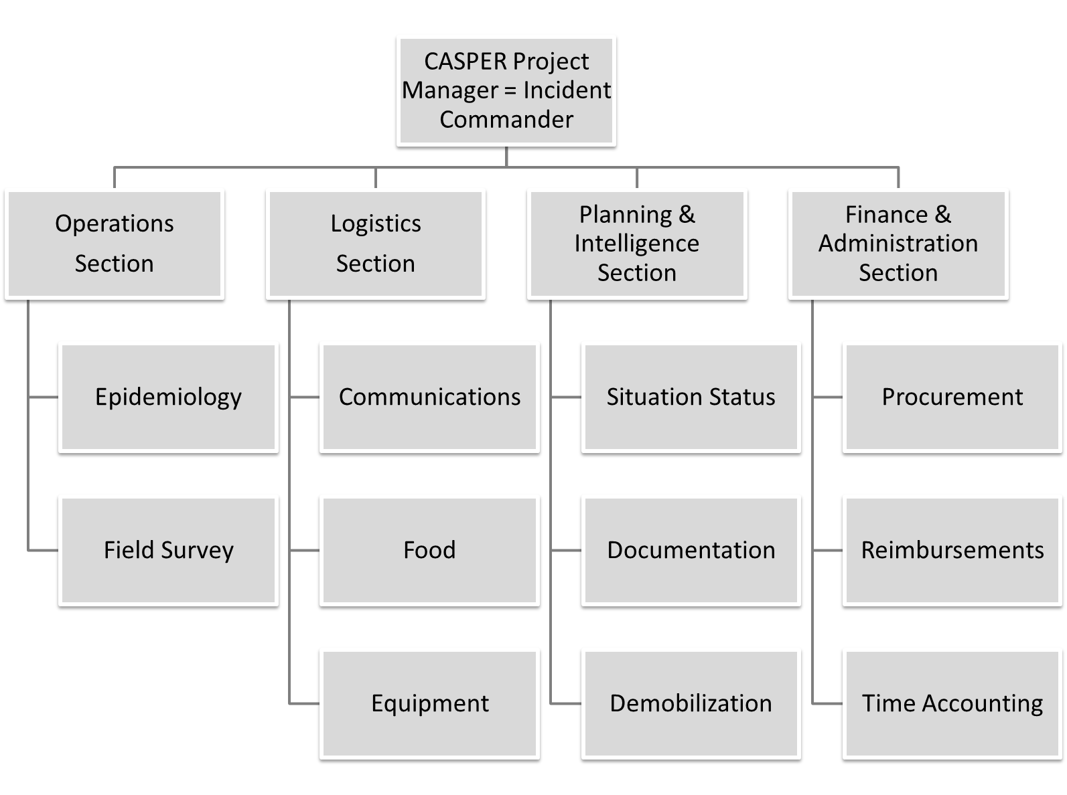

Figure 2. Example Operations Section CASPER activities.
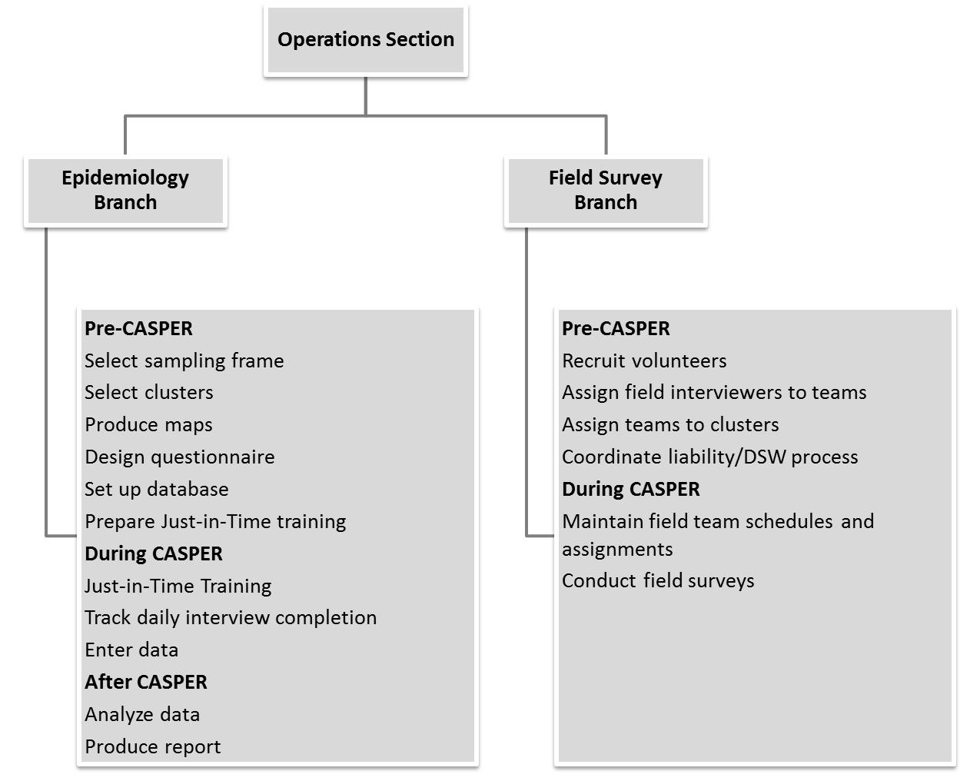
Figure 3. Example Planning & Intelligence Section CASPER activities.
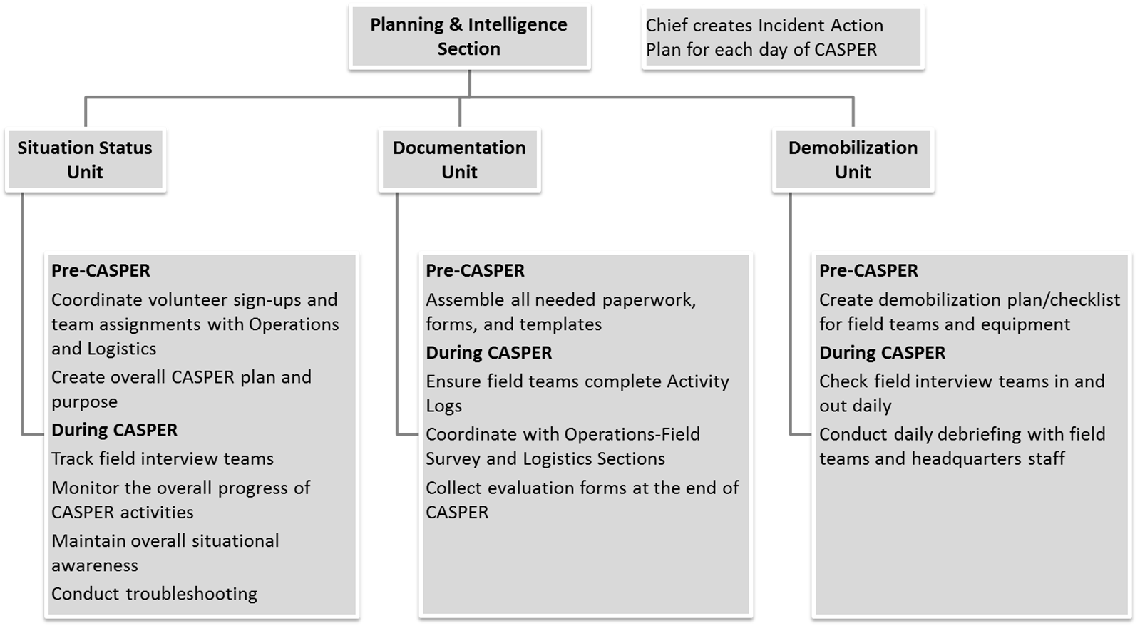
PHEP and CASPER
Centers for Disease Control and Prevention developed 15 capabilities to serve as national public health preparedness standards (https://www.cdc.gov/phpr/capabilities/) to guide state and local health departments in preparing for and responding to public health emergencies and incidents. PHEP Capabilities are at the intersection of public health essential services and emergency management, and include CDC requirements for training and exercises (https://www.cdc.gov/phpr/capabilities/dslr_capabilities_july.pdf). Council of State and Territorial Epidemiologists has published a crosswalk document illustrating how disaster epidemiology tools, such as CASPER, can be used to meet PHEP capabilities (http://c.ymcdn.com/sites/www.cste.org/resource/resmgr/PDFs/Crosswalk_5.28.15.pdf). Specifically, conducting a CASPER not only allows a jurisdiction to collect valuable data, but also provides an opportunity to train and exercise various PHEP Capabilities by: engaging multiple partners, directly interacting with the affected communities, implementing an organizational management system (i.e., ICS), evaluating specific plans and processes, as well as formulating and executing improvement strategies.
Tulare County CASPER
Tulare County Health and Human Services Agency partnered with Tulare County Office of Emergency Services (OES) and Tulare County Fire Department. Tulare County PHEP Manager served as Incident Commander; county Health Officer served as a Deputy Incident Commander. The vast majority of field teams were volunteers from local community organizations or county departments. The County’s EOC facility was utilized as the Incident Command Post and call center to manage all aspects of the two simultaneous CASPERs. The EOC facility served as the Just-In-Time training site on the first day and then became the hub for logistics and communications. To maintain the ICS concept of span of control over the geographically large operating area, the Operations section was split into Northern and Southern branches that corresponded to the sampling frames. In each sampling frame, a fire station was designated as a “forward operating base” (Figure 4). Field supervisors from Tulare OES and scientific staff from CDPH staffed the fire station bases to handle field team check-in, check-out, meal breaks, and end-of-the-day debriefs. All teams checked in at their respective fire station base to collect their materials and receive instructions at the beginning of the day, returned to the base for lunch and to turn in questionnaires completed in the morning round, and checked out at the end of the day after a daily debrief. At the conclusion of the three-day CASPER period, interview teams were demobilized by the forward operating base staff.
Every field team received a UHF radio, operated on one of the Sheriff’s channels as a backup to cell phones. Teams either radioed or called their whereabouts as they progressed through their CASPER clusters and to report each completed questionnaire. Command staff used Google Fusion Tables (https://support.google.com/fusiontables/answer/2571232?hl=en) to monitor teams through the call center, which allowed for universal awareness of team whereabouts at the Incident Command Post and forward operating bases. Incident Command Post staff watched for teams with long out-of-contact times. To help teams that have gotten lost and to ensure all teams’ safety in the field, teams with long out-of-contact times were called by the Command Post or forward operating base staff to determine status. Forward operating base staff had county vehicles to respond to any team that was in need of assistance or unreachable.

Figure 4. Tulare County CASPER sampling frame, Emergency Operations Center headquarters, and forward operating bases locations
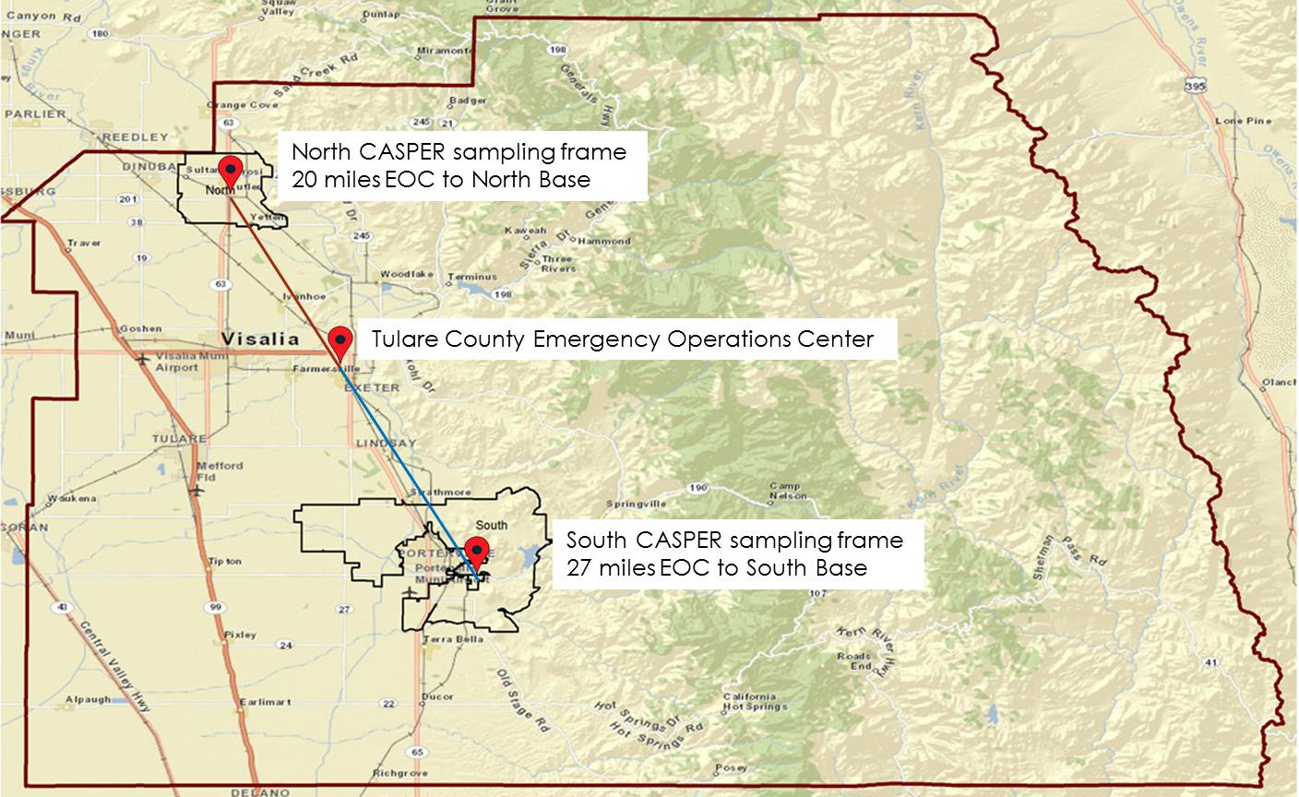
Mariposa County CASPER
Mariposa County Health Department (MCHD) partnered with Mariposa Amateur HAM Radio Group and Mariposa County OES. Mariposa County PHEP Coordinator served as the Incident Commander; the acting county Health Officer participated as a field interviewer. Field team membership included county agency staff, local volunteers, and a small number of out-of-the-area volunteers. Mariposa County did not use its EOC for the CASPER; a fire station was designated as the headquarters. Various county personnel and scientific staff from CDPH staffed the headquarters to handle field team check-in, check-out, meal breaks, and end-of-the-day debriefs. Operations Section included Divisions, based on geographical areas within the county; each field interview team was assigned to a Division. All teams checked in at the fire station to collect their materials and receive instructions at the beginning of the day, returned to the headquarters for lunch and to turn in questionnaires completed in the morning round, and checked out at the end of the day after a daily debrief. At the conclusion of the three-day initial CASPER period, interview teams were demobilized by the headquarters staff. However, because of the small number of field interview teams, CASPER had to be extended, and several teams operated out of MCHD office for another two weeks to complete the necessary number of interviews.
Mariposa County has poor cellular phone coverage and a robust local Amateur HAM Radio Group, which chose CASPER as an opportunity to exercise its procedures and equipment. The radio operators integrated into the ICS structure, developed the communications plan, and managed the Communications Unit within the Logistics Section. Roving radio operator teams were assigned to CASPER field teams in various regions of the county; they were essential to relay radio transmissions from survey areas to the Communications Unit to keep track of team status and assure safety. Every field team received a radio as the primary communication method. Teams radioed (called or texted in areas with cell coverage) their whereabouts as they progressed through their CASPER clusters. Roving radio operators were dispatched to locate teams with long out-of-contact times in their assigned areas.

ICS Forms
FEMA offers templates of all ICS forms, such as Incident Action Plan (ICS 201) and Activity Log (ICS 214), that can be used to document CASPER operations, which is especially critical for reimbursements following a declared emergency (https://training.fema.gov/emiweb/is/icsresource/jobaids.htm).
Both Tulare and Mariposa counties took advantage of existing ICS form templates to create drought CASPER implementation plans and to document their activities. The incident commanders generated an Incident Action Plan (ICS form 201) for each day and compiled incident objectives (ICS form 202, Figure 5). Command staff in both counties used Assignment List (ICS form 204) to manage field teams. Recognizing the rural and remote nature of the sampling frame, Mariposa’s Safety Plan (ICS Form 208, Figure 6) listed important safety messages to share with the field teams during the Just-In-Time training. The Finance Section in Mariposa County required all field interview teams to fill out Activity Logs (ICS form 214), which were used for mileage and other reimbursement calculations. Tulare County used a sophisticated Excel spreadsheet to manage all of its ICS forms in a centralized document.
Figure 5. Example of ICS 202 incident objectives
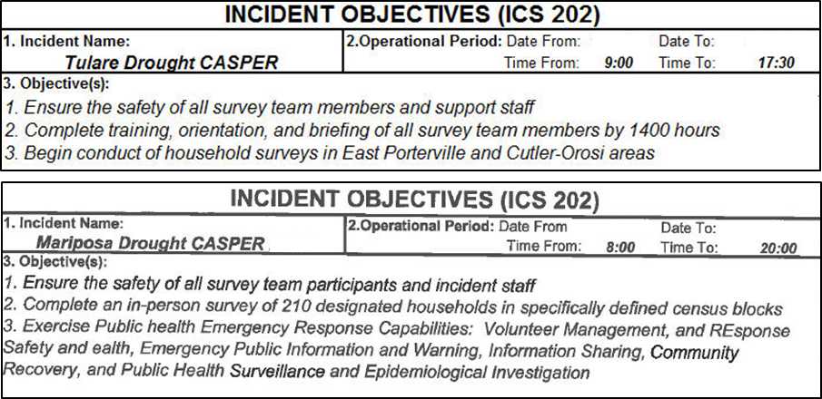
Figure 6. Example of ICS 208 safety plan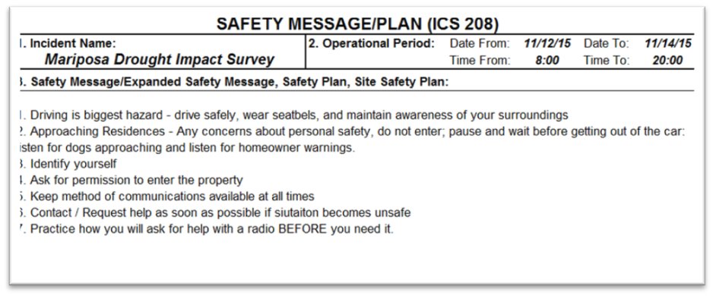
Exercise of PHEP Capabilities
As part of PHEP funding, all local health jurisdictions in California are required to participate in an annual statewide health and medical exercise. In lieu of the exercise, Mariposa County used the drought CASPER to test the following PHEP Capabilities: Community Preparedness (Capability 1); Community Recovery (Capability 2); Emergency Operations Coordination (Capability 3); Emergency Public Information and Warning (Capability 4); Responder Safety and Health (Capability 14); Volunteer Management (Capability 15). At the conclusion of all CASPER activities, the County has developed an After Action Report and Improvement Plan.

Following is a detailed example of how CASPER and use of ICS tested Capability 3 in Mariposa County:
- For Function 1 (Conduct preliminary assessment to determine need for public activation), CDPH and MCHD defined knowledge gaps and priority topics for assessing public health impact of the drought, gathered appropriate stakeholders (e.g. radio operators) for the incident command operations, and established lead and supporting roles.
- For Function 2 (Activate public health emergency operations), the County engaged its resources (human, technical, physical space, and physical assets) to address CASPER in accordance with the National Incident Management System and consistent with jurisdictional standards and practices (e.g., MCHD opened its Department Operations Center; county PHEP Coordinator assumed the Incident Commander role; county staff were pulled from their daily jobs to assume ICS roles at CASPER headquarters or as field interviewers).
- For Function 3 (Develop incident response strategy), Mariposa PHEP Coordinator in the role of the Incident Commander produced an Incident Action Plan (IAP) for each operational period, disseminated the plan to all staff, and revised the plan as necessary based on CASPER interview progress.
- For Function 4 (Manage and sustain the public health response), Mariposa County and CDPH had to extend field interview activities past the planned three days because of the county’s large geographic area and a small number of volunteers able to dedicate three full days to the CASPER. IAP and other activities were adjusted accordingly.
- For Function 5 (Demobilize and evaluate public health emergency operations), all field interview teams were debriefed and demobilized at the conclusion of CASPER, all deployed equipment (e.g., radios, safety kits, map atlases) was collected and inventoried, Activity Logs were turned over to finance, and an After Action Report (AAR) and the Improvement Plan (IP) were produced. The AAR and IP addressed every single exercised Capability and provided recommendations for improving county procedures. For example, as discovered during field team debrief, the check-in process on the first day was unclear and chaotic. Therefore, the IP included specific recommendations for developing a smoother check-in process, which was successfully implemented during the 2016 follow up drought CASPER in Mariposa.

Administration of any CASPER directly fulfills two functions of Capability 14, Responder Safety and Health (identify responder safety and health risks; identify safety and personal protective needs) and the four functions of Capability 15, Volunteer Management (coordinate volunteers; notify volunteers; organize, assemble, and dispatch volunteers; demobilize volunteers). Therefore, jurisdictions conducting CASPERs could account for those activities in their PHEP deliverables as well.

Conclusion

Following an ICS while preparing for and conducting drought CASPERs in Mariposa and Tulare counties worked very well. The major advantages included clear roles and responsibilities among all partners, awareness of where field interview teams were at all times, and easier accountability of the resources (staff, equipment, questionnaires, and expenditures). Utilizing the EOC facility as an Incident Command Post in Tulare allowed for centralization of resources and communications in a single command center; operation of the bases in each of the sampling frames benefitted field teams who otherwise would have very long drives to the headquarters. Mariposa exercised its PHEP Capabilities and successfully partnered with the local radio operator group, whose members provided critical communications for the CASPER field teams (and filled in as interviewers when necessary). In addition to providing important public health impact data, the drought CASPERs in both counties stressed that maintaining a close working relationship between public health, emergency management, and community organizations is crucial for overall community preparedness and building of local resilience.

A comprehensive list of resources of CASPERs are available on the following web site that can provided the details of the assessment procedures and help the SLTT HD and public health professional in developing the local capacity for disaster response:
- Center for Disease Control and Prevention (CDC).
  - The National Center for Environmental Health’s Health Studies Branch (HSB) at the Centers for Disease Control and Prevention (CDC) is the response branch for the Center. HSB responds to natural or human-induced disasters by assisting SLTT in conducting CASPER in the field or providing technical assistance remotely such as sampling and mapping or reviewing a questioner and analysis method. The CASPER toolkit and the web based training resources are available at (https://www.cdc.gov/nceh/hsb/disaster/casper/default.htm)

- Council of State and Territorial Epidemiologist (CSTE)
  - The CSTE Disaster Epidemiology (DE) subcommittee has identified the need to share information among state, local, and federal epidemiologists on disaster related methods, tools, and lessons learned. To meet this need, the DE subcommittee has created a repository of DE tools including CASPER and related guidance on their uses. Members of the subcommittee created a Disaster Epidemiology and Public Health Preparedness capabilities crosswalk to provide resources to health departments on disaster epidemiology tools that are available to help meet the capabilities. http://www.cste.org/group/disasterepi

- National Institute of Health (NIH)
  - The NIH Disaster Research Response Program (DR2) is the national framework for research on the medical and public health aspects of disasters and public health emergencies. The DR2 website, provided by the National Institute of Environmental Health Sciences and the National Library of Medicine, supports disaster science investigators by offering data collection tools, research protocols, disaster research news and events. https://dr2.nlm.nih.gov/

- North Carolina Health and Human Services (NCHHS)
  - North Carolina's disaster epidemiology program has advanced Community Assessment for Public Health Emergency Response (CASPER) tools developed by the Centers for Disease Control and Prevention (CDC) to conduct community-based surveys. A combination of standardized paper forms and state-of-the-art technologies are used to collect data in the field and share information quickly with a range of public health partners. CASPER methods are also used for routine community health assessments and during research studies. The PHP&R Branch provides disaster epidemiology consultation, technical assistance and training to the state's public health agencies and largest hospital systems to ensure preparedness and response capabilities that meet community needs, national standards, and state health department accreditation requirements. http://epi.publichealth.nc.gov/phpr/disaster.html

- Texas Department of State Health Services (TXDSHS)
  - The Texas Department of State Health Services at Austin has established a CASPER Team to assist and partner with local and regional health departments in responding to public health emergencies in their communities.

- California Department of Public Health (CADPH)
  - CADPH, Division of Environmental and Occupational Disease Control (DEODC) Emergency Preparedness (EP) Team conducted several investigation using the CASPER methodology. https://www.cdph.ca.gov/programs/ept/Pages/default.aspx

