Disaster Epidemiology Tool: Community Assessment for Public Health Emergency Response (CASPER)

The Community Assessment for Public Health Emergency Response (CASPER) – also referred to as Rapid Need Assessment (RNA), Rapid Epidemiologic Assessment (REA), and Rapid Health Assessment (RHA), contains a specific set of tools designed to provide quickly and at low cost, household-based information about an affected community’s needs after a disaster in a simple format to decision-makers (REF). CASPER will assist public health practitioners and emergency management officials in determining community readiness and preparedness level, health status and basic needs of the affected community following a disaster. The advantage of using the CASPER is that within a few days of deploying personnel, response-leadership will have a preliminary report that provides a snapshot of the community health needs (REF). Rapidly identifying the needs of a community, and providing that information to response management invokes more effective and appropriately-targeted response efforts (REF).

The sampling method used for a CASPER is a two stage cluster sampling with probability of selection proportional to the number of housing units. In the first stage, “30” clusters will be selected from the affected area (sampling frame) and then “7” houses in each cluster will be selected for interview (30X7) systematically by the field team (REF). The goal is to interview a representative sample of 210 households. The selected houses are visited by interview teams who conduct a standardized interview/questionnaire.

The primary objectives of CASPER are to:
- Assess emergency or disaster preparedness level of the community
- Determine the critical health needs and assess the impact of the disaster on the community.
- Produce household-based estimates of topics of interest for evidence-based public health action
- Evaluate the effectiveness of relief efforts by conducting follow-up CASPER

There are many uses of CASPER and its use continues to expand and diversify throughout the United States (REF). CASPER has been used during the four phases of disaster; preparedness, response, recovery and mitigation. The following examples (case studies) demonstrate four of the many different uses of CASPER.
Preparedness CASPER
Assessing Preparedness Planning by Using Community Assessment for Public Health Emergency Response (CASPER) Methodology, Oakland, Michigan 2012

Background

The state of Michigan is at risk for both natural and human-induced disasters such as flood, tornado and radiological disaster. Recent events in Michigan have highlighted the importance of emergency planning and public health response to disasters (1). In June 2008, tornado and associated severe weather affected several counties in the state (2). In July 2010, an oil pipeline ruptured near Marshall, Michigan, releasing an estimated 844,000 gallons of heavy crude oil into the surrounding waterways (3). Approximately 1.2 million persons in Oakland County, Michigan alone reside less than 50 miles from the Fermi Nuclear Power Plant, Unit 2. The proximity of Michigan to the Great Lakes makes it susceptible to extreme weather events, including lake-effect storms (rain or snow1) (4). In 2010, Michigan conducted a large scale response to assess health risks from the oil exposure and to issue warnings and take other public health measures to reduce the risk of exposure.

As part of the ongoing efforts to develop disaster epidemiology capabilities in Michigan, the Oakland County Health Division (OCHD) and MDCH requested the assistance of the CDC in conducting an assessment of household emergency preparedness in Oakland County, in September 2012.

The objectives of this assessment were to provide knowledge transfer and capacity building for the state and local public health partners in terms of disaster preparedness and response epidemiology and to fulfill the specific objectives of the CASPER, which were as follows: 1) to determine the types of emergency preparations households in Oakland County have in place; 2) to identify the most trusted and main sources of information for Oakland County households during a radiation emergency; and 3) to assess the likelihood that households in Oakland County would follow public health instructions following a disaster involving radioactive material.

To accomplish these objectives, OCHD and MDCH with assistance from CDC conducted a CASPER in Oakland County on September 10-12, 2012. OCHD, MDCH and CDC developed a two-page data collection instrument. The questionnaire addressed household needs, emergency preparedness, response to a radiation emergency, and sources of information in emergencies.
Sample selection
On the basis of information obtained from OCHD and MDCH, all housing units in Oakland County, comprising 527,255 recorded by the 2010 US Census, were included in defining the sampling frame. For the first stage of sampling, 30 census blocks, or clusters, were selected with a probability proportional to the number of housing units within the clusters by using the geographic information systems (GIS) CASPER tool.

GIS tool application
To obtain a block level (cluster) map with streets, highway and water body information, we applied the GIS CASPER tool (a set of program developed by CDC-GRASP and HSB to enhance the cluster sampling and mapping method) in Environmental Systems Research Institute (ESRI) ArcMap 10.1 software and selected the 30 clusters during the preparation phase of CASPER. The ArcMap 10.1 software package comes with a library of map files that could be downloaded from the Bureau of Census website (5) and from other data sources (e.g. gdt). The data files needed were the Oakland county shape files, population, and the housing units. The GIS CASPER tool automatically generated the cumulative number of housing unit and excluded blocks with “0” housing unit from the sampling frame. Based on the cumulative house number of the clusters, 30 clusters were selected randomly (first stage of sampling). Printed street maps of clusters showing geographical identifiers in PDF format were generated using a GIS Map Book. In Addition, KMZ files were created in GIS to see the selected clusters map in Google earth that shows the aerial view of the selected clusters.
We provided the interview teams with a three-hour training session on the overall purpose of the CASPER, household selection methods, questionnaire content, interview techniques, safety and logistics. There were a total of 17 teams on the first day and 15 teams on the second day, which primarily consisted of state and local public health staff, with assistance provided by CDC staff.
All potential respondents approached were given an information sheet with contact telephone numbers for OCHD, educational material from OCHD regarding emergency preparedness, an OCHD bag to store emergency supplies and other timely OCHD information on West Nile virus and flu shots. Further, the OCHD alerted the community to the presence of interviewers in Oakland County through a news announcement.
Eligible respondents were at least 18 years of age or older and resided in the selected household. Additionally, the interviewers were instructed to complete confidential referral forms whenever they encountered urgent physical or mental health needs
Result:
Interview teams completed 192 surveys over three days for an overall completion rate of 91.4. Teams completed interviews in 37.1% of houses approached. Of the households with an eligible participant answering the door, 56.5% completed an interview
Most households reported having basic supplies to last three days in an emergency including non-perishable food (85.4%), water (1 gallon/person/day) (64.7%), and a way to cook food without utilities (76.4%).
Households in Oakland County had a very high willingness to follow instructions from officials in the event of “release of radioactive material that could affect your community.” Most households were willing to go to a radiation screening center (93.3%), evacuate (96.0%), and shelter-in-place (91.8%) if told to do so by officials
More than half of the households said they would rely on the television (55.8%) to keep up-to-date during a radiation emergency. Radio (18.4%) was the next most common source of information,
Discussion
During the week of the assessment, CDC staff provided group and one-on-one CASPER training to MDCH staff regarding the process and analysis aspects of administering a CASPER. Data analysis was conducted with three MDCH staff for knowledge translation purposes. The participation of OCHD and MDCH in the training, development and implementation of the assessment enabled disaster epidemiology knowledge translation and capacity development to strengthen the local and state level preparedness and response capability.
Similarly, the GIS CASPER tool for sampling and mapping, used to create the clusters map in the first steps of CASPER, dramatically shortened the processing time. Futures of GIS –CASPER tool such as computerized random selection of the 30 clusters and the capacity to generate clusters map in PDF and KMZ format, makes more useful this tool than sampling and mapping method using census 2010 described elsewhere (6). The MI CASPER map developed using the GIS CASPER tool along the aerial view of the selected clusters map developed by linking the KMZ files to Google Earth provided detail information of the assessment area. In addition the GIS CASPER tool is flexible, easy to customize and generate better quality map than census 2010 block map. At the virtue of the GIS map, the MI CASPER field teams had better understanding of the selected clusters in advance and were able to navigate easily to their respective clusters.

Integrating the CASPER methodology in GIS is important to enhance the assessment process; however, GIS application in CASPER is dependent upon equipment and methodologies being practical and appropriate for field use. In Addition application of this technology requires license to maintain the software, basic GIS training, and access to ESRI and GDT data.
The results of this CASPER provided a rapid assessment of household emergency preparedness in Oakland County from which OCHD and MDCH can further develop their public health emergency plans.
Response CASPER:

Mental Health Needs Assessment After 2010 Gulf Oil Spill

On April 20, 2010, the Mobile Offshore Drilling Unit (MODU) Deepwater Horizon exploded 40 miles south of the coast of Louisiana. This event resulted in 11 deaths, 17 injuries, and the largest marine petroleum release in history. Over the following 3 months, over 4.9 million barrels of oil were released into the Gulf of Mexico. Although the oil well was capped on July 15, 2010, stopping the flow of oil into the ocean, the released crude oil has prolonged negative effects on marine biota. This released oil has detrimental consequences for the fishing industry, coastal attractions; and estuarine, marsh and protected ecosystems of the Gulf States of Louisiana, Alabama, and Mississippi and placed these resources in jeopardy of destruction (REF: AL report).

Following the oil spill, the Alabama Department Public Health (ADPH), and Mississippi Department of Public Health (MDPH) officials, were concerned that some health effects, particularly mental health outcomes, were not adequately captured by routine surveillance systems. To address these concerns and assess the mental health status of the community, the ADPH and MDPH in association with the Alabama and Mississippi Department of Mental Health requested CDC assistance in conducting a Community Assessment for Public Health Emergency Response (CASPER) in Gulf coast counties. The goals of these assessments were to determine the general and mental health needs of the community following the oil spill, and to provide the state and local public health officials with information to guide responses and allocate resources.

The sampling frame (assessment area) in Gulf Coast counties of Alabama and Mississippi were divided into three areas for the purpose of this assessment: (1) Baldwin County, Alabama; (2) Mobile County, Alabama; and (3) coastal Mississippi. The first two assessment areas consisted of only the coastal portions of Mobile and Baldwin counties in Alabama. The assessment area in coastal Mississippi included all three of its Gulf Coast counties: (1) Hancock County; (2) Harrison County; and (3) Jackson County. These three counties (hereinafter referred to as ‘Mississippi’ [REF; published 210 article])

A two-page data collection instrument was developed in coordination with Alabama and Mississippi Departments of Mental Health, the state health departments, and the CDC’s Division of Behavioral Surveillance of the Public Health Surveillance Program Office. The questionnaire included questions regarding dermatologic, and other physical symptoms and signs that had arisen or worsened in the previous 30 days, standardized questions on quality of life, mental health, and social context, as well as individual and household level exposure questions related to the oil spill

Result:
In Alabama, interview teams completed 128 of the goal of 210 interviews in Mobile County (61% response rate) and 168 interviews in Baldwin County (72% response rate). In Mississippi, 173 interviews (67% response rate) were completed (Table 1)

The proportion of respondents reporting ≥14 days of poor physical health, mental health, or limited activity in the past 30 days was greater in all three assessment areas than was reported somewhere (2009 BRFSS state estimates). The highest percentage of individuals (21.6%) who reported ≥ 14 days of poor physical health in the previous 30 days was noted in the residents of the area surveyed in Mississippi.

Table 1. Demographics and Health Quality of Live and Symptoms by CASPER Sampling in Mobile and Baldwin Counties, Alabama and the Gulf Coast of Mississippi, 2010

 | Mobile County, A | Baldwin County, AL | Mississippi
Demographic | Weighted % (95% CI) | Weighted % (95% CI) | Weighted % (95% CI)
Gender
Male | 45.6 (33.9-57.3) | 54.6 (47.1-62.1) | 38.8 (28.3-49.2)
Female | 54.5 (42.7-66.2) | 45.4 (37.9-52.9) | 61.2 (50.7-71.6)
Health-Related Quality of Life and Symptoms
≥ 14 physically unhealthy days | 19.7 (8.0-31.4) | 15.8 (9.8-21.9) | 21.6 (14.7-28.5)
≥ 14 mentally unhealthy days | 22.7 (10.9-34.6) | 16.3 (9.1-23.4) | 22.1 (13.8-30.4)
≥ 14 activity limitation days | 12.9 (5.2-20.5) | 9.4 (3.1-15.6) | 12.2 (6.1-18.3)
Depressive symptoms | 23.9 (13.0-34.8) | 15.3 (9.0-21.5) | 24.5 (16.4-32.7)
Symptoms of anxiety | 28.7 (15.1-42.3) | 20.8 (13.1-28.6) | 31.5 (21.5-41.9)
Worry or Stressed
Worried/stressed about money for mortgage/rent  Always/usually  Sometimes  Rarely/never | 28.1 (18.3-37.9)  14.7 (8.4-21.0)  57.0 (46.9-67.1) | 24.2 (16.9-31.4)  19.6 (11.8-27.4)  56.1 (47.7-64.5) | 37.2 (25.9-48.6)  15.6 (9.2-22.0)  47.1 (37.0-57.2)
Worried/stressed about money to buy meals  Always/usually  Sometimes  Rarely/never | 18.1 (8.9-27.2)  16.6 (8.2-24.9)  65.2 (53.5-76.9) | 12.5 (6.4-18.7)  10.7 (4.4-16.9)  76.6 (67.4-85.9) | 19.8 (12.4-27.3)  16.0 (9.6-22.3)  64.0 (54.5-73.6)

The findings of this assessment were shared with stakeholders in a meeting at the end of the assessment highlighting the major findings and recommendations that was distributed to emergency managers, state epidemiologists, or State Local health department authorities within 48 hours of completing the assessment to support evidence-based public health decisions. This assessment was unique because for the first time demonstrated the usefulness of the CASPER methodology in mental health response and planning. This CASPER was a successful collaboration of States, Local, and Federal health agencies and provided an opportunity to engage with the community and improve mental health outreach programs.

Recovery CASPER
Conducting Descriptive Epidemiology Following a Disaster: West, Texas Fertilizer Plant Explosion

- Background of the Fertilizer Plant Explosion
On April 17, 2013, a ﬁre and subsequent explosion occurred at the West Fertilizer Company plant in West, Texas. This is plant is located in central Texas, in McLennan County. The explosion caused extensive damage to the homes, businesses, and schools near the plant. Because explosions of this magnitude are rare, an epidemiologic investigation was initiated to describe the fatal and nonfatal injuries caused by the explosion. The investigation found that the explosion killed 15 individuals and directly injured an additional 252 individuals.
This investigation serves as a case study on how descriptive epidemiology can be used after a disaster.
Below is an overview of the investigation, the challenges and promising best practices.
(For detailed information of the investigation, please see: Metzger K, Akram H, Feldt B, Stone K, Alvey S, Henley S, Hernandez A, Melville S, Haywood T, Zane D. Epidemiologic Investigation of Injuries Associated with the 2013 Fertilizer Plant Explosion in West, Texas. Disaster Med Public Health Prep. 2016 Aug;10(4):583-90.
- Collaboration among Multiple Governmental Partners
The investigation was implemented by the following agencies:
- Local – Waco/McLennan County Public Health District (WMCPHD)
- Regional – Texas Department of State Health Services, Health Service Region 7 (Temple)
- State – Texas Department of State Health Services, Central Office (Austin)

This multi-organization collaboration among local, regional and state agencies was amongst the main strength of this investigation and had a direct impact on planning, logistics, implementation, data management and dissemination phases of the study. During the planning phase, Texas Department of State Health Services (DSHS) facilitated protocol development through consultation with Oklahoma State Department of Health and Center for Disease Control and Prevention. DSHS also assisted with the Institutional Review Board (IRB) process. To identify the acutely injured, WMCPHD and DSHS coordinated with health care facilities and hospitals most likely to have received acutely injured patients to review medical records and facilitate the data collection process.
The local health department had knowledge of the community and had existing relationships with local hospitals and healthcare organizations, which expedited the data collection process and enabled the entire team to review medical records. WMCPHD maintains a database of all healthcare facilities in the county along with schools, nursing homes, and daycare facilities routinely as part of their disease surveillance related activities. In addition, DSHS was able to obtain contacts from the Federal Emergency Management Agency (FEMA) a list of applicants for assistance, death certificates, medical examiner reports and mobile medical unit list. Collaboration with regional and state DSHS offices provided the team the authority to obtain data from the facilities that were outside of McLennan County boundaries. All organizations collaborated in medical record review and conducting phone interviews with injured survivors which accelerated the investigation process. After completing the data collection and survivor interviews phases, DSHS provided data analysis, GIS, and related technical support to interpret the findings.
- Skills of the Investigative Team
The team consisted of five epidemiologists, one preparedness coordinator, two public health nurses, one public health planner, and one health geographer. This allowed an integrated team environment which facilitated reciprocal transfer of knowledge, expertise and capacity.

- Epidemiologists: Epidemiological skills were essential in protocol/survey development, client interviews and data management including analysis and interpretation.
- Preparedness Coordinator and Public Health Planner: Coordination, planning and logistical support; the staff was also trained in client interviews as a part of WMCPHD Epi-teams program.
- Public Health Nurses: Client interviews, medical records review, understanding of International Classification of Diseases (ICD) coding system, and counselling skills.
- Health Geographer: Analytical support, geocoding of addresses, development of map books, and mapping of individual’s approximate location at the time of the explosion.

Overall this multidisciplinary team allowed for better and more efficient use of resources, minimization of costs, and led to improvement in project-related performance and work quality. Experts with diverse skill-set provided different perspectives and solutions to problems; the team worked collaboratively and in a professional manner to complete the investigation. The team held weekly conference calls with prepared agendas and discussed team activities and goals.
- Objectives of the Investigation
In an effort to understand the types and characteristics of injuries and healthcare resources that were used during and after the explosion, the investigation team sought to:
- To describe the characteristics of fatal injuries caused by the explosion
- To describe the physical injuries of survivors of the explosion
- To describe risk factors associated with injuries caused by the explosion, including location at the time of the blast, timing of injury, and demographic characteristics.
- To quantify the number of acutely injured persons who sought medical care
- To describe the medical care received by the injured

- Methods
A multi-pronged approach was used to identify and collect data on injuries.
Case definition:
Fatal injuries due to the incident were recorded through the review of medical examiner records and death certificates of individuals who died within 1 week of post-explosion time period in the county. Non-fatal injuries that occurred within 5 days of the explosion and related to the blast in terms of location, timing, and cause were recorded through the review of medical records from hospitals and urgent care facilities located in the county and an adjacent county.

Data collection:
Standardized data collection tools based on the questionnaires from the 1995 Oklahoma City bombing, 2012 Alabama tornado outbreak and the blast injury forms developed by the Centers for Disease Control and Prevention and the American College of Emergency Physicians were used. This comprised of a fatal injury abstraction form, a non-fatal injury abstraction form, and a telephone survey for survivors.
Eligible injured patients identified through medical records were contacted to participate in a survivor survey. Contact information, including residential address and telephone number, was obtained from medical records when possible. Patient records were linked with the demographic data obtained from the FEMA data on West residents whose homes were damaged or destroyed and subsequently applied for emergency assistance from the federal government. In addition, investigators conducted phone interviews with survivors to obtain additional information about their locations and whether they were indoors or outdoors at the time of the explosion. The investigation protocol and participant consent process were reviewed and approved by the state health department’s IRB.
Data analyses:
Descriptive statistics, chi-square tests and Satterthwaite t-tests, and logistic regression models were used to analyze the data. In addition, geographical information systems were used to geocode and then map the known approximate location, at the time of the explosion, of all chart-abstracted and interviewed cases. The distance proximity of cases to the explosion’s epicenter were then calculated.

- Selected Recommendations from the Investigation Findings
Hospitals should review the results of this investigation and similar studies to better predict and plan for the types of injuries that might occur in similar emergency incidents and when and how those patients might be arriving to the medical facility, which may improve medical recognition and management of those injured. While examining apparent physical injuries, medical providers should also screen for ear and brain injuries that may result from similar emergency incidents.
Long-term care facilities (e.g., nursing homes, assisted-living facilities) should review their procedures for gathering patient medical records when evacuating or moving patients in a similar emergency and also exercise their evacuation plans regularly.
Public health entities are encouraged to use this investigation as a model for collaboration between local, regional, state, and federal agencies. A tabletop exercise using these speciﬁc incidence data and challenges would help epidemiologists improve their capacity to conduct these types of investigations in the future.

- Challenges
- Submission of study protocol to the IRB

WMCPHD and Texas DSHS staff sought IRB approval to ensure the study protocol would be appropriate and uphold the highest level of ethics through the process. Despite the investigation team already having public health authority in the state to investigate this incident, IRB approval was thought to be the best approach in light of this high-profile incident. The IRB process took approximately three months to complete. The team spent over two months developing the study protocol including the data abstraction tools, survivor interview forms, and detailed plans for data analysis and retention. Perhaps the most time-consuming element that was developed by the team was deciding on the appropriate case definitions. The expedited review process by the IRB took one month before approval was granted. The time-consuming nature of submitting an IRB application should be noted for future investigations, though this IRB process helped the team carefully craft the study protocols.

- Communication of the case definitions to data sources

Several case definitions (described above) were made by the team, with varying complexity. Case definitions were developed to clearly and easily identify which persons were considered a case and associated with the explosion and which were not. The team contacted and provided acute care facilities with case definitions to aid in querying medical records for abstraction. Unfortunately, the case definitions often confused the health facility personnel, resulting in delays receiving relevant medical records and subsequent quality checks from the investigation team to ensure the appropriate records were being abstracted and that no additional records were missed. Having points of contacts and relationships with medical records departments at acute care facilities sped the process up.

- Intense media interest

Naturally, of a disaster of this magnitude, there was a great deal of sustained interest from local and state media on the investigation. The media was interested in learning more about the methodology of the investigation (e.g., counting acute physical injuries versus mental health conditions, hospital-based focus versus physician offices surveillance, future plans for long term tracking of survivors), costs, status, and timeline. The public information officers from the local and state health department worked closely with the epidemiology team on these inquiries; there was excellent collaboration among the public information officers from the local and state health department themselves, to timely, consistently, and accurately respond to these media inquiries.

- Timeliness issue of the completed report

Perhaps one of the greatest challenges the investigation team encountered was the time required to fully complete the study, write, and publish the final report. It took one year to publish the first public health report from the initial investigation meeting and almost three years to publish the study as a manuscript in a peer-reviewed journal. Each phase of the study (i.e. medical record abstraction, survivor interviews, analysis) was underestimated for the time required, pushing the completion of the study back. By the time the study reached the report writing phase (almost one year later), other workplace duties competed for time and priority. Once all data were collected and analyzed, the team spent two months writing the final report, passing drafts back and forth frequently. Knowing there was intense media interest, the report was carefully crafted to ensure ultimate clarity with little room for misunderstanding or misinterpretation from the results.

- Promising Best Practices
- Designated coordinator for investigation

This investigation as already noted took significant time to complete. To keep the investigation moving forward, one member of the team served as coordinator to facilitate weekly calls to discuss progress, issues, and task assignments. Having a designated coordinator to keep the multidisciplinary team focused was critical to the completion of this investigation and highly recommended for similar future investigations.

- Existing epidemiology capacity at local, region, state levels

Existing epidemiology capacity at the local, regional, and state levels was critical for the successful completion of this investigation. As noted above, the epidemiology capacity consisted of protocol/survey development, client interviews and data management including analysis and interpretation. But it also included a willingness to apply these capabilities in response to a disaster to describe what happened and to provide subsequent recommendations for hospitals, long-term care facilities, and public health agencies. This capacity was supported by local, state, and federal funding.

- Consultation with blast and disaster experts

Because explosions of this magnitude are rare, the epidemiologic team reached out for advice to state and federal public health colleagues that had conducted similar investigations. As noted above, conference calls were held with epidemiologists that responded to the 1995 Oklahoma City bombing and the 2012 Alabama tornado outbreak. These conversations yield valuable insights which contributed to the development of the epidemiologic investigation approach to this disaster. Talking with colleagues with similar experience was extremely valuable and built confidence that this investigation would be successful.

- Established working relationships with hospitals and urgent care facilities

Access to hospital medical records is key to this type of investigation; therefore it was very valuable for DSHS and WMCPHD to have established relationships with those hospitals and urgent care facilities. Due to the complexity of the case definitions, extensive communication with the facility staff was necessary to ensure all records that pertained to the investigation were included. WMCPHD clinic staff and epidemiologists work with hospital staff in a variety of different capacities daily. Existing contacts from these staff were able to direct the investigative team to the appropriate department contacts who could release the needed records. Medical facilities must take every effort to protect the health information of their patients, and existing confidentiality and privacy laws can create a barrier to accessing the medical record data. Being a trusted partner agency with existing information sharing mechanisms makes the process quicker.

- Mental health training/awareness provided to medical abstraction and interview teams

The epidemiologic plan was for team members to review medical charts and interview survivors of the explosion. It was anticipated that reading graphic description of injuries, listening to survivors’ vivid stories of their experiences, and acknowledging the enormous grief in the community may impact the mental health of the epidemiology team. As such, early on, a psychiatrist colleague provided mental health training to the team so that they would be better equipped to recognize, process, cope, and seek professional assistance with emotions and feelings that might be experienced during the investigation.

- Access to FEMA data

The local health department contacted state FEMA representatives and requested permanent and temporary residential address and alternate telephone numbers on West residents whose homes were damaged or destroyed and subsequently applied for emergency assistance from the federal government. The goal was to obtain this information as part of the epidemiologic plan to conduct survivor interviews. A Centers for Disease Control and Prevention colleague had informed us that a request of this nature to FEMA was allowed as announced in the Federal Registry (Disaster Assistance Recovery Files, Notice of Privacy Act System of Records , 78 Federal Register 25282, 48765-6, April 30, 2013), incidentally published just two weeks after the explosion. The request for FEMA individual assistance files is allowed “for the purpose of contacting FEMA applicants to seek their voluntary participation in surveys or studies concerning effects of disasters, program effectiveness, and to identify possible ways to improve community preparedness and resiliency for future disasters.” FEMA representatives provided the requested information quickly.

- Use of GIS in injury mapping

Mapping was an invaluable tool in this epidemiologic investigation. Geocoding the approximate location, at the time of the explosion, of all chart-abstracted and interviewed individuals allowed for the calculation of their distance proximity to the explosion’s epicenter. This led to the conclusion that patients located closer to the explosion were more likely to be admitted to the hospital for treatment of injuries than were those who were located further away.
Assessing the public health impact of drought in Mariposa and Tulare counties using CASPER Methodology: California 2015?
Background
California’s unprecedented drought began in 2012; thousands of private wells have gone dry reducing access to potable water, and millions of trees have died in drought-stricken forests resulting in increased risk of wildfires, landslides, and costs to property owners. Governor Edmund G. Brown Jr. proclaimed a State of Emergency in January 2014 (https://www.gov.ca.gov/news.php?id=18368) and by the end of 2015, California recorded 63 Emergency Proclamations from city, county, tribal governments, and special districts (http://drought.ca.gov/pdf/archive/WeeklyDroughtUpdate(11-25-15).pdf).
A severe drought is a slow-onset disaster with far-reaching impacts on the economy, environment, and communities. Drought-associated adverse outcomes might be the result of long exposures, leading to both direct and indirect health consequences. Drought-impacted households might lack running or potable water, might experience physical and mental health effects, and might face financial losses related to the drought; however, little has been reported on the public health impacts of drought.
California Department of Public Health (CDPH) collaborated with two severely impacted counties in 2015, to conduct CASPERs to better quantify drought-related population impacts and to inform public health decisions and action. Tulare County, a largely agricultural county in the heart of California’s Central Valley, has had the majority of reported private well failures in the state. Mariposa County, located at the foothills of the Sierra Nevada Mountains, had the most affected forests, with an estimated 30–50% mortality of pine, fir, and oak. These CASPERs assessed knowledge, attitudes, and practices regarding the drought; access to and use of water; water conservation practices; perceived impacts of the drought on health, mental health, and finances; preferred emergency communication methods; and household demographics.
Tulare County conducted two simultaneous CASPERs, one in the northern and one in the southern parts of the county; the two sampling frames were designed to enrich for private well ownership. Mariposa chose a single county-wide sampling frame. The complete results of the assessments are available at CDPH website here: https://www.cdph.ca.gov/programs/ept/Pages/default.aspx. In this case study, we discuss how CASPER fits with the Incident Command System (ICS) infrastructure. Both Tulare and Mariposa counties implemented ICS for the drought CASPERs; Tulare exercised its Emergency Operations Center (EOC) activation and Mariposa exercised their Public Health Emergency Preparedness (PHEP) Capabilities.
Incident Command System and CASPER
ICS is designed to enable effective and efficient incident management by integrating personnel, equipment, procedures, and communications in a common organizational structure, which has five major functional areas: Command, Operations, Planning & Intelligence, Logistics, and Finance & Administration (for more information: https://www.fema.gov/incident-command-system-resources).
While CASPER itself is a specific epidemiological method, the overall process necessary for its implementation – from selecting a sampling frame to designing a questionnaire to managing field interview teams to data entry and analysis – largely fit with the ICS structure (Figures 1-3). Potential benefits of conducting a CASPER using an ICS structure include: partnering with emergency management and other agencies to reduce costs and increase efficiency; opportunity to conduct PHEP-mandated training and exercise in a real public health application; assigning roles and responsibilities in a standardized manner; creating a clear chain of command and communication flow among all the partners and volunteers; keeping interview teams safe in the field; and having standard templates and forms for keeping track of activities, expenditures, and equipment.
Figure 1. Example of CASPER ICS structure
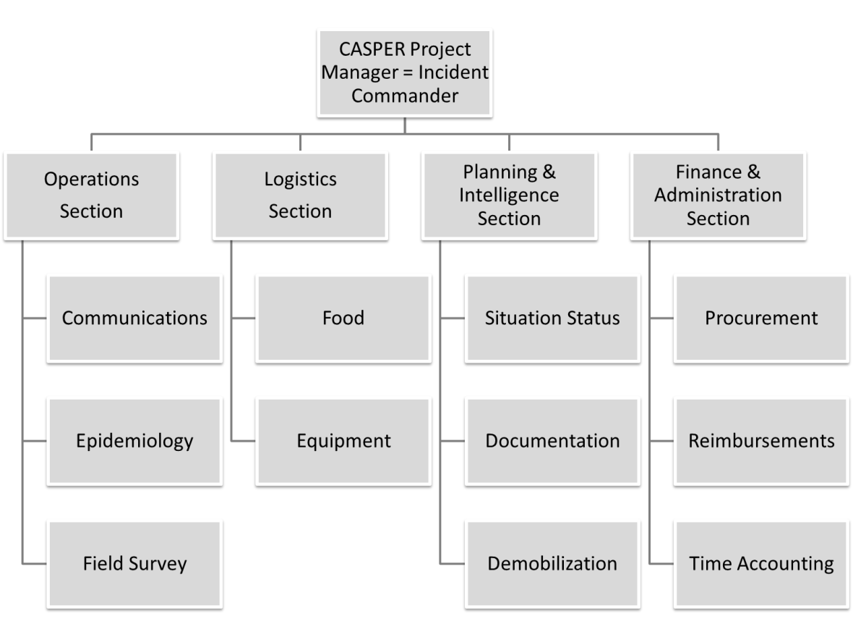
Figure 2. Example Operations Section CASPER activities
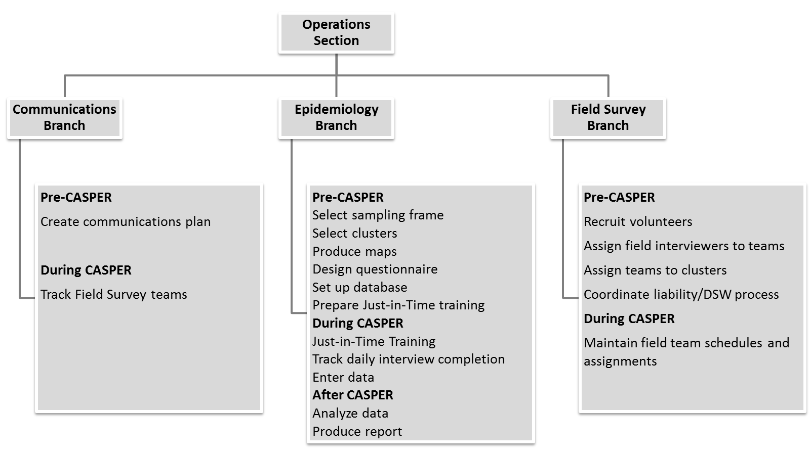
Figure 3. Example Planning & Intelligence Section CASPER activities
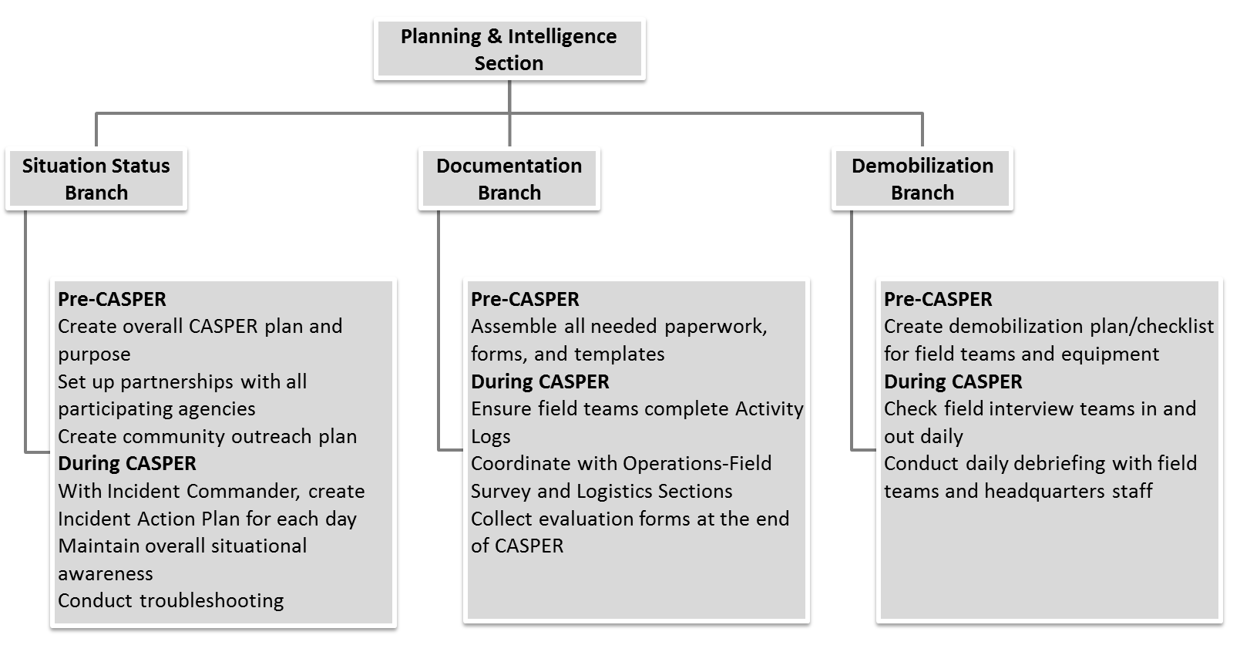
PHEP and CASPER
Centers for Disease Control and Prevention developed 15 capabilities to serve as national public health preparedness standards (https://www.cdc.gov/phpr/capabilities/) to guide state and local health departments in preparing for and responding to public health emergencies and incidents. PHEP Capabilities are at the intersection of public health essential services and emergency management, and include CDC requirements for training and exercises (https://www.cdc.gov/phpr/capabilities/dslr_capabilities_july.pdf). Council of State and Territorial Epidemiologists has published a crosswalk document illustrating how disaster epidemiology tools, such as CASPER, can be used to meet PHEP capabilities (http://c.ymcdn.com/sites/www.cste.org/resource/resmgr/PDFs/Crosswalk_5.28.15.pdf).
Tulare County CASPER
Tulare County Health and Human Services Agency partnered with Tulare County Office of Emergency Services (OES) and Tulare County Fire Department. Tulare County PHEP Coordinator served as Incident Commander; county Health Officer served as a Deputy Incident Commander. The vast majority of field teams were volunteers from local community organizations or county departments. The County’s EOC was activated to manage all aspects of the two simultaneous CASPERs. The EOC served as the Just-In-Time training site on the first day and then became the hub for logistics and communications. In each sampling frame, a fire station was designated as a “forward operating base” (Figure 4). Field supervisors from Tulare OES and scientific staff from CDPH staffed the fire station bases to handle field team check-in, check-out, meal breaks, and end-of-the-day debriefs. All teams checked in at their respective fire station base to collect their materials and receive instructions at the beginning of the day, returned to the base for lunch and to turn in questionnaires completed in the morning round, and checked out at the end of the day after a daily debrief. At the conclusion of the three-day CASPER period, interview teams were demobilized by the forward operating base staff.
Every field team received a 800 MHz radio, operated on one of the Sheriff’s channels as a backup to cell phones. Teams either radioed, called, or texted their whereabouts as they progressed through their CASPER clusters and to report each completed questionnaire. Command staff used Google Fusion Tables (https://support.google.com/fusiontables/answer/2571232?hl=en) to monitor teams through the call center, which allowed for universal awareness of team whereabouts at the EOC and forward operating bases. EOC watched for teams with long out-of-contact times. To help teams that have gotten lost and to ensure all teams’ safety in the field, forward operating bases dispatched staff when any team had long out-of-contact times.
Figure 4. Tulare County CASPER sampling frame, Emergency Operations Center headquarters, and forward operating bases locations
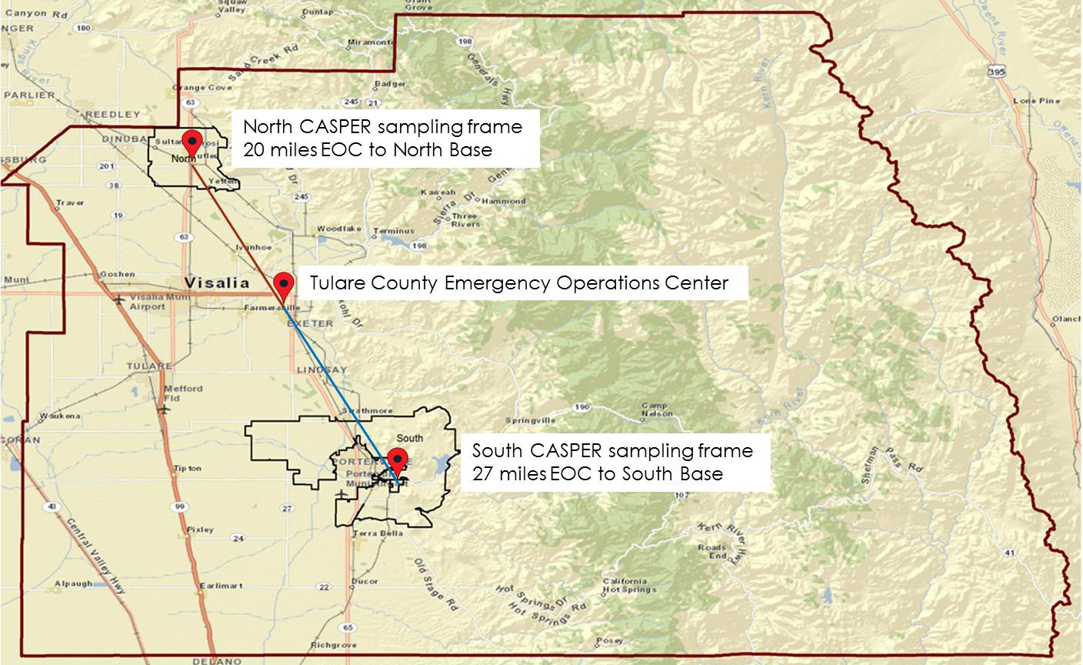
Mariposa County CASPER
Mariposa County Health Department partnered with Mariposa Amateur HAM Radio Group and Mariposa County OES. Mariposa County PHEP Coordinator served as the Incident Commander; the acting county Health Officer participated as a field interviewer. Field team membership included county agency staff, local volunteers, and a number of out-of-the-area volunteers (e.g. epidemiology trainees from health departments across the state). Mariposa County did not activate its EOC for the CASPER; a fire station was designated as the headquarters. Various county personnel and scientific staff from CDPH staffed the headquarters to handle field team check-in, check-out, meal breaks, and end-of-the-day debriefs. All teams checked in at the fire station to collect their materials and receive instructions at the beginning of the day, returned to the headquarters for lunch and to turn in questionnaires completed in the morning round, and checked out at the end of the day after a daily debrief. At the conclusion of the three-day initial CASPER period, interview teams were demobilized by the headquarters staff. However, because of the small number of field interview teams, CASPER had to be extended, and several teams operated out of Mariposa County Health Department office for another two weeks to complete the necessary number of interviews.
Mariposa County has poor cellular phone coverage and a robust local Amateur HAM Radio Group, which chose CASPER as an opportunity to exercise its procedures and equipment. The radio operators integrated into the ICS structure, developed the communications plan, and managed the communications unit. Roving radio operator teams were assigned to CASPER field teams in various regions of the county. Every field team received a radio as the primary communication method. Teams radioed (and called or texted in areas with cell coverage) their whereabouts as they progressed through their CASPER clusters. Roving radio operators were dispatched to locate teams with long out-of-contact times in their assigned areas.
ICS Forms
FEMA offers templates of all ICS forms, such as Incident Action Plan (ICS 201) and Activity Log (ICS 214), that can be used to document CASPER operations, which is especially critical for reimbursements following a declared emergency (https://training.fema.gov/emiweb/is/icsresource/jobaids.htm).
Both Tulare and Mariposa counties took advantage of existing ICS form templates to create drought CASPER implementation plans and to document their activities. The incident commanders generated an Incident Action Plan (ICS form 201) for each day and compiled incident objectives (ICS form 202, Figure 5). Command staff in both counties used Assignment List (ICS form 204) to manage field teams. Recognizing the rural and remote nature of the sampling frame, Mariposa’s Safety Plan (ICS Form 208, Figure 6) listed important safety messages to share with the field teams during the Just-In-Time training. The Finance Section in Mariposa County required all field interview teams to fill out Activity Logs (ICS form 214), which were used for mileage and other reimbursement calculations. Tulare County used a sophisticated Excel spreadsheet to manage all of its ICS forms in a centralized document.
Figure 5. Example of ICS 202 incident objectives
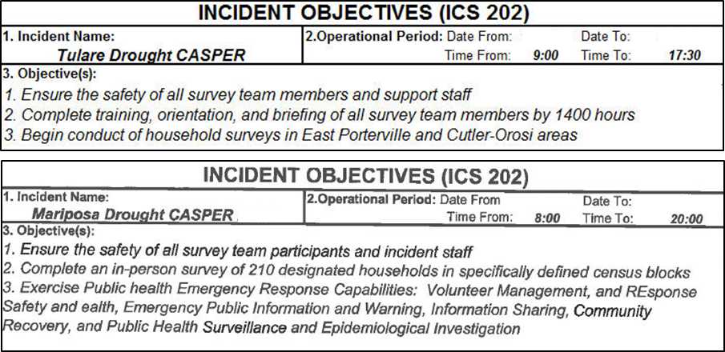
Figure 6. Example of ICS 208 safety plan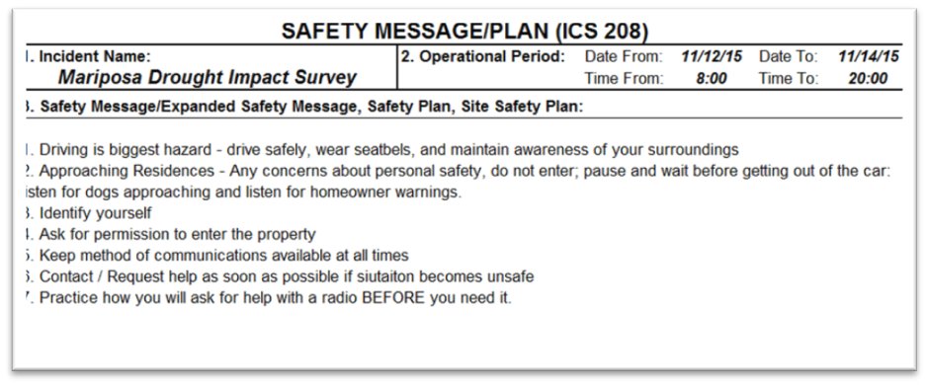
Exercise of PHEP Capabilities
As part of PHEP funding, all local health jurisdictions in California are required to participate in an annual statewide health and medical exercise. In lieu of the exercise, Mariposa County used the drought CASPER to test the following PHEP Capabilities: Community Preparedness (Capability 1); Community Recovery (Capability 2); Emergency Operations Coordination (Capability 3); Emergency Public Information and Warning (Capability 4); Responder Safety and Health (Capability 14); Volunteer Management (Capability 15). At the conclusion of CASPER, the County has developed an After Action Report and Improvement Plan.
Following is a detailed example of how CASPER and use of ICS tested Capability 3:
- For Function 1 (Conduct preliminary assessment to determine need for public activation), CDPH and Mariposa Health Department defined knowledge gaps and priority topics for assessing public health impact of the drought, gathered appropriate stakeholders (e.g. radio operators) for the incident command operations, and established lead and supporting roles.
- For Function 2 (Activate public health emergency operations), the County engaged its resources (human, technical, physical space, and physical assets) to address CASPER in accordance with the National Incident Management System and consistent with jurisdictional standards and practices (e.g., county PHEP Coordinator assumed the Incident Commander role; county staff were pulled from their daily jobs to assume ICS roles at CASPER headquarters).
- For Function 3 (Develop incident response strategy), Mariposa PHEP Coordinator in the role of the Incident Commander produced an Incident Action Plan for each operational period, disseminated the plan to all staff, and revised the plan as necessary based on CASPER interview progress.
- For Function 4 (Manage and sustain the public health response), Mariposa County and CDPH had to extend field interview activities past the planned three days because of the county’s large geographic area and a small number of volunteers able to dedicate three full days to the CASPER.
- For Function 5 (Demobilize and evaluate public health emergency operations), all field interview teams were debriefed and demobilized at the conclusion of CASPER, all deployed equipment (e.g., radios, safety kits, map atlases) was collected and inventoried, Activity Logs were turned over to finance, and an After Action Report (AAR) and the Improvement Plan (IP) were produced. The AAR and IP addressed every single exercised Capability and provided recommendations for improving county procedures. For example, as discovered during field team debrief, the check-in process on the first day was unclear and chaotic. Therefore, the IP included specific recommendations for developing a smoother check-in process, which was implemented during the 2016 follow up drought CASPER in Mariposa.
Administration of any CASPER directly fulfills two functions of Capability 14, Responder Safety and Health (identify responder safety and health risks; identify safety and personal protective needs) and the four functions of Capability 15, Volunteer Management (coordinate volunteers; notify volunteers; organize, assemble, and dispatch volunteers; demobilize volunteers). Therefore, jurisdiction conducting CASPERs could account for those activities in their PHEP reports.
Conclusion
Following an ICS while preparing for and conducting drought CASPERs in Mariposa and Tulare counties worked very well. The major advantages included clear roles and responsibilities among all partners, awareness of where field interview teams were at all times, and easier accountability of the resources (staff, equipment, questionnaires, and expenditures). Activation of the EOC in Tulare allowed for centralization of resources and communications in a single command center; operation of the bases in each of the sampling frames benefitted field teams who otherwise would have very long drives to the headquarters. Mariposa exercised its PHEP Capabilities and successfully partnered with the local radio operator group, whose members provided critical communications for the CASPER field teams (and filled in as interviewers when necessary). In both counties the drought CASPER stressed that maintaining a close working relationship between public health, emergency management, and community organizations is crucial for overall community preparedness and building of local resilience.
A comprehensive list of resources of CASPERs are available on the following web site that can provided the details of the assessment procedures and help the SLTT HD and public health professional in developing the local capacity for disaster response:
- Center for Disease Control and Prevention (CDC).
  - The National Center for Environmental Health’s Health Studies Branch (HSB) at the Centers for Disease Control and Prevention (CDC) is the response branch for the Center. HSB responds to natural or human-induced disasters by assisting SLTT in conducting CASPER in the field or providing technical assistance remotely such as sampling and mapping or reviewing a questioner and analysis method. The CASPER toolkit and the web based training resources are available at (https://www.cdc.gov/nceh/hsb/disaster/casper/default.htm)

- Council of State and Territorial Epidemiologist (CSTE)
  - The CSTE Disaster Epidemiology (DE) subcommittee has identified the need to share information among state, local, and federal epidemiologists on disaster related methods, tools, and lessons learned. To meet this need, the DE subcommittee has created a repository of DE tools including CASPER and related guidance on their uses. Members of the subcommittee created a Disaster Epidemiology and Public Health Preparedness capabilities crosswalk to provide resources to health departments on disaster epidemiology tools that are available to help meet the capabilities. http://www.cste.org/group/disasterepi

- National Institute of Health (NIH)
  - The NIH Disaster Research Response Program (DR2) is the national framework for research on the medical and public health aspects of disasters and public health emergencies. The DR2 website, provided by the National Institute of Environmental Health Sciences and the National Library of Medicine, supports disaster science investigators by offering data collection tools, research protocols, disaster research news and events. https://dr2.nlm.nih.gov/

- North Carolina Health and Human Services (NCHHS)
  - North Carolina's disaster epidemiology program has advanced Community Assessment for Public Health Emergency Response (CASPER) tools developed by the Centers for Disease Control and Prevention (CDC) to conduct community-based surveys. A combination of standardized paper forms and state-of-the-art technologies are used to collect data in the field and share information quickly with a range of public health partners. CASPER methods are also used for routine community health assessments and during research studies. The PHP&R Branch provides disaster epidemiology consultation, technical assistance and training to the state's public health agencies and largest hospital systems to ensure preparedness and response capabilities that meet community needs, national standards, and state health department accreditation requirements. http://epi.publichealth.nc.gov/phpr/disaster.html

- Texas Department of State Health Services (TXDSHS)
  - The Texas Department of State Health Services at Austin has established a CASPER Team to assist and partner with local and regional health departments in responding to public health emergencies in their communities. https://www.dshs.texas.gov/commprep/disasterepi/casper.aspx
- California Department of Public Health (CADPH)
  - CADPH, Division of Environmental and Occupational Disease Control (DEODC) Emergency Preparedness (EP) Team conducted several investigation using the CASPER methodology. https://www.cdph.ca.gov/programs/ept/Pages/default.aspx

References:
- .
- ..
- …
- ….
- …..

