RCKMS January 2024 Authoring Tool Release - Updates to User Interface and Reports

This information pertains to the RCKMS Authoring Tool deployment that is scheduled for Wednesday, January 31, 2024. The upcoming deployment includes the following new features that are intended to support jurisdictions’ authoring efforts and reporting needs.

New Login Message

- The below message is now presented to jurisdiction users each time they log into the RCKMS Authoring Tool. The user must click ‘Accept’ to complete the login process.

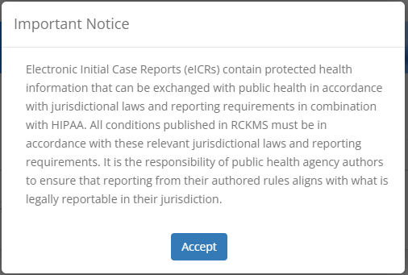

- The RCKMS User Guide has been updated to the latest version: Fall 2023 | Version 4.0
- A new read-only ‘Nationally Notifiable?’ checkbox has been added to the Details tab of the Reporting Specification Editor to indicate whether a condition is nationally notifiable.
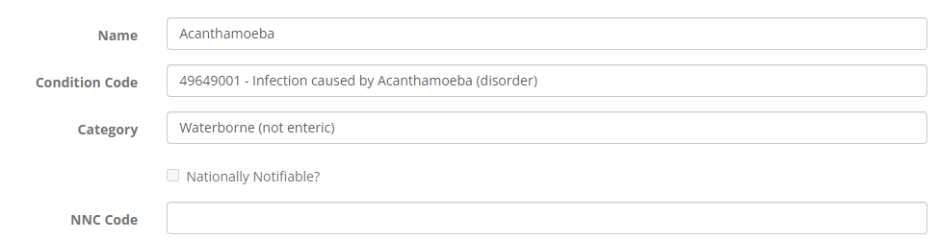

- The "Nationally Notifiable?" column in the Reporting Specifications list now references the new “Nationally Notifiable?” flag. Previously, the presence or absence of an NNC code, which is not a definitive indicator, was used to determine if a Y or N should be displayed in this column.

Authoring Status Report

- The following information is now included for each condition in the online version of the report, as well as in the PDF and Excel exports:
  - Code
  - Category
  - Last Published date
  - Nationally Notifiable (Y/N)
  - NNC Code
  - Report if care is provided in this jurisdiction (Y/N)
  - Report if lab is located in this jurisdiction (Y/N)
  - Report if patient is a resident of this jurisdiction (Y/N)
- To accommodate the added data elements, in the user interface the information for each condition is now displayed in its own panel, rather than in columns.
- The list of conditions and the ‘External Links and References’ section of the report are now sorted alphabetically by condition name.

An example of the new layout for each condition in the Authoring Status Report is below:

