[insert date]
Dear Influenza Surveillance partner,
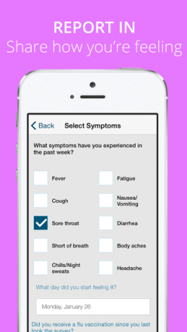
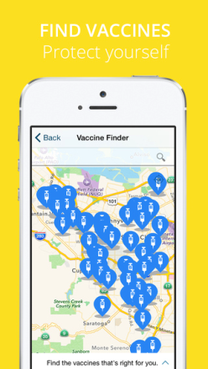
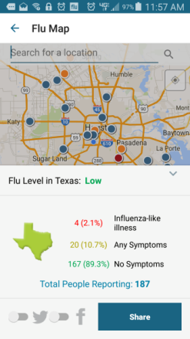
The seasonal flu season begins in October. Flu Near You (FNY) is a participatory surveillance (crowd sourcing) tool which compliments traditional disease surveillance activities. The Seasonal Influenza Weekly reports are posted on the Houston Health Department website.
MAP CASES

Flu Near You is participatory surveillance tool with features to:
- Report and share: select categories of symptoms
- Find vaccines: interactive search gives locations
- Map cases: real-time flu activity in the Greater Houston Metropolitan area (flu map) and Texas (percentages of ILI)
- Get news: stay informed with up to date flu news
- Share on social media: tell friends and family how you feel
Flu Near You has several ways to register. Users can register on the website, obtain the mobile application or join via Facebook. In order to register, individuals must be 13 years of age or older. Users can register their household members, including school aged children. During the registration process users are asked to provide their email, gender, birthdate, and ZIP code.
Once registered, users receive a weekly email or push notification to report on 10 symptoms of ILI. In the Greater Houston Metropolitan area there are 450 registered participants residing in over 100 ZIP codes. We average 100 reports per week. We are reaching out to you to increase participation in the Houston area.
This email contains recruitment tool kit which includes the following items:

- Template for stickers or reminders to distribute
- Infographic with overview of the number of users and weekly reporters in March 2015
- Information flyer to distribute
- Flu fun facts to share with during educational activities
- FNY Human Bingo for promotional activities

For more information visit the FNY website at https://flunearyou.org/ or call [insert contact information].

