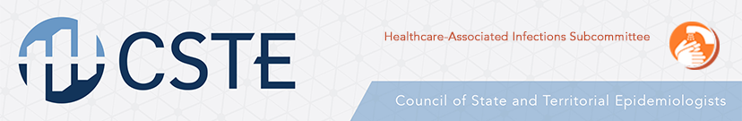
Building State-Based Healthcare-Associated Infection Control Capacity
Project Proposal

Overview:
The Centers for Disease Control and Prevention rely on state health departments to develop, coordinate, and implement comprehensive local and regional prevention strategies. Their role is to understand the burden of disease through prevalence and incidence, inform healthcare facilities about risk of disease in the region, aid in communication between different healthcare facilities, develop prevention strategies, and provide resources to health professionals dealing with infections.
Through a collaborative effort by the Centers for Disease Control and Prevention and the Council of State and Territorial Epidemiologists, this funding opportunity is available to state health departments currently in need of support for improving their healthcare-associated infection prevention efforts. The goal of this project is to provide financial support and professional guidance to states that show a need for capacity building. This project should enable states to fulfill the CDC’s recommended guidelines for state health departments regarding the prevention of healthcare-associated infections.
Project Summary:
- States may conduct a state-wide screening survey to determine the local prevalence and incidence of carbapenem-resistant Enterobacteriaceae and Candida auris. That survey may be implemented by multiple states in a geographic region to determine a regional prevalence. The survey may include working across state lines to determine the risk of disease transmission between states.
- Local monitoring of acute long-term care facilities regarding hygienic practices related to increased healthcare-associated infection risk. The state health department may send officials for healthcare professional observations of practice using a check-list of recommended protocols to ensure proper prevention measures are taking place. The goal is to inform healthcare facilities about proper protocol and develop a list of best practices that may be shared with the CDC for broad distribution.
- Revising and updating current CDC guidelines surrounding healthcare-associated infections and developing a list of best practices. Funding may go towards planning regional meetings focused on this objective and bringing state health departments together to discuss improving prevention efforts regionally.
- Funds may be used to hire APIC consultants for regions or states that show need for support or mentoring.

Project Guidelines:
- Preference will be given to states that did not receive K2 funding (except for states that received limited K2 funding).
- Qualified states will define their need for capacity building and outline a strategy for addressing healthcare-associated infections in their state.
- Funding is available for approximately 5-6 states based on level of need.
- The award amount will range between 50-75 thousand dollars as determined by the selection process.
- Project efforts should focus primarily on carbapenem-resistant Enterobacteriaceae and Candida auris, but may be expanded to other healthcare-associated infections given states needs.
- States should provide these key deliverables:
  - List of best practices determined during the project implementation
  - Feedback regarding current CDC HAI infection control materials
  - Formal Project evaluation
- Formal project evaluation submission deadline is June 1st, 2018.
- Funding application deadline is November 30th, 2017.
- Successful state projects that show interest and need for future funding opportunities may be eligible for continued financial support.
References
Centers for Disease Control and Prevention. Carbapenem-resistant Enterobacteriaceae in Healthcare Settings: State Health Departments. 2017. https://www.cdc.gov/hai/organisms/cre/cre-statehealth.html

