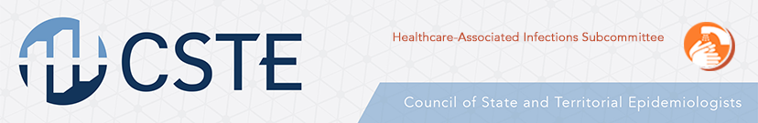
Building State-Based Healthcare-Associated Infection Control Capacity
Project Proposal

Overview:
The Centers for Disease Control and Prevention (CDC) relies on state health departments to develop, coordinate, and implement comprehensive local and regional antimicrobial resistance surveillance and prevention strategies. Their role is to understand the burden of disease, inform healthcare facilities about risk of spread in the region, aid in communication between different healthcare facilities, develop prevention strategies, and provide resources to health professionals working to control the spread of these organisms.
Through a collaborative effort between the CDC Division of Healthcare Quality and Promotion and the Council of State and Territorial Epidemiologists (CSTE), this funding opportunity is available to state health departments currently in need of support for improving their antimicrobial resistance prevention efforts. The goal of this project is to provide financial support and professional guidance to states for capacity building. This project should enable states to facilitate the implementation of CDC recommended practices regarding surveillance for, response to, and prevention of antimicrobial resistant pathogens.
Project Activities (applicants should select one of these options to implement)?:
- The health department (or designee) will perform healthcare professional observations of practice in high-acuity post-acute care facilities to identify gaps in infection prevention and control practices that are critical to preventing transmission of emerging antimicrobial resistance threats (e.g., gown/glove use, hand hygiene) and suggest strategies to address these gaps. The goal is to inform healthcare facilities about proper prevention practices and develop a list of resources (e.g., including check-lists or recommended protocols) that can assist with implementing these programs more broadly. Providing ongoing support including but not limited to follow up visits or conference calls is expected.
- Developing best practices for implementing “containment” responses to novel and emerging antimicrobial resistant threats. This may include hosting or convening meetings/discussions to bring health departments and healthcare facilities together to discuss improving prevention and containment efforts regionally.
- Funds may be used to hire consultants for regions or states that show need for increased capacity.
Project Guidelines:
- Preference may be given to states that did not receive ELC K2 funding.
- Qualified states will define their need for capacity building and outline a strategy for implementing one of the projects above.
- Funding is available for approximately 5-6 states.
- The award amount will range between $25,000 to $75,000 as determined by the selection process.
- Project efforts should focus primarily on carbapenemase-producing carbapenem-resistant Enterobacteriaceae and Candida auris, but may be expanded to other antimicrobial resistant pathogens if consistent with the needs of the state.
- States should provide these key deliverables:
  - Description of best practices for implementing the prevention approaches outlined above. This includes identifying barriers and how barriers were overcome
  - Feedback regarding currently available resources/tools and additional resource/tool needs
  - Formal Project evaluation
  - Regularly scheduled conference calls with CDC DHQP and CSTE
- Formal project evaluation submission deadline is June 1st, 2018.
- Funding application deadline is November 30th, 2017.
- Successful state projects that show interest and need may be eligible for future funding opportunities.
References
Centers for Disease Control and Prevention. Carbapenem-resistant Enterobacteriaceae in Healthcare Settings: State Health Departments. 2017. https://www.cdc.gov/hai/organisms/cre/cre-statehealth.html

