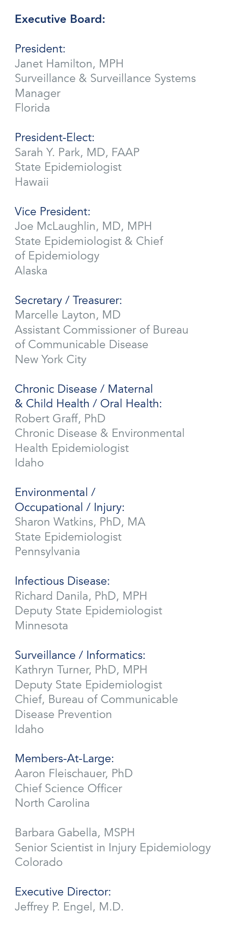 | September 15, 2017  Marion Kainer, MD, MPH  Director, Healthcare Associated Infections and Antimicrobial Resistance Program  Tennessee Department of Health  425 5th Avenue N  CEDS, Cordell Hull Bldg, Floor 1  Nashville, TN 37243-4911  RE: Travel Arrangements to the HICPAC meeting, November 8-9 in Atlanta, GA  Dear Dr. Kainer,  As a recipient of funding support through the CSTE-CDC Cooperative Agreement, we are pleased you will be attending the HICPAC Meeting on November 8-9 in Atlanta, GA. Travel support for this meeting will include airline transportation, ground transportation (excludes rental cars and taxi service other than to and from the hotel and airport), hotel accommodations at the designated rate for up to 2 nights, and per diem allowance. If you are unsure if an expense will be reimbursed, contact me (manderson@cste.org) for clarification. Please read the full disclosure of the CSTE Travel Support Guidelines that include guidelines regarding expenses and cancellations at: http://c.ymcdn.com/sites/www.cste.org/resource/resmgr/PDFs/2014TravelPolicyRevisedFINAL.pdf.  Transportation  Airline transportation will be provided to and from your originating city and the venue city, Atlanta, GA. Flight reservations must be made through the CSTE official travel agent, American Express (1-800-872-9954). Airline reservations should be made three weeks before the meeting. The CSTE National Office must pre-approve travel arrangements not made through our travel agent in order for the traveler to receive reimbursement. If you have questions or need assistance with airline transportation, contact CSTE at (770) 485-3811.  Hotel Accommodations  You will be responsible for arranging your own hotel accommodations. CSTE will reimburse up to the federal per diem allowance for Atlanta, GA of $148.00 + tax per night for 2 nights. Incidentals or other lodging expenses are not reimbursable.  Per Diem  Meal expenses are reimbursed at the federal per diem allowance for Atlanta, GA of $69.00 per day less any meals provided at the meeting.  Reimbursement Procedure  After the meeting, complete the reimbursement form provided and include any receipts greater than $50.00 and all airline boarding passes. Please mail the signed expense reimbursement form to the CSTE National Office (address above), email it to travel@cste.org, or fax it to (770) 407-5110. Expenses will not be reimbursed until after the meeting.  Sincerely,  Michael M. M. Anderson  Michael M. M. Anderson, MPH  Program Analyst I

