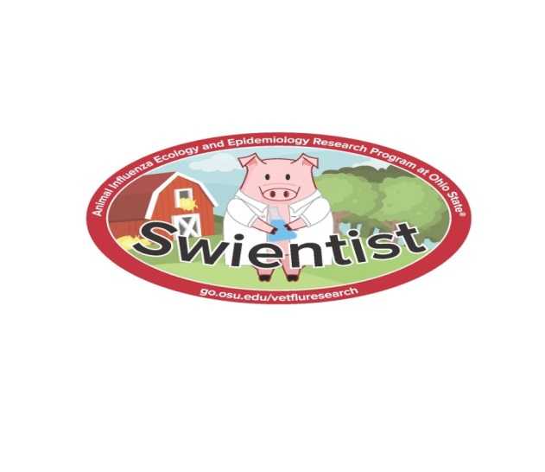

Becoming a Swientist

Agenda - May 20, 2017
Welcome - Bowman
- Introduce Becoming a Swientist Program – give handout and answer questions
- NPB Survey
Divide into groups <13 – Nolting >13 – Bowman
How Disease Spread
- Once divided, but before they sit down, describe scenario
- Pick up cups of water and swap with at least 3 friends
- Add Indicator
- Discard cups as they find a seat in bleachers
- Activity wrap up
Zoonotic Disease Chapter
- Handout chapter to all youth
- Briefly cover material in order until you get to hand washing
Proper Hand washing Demo
- Pick several volunteers
- Administer glo-germ and look with black light
- Have volunteers wash hands as they typically would
- Look with light
- Go through proper hand washing and have them try again
- Describe portable hand washing station
- Thank volunteers and have them return to seats
Biosecurity Intro
- Define biosecurity – ask for ideas they are already doing
- Briefly describe zoonotic disease of interest and what biosecurity could be used to prevent disease transmission
Biosecurity Buckets
- Go through big buckets one item at a time
- Intro take home buckets and go through each item
- Program close
- Facilitate bucket assembly and remind participants about selfies

