
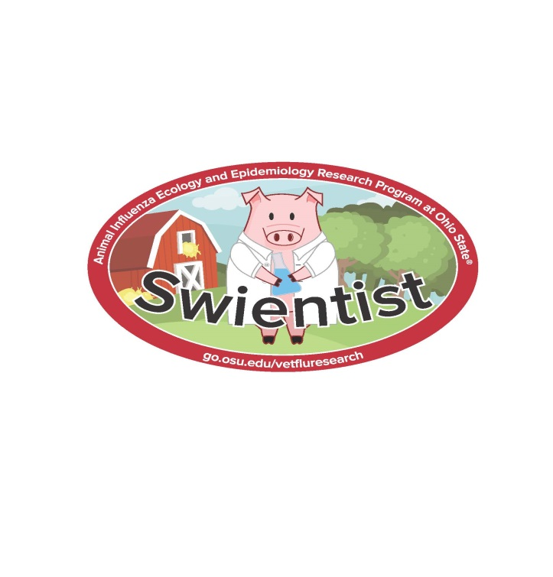

Additional questions?
Call Ohio State staff at 614-292-6616
Or visit us on the web at www.go.osu.edu/vetfluresearch
Uploading Selfies
www.go.osu.edu/swientist
1. Click on “Register Now” and create an account for each individual participant
2. If participant is under 13, enter account key to give parental permission.
2. Once profile is completed you’ll be taken to the photo submission page
3. Upload your selfie and add a caption describing your actions. (ex. Brutus with Biosecurity Bucket)
4. Go to “My Submissions” tab to see all previous submissions

How do I earn points?
Upload selfies (or photos) of yourself doing healthy habits. There is no limit to the number of photos you can upload, so you can earn points all season long! All photos must be uploaded by July 15 to be included in the final contest.
Example photos include (but are not limited too):
- Washing hands
- Cleaning and/or disinfecting equipment
- Changing boots and/or coveralls
- Keeping sick animals home from a show
- Participant with a pig’s vaccination record
- Show us where you put your Swientist sticker
- Learn more about zoonotic disease
  - Online training at http://www.cfsph.iastate.edu/YouthInAg/
  - Reading “Swine Zoonotic Disease Risks and Prevention” handout

What do I win?
Top point earners in each age division will win an Apple iPad

Prizes will be awarded at the OH-PIGS Banquet

Pr

Afdsj
Why become a swientist?
Learn and practice healthy habits to prevent disease transmission between you and your pig while earning prizes.

How do I become

a Swientist?

All youth who create an online account and upload at least one photo will receive a free t-shirt!!

