Background and Risks of Influenza A Viruses in Swine at County Fairs
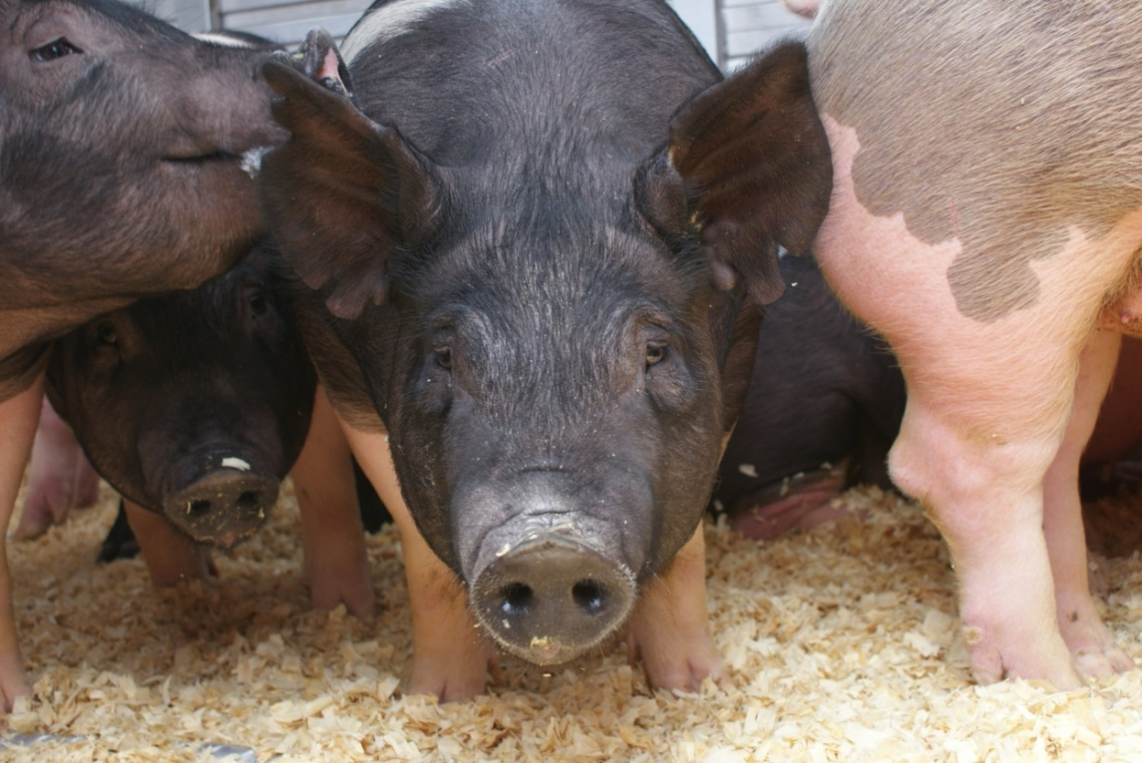

Instructional Plans

Objectives

- Without using notes, name three potential mitigation strategies to stop the spread of influenza from pigs to people, by the end of the hour session.

- Within a peer group, complete the real-life scenarios, within the 30 minutes allotted.

Questions to be answered

- What is influenza A virus in swine and why do we care?
- What can be done on the farm, before the fair, to reduce the likelihood of swine coming to the fair with influenza?
- What techniques can be used at the fair to reduce transmission of the virus? How can learners protect themselves?
- What needs to be done after the fair with the pigs that don’t go to harvest?

Interest Approach

Students will be seated in small groups around tables. A stuffed pig that has been previously coated with glitter will be in the middle of each table. Learners will be asked to introduce themselves including their names, where they are from, how many years they have been in 4-H, and how long they have been raising pigs. Whichever student is speaking with hold the pig, then pass it to whomever at the table they choose. After the introductions are complete, the facilitator will ask the students to look at their hands to see if they notice anything out of the ordinary. The fact that glitter ends up everywhere will be used to introduce the method by which influenza viruses spread.

Lesson

Upon completion of the above mentioned interest approach the following events will occur:

1. Pre-test evaluation (5 minutes)
- (see appendix)

2. Power point lecture – (20 minutes)

  - What is influenza?
  - What does influenza look like in swine?
  - History of influenza A virus in swine at agricultural fairs and exhibition
  - Snout wipe video: https://www.youtube.com/watch?v=UhnGak-SrvI
  - What is bio-security?
  - What to do if your pig gets sick before, during, or after the fair

4. Group Scenario Activity (20 minutes)

- Participants will work together in groups of 8-10 to complete the scenario handout. The groups will discuss the questions amongst themselves to formulate their ideas regarding the following questions:

- What is swine influenza?
- What should I do if my pig gets sick before the fair?
- What should I do if my pig gets sick during the fair?
- What should I do after the fair if I take pigs home

5. Group reporting and wrap-up (15 minutes)

- All small group discussions will cease and as a larger group each question will be addressed. Individual groups will first report their ideas on the topic and then facilitators will offer suggestions

- Summary of take home messages

- Post-test administration (see appendix)

- Questions and Answers

- Pass out handouts

Handouts

- “Measures to Minimize Influenza Transmission at Swine Exhibition, 2014”
- “Biosecurity Considerations”
- “Influenza H3N2v: Key Facts for People Exhibiting Pigs at Fairs”
- “ A Champions Guide to Youth Swine Exhibition”

