Media Graphics with Additional Verbiage

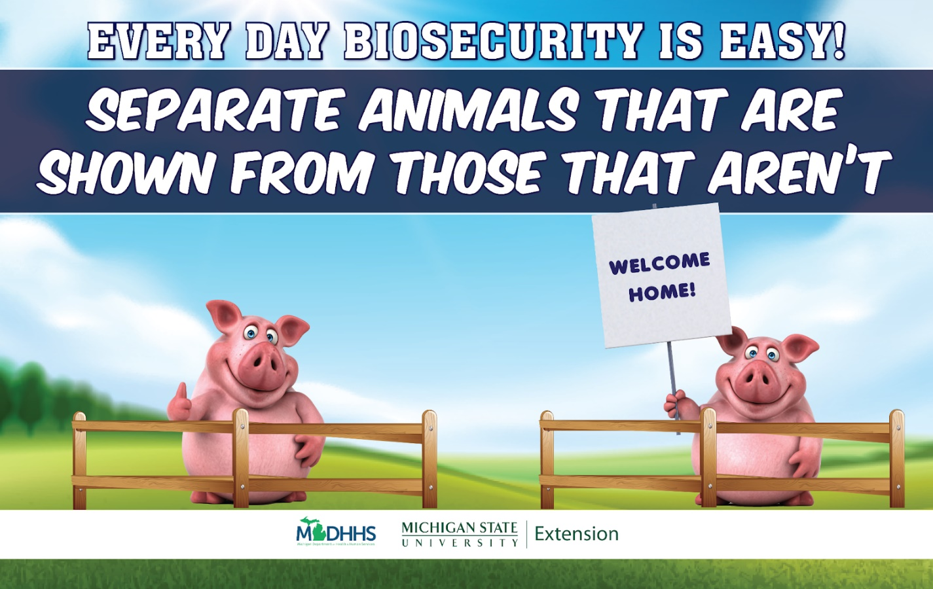
Keeping your animals healthy is a priority! Remember! Animals should avoid nose to nose contact for 21 days after returning from a show and be symptom free before commingling other animals.

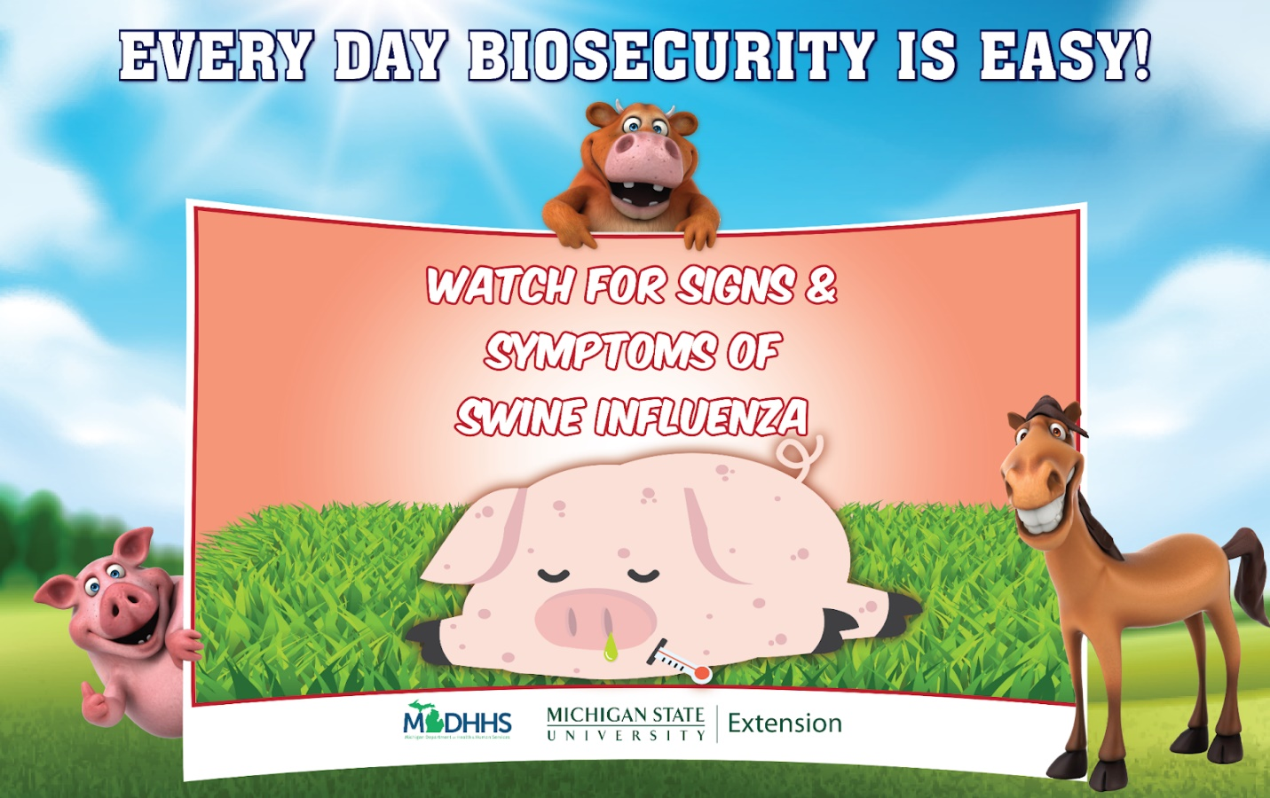

Daily observation, watching your animals for signs of sickness is important. Symptoms of swine influenza may include temperature above 103º F, coughing, discharge from the nose or eyes, breathing difficulties, going off feed. Contact your veterinarian if your pig has any of these symptoms.

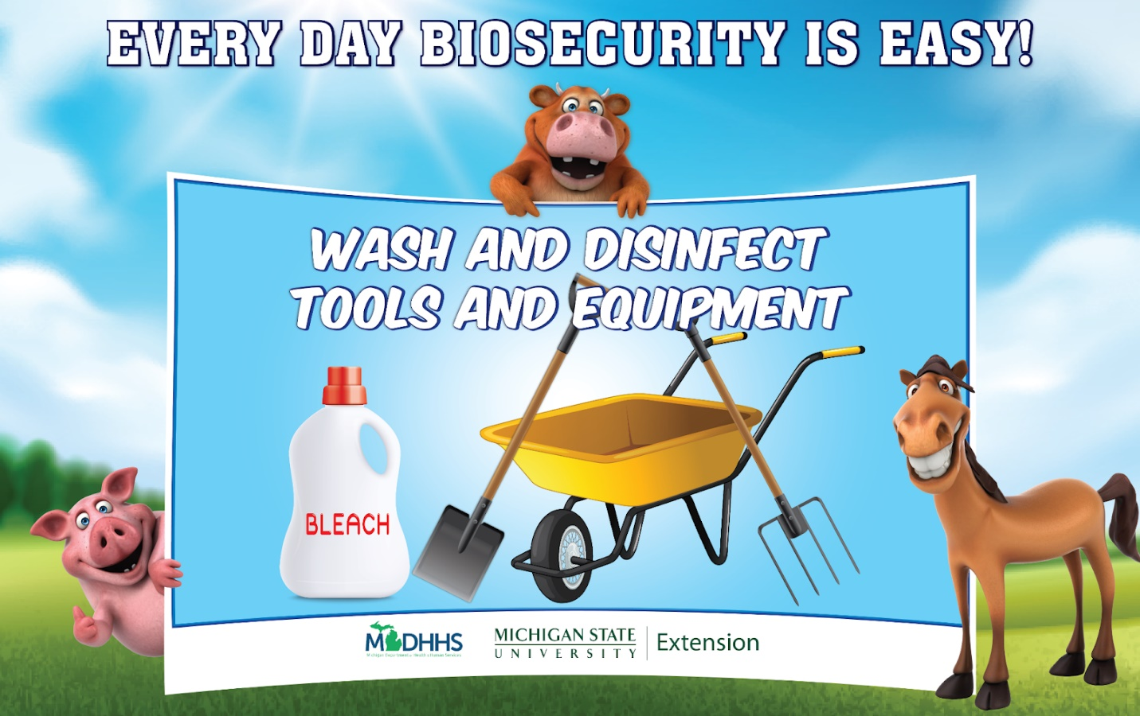

Tools and equipment should be cleaned and disinfected with a 3% bleach solution.

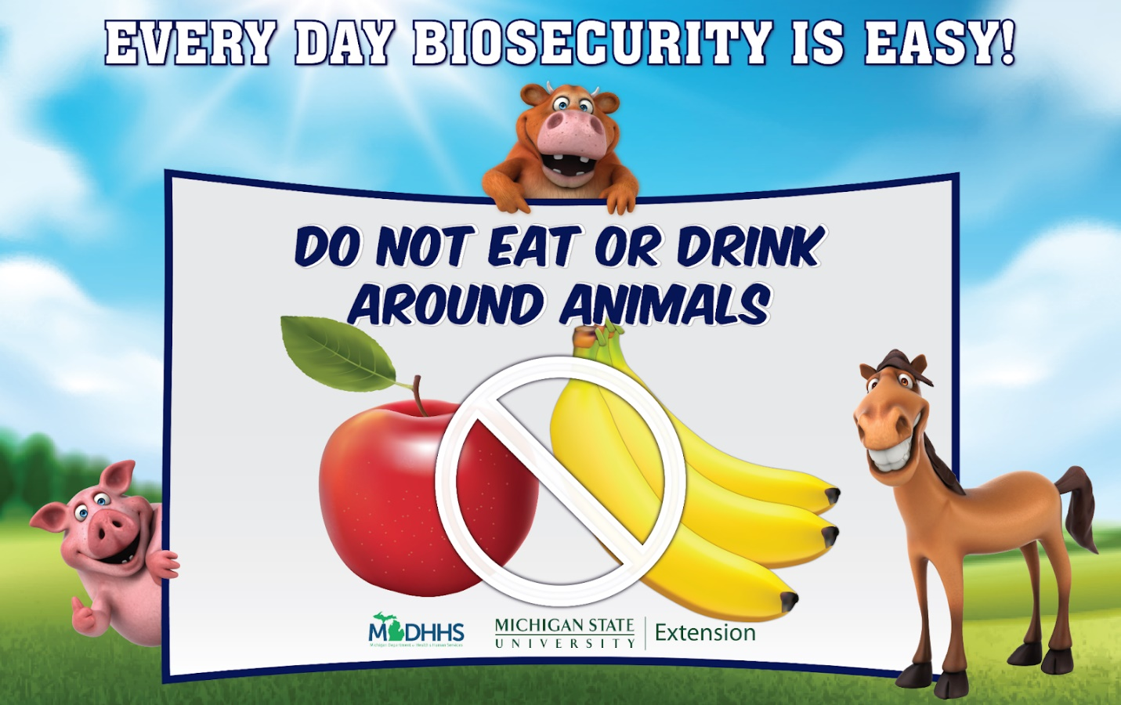
Sometimes animals and people can share germs and make each other sick, when this happens it is called a zoonotic disease. To help decrease the risk of this happening you should not eat or drink around animals or in the barn.

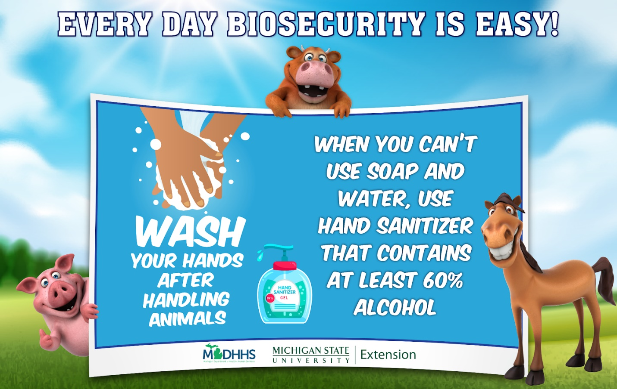
Soap and water are always the best option for proper handwashing. When not available hand sanitizer can be used, but handwashing should be done before eating food.

