Activity 3. GERM-O
Game Description

GERM-O is a card game modeled after the game UNO. Each GERM-O game comes with a detailed set of playing instructions. The GERM-O game is available to order if you do not already have a copy, by emailing influenza.dhhs@maine.gov.

- Each set of cards is intended for a group of three to five players. Each card in the set either has a picture of a pathogen/germ, the host of the pathogen/germ, or a preventative measure (handwashing, cover your cough, etc.) that can be used against the pathogens/germs.

- The deck is color coded, and the color encodes a host (poultry/cattle/human/swine) of the pathogen/germ.





- The pathogen/germ will appear on multiple colors if the pathogen/germ has multiple animal hosts. The preventative measures cards appear in all colors since these actions can stop disease
transmission between hosts.
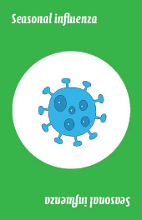
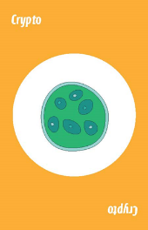
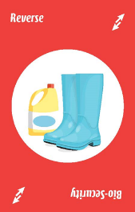


- Below is a suggestion of how to incorporate GERM-O into a youth agricultural education session about promoting animal and human health in agricultural settings:

Present educational curriculum (for example, all or part of the “Healthy Animals, Health People” presentation) to the group. Throughout the presentation, remind your group that they should pay close attention to the names of the pathogens/germs, which animals can serve as hosts, and what you can do to prevent illness.
- To play the game: Members of the group sit in a circle, the cards are shuffled, and seven cards are dealt to each player. Note: Five cards per person may be dealt for a shorter game. The remaining cards are placed face down, as the draw pile. The first card in the draw pile is turned face up to start a discard pile.
The player to the left of the dealer begins, and s/he chooses one of their cards to put down. The card played has to match the color, pathogen/germ, or action card (prevention/wild/skip/reverse/draw cards). The play continues clockwise. Wild cards can be used by a player to change the color that is being used. If the player has no matches, they must draw one card from the draw pile and the game moves on to the next person.
The game continues until a player becomes GERM free, by using all of the cards in their hand before anyone else. Players announce “GERM-O” when playing her/his second to last card to make other players aware of their GERM-O status.
- Facilitator’s Role:
During or after play, use the cards played as cues to remind players about which animals can serve as a host for different diseases, signs the animals may show when sick, and prevention measures that work to stop disease transmission. For example, as influenza cards get played, ask students if they remember what the signs of influenza are in humans, in poultry, in swine, etc.

