How to Create a Handwashing Station
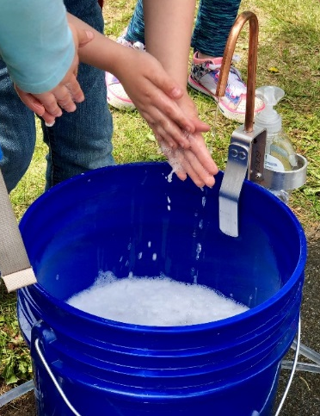
You can create a fairly inexpensive handwashing station for your agricultural events. Maine’s Department of Agriculture, Conservation, and Forestry sees many innovative ideas for handwashing stations in the field, from simple water jugs over a 5-gallon bucket to foot pedal sinks. Only your imagination is the limit! See the directions below if you would like to create the same type of handwashing station that is pictured to the right.
Materials Needed
- Hands Free Camp Sanitation Kit which includes:
  - Tubing
  - Pipe Spigot
  - Foot Pump
  - Mesh Carry Bag
- Hand Soap (Not included with the sanitation kit)
- Two five-gallon buckets (Not included with the sanitation kit)

Directions
- Purchase the sanitation kit, buckets, and hand soap. The sanitation kit can be bought on Amazon by searching “Hands Free Camp Sanitation.” Several options are available and each cost around sixty-five to seventy-five dollars.
- Assemble the Kit. Each kit comes with directions on how to assemble the handwashing station, which takes approximately two minutes.
- Just add water to the “clean water” bucket and step on the foot pump several times.

Tips
- Be sure to empty the dirty water bucket once it is about half full.
- When your event is done make sure to step on the foot pump several times once the hose is removed from the clean water bucket. This will help to empty the system of water to make it ready for your next event.

Additional Handwashing Station Images
- Pictured below is the hands-free sanitation kit when mailed (left) and materials needed for the handwashing station (right).
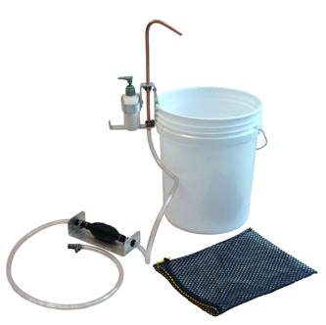
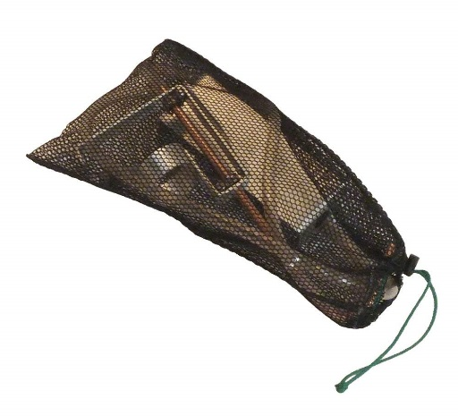

Other Handwashing Stations Used in Maine
- Top Row: A simple but effective station using a water jug with a spigot (left) and a sink hooked to a standard garden hose (right). The drain pipe is connected to another hose and is draining into the nearby drain field.
- Bottom Row: Two variations on the garden hose sink. Both stations have a foot activation turn on valve that was created with items from a hardware store. Each station has a unique faucet head.
