Please return completed Interim Progress Report to CSTE at mhuynh@cste.org by July 31, 2020.
Note: Please submit one response per site.

- List project deliverables and describe progress made towards completion of these deliverables:

- Deliverable 1: Host “Becoming a Swientist” programming with OH-pigs Ohio Summer Swine Circuit
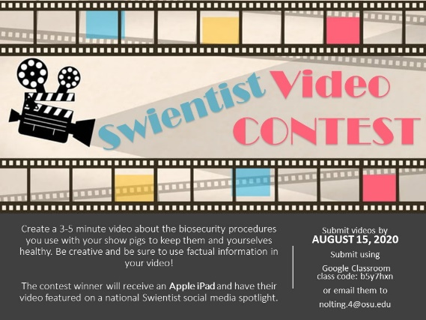
Accomplishments/Progress to-date: Hands on activities were unable to occur at OH-Pigs shows this spring, however Swientist-in-a-Box activities are scheduled for four days during a large show in August, that is not limited to OH-Pigs exhibitors. In previous years, we’ve hosted the Becoming a Swientist selfie contest and biosecurity poster competition, however we altered the competition this year due to COVID-19, and are hosting a video contest that runs through August 15. We are hopeful students will incorporate key biosecurity and zoonotic disease mitigation strategies in a fun, creative manner to produce videos that will be featured on local and national social media outlets.
Did this deliverable include an educational intervention: Yes – Won’t occur until August

- Deliverable 2: Partner with the Ohio FFA Association to develop and disseminate zoonotic disease risk and prevention curriculum in accordance with Ohio Department of Education standards
Accomplishments/Progress to-date: Curriculum development is on-going and will be made available to career tech educators during phase 2 of this program.
Did this deliverable include an educational intervention: Yes- will occur in Phase 2

- Deliverable 3: Develop and disseminate a Zoonotic Disease Risk and Prevention chapter for the poultry resource handbook used by Ohio poultry exhibitors
Accomplishments/Progress to-date: The Zoonotic Disease Risk and Prevention chapter for poultry has been created and is awaiting print in the new version of the Poultry Resource Handbook. The chapter has been uploaded to basecamp for your review. To access knowledge gain a skill-a-thon station, much like the previously developed swine station, was created and will be piloted at the Ohio State Fair before being widely disseminated to local extension educators. Because the 2020 Ohio State Fair was cancelled, the pilot of the skill-a-thon station will be delayed until the 2021 fair.
Did this deliverable include an educational intervention: Yes – Skill-a-thon pilot will occur in 2021

- Deliverable 4: Collaborate with the National Junior Swine Association to engage national level swine jackpot show participants at various shows across the country
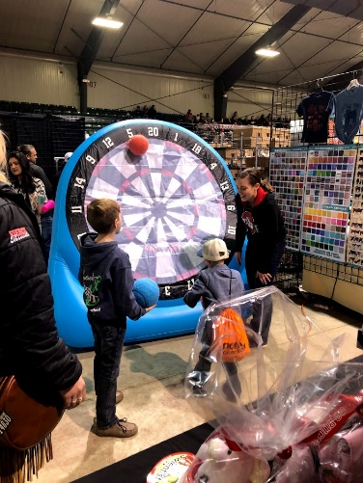
Accomplishments/Progress to-date: Swientist activities were held in Perry, Georgia in January 2020. Our study team created “Biosecurity Brain Quest” decks and used them to quiz youth visiting the booth at the show. For each correct answer, the child received a ball to throw at a large inflatable bullseye to try to earn the most points. Two sets of card decks were created to be appropriate for different aged children.

In addition to the Perry, GA show, Swientist hit the road in July and hosted a booth at the National Junior Show in Des Moines, Iowa. Although social distancing prohibit our usual hands-on activities, we were still able to share knowledge regarding zoonotic disease spread and mitigation to youth through Swientist-in-a-Box activities. As is typically the case at The Expo, each day had a different theme and activity for youth to engage in which included; Biosecurity Shoot Out, Virus Infected Snot, and Healthy vs. Sick. We received great feedback from youth, parents, and show organizers on the activities available during an otherwise challenging time.

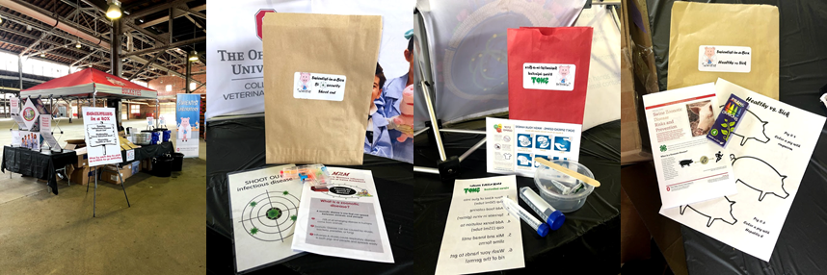

Did this deliverable include an educational intervention: Yes
- Deliverable 5: Develop a hands-on curriculum to accompany existing written materials used by the National Pork Board to educate youth involved in swine production Accomplishments/Progress to-date: National Pork Board has edited the written materials and has begun disseminating updated handouts and electronic versions of the document. Curriculum development is ongoing and will be completed during Phase 2.
Did this deliverable include an educational intervention: Yes – completed in Phase 2

- List the collaborators involved to-date and briefly describe their role in the project (i.e. 4H/FFA, State PH, State Animal Health).
Animal Influenza Ecology and Epidemiology Research Program:
The Animal Influenza Ecology and Epidemiology Research Program (AIEERP) at The Ohio State University has taken the lead on each objective and works closely with other collaborators to make progress toward completion. AIEERP hosts the Becoming a Swientist program, designing and implementing all program activities. In addition, AIEERP developed the first drafts of the poultry zoonotic disease chapter and is currently working toward the development of FFA and NBP curriculum.
Ohio 4-H Youth Development:
4-H animal sciences was responsible for the final edits and dissemination for the poultry resource handbook chapter. In addition, they will host the skill-a-thon station at the 2021 Ohio State Fair.

National Swine Registry:
The National Swine Registry (NSR) sponsors the National Junior Swine Association (NJSA) and hosts multiple swine exhibitions. Without their support, the Becoming a Swientist program would not be possible; especially during restrictions due to COVID-19.
Ohio Department of Agriculture:
Ohio Department of Agriculture (ODA) supports activities being held in Ohio to educate youth in agriculture.
Ohio Department of Health:
The Ohio Department of Health (ODH) supports activities being held in Ohio to educate youth in agriculture.
National Pork board:
NPB has completed the edits to written materials and begun dissemination of electronic and printed versions.
Ohio FFA:
Ohio FFA has provided the AIEERP team with career technical competencies to develop curriculum around and continues to offer support for all aspects of the program.

- Have you incorporated COVID-19 into activities or deliverables completed in Phase 1 of this project period? If so, please describe in detail (e.g., partners involved, role of each partner, etc.). (Please note: changes to activities, budget, and timeline initially proposed for Phase 2 should be documented in an updated workplan during the contract amendment process).
The activities included in our program are not specific to influenza, but to zoonotic disease in general. Therefore, the work we’ve been doing does include information that applies to COVID-19, however the scope of work has not changed.

- Describe areas of concern or challenges in meeting the objectives or providing deliverables especially as it relates to COVID-19.
Social distancing and the cancellation of swine shows has impacted our work and are likely continue to impacting our efforts, however the development of Swientist-in-a-Box activities have allowed for continued education in light of restrictions. At this time, we expect to meet all deliverables.

Impact Chart
If the activity/deliverable described is/included an Educational Intervention, please complete this portion of the report
Impact |  |  |  |  |  |  | Evaluation
Intervention Activity | Baseline # prior to current grant period | How did you measure the baseline? Did you include direct participants, families, etc? | 2020 Audience (youth, community leaders, etc?) | # of attendees/  participants | # of materials distributed | Did you collaborate with another state? If so, which one(s)? | Pre-test administered? (How many? To whom?) | Post-test administered? (How many? To whom?)
EXAMPLE: Four Scenario based training exercises | X# of training sessions held in 2016 to X total youth aged 11-15 | Only counted the number of actual youths who attended the session | Youth aged between 12 and 16 | X # attendees per training; total of X attendees
Becoming a Swientist – OH-Pigs video contest | 50 | Counted number of youth enrolled in the 2019 Becoming a Swientist Program | Youth aged 3-21 | TBD |  | No | NA | NA
Poultry Zoonotic Disease Risk and Prevention chapter | Not previously available | Not previously available | Youth aged 9-19 | TBD | TBD | No | NA | NA
Becoming a Swientist in Perry, GA | 400 youth attending show | Counted number of youth registered at show | Youth aged 3-21 | 700 youth registered at show | 200 swientist stickers  500 germ stress balls | No | NA | NA
Becoming a Swientist in Des Moines, IA | 1000 youth | Counted number of youth registered at show | Youth aged 3-21 | 1250 registered at show | 600 of each day’s Swientist-in-a-Box activity (1800 total)  1000 bottles mini hand sanitizers  500 germ stress balls  200 Swientist stickers | No | NA | NA

