Please return completed Final Progress Report to CSTE at mhuynh@cste.org by December 31, 2020.
Note: Please submit one response per site.

- Identify your top achievements for the project.
A. Host “Becoming a Swientist” programming with OH-pigs Ohio Summer Swine Circuit

Hands on activities were unable to occur at OH-Pigs shows this spring, however Swientist-in-a-Box activities were held for four days during a large show in August, that is not limited to OH-Pigs exhibitors. In previous years, we’ve hosted the Becoming a Swientist selfie contest and biosecurity poster competition, however we altered the competition this year due to COVID-19, and instead hosted a video contest. Participants did a great job showcasing the how they incorporate key biosecurity and zoonotic disease mitigation strategies at their farms. The winning student earned an iPad for her efforts.

B. Developed a Zoonotic Disease Risk and Prevention chapter for the poultry resource handbook used by Ohio poultry exhibitors
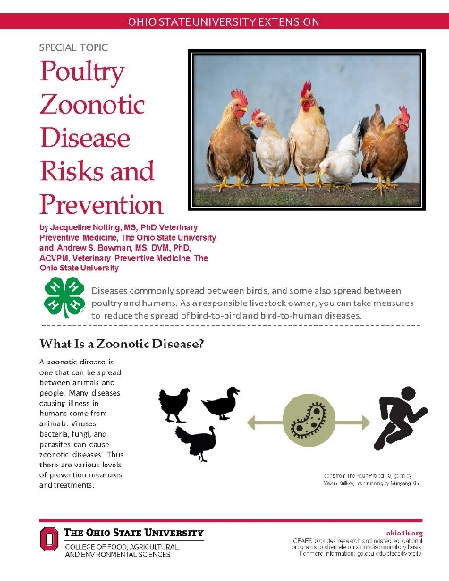
The Zoonotic Disease Risk and Prevention chapter for poultry has been created and is awaiting print in the new version of the Poultry Resource Handbook. The chapter has been uploaded to basecamp for your review. To access knowledge gain a skill-a-thon station, much like the previously developed swine station, was created and will be piloted at the Ohio State Fair before being widely disseminated to local extension educators. Because the 2020 Ohio State Fair was cancelled, the pilot of the skill-a-thon station will be delayed until the 2021 fair.

C. Collaborated with the National Junior Swine Association to engage national level swine jackpot show participants at various shows across the country
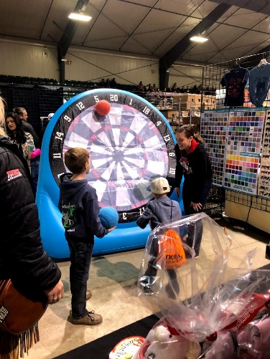
Swientist activities were held in Perry, Georgia in January 2020. Our study team created “Biosecurity Brain Quest” decks and used them to quiz youth visiting the booth at the show. For each correct answer, the child received a ball to throw at a large inflatable bullseye to try to earn the most points. Two sets of card decks were created to be appropriate for different aged children.

In addition to the Perry, GA show, Swientist hit the road in July, September, and October hosting booths at national junior swine shows in Iowa, Indiana, and Oklahoma. Although social distancing prohibited our usual hands-on activities, we were still able to share knowledge regarding zoonotic disease spread and mitigation to youth through Swientist-in-a-Box activities. As in years past, each day had a different theme and activity for youth to engage in which included; Biosecurity Shoot Out, Virus Infected Snot, and Healthy vs. Sick. We received great feedback from youth, parents, and show organizers on the activities available during an otherwise challenging time.

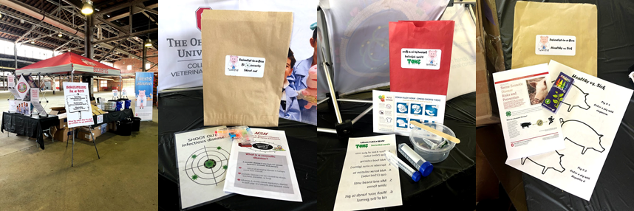

- If there have been changes to the collaborators on this project since completion of the interim report, please list the updated collaborators and briefly describe their role in the project (i.e. 4-H, State PH, State Animal Health).
There have been no changes to the study team since the interim report.

- Please describe areas of concern or challenges in meeting the objectives or providing deliverables.
COVID-19 has slowed our efforts, but we expect to fully meet our objectives by the end of the extended study.

- Do you expect one or more deliverables to be unmet by the project end date of December 31, 2020? If so, please indicate whether you would like to request a contract extension and what the new end date would be. Additionally, please include an updated project timeline.

We are continuing to develop and pilot curriculum to be used in agricultural education classrooms and ask for an extension of funds through May 31, 2021.

Impact Chart
If the activity/deliverable described is/included an Educational Intervention, please complete this portion of the report. Please note: the chart below should be reflective of the cumulative project period and can include deliverables met in the interim report.
Impact |  |  |  |  |  |  | Evaluation
Intervention Activity | Baseline # prior to current grant period | How did you measure the baseline? Did you include direct participants, families, etc? | 2020 Audience (youth, community leaders, etc?) | # of attendees/  participants | # of materials distributed | Did you collaborate with another state? If so, which one(s)? | Pre-test administered? (How many? To whom?) | Post-test administered? (How many? To whom?)
EXAMPLE: Four Scenario based training exercises | X# of training sessions held in 2016 to X total youth aged 11-15 | Only counted the number of actual youths who attended the session | Youth aged between 12 and 16 | X # attendees per training; total of X attendees
Becoming a Swientist – OH-Pigs video contest | 50 | Counted number of youth enrolled in the 2019 Becoming a Swientist Program | Youth aged 3-21 | TBD |  | No | NA | NA
Poultry Zoonotic Disease Risk and Prevention chapter | Not previously available | Not previously available | Youth aged 9-19 | TBD | TBD | No | NA | NA
Becoming a Swientist in Perry, GA | 400 youth attending show | Counted number of youth registered at show | Youth aged 3-21 | 700 youth registered at show | 200 swientist stickers  500 germ stress balls | No | NA | NA
Becoming a Swientist in Des Moines, IA | 1000 youth | Counted number of youth registered at show | Youth aged 3-21 | 1250 registered at show | 600 of each day’s Swientist-in-a-Box activity (1800 total)  1000 bottles mini hand sanitizers  500 germ stress balls  200 Swientist stickers | No | NA | NA
Becoming a Swientist in Woodward, OK | 0 youth | Counted number of youth registered at show | Youth aged 3-21 | 215 registered at show | 200 of each day’s Swientist-in-a-Box activity (400 total)  400 bottles mini hand sanitizers  100 Swientist stickers | No | NA | NA
Becoming a Swientist in Richmond, IN | 0 youth | Counted number of youth registered at show | Youth aged 3-21 | 235 registered at show | 200 of each day’s Swientist-in-a-Box activity (400 total)  400 bottles mini hand sanitizers  200 stethoscopes  500 Plush Swientist pigs | No | No pre-post test, however a Healthy/Sick activity included youth turning in their drawings of pigs exhibiting specific infections. | NA
Becoming a Swientist at OYLE in accordance with OH-Pigs Youth Show Circuit | 0 youth | Counted number of youth registered at show | Youth aged 3-21 | 500 registered at show | 200 of each day’s Swientist-in-a-Box activity (800 total)  1000 bottles mini hand sanitizers  200 stethoscopes  500 Plush Swientist pigs | No | NA | NA
Becoming a Swientist in Reno, NV | 0 youth | Counted number of youth registered at show | Youth aged 3-21 | 175 registered at show | 175 Swientist-in-a-Box “Virus Trap” activities were included in participant registration bags | No | NA | NA

