General Comments to Resource Repository Updates – August 4, 2021
We would like the webpage modified to look like the following homepage https://improvingliteracy.org/resource-repository. Below are specific itemized changes to the current format:
- Add large header at the top
- Consistent tonal color scheme throughout all pages
- Each resource has a title, brief description, and icons to identify type of resource
- Default search is by resource, not collection. Option to view whole collection is available when viewing a specific resource
- Make filters collapsible, with text in larger font for readability. Suggested organization for filters:
    - Categories
      - Activities
      - Courses
        - In-person courses
        - Web-based courses
      - Facilitator training
        - Train the trainer
      - Presentations
      - Printable Resources and son-digital media
        - Fact sheets
        - Posters
      - Publications
        - Abstracts
        - Manuscripts
      - Social media
      - Videos
    - Topics
      - Agrotourism
      - Disease transmission
      - Fairs
      - Food safety
      - Hand hygiene
      - Human-animal interaction
      - Stakeholder engagement
      - Zoonotic disease-specific content
        - Campylobacter
        - Cryptosporidiosis
        - E. coli
        - Influenza
        - Salmonella
    - Intended audience
      - Teachers/instructors
      - Students/youth
        - Elementary age
        - Middle/high school age
      - Community members
      - Agrotourism industry
      - Trainer/trainee
      - Health departments

Specific comments in images:
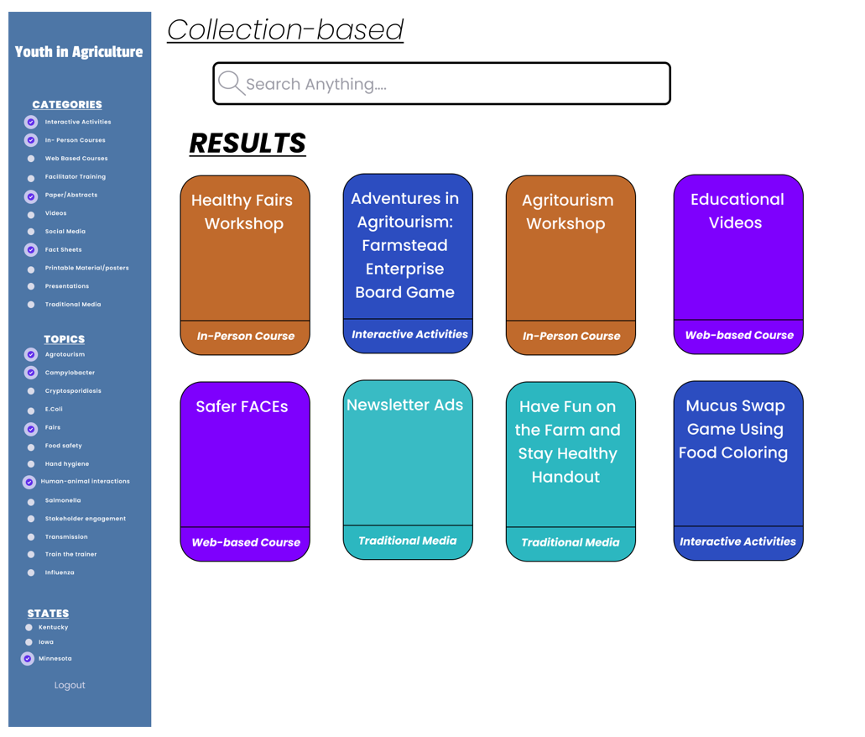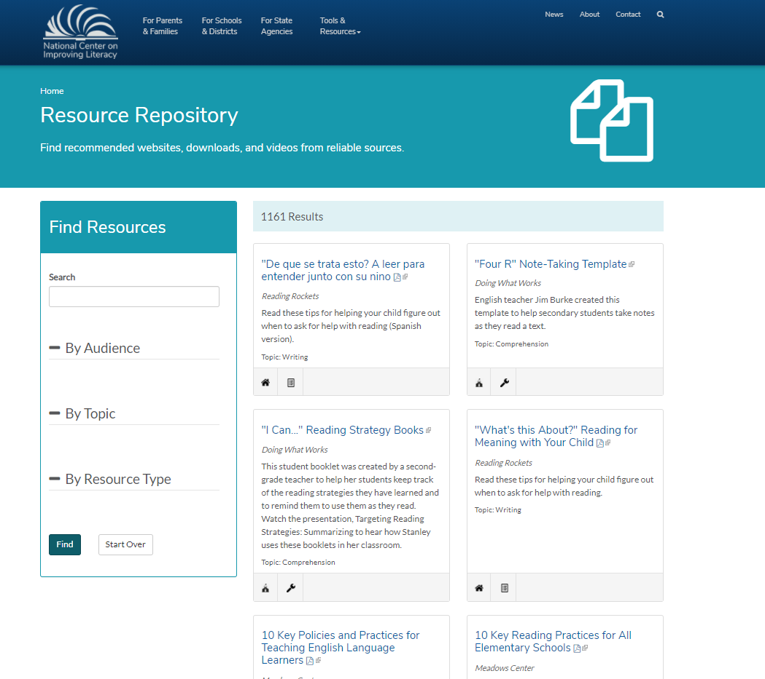
The image on the right is the layout/style we had in mind. We like that the page looks more like a normal webpage than a search page and has a large header for the resource repository and could still have a separate program header at the top. The search options are large and collapsible. The tiles for each resource are simple and clean but provide enough information to determine what they are. We like the icons used to identify the type of resource which also says the type of resource in text when you hover over the icon.

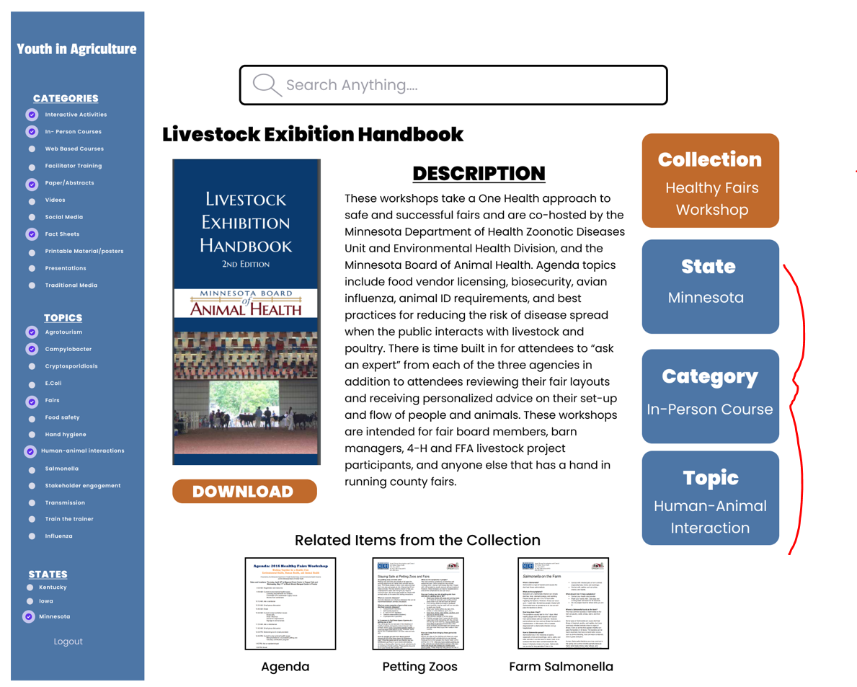
In general, we like this view of each particular resource and that the items from the collection are viewable. Is there a way to click to view the whole collection? Could we make the blue boxes showing the filters smaller? Are they intended to be filters that can be cleared? What will this page look like if resource is a video?
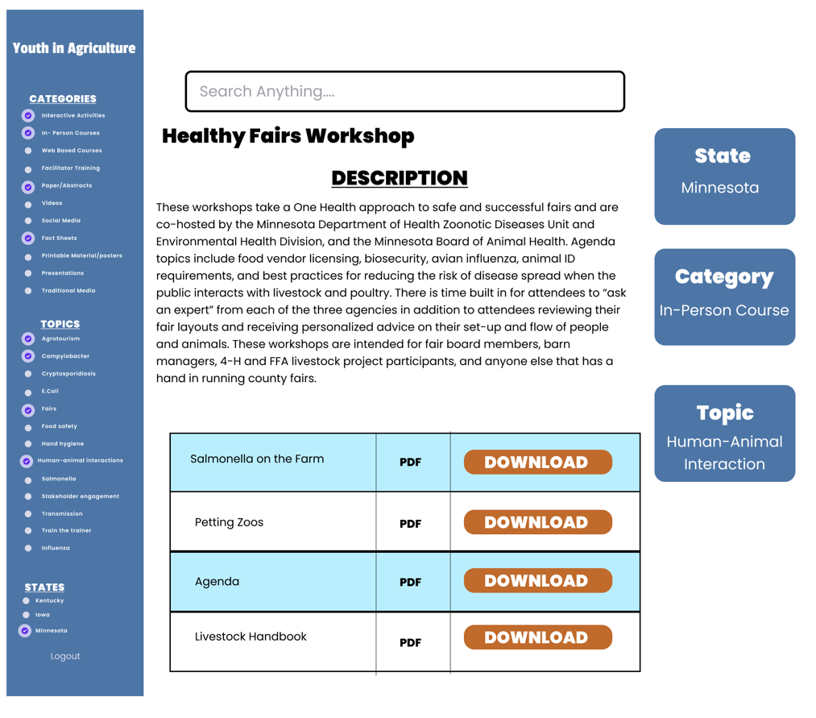
It may be helpful to add “Materials” or “Collection” after the title to make it’s clear that these are all related. Perhaps the individual documents in each collection should appear as tiles, like they would on the main search page? In this table format, there isn’t much information provided about the individual resources.

