Please return completed Interim Progress Report to CSTE at mhuynh@cste.org by July 31, 2021.
Note: Please submit one response per site.

- List project deliverables and describe progress made towards completion of these deliverables:

- Deliverable 1.A: Host “Becoming a Swientist” programming with OH-pigs Ohio Summer Swine Circuit.
Accomplishments/Progress to-date: Content was delivered at each of the ten weekend OH-Pigs Summer Jackpot Circuit shows focused on the immune system. Youth were asked each week to complete a short survey to gauge gain in knowledge and data analysis is ongoing. There were more than 150 youth participating in the circuit and 100-400 youth participating in the shows each weekend. The following table is an overview of the activities presented at each weekend.
Lesson | Activity | Give-away
Infectious Agents Aren't All Alike | "How do viruses react to soap?" activity | Bubbles
What is immunology? | 3 lines of Defense Obstacle Course Obstacle 1: Balance Beam Obstacle 2: Drive the pig thru maze Obstacle 3: Get the germ to the host cell | Swientist Maze Game
What parts of the pig make up the immune system? | Pig diagrams with light box -- Label parts of immune system on their pig puzzle | Pig Mini-Logo Puzzle
Types of Immune cells and their functions | Build a catapult to launch different immune cells at germs - Components of catapult are immune system components | Germ Stress Reliever
What is the immune response? | Build a fortress of immune cells and try to invade as a pathogen | Thermometer
What are antibodies? | Water beads, ball bearings, magnet game | Antibody key chain
How do antibodies work? | Velcro pad/ball game | Velcro pad/ball game
How do vaccines work? | Herd Immunity Jenga | Syringe pen
Vaccines target specific pathogens | Vaccine target kick-ball | Squirt gun and target
How to properly give an injection | Vaccinate oranges | Sharps containers

Did this deliverable include an educational intervention: Yes

- Deliverable 1.B: Collaborate with the National Junior Swine Association to engage national level swine jackpot show participants at various shows across the country.
Accomplishments/Progress to-date: Immunology lessons developed for the OH-Pigs shows were taken to two NJSA, national level jackpot shows during Phase 1. We were at the “The Expo” in Indianapolis, IN with different content each day for four days. Over 1500 youth registered to show pigs at the event and many visited the Swientist booth each day. Giveaways ranged from 100-400 each day of the show. The second national show we attended was “Summer Spectacular” held in Louisville, KY. Over 800 youth were registered at this show, and participated in Swientist activities that were different from those presented in Indianapolis, but still focused on immunology.
Did this deliverable include an educational intervention: Yes
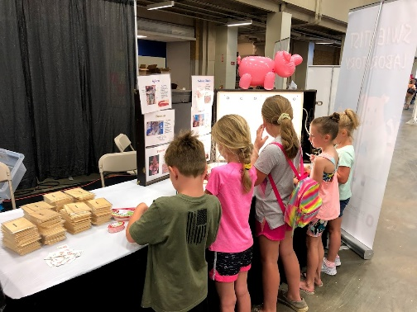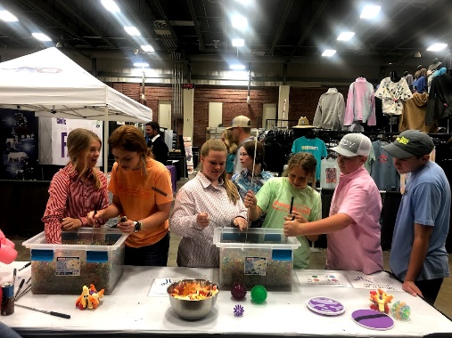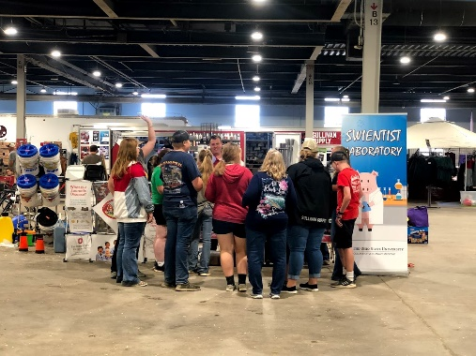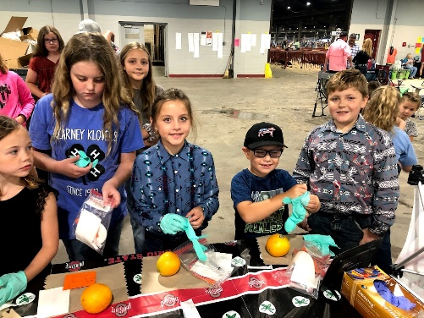

- Deliverable 2.A: Partner with the Ohio FFA Association to develop and disseminate zoonotic disease risk and prevention curriculum in accordance with Ohio Department of Education standards for middle school agricultural education students.
Accomplishments/Progress to-date: High school curriculum was rolled out to agriculture educators at their annual meeting, June 2021. During that time connections were made with educators to brainstorm ideas for developing the middle school content. Curriculum development has not begun and will be achieved during Phase 2.
Did this deliverable include an educational intervention: No

- Deliverable 2.B: Collaborate with the American Association of Swine Veterinarians to build awareness for swine health careers in youth who show swine at a state and national level.
Accomplishments/Progress to-date: Curriculum development has not begun and will be achieved during Phase 2.
Did this deliverable include an educational intervention: No
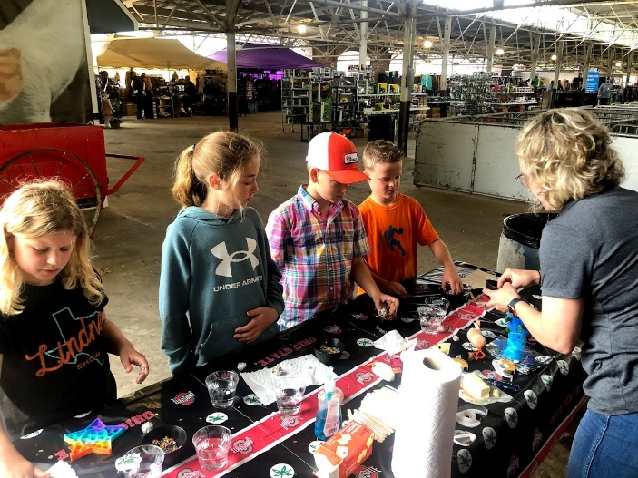
- Deliverable 3.A: Collaborate with Team Purebred to engage national level swine jackpot show participants at various shows across the country
Accomplishments/Progress to-date: Immunology lessons developed for OH-Pigs shows were used at one national level Team Purebred show held in May in Des Moines, IA. There were 300 total youth registered at the show and 100 giveaways were passed out to participants completing our activities.

Did this deliverable include an educational intervention: Yes

- Deliverable 3.B: Host Becoming a Swientist events to youth involved in jackpot shows with multiple species in Pennsylvania.
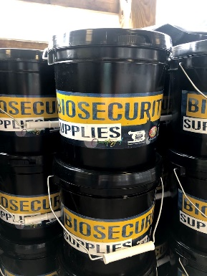
Accomplishments/Progress to-date: A Swientist Biosecurity workshop was held in Dunbar, PA at the PA Club Livestock Association Summer Jackpot Series Kickoff in association with Pennsylvania Pork Council and PennAg. There were 95 youth registered to attend a 2-hour swientist workshop with 4 activities highlighting the importance of biosecurity. Participants showed a variety of livestock species, therefore the workshop was not focused on swine. Each participant was given a biosecurity bucket (pictured) to take home and initiate biosecurity procedures at their farms. Pre- and post- test assessments were conducted to measure gains in knowledge.
Did this deliverable include an educational intervention: Yes

- List the collaborators involved to-date and briefly describe their role in the project (i.e. 4H/FFA, State PH, State Animal Health).
Animal Influenza Ecology and Epidemiology Research Program:
The Animal Influenza Ecology and Epidemiology Research Program (AIEERP) at The Ohio State University has taken the lead on each objective and works closely with other collaborators to make progress toward completion. AIEERP hosts the Becoming a Swientist program, designing and implementing all program activities. In addition, AIEERP has developed all curriculum that is being used for Swientist workshops.

National Swine Registry:
The National Swine Registry (NSR) sponsors the National Junior Swine Association (NJSA) and hosts multiple swine exhibitions. Without their support, the Becoming a Swientist program would not be possible.

Team Purebred:
Team Purebred hosts multiple swine exhibitions and supports the Becoming a Swientist program by providing space at the shows and access to association members.

Ohio Pork Council:
The Ohio Pork Council sponsors the OH-Pigs Summer Jackpot Circuit and graciously has an open-door policy to their events for the Swientist program. Their continued support of educational outreach is unmatched and has been crucial to the success of the Becoming a Swientist program.

Ohio Department of Agriculture:
Ohio Department of Agriculture (ODA) supports activities being held in Ohio to educate youth in agriculture.
Ohio Department of Health:
The Ohio Department of Health (ODH) supports activities being held in Ohio to educate youth in agriculture.
Ohio FFA:
Ohio FFA has provided the AIEERP team with career technical competencies to develop curriculum around and continues to offer support for all aspects of the program.

- As relevant, describe areas of concern or challenges in meeting the objectives or providing deliverables especially as it relates to COVID-19.
COVID-19 has not been a barrier to completing the deliverables of the project in 2021, except for staffing shortages caused by societal shifts.

- Please outline your evaluation goals and timeline for the remainder of the project period (August 1 – December 31, 2021). Data collected from surveys and pre- and post-tests will be analyzed a reported in the final report. Evaluation forms will also be distributed to NSR, Team Purebred, OH-Pigs, and PennAg to gain insight into the quality of Swientist workshops and curriculum. Summaries will be reported in the final report.

OPTIONAL (responses to these prompts are not required but your input is greatly appreciated and welcome):

- Would it be valuable for your site if the Youth in Agriculture program developed a standardized set of learning objectives, lessons, etc. to expand the reach of the program beyond your site? If so, would you be interested in contributing or being further involved in discussions around the development of a national standardized curriculum? There would be benefits to having standardized messaging between groups to build credibility within the program. We are happy to be included in the development of the standardized curriculum.

Impact Chart
If the activity/deliverable described is/included an Educational Intervention, please complete this portion of the report
Impact |  |  |  |  |  |  | Evaluation
Intervention Activity | Baseline # prior to current grant period | How did you measure the baseline? Did you include direct participants, families, etc? | 2021 Audience (youth, community leaders, etc?) | # of attendees/  participants | # of materials distributed | Did you collaborate with another state? If so, which one(s)? | Pre-test administered? (How many? To whom?) | Post-test administered? (How many? To whom?)
EXAMPLE: Four Scenario based training exercises | X# of training sessions held in 2021 to X total youth aged 11-15 | Only counted the number of actual youths who attended the session | Youth aged between 12 and 16 | X # attendees per training; total of X attendees
Immunology content workshops | ~100 youth in OH-Pigs in 2018-2020 participated in Swientist workshops at one show | Counted total number of youth enrolled in OH-Pigs Summer Jackpot Circuit | Youth aged 3-21 | 150 total youth enrolled in OH-Pigs Summer Jackpot Circuit. There were 150-300 youth who participated each week in the shows. | A minimum of 100 giveaways were distributed each week. Some weeks 200 items were given away. | No | Surveys were collected each week from participants | Surveys were collected each week from participants
Daily activities at “The Expo” national jackpot show | 1250 youth registered at 2020 show | Counted number of youth registered at show | Youth aged 3-21 | 1500 youth registered at show | Daily 100-400 items were given away | No | No | No
Daily activities at “Summer Spectacular” national jackpot show | 600 youth registered at 2020 show | Counted number of youth registered at show | Youth aged 3-21 | 880 youth registered at show | 250 items were given away each day of show | No | No | No
Daily activities at “The Recovery” national jackpot show | 2021 was the first time this show was held | NA | Youth aged 3-21 | 880 youth registered at show | 250 items were given away each day of show | No | No | No
Becoming a Swientist – PA Club Livestock Association Summer Jackpot Series Kickoff | 2021 was the first time this workshop was held | NA | Youth aged 3-21 | 95 | 95 | PA | Yes | Yes

